**Finite Element Analysis of Interacting Defects in Corroded Pipelines**

by

Noor Azliza bt Abdull Kadir

Dissertation submitted in partial fulfillment of

the requirements for the

Bachelor of Engineering (Hons)

(Mechanical Engineering)

DECEMBER 2010

Universiti Teknologi PETRONAS

Bandar Seri Iskandar

31750 Tronoh

Perak Darul Ridzuan

**ABSTRACT**

Unprotected pipelines, whether buried in the ground, exposed to the atmosphere, or submerged in water, are susceptible to corrosion. Without proper maintenance, every pipeline system will eventually deteriorate. Corrosion can weaken the structural integrity of a pipeline and make it an unsafe vehicle for transporting potentially hazardous materials. The loss of metal due to corrosion in pipelines usually results in localized pits with various depths and irregular shapes on its internal and external surfaces. An interacting defect is one that interacts with neighboring defects in an axial or circumferential direction. The maximum allowable pressure that can be sustained in a pipeline with interacting defects is lower than it is in single defects due to interaction of neighboring defects. Several techniques have been developed to evaluate the integrity of corroded pipeline with interacting defects for the purpose of fit-for-service assessment. Finite element analysis is one of the methods to predict the reliability of the corroded pipeline. The main objective of this project is to implement the finite analysis technique in finding maximum allowable pressure and to predict the strength of corroded pipeline. The FEA results show that interacting defects in corroded pipelines can be assessed using the nonlinear analysis method in FEA to provide the best solution and to reduce the conservatism involved in the existing codes.

**TABLE OF CONTENTS**

**ABSTRACT. . . . . . . . . . i**

**List of Figures. . . . . . . . . iv**

**List of Tables . . . . . . . . . vi**

**Chapter 1: INTRODUCTION. . . . . . . 1**

1.1 Background. . . . . . . . . 1

1.2 Problem Statement. . . . . . . . 2

1.3 Objectives and Scope of Study. . . . . . 2

**Chapter 2: LITERATURE REVIEW. . . . . . 3**

2.1 Corrosion. . . . . . . . . 3

2.2 Pipeline Corrosion. . . . . . . . 4

2.3 Interacting Defects. . . . . . . . 4

2.4 Codes and Standards. . . . . . . . 5

2.5 Finite Element Analysis. . . . . . . 5

**Chapter 3: METHODOLOGY. . . . . . . 7**

3.1 Project Work. . . . . . . . . 7

3.2 Allowable Corroded Pipe Pressure Estimate Using DNV Method. . 10

3.3 Project Planning. . . . . . . . 16

3.4 Allowable Corroded Pipe Pressure Estimate Using Finite Element

Analysis (FEA) . . . . . . . 17

**Chapter 4: RESULTS AND DISCUSSIONS. . . . . 26**

4.1 Empirical Results. . . . . . . . 26

4.2 Current Result Summary. . . . . . . 29

**Chapter 5: CONCLUSIONS. . . . . . . 37**

**REFERENCES. . . . . . . . . 38**

**LIST OF FIGURES**

Figure 2.1: Uniform Corrosion . . . . . . 4

Figure 2.2: Localized Corrosion. . . . . . 4

Figure 3.1: Flow Chart for Project Work. . . . . . 9

Figure 3.2: Corrosion Depth Adjustment for Defects with Background

Corrosion. . . . . . . . 11

Figure 3.3: Projection of Circumferentially Interacting Defects. . 11

Figure 3.4: Projection of Overlapping Sites onto a Single Projection Line

and the Formation of a Composite Defect . . . . 12

Figure 3.5: Change the Jobname of File. . . . . 17

Figure 3.6: Defining the Element Types of The model. . . . 18

Figure 3.7: Engineering Stress vs Strain Graph for X65. . . . 19

Figure 3.8: Engineering Stress vs Strain Graph for X65 . . . 20

Figure 3.9: Defining the Material Properties of Model. . . . 20

Figure 3.10: Defining Material Properties for Non Linear Analysis. . 20

Figure 3.11: Creating Model by Areas on Workpane . . . 21

Figure 3.12: Half of the Pipe with Two Defects. . . . . 21

Figure 3.13: Mapped Mesh of the Pipe. . . . . . 22

Figure 3.14: Symmetric Boundary Conditions of the Model . . 23

Figure 3.15: Internal Load Applied . . . . . . 24

Figure 3.16: Contour Plot of Stress Distribution along Pipe. . . 24

Figure 4.1: Allowable Corroded Pipe Pressure (MPa) vs  for

*d/t2*= 0.75 (X65 Steel). . . . . . 30

Figure 4.2: Graph of *pcorr* vs *dnm/t* for different stopping criterion . 32

Figure 4.3: Linear Analysis for ****= 0.5 *d/t1*= *d/t2*= 0.25 *. .* 33

Figure 4.4: Non-Linear Analysis for ****= 0.5 *d/t1*= *d/t2*= 0.25 *. .* 33

Figure 4.5: Graph of Normalized Corroded Pressure, *Pcorr* vs spacing per

square root of unit depth with thickness,  . . 35

Figure 4.6: Linear Analysis for = 0.5 *d/t1*= 0.25and *d/t2*= 0.5. . 37

Figure 4.7: Non-Linear Analysis for = 0.5 *d/t1*= 0.25and *d/t2*= 0.5. 37

**LIST OF TABLES**

Table 3.1: Partial Safety Factor (). . . . . . 15

Table 3.2: Partial Safety Factor () and Fractile Value (). . . 15

Table 3.3: Standard Deviation and Confidence Level. . . . 15

Table 3.4: Gantt chart for FYP 2. . . . . . 16

Table 3.5: The Analysis Matrix. . . . . . . 22  
Table 4.1: Parameters of Sample with *d/t*1= *d/t*2= 0.25 and

= 0.5 . . . . . . . 24

Table 4.2: Trend comparison for Normalized Corroded Pressure, *pcorr/patm*

vs combined depth of defects per unit thickness, *dnm/t*. . 28

Table 4.3: Results for Stopping Criterion in Nonlinear Analysis for X65

Steel . . . . . . . . 34

**CHAPTER 1**

**INTRODUCTION**

* 1. **PROJECT BACKGROUND**

Integrity assessment of corroded pipelines is very vital in oil and gas industry.   
In pipeline terms, even the best designed and maintained pipeline will become defective as it operates through its design life. Therefore, it is necessary for the engineers to assess the integrity of these pipelines. The increasing use of high-technology maintenance such as intelligent pigs is helping pipeline owners to assess the condition of their lines, and if these modern maintenance methods are combined with modern defect-assessment methods, they can provide a very powerful and cost-effective tool. This project is about developing a platform for engineers to assess the interacting defects in corroded pipelines using finite element analysis (FEA). The modeling will be conducted in Ansys software. The results from FEA will be compared to empirical solution that is provided by DNV RP-F101, a Recommended Practice for Corroded Pipeline [1].

**1.2 PROBLEM STATEMENT**

Frequently plants are shut down or portions of processes stopped due to unexpected corrosion. In pipeline, the interior and exterior parts are exposed to this corrosion problem. Corrosion monitoring of pipeline is helpful in preventing unexpected corrosion failure [2]. In addition, it is important to know the maximum allowable operation pressure of the corroded pipelines segment to ensure the pipelines are working under safe condition. Due to interacting defects resulted from uniform corrosion inside the pipelines the maximum operation pressure will be lower than it is in single defects. Better understanding is required in order to reduce the conservatism involved in the current assessment method. Therefore, there is a need to develop a model that can be a platform for engineers to assess the integrity of corroded pipelines with interacting defects using finite element analysis (FEA) method.

**1.3 OBJECTIVE AND SCOPE OF STUDY**

The objectives of this project are:

* To assess the integrity of corroded pipelines due to interacting defects.
* To compare the results obtained from finite element analysis with those from the available codes.

The scope of this project will be simplified as follows:

* The material of the pipelines are API 5L X65 and X100.
* Result from Finite Element Analysis will be compared with empirical solutions provided by DNV-RP-F101.
* The pipelines will be subjected to internal pressure loading only.

**CHAPTER 1**

**INTRODUCTION**

* 1. **PROJECT BACKGROUND**

Integrity assessment of corroded pipelines is very vital in oil and gas industry.   
In pipeline terms, even the best designed and maintained pipeline will become defective as it operates through its design life. Therefore, it is necessary for the engineers to assess the integrity of these pipelines. The increasing use of high-technology maintenance such as intelligent pigs is helping pipeline owners to assess the condition of their lines, and if these modern maintenance methods are combined with modern defect-assessment methods, they can provide a very powerful and cost-effective tool. This project is about developing a platform for engineers to assess the interacting defects in corroded pipelines using finite element analysis (FEA). The modeling will be conducted in Ansys software. The results from FEA will be compared to empirical solution that is provided by DNV RP-F101, a Recommended Practice for Corroded Pipeline [1].

**1.2 PROBLEM STATEMENT**

Frequently plants are shut down or portions of processes stopped due to unexpected corrosion. In pipeline, the interior and exterior parts are exposed to this corrosion problem. Corrosion monitoring of pipeline is helpful in preventing unexpected corrosion failure [2]. In addition, it is important to know the maximum allowable operation pressure of the corroded pipelines segment to ensure the pipelines are working under safe condition. Due to interacting defects resulted from uniform corrosion inside the pipelines the maximum operation pressure will be lower than it is in single defects. Better understanding is required in order to reduce the conservatism involved in the current assessment method. Therefore, there is a need to develop a model that can be a platform for engineers to assess the integrity of corroded pipelines with interacting defects using finite element analysis (FEA) method.

**1.3 OBJECTIVE AND SCOPE OF STUDY**

The objectives of this project are:

* To assess the integrity of corroded pipelines due to interacting defects.
* To compare the results obtained from finite element analysis with those from the available codes.

The scope of this project will be simplified as follows:

* The material of the pipelines are API 5L X65 and X100.
* Result from Finite Element Analysis will be compared with empirical solutions provided by DNV-RP-F101.
* The pipelines will be subjected to internal pressure loading only.

**CHAPTER 2**

**LITERATURE REVIEW**

**2.1 CORROSION**

Corrosion is defined as the destruction or deterioration of a material because of its reaction with the environment. In other term, corrosion means partial or complete wearing away, dissolving, or softening of any substance by chemical or electrochemical reaction with its environment [2]. In the most common use of the word, this means electrochemical oxidation of metals in reaction with an oxidant such as oxygen. Formation of an oxide of [iron](http://en.wikipedia.org/wiki/Iron) due to oxidation of the iron [atoms](http://en.wikipedia.org/wiki/Atom) in solid solution is a well-known example of electrochemical corrosion, commonly known as [rusting](http://en.wikipedia.org/wiki/Rusting). This type of damage typically produces [oxide](http://en.wikipedia.org/wiki/Oxide)(s) and/or [salt](http://en.wikipedia.org/wiki/Salt_(chemistry))(s) of the original metal.

**2.2 PIPELINE CORROSION**

Some pipelines deteriorate gradually, and in certain cases pipeline life has been reliably targeted at 70 years or more. Apart from the quality of the construction, coatings, cathodic protection systems etc, the factors which affect pipeline life include nature of the product transported, nature of the external environment, operating conditions and quality of maintenance [3].

The corrosion in pipelines is divided into two main types. They are uniform corrosion and localized corrosion. Uniform corrosion (Figure 2.1) is the well distributed and low level attack against the entire metal surface with little or no localized penetration while localized corrosion (Figure 2.2) is deep penetration of the metal surface with little general corrosion in the surrounding area [4, 5].

Corroded Region (Uniform)

Affected Area

Affected Area

Corroded Region (Localized)

Metal Base

1korro.gif (3364 bytes)2korro.gif (2839 bytes)

Figure 2.2: Localized Corrosion

Figure 2.1: Uniform Corrosion

**2.3 INTERACTING DEFECTS**

Interacting defects are defects that interact with neighboring defects in an axial or circumferential direction. The failure pressure of an interacting defect is lower than it would be if the interacting defect was a single defect, because of the interaction with neighboring defects [1].

**2.4 CODES AND STANDARDS**

The codes used for defect assessment of corroded pipelines are:

**2.4.1 DNV RP-F101- Recommended Practice for Corroded Pipeline** [1]**.**

This document provides recommended practice for assessing pipelines containing corrosion. Recommendations are given for the assessment of corrosion defects subjected to internal pressure loading only and internal pressure loading combined with longitudinal compressive stresses.

**2.4.2 ASME B31.G – Manual for Determining the Remaining Strength of Corroded Pipelines.**

ASME B31.G idealizes the complex geometry of a corrosion pit as an elliptical shape, and applies a bulging factor for the consideration of defect geometry.

**2.5 FINITE ELEMENT ANALYSIS**

Finite element analysis is a numerical procedure that can be used to obtain solutions to a large class of engineering problems involving stress analysis, heat transfer, electromagnetism and fluid flow [6]. In practice, a finite element analysis usually consists of three principal steps:

1. **Preprocessing**: The user constructs a model of the part to be analyzed in which the geometry is divided into a number of discrete sub regions, or elements, connected at discrete points called nodes. Certain of these nodes will have fixed displacements, and others will have prescribed loads. These models can be extremely time consuming to prepare, and commercial codes vie with one another to have the most user-friendly graphical preprocessor to assist in this rather tedious chore.
2. **Analysis:** The dataset prepared by the preprocessor is used as input to the finite element code itself, which constructs and solves a system of linear or nonlinear algebraic equations:

**Kjuj = fi**

where **u** and **f** are the displacements and externally applied forces at the nodal points. The formation of the **K** matrix is dependent on the type of problem being attacked, and this module will outline the approach for truss and linear elastic stress analyses. Commercial codes may have very large element libraries, with elements appropriate to a wide range of problem types. One of FEA's principal advantages is that many problem types can be addressed with the same code, merely by specifying the appropriate element types from the library.

1. **Post processing:** In the earlier days of FEA, the user would pore through reams of numbers generated by the code, listing displacements and stresses at discrete positions within the model. It is easy to miss important trends and hot spots this way, and modern codes use graphical displays to assist in visualizing the results. Typical postprocessor display overlays colored contours representing stress levels on the model, showing a full field picture similar to that of photo elastic or moiré experimental results.

**CHAPTER 3**

**METHODOLOGY**

**3.1 PROJECT WORK**

Firstly, the empirical solution provided by DNV RP-F101 is studied. Few parameters such as depth of defects, length of defects, diameter of the pipelines and spacing between defects are manipulated. The purpose is to analyze the effect of each parameter to the maximum pressure that can be applied in the pipe.

Second step is to identify the key parameter to be manipulated from the empirical solutions. From the analysis, the most crucial parameter will be determined as the key parameters for the analysis in Ansys software.

The next step involves determination of the appropriate boundary conditions to the sample. For structural problems, the potential boundary conditions that may involve are displacements, forces, distributed loads (pressures), temperature for thermal expansion and gravity.

After that, the modeling of the sample will be conducted in Ansys software. The steps involved in creating the models are defining the types and options, defining the element real constants if required for the chosen element type, defining material properties, creating model geometry, defining mesh controls and meshing of the object created.

After the model has been created, the next step is to apply load and constraints to the sample. In this project, the type of loading involved is the internal pressure loading in the form of distributed load.

Results from the finite element model are obtained for further study. Contour plot of the model is displayed to study the stress distribution throughout the pipe. The results obtained from the finite element analysis will then be compared with the results obtained from the standards.

The overall project work follows the flow chart in Figure 3.1.

Start

1. Determine the empirical solution to be used.

8. Discussions and Conclusions

7. Compare the results with empirical solution results

5. Apply load to the sample

4. Create the model using ANSYS

3. Determine the boundary condition of the sample.

2. Identify the key parameter to be manipulated from the empirical solution.

6. Solve the finite element analysis

**Figure 3.1: Flow chart for the Project Work**

**3.2 ALLOWABLE CORRODED PIPE PRESSURE ESTIMATE USING DNV METHOD**

The allowable corroded pipe pressure of a colony of interacting defects can be estimated using the following procedure:

3.2.1 For regions where there is background metal loss (less than 10% of the wall thickness) the local pipe wall thickness and defect depths can be used (Figure 3.2).

3.2.2 The corroded section of the pipeline should be divided into sections of a minimum length of, with a minimum overlap of.

3.2.3 Construct a series of axial projection lines with a circumferential angular spacing of:

 (Degrees)

3.2.4 Consider each projection line in turn. If defects lie within ±Z, they should be projected onto the current projection line (Figure 3.3).

3.2.5 Where defects overlap, they should be combined to form a composite defect. This is formed by taking the combined length, and the depth of the deepest defect (Figure 3.4). If the composite defect consists of an overlapping of internal and external defect then the depth of the composite defect is the sum of the maximum depth of the internal and external defects.



**Figure 3.2: Corrosion depth adjustment for defects with background corrosion**



**Figure 3.3: Projection of circumferential interacting defects**



**Figure 3.4: Projection of overlapping sites onto a single projection line and the formation of a composite defect**

3.2.6 Calculate the allowable corroded pipe pressure (*p1,p2 … pN*) of each defect, to the Nth defect, treatingeach defect, or composite defect, as a single defect:

 *i=*1, 2

where,





= Minimum yield strength of the material (415MPa)

=Partial safety factor for model prediction (**Table 3-1**)

=Partial safety factor for corrosion depth (**Table 3-2**)

= Factor for defining fractile value for the corrosion depth (**Table 3-2**)

StD[d/t] = Standard deviation of the measured (*d/t*) ration (**Table 3-3**)

3.2.7 Calculate the combined length of all combinations of adjacent defects.

For defects *n* to *m* the total length is given by:



3.2.8 Calculate the effective depth of the combined defect formed from all of the interacting defects from *n* to *m*, as follows:



3.2.9 Calculate the allowable corroded pipe pressure of the combined defect from *n* to *m* (*pnm*) using *lnm* and *dnm* in the single defect equation:



where,





3.2.10 The allowable corroded pipe pressure for the current projection line is taken as the minimum of the failure pressures of all of the individual defects *(p1* to *pN*), and of all the combinations of individual defects (*pnm*), on the current projection line.



3.2.11 The allowable corroded pipe pressure for the section of corroded pipe is taken as the minimum of the allowable corroded pipe pressures calculated for each of the projection lines around the circumference.

|  |  |  |  |
| --- | --- | --- | --- |
| Inspection Method  **Table 3-1: Partial Safety Factor (****)** | Safety Class | | |
| Low | Normal | High |
| Relative (MFL) | 0.79 | 0.74 | 0.70 |
| Absolute ( UT) | 0.82 | 0.77 | 0.72 |

**Table 3-2: Partial Safety Factor (****) and Fractile Value (****)**

|  |  |  |  |  |
| --- | --- | --- | --- | --- |
| Inspection Sizing Accuracy StD(d/t) |  | Safety Class | | |
| Low | Normal | High |
| Exact 0.00 | 0.00 | 1.00 | 1.00 | 1.00 |
| 0.04 | 0.00 | 1.16 | 1.16 | 1.16 |
| 0.08 | 1.00 | 1.20 | 1.28 | 1.32 |
| 0.16 | 2.00 | 1.20 | 1.38 | 1.58 |

**Table 3-3: Standard Deviation and Confidence Level**

|  |  |  |
| --- | --- | --- |
| Relative Sizing Accuracy | Confidence Level | |
| 80% (0.80) | 90% (0.90) |
| Exact ± (0.0 of *t*) | 0 | 0 |
| ± 0.05 of t | 0.04 | 0.03 |
| ± 0.10 of t | 0.08 | 0.06 |
| ± 0.20 of t | 0.16 | 0.12 |

**3.4 ALLOWABLE CORRODED PIPE PRESSURE ESTIMATE USING FINITE ELEMENT ANALYSIS (FEA)**

After conducting the analysis using DNV RP-F101 code, finite element models are developed using ANSYS, a well known engineering simulation software. The loading involved in this simulation is distributed internal pressure loading. The purpose of this analysis is to estimate the corroded pipe pressure. The finite element analysis (FEA) is conducted according to the following procedure:

**3.4.1 Pre-processing**

1. Jobname

The jobname is a name that identifies the ANSYS job. When a jobname is defined for an analysis, the jobname becomes the first part of the name of all files the analysis creates. (The extension or suffix for these files' names is a file identifier such as .DB.) By using a jobname for each analysis, no files are overwritten.

**Utility menu > File > Change Jobname. (Figure 3.5)**

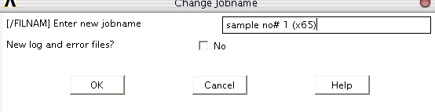

**Figure 3.5: Change the Jobname of a File**

1. Define element type

The ANSYS element library contains more than 100 different element types. Each element type has a unique number and a prefix that identifies the element category. The element type determines whether the element lies in two-dimensional or three-dimensional space and the degree-of-freedom set (which in turn implies the discipline - structural, thermal, magnetic, electric, quadrilateral, brick, etc.)

Brick 20 node 95 (SOLID 95) is chosen because it is applicable for mapped meshing (controlled meshing). It also can tolerate irregular shapes without as much loss of accuracy and well suited for modeling curved boundaries.

**Main Menu > Preprocessor > Element Type > Add / Edit / Delete (Figure 3.6)**

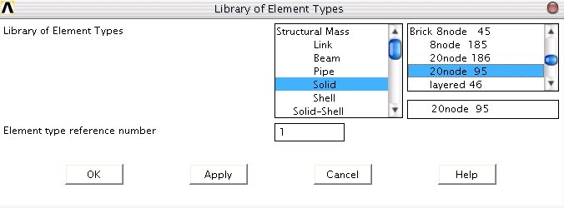**Figure 3.6: Defining the Element Types of the Model**

3. Define material properties

Most element types require material properties. Depending on the application, material properties may be linear or nonlinear, isotropic, orthotropic, or anisotropic, constant temperature or temperature-dependent.

As with element types and real constants, each set of material properties has a material reference number. Table 3.5 consists of the physical properties of Steel X65 and Steel X100. The Young’s modulus and Poisson’s ratio were considered in the linear isotropic analysis.

Table 3-5: Material Properties of Steel X65 and X100.

|  |  |  |  |  |
| --- | --- | --- | --- | --- |
| Material | Young’s modulus (GPa) | Poisson’s ratio | Yield stress (MPa) | UTS  (MPa) |
| Steel X65 | 203 | 0.3 | 448.0 | 530.9 |
| Steel X100 | 203 | 0.3 | 714.0 | 801.7 |

**Main Menu > Preprocessor > Material Props > Material Models > Structural > Linear > Elastic > Isotropic. Insert the material properties of Young’s Modulus (EX) and Poisson’s Ratio (PRXY) (Figure 3.7)**

**Main Menu > Preprocessor > Material Props > Material Models > Structural > Nonlinear > Elastic > Multilinear Elastic (Figure 3.8)**

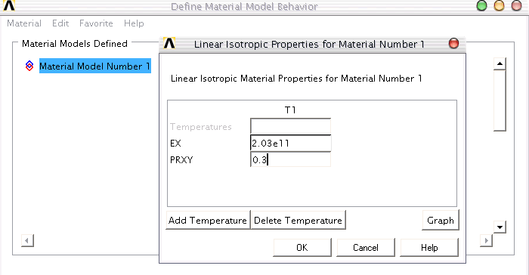 **Figure 3.7: Defining the Material Properties of theModel**

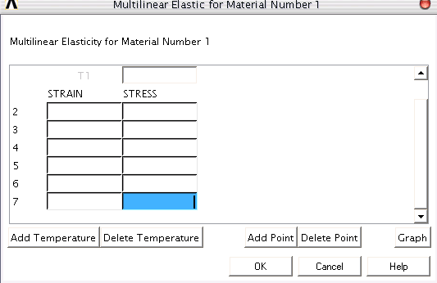

Figure 3.8: Defining the Material Properties for Non Linear Analysis

On the other hand, non-linear simulation requires the engineering stress versus strain graph values. The engineering stress versus strain graph for material X65 and X100 are as in Figure 3.9 and Figure 3.10.

**Figure 3.9: Engineering Stress vs. Strain Graph for X65**

**Figure 3.10: Engineering Stress vs. Strain Graph for X100**

4. Creating the model geometry

The model is created by dividing the area to segments for the purpose of controlling the mesh.

**Main Menu > Preprocessor > Modeling > Create > Area > Partial Annulus (Figure 3.11)**

Then, the 2D segments of the pipe are extruded to form volume and the volume components of the pipe are glued together to preserve the boundary planes between them.

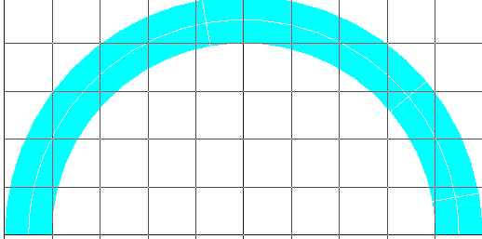**Main Menu > Preprocessor > Modeling > Operate > Extrude > along normal (Figure 3.12)**

**Figure 3.11: Creating Model by Areas on Work plane**

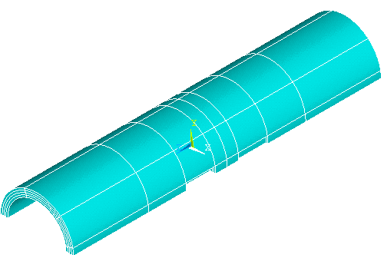

**Figure 3.12: Half of the Pipe with Two Defects**

5. Meshing

ANSYS Meshing allows a user to specify which face(s) to be forced with a mapped mesh.  The user can also specify options on how the face should be sub mapped if it has more than 4 sides. Faces marked with a mapped mesh control that cannot be mapped will then be meshed with a free mesh and the software will notify the user.  This is convenient as the user can mark all faces to be mapped meshed to try to force more orthogonal meshing.  For solid parts being meshed with a tetrahedron mesh, the quads will be split into triangles. The subsequent GUI is followed to control the division lines and to mesh the model.

1. **Main Menu > Preprocessor > Meshing > Size Cntrls > Lines > All Lines > Change division of the lines.**
2. **Main Menu > Preprocessor > Meshing > Volume > Mapped > 4 to 6 sided. (Figure 3.13)**

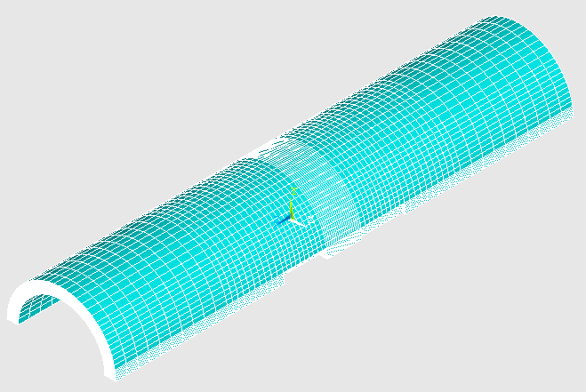

**Figure 3.13: Mapped Mesh of the Pipe**

6. Load

Ansys software has the capability to solve problems that are symmetrical in shape. Therefore, only half of the model is created and appropriate boundary condition is applied at the areas with symmetrical shape loading. Then, the pressure is applied at the internal surfaces of the pipe.

* + 1. **Main Menu > Pre-processor > Loads > Define Loads > Apply > Structural > Displacement > Symmetry B.C. > Areas (Figure 3.14)**
    2. **Main Menu > Pre-processor > Loads > Define Loads > Apply > Structural > Pressure > On Areas (Figure 3.15)**
    3. **Main Menu > Solution > Solve > Current LS**

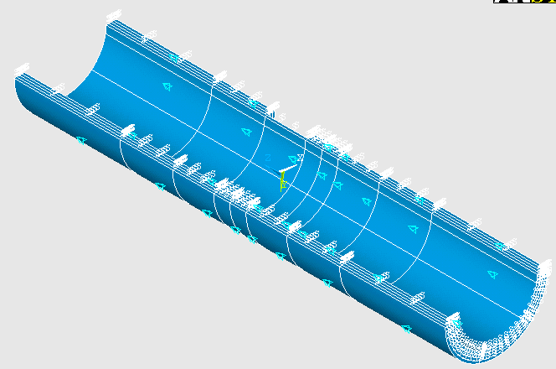

Symmetric Boundary Condition

**Figure 3.14: Symmetry Boundary Conditions of the Model**

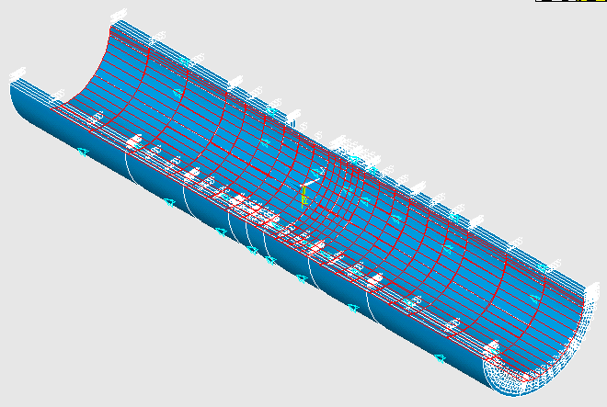

Load/ Pressure

**Figure 3.15: Internal Load Applied**

**3.4.2. Post Processor**

To view the contour plot of the results after simulation is completed, the following steps are followed:

**Main Menu > General Postproc > Plot Results > Contour Plot > Nodal Point > Stress > Von Mises Stress. Click OK. (Figure 3.16)**

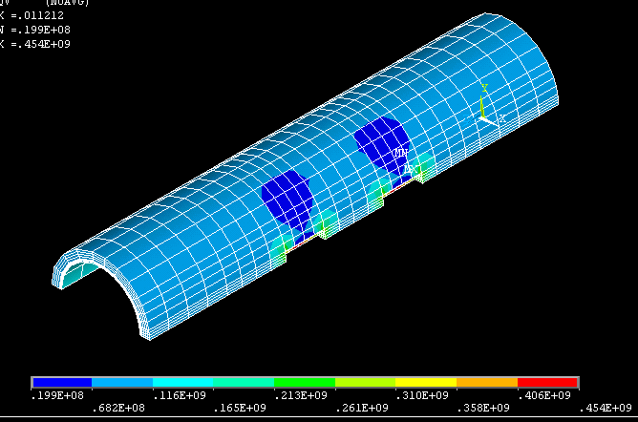

**Figure 3.16: Contour Plot of Von Mises Stress Distribution along the Pipe**

**3.4.3 Comparison of Results**

During modelling, parameters such as defect depth, *d* and spacing between the defects, *s* is varied. The parameters are varied as in Table 3.5. Pipe materials used are steel X65 and X100. In ANSYS, the properties of the steel should be filled. Each of the combination is represented by one model in FEA. Table 3.5 is the analysis matrix used to tabulate the results obtained from all 3 methods.

**Table 3.5: The Analysis Matrix**

|  |  |  |  |  |  |  |  |  |
| --- | --- | --- | --- | --- | --- | --- | --- | --- |
|  | ***(d/t)1*** | ***(d/t)2*** | **Failure Pressure (MPa)** | | | | | |
| **X65** | | | **X100** | | |
| **FEA**  **(Linear)** | **FEA**  **(Non-Linear)** | **DNV-RP-F101** | **FEA**  **(Linear)** | **FEA**  **(Non-Linear)** | **DNV-RP-F101** |
| 0.5 | 0.25 | 0.25 |  |  |  |  |  |  |
| 0.50 |  |  |  |  |  |  |
| 0.75 |  |  |  |  |  |  |
| 0.50 | 0.50 |  |  |  |  |  |  |
| 0.75 |  |  |  |  |  |  |
| 0.75 | 0.75 |  |  |  |  |  |  |
| 1.00 | 0.25 | 0.25 |  |  |  |  |  |  |
| 0.50 |  |  |  |  |  |  |
| 0.75 |  |  |  |  |  |  |
| 0.50 | 0.50 |  |  |  |  |  |  |
| 0.75 |  |  |  |  |  |  |
| 0.75 | 0.75 |  |  |  |  |  |  |
| 1.50 | 0.25 | 0.25 |  |  |  |  |  |  |
| 0.50 |  |  |  |  |  |  |
| 0.75 |  |  |  |  |  |  |
| 0.50 | 0.50 |  |  |  |  |  |  |
| 0.75 |  |  |  |  |  |  |
| 0.75 | 0.75 |  |  |  |  |  |  |

**CHAPTER 4**

**RESULTS AND DISCUSSIONS**

**4.1 EMPIRICAL RESULTS**

The calculation parameters shown below (Table 4.1) are for longitudinal corrosion defect with internal pressure loading only**.**



Table 4.1: Parameters of Sample with *d/t*1= *d/t*2= 0.25 and = 0.5

|  |  |
| --- | --- |
| **Parameter** | **Value** |
| Thickness, *t* | **50 mm** |
| Diameter*, D* | **500 mm** |
| Defects Length, *l*1= *l*2 | **200 mm** |
| Safety Factor for Model, *γm* (**Table 3-1**) | **0.77** |
| Tensile Strength, *fu* (**Table 3-2**) | **530.9 MPa** |
| Standard Deviation of the Measured (*d/t*) StD(*d/t*) (**Table 3-3)** | **0.08** |
| Safety Factor for Defining Fractile Value for Corrosion Depth **(Table 3-2)** | **1** |
| Safety Factor for Corrosion Depth,*γd* (**Table 3-2**) | **1.16** |
| Depth, *d1 = d2* | **12.5 mm** |
| Spacing, *s* | **79.05 mm** |

**4.1.1 Allowable Corroded Pressure for Single Defects*, p1* and *p2***

1. Length Correction Factor, *Q*1



= 

**= 1.223**

2. Allowable corroded pressure, *p1* and *p2*



=

**= 84.28 MPa**

**4.1.2 Allowable Corroded Pressure for Interacting Defects*, pnm***

1. Total length, *l*nm



= (200+ 200 + 79.05) mm

**= 479.05 mm**

1. Effective Depth, *d*nm



= (12.5mm x 200 mm) + (12.5mm x 200 mm)

479.05 mm

**= 10.44 mm**

1. Length Correction Factor, *Q*nm



= 

**= 1.96**

1. Adjusted depth ratio, (*dnm/t*)*  
   

= 

**= 0.2888**

1. Allowable corroded pressure, *pnm*



=

**= 72.86 MPa**

**4.1.3 Maximum Allowable Corroded Pressure, *pcorr***

*p* = min (*p1, pnm*)

= **72.86 MPa**

**4.2 OVERALL RESULTS SUMMARY**

**4.2.1 X65 Steel**

Two types of graphs are plotted. Allowable corroded pressure vs. normalized depth parameter, is considered for the first type of graph while allowable corroded pressure vs. normalized space parameter,  is considered for the second graph. Both linear and non-linear analyses were conducted using the ANSYS software. The overall results summary for X65 steel is as in Table 4.2.

Table 4.2: Overall Result Summary for Steel X65

|  |  |  |  |  |  |  |
| --- | --- | --- | --- | --- | --- | --- |
|  | ***(d/t)1*** | ***(d/t)2*** | ***dnm/t*** | **Failure Pressure (MPa)** | | |
| **FEA (Linear)** | **FEA (Non-Linear)** | **DNV-RP-F101** |
| 0.5 | 0.25 | 0.25 | 0.289 | 70.08 | 125.90 | 72.86 |
| 0.50 | 0.393 | 51.80 | 123.24 | 64.39 |
| 0.75 | 0.497 | 27.60 | 80.21 | 15.87 |
| 0.50 | 0.75 | 0.602 | 27.65 | 81.22 | 15.87 |
| 0.75 | 0.75 | 0.706 | 27.94 | 79.93 | 15.87 |
| 1.00 | 0.25 | 0.25 | 0.259 | 62.21 | 127.11 | 73.56 |
| 0.50 | 0.349 | 46.58 | 98.09 | 66.24 |
| 0.75 | 0.438 | 27.30 | 88.98 | 15.87 |
| 0.50 | 0.75 | 0.528 | 27.37 | 83.13 | 15.87 |
| 0.75 | 0.75 | 0.618 | 27.41 | 82.28 | 15.87 |
| 1.50 | 0.25 | 0.25 | 0.237 | 56.31 | 135.26 | 74.17 |
| 0.50 | 0.315 | 41.48 | 123.44 | 67.69 |
| 0.75 | 0.394 | 27.51 | 78.65 | 15.87 |
| 0.50 | 0.75 | 0.472 | 27.40 | 74.99 | 15.87 |
| 0.75 | 0.75 | 0.551 | 27.38 | 73.99 | 15.87 |

From the results obtained, it can be concluded that the pressure obtained using the FEA is higher compared to the pressure obtained using the codes. However, linear analysis is not acceptable for corroded pipeline with interacting defects. This is due to different trend observed during the simulations. Linear analysis is a tedious process because it is difficult to analyze the stress distribution across the thickness of the model. On the other hand, non-linear analyses yield results which are in similar trend with the results provided by empirical solutions. It also provides higher allowable pressure in contrast to the linear analysis. Therefore, the results obtained from the non-linear analysis are considered more reliable because the values from the engineering stress versus strain curve of the material are taken into account in this analysis. The overall results for X65 steel are represented in Figure 4.1 for normalized spacing parameter and in Table 4.2 for normalized depth parameter.

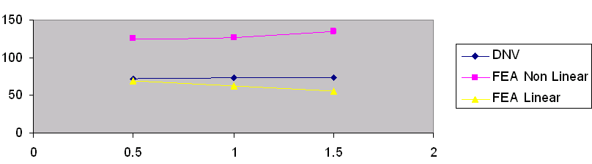 *pcorr/ patm*



Figure 4.1: Graph of Normalized Corroded Pressure, *pcorr /patm* vs spacing per square root of unit depth with thickness, 

From the graph above, it can be concluded that the allowable corroded pressure is increasing when the spacing between defects is increased. This is due to lesser interaction between defects when the defects are located far from each other.

Table 4.2: Trend comparison for Normalized Corroded Pressure, *pcorr/patm* vs combined depth of defects per unit thickness, *dnm/t*

|  |  |
| --- | --- |
|  | Graph of Corroded Pressure, *Pcorr* vs combined depth of defects per unit thickness, *dnm/t* |
| 0.5 | *pcorr/ patm*  X65 1*dnm/t* |
| 1.0 | *pcorr/ patm*  X65 2*dnm/t* |
| 1.5 | *pcorr/ patm*  X65 3*dnm/t* |
| legend Legend: | |

From the graphs above, it is observed that as the depth of the defects increase, the maximum allowable corroded pressure will decrease. FEA non-linear analysis always show similar trend to DNV RP-F101 results but the results are always higher. This is due to safety factor applied in the calculation for DNV-RP-F101. Design factors are not considered in the FEA, hence the results obtained is greater. If the values from the non-linear analysis are multiplied to factor of 0.56, the results obtained are similar to the DNV code.

The Von-Mises stress distribution varies depending on the defect geometry. The simulation stops when the Von-Mises stress reaches the ultimate tensile strength across the entire ligament of the pipe. The stopping criterion has been verified by comparing results of both stopping criterions and observing the trend similarity with the results provided by DNV. The results from both stopping criterion are plotted as in Figure 4.2.

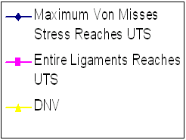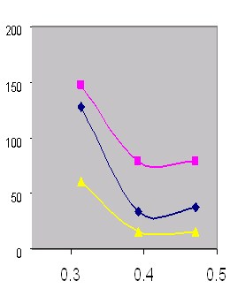

*dnm/t*

*pcorr/patm*

Figure 4.2: Graph of *pcorr* vs *dnm/t* for different stopping criterion

From the graph, it can be concluded that the best stopping criterion is when the Von-Mises stress reaches the ultimate tensile stress across the entire ligament of the pipe. Figure 4.3 shows the example of linear analysis and Figure 4.4 shows the example of non-linear analysis.

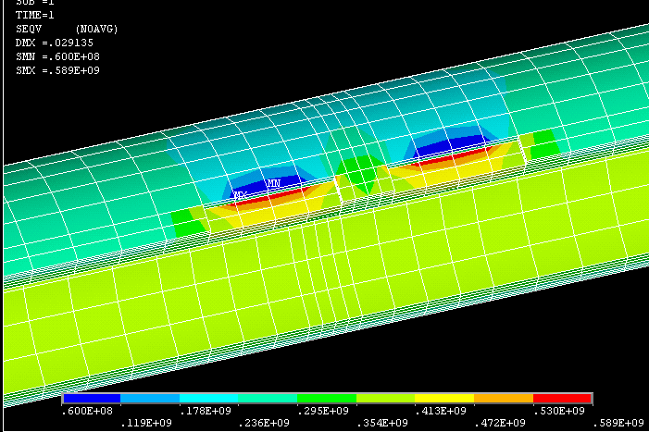

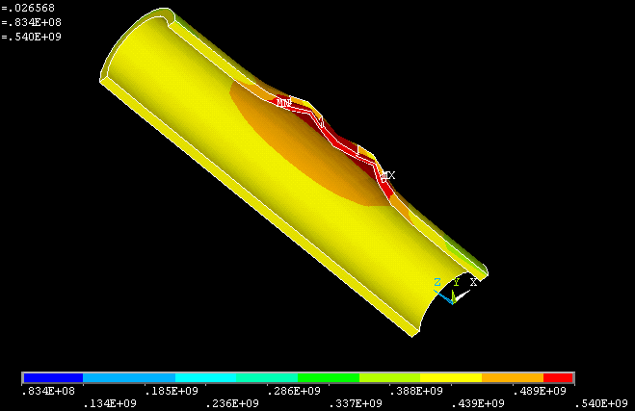Figure 4.3: Linear Analysis for ****= 0.5 *d/t1*= *d/t2*= 0.25

Figure 4.4: Non-Linear Analysis for ****= 0.5 *d/t1*= *d/t2*= 0.25

**4.2.2 X100 Steel**

All results obtained from the codes and FEA are tabulated in a table similar to the analysis done on X65 Steel. Both linear and non-linear analyses are conducted using the ANSYS software. The overall results summary for X100 steel is as in Table 4.3.

Table 4.3: Overall Result Summary for Steel X100

|  |  |  |  |  |  |  |
| --- | --- | --- | --- | --- | --- | --- |
|  | ***(d/t)1*** | ***(d/t)2*** | ***dnm/t*** | **Failure Pressure (MPa)** | | |
| **FEA (Linear)** | **FEA (Non-Linear)** | **DNV-RP-F101** |
| 0.5 | 0.25 | 0.25 | 0.289 | 105.8 | 191.11 | 110.02 |
| 0.50 | 0.393 | 75.00 | 167.01 | 97.23 |
| 0.75 | 0.497 | 41.65 | 90.41 | 23.98 |
| 0.50 | 0.75 | 0.602 | 41.76 | 90.38 | 23.98 |
| 0.75 | 0.75 | 0.706 | 42.20 | 89.49 | 23.98 |
| 1.00 | 0.25 | 0.25 | 0.259 | 93.95 | 176.98 | 111.08 |
| 0.50 | 0.349 | 70.34 | 120.26 | 100.03 |
| 0.75 | 0.438 | 41.22 | 93.95 | 23.98 |
| 0.50 | 0.75 | 0.528 | 41.24 | 91.45 | 23.98 |
| 0.75 | 0.75 | 0.618 | 41.40 | 90.03 | 23.98 |
| 1.50 | 0.25 | 0.25 | 0.237 | 85.02 | 189.65 | 112.01 |
| 0.50 | 0.315 | 62.63 | 171.26 | 102.2 |
| 0.75 | 0.394 | 41.54 | 106.00 | 23.98 |
| 0.50 | 0.75 | 0.472 | 41.50 | 105.66 | 23.98 |
| 0.75 | 0.75 | 0.551 | 41.51 | 99.28 | 23.98 |

In order to verify the data for X65 steel analysis, another type of steel, X100 steel is used for the simulation. X100 steel has higher ultimate tensile strength and hardness compared to X65 steel. Overall results for X100 shows similar trend to X65 steel. FEA non-linear analysis is the most conservative method to assess the maximum allowable corroded pressure inside pipeline with interacting defects. The stopping criterion used in finite element analysis is when the Von-Mises stress reaches the ultimate tensile stress across the entire ligament of the pipe.

The overall results for X100 steel are represented in a graphical form as in Figure 4.5 for corroded pressure, *pcorr/patm* vs spacing per square root of unit depth with thickness,**** and in Table 4.4 for corroded pressure, *pcorr/patm vs* normalizing depth parameter.

*pcorr/ patm*

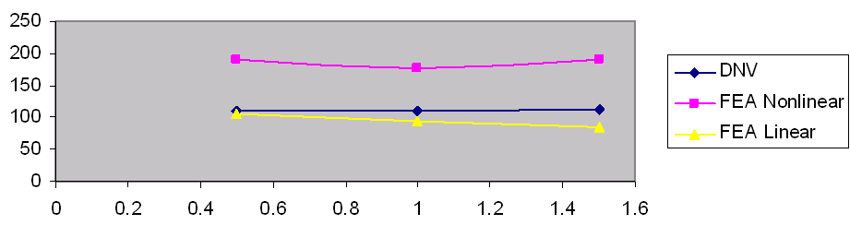



Figure 4.5:Graph of Normalized Corroded Pressure, *Pcorr* vs spacing per square root of unit depth with thickness, 

From the graph above, it can be concluded that the allowable corroded pressure is increasing when the spacing between defects is increased. This is due to lesser interaction between defects when the defects are located far from each other. However, the maximum allowable corroded pressure is higher compared to X65 steel due to higher mechanical properties of X100 steel. The trend is similar as in previous analysis using X65 steel.

Table 4.4: Trend comparison for Corroded Pressure, *pcorr/patm* vs combined depth of defects per unit thickness, *dnm/t*

|  |  |
| --- | --- |
|  | Graph of Corroded Pressure, *Pcorr* vs combined depth of defects per unit thickness, *dnm/t* |
| 0.5 | *pcorr/ patm*  X100 1  *dnm/t* |
| 1.0 | *pcorr/ patm*  X100 2  *dnm/t* |
| 1.5 | *pcorr/ patm*  X100 3  *dnm/t* |
| legend Legend: | |

As the depth of the defects increase, the maximum allowable corroded pressure will decrease. FEA non-linear analysis show similar trend to DNV RP-F101 results except when ****= 1.0. This is due to meshing and model error. Figure 4.6 shows the example of linear analysis and Figure 4.7 shows the example of non-linear analysis for X100 steel.

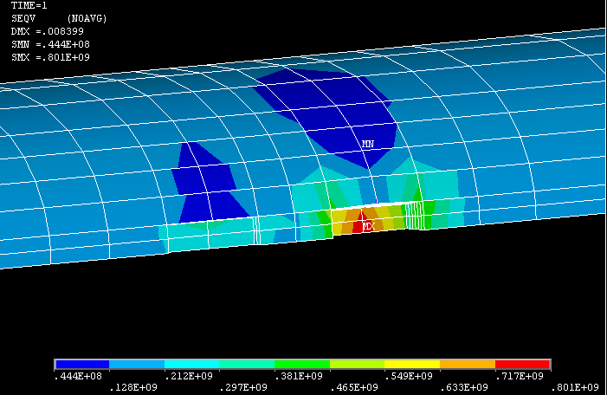

Figure 4.6: Linear Analysis for = 0.5 *d/t1*= 0.25and *d/t2*= 0.5

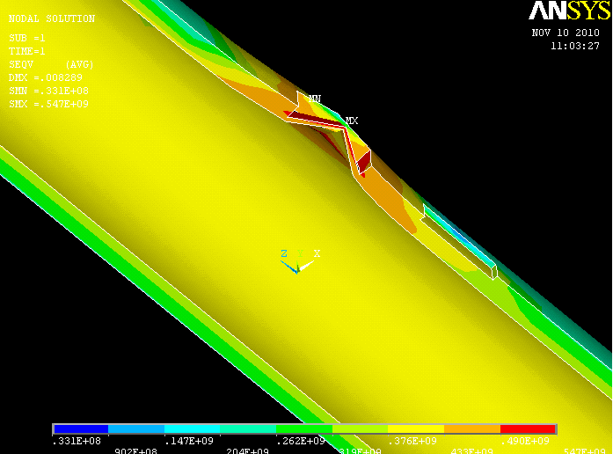

[Type a quote from the document or the summary of an interesting point. You can position the text box anywhere in the document. Use the Text Box Tools tab to change the formatting of the pull quote text box.]

Figure 4.7: Non-Linear Analysis for = 0.5 *d/t1*= 0.25and *d/t2*= 0.5

In order to verify the results of all the analysis, a model of pipe with single defect is created using the same methodology as in interacting defects simulation. The result is then compared with burst test result. In the burst test, water was pumped into the pipe until burst. The water pump used had a capacity of 1000 bar. All tests were performed at room temperature of about 30oC. The diameter of the pipe is 273.05mm and the material used is X52 steel. The result for burst test is as in Table 4.5.

Table 4.5: Comparison of FEA Result with Burst Test Result

|  |  |  |  |  |  |  |
| --- | --- | --- | --- | --- | --- | --- |
| Pipe Thickness, (mm) | Defect Dimensions, (mm) | | | Burst Pressure (MPa) | | |
| Depth, *d* | Length, *L* | Width *w* | Burst Test | FEA | Error (%) |
| 10.87 | 4 | 200 | 100 | 32.65 | 30.94 | 5.23 |

From the result above, it can be concluded that the results for finite element analysis of interacting defects in corroded pipeline is valid. The results have low percentage of error which can be tolerated.

**4.3 Recommendations**

The Finite Element analysis simulations can be improved to yield more accurate results by:

1. Including chamfering of defect to reduce stress concentration at the edges of the defects. In this project, mapped mesh was used to mesh the model. Mapped mesh could not be used at the chamfers of the defect. Therefore, it is recommended that further studies to be conducted in order to include chamfering in the defect geometry.

**CHAPTER 5**

**CONCLUSIONS**

The available codes can be used to obtain the allowable corroded pipeline pressure. The main concern in the industry is that the values from these codes are considered too conservative. Therefore, the FEA analysis is crucial to provide solution to this problem. A pipeline with interacting corrosion defects can be modelled using FEA software and the *pcorr*obtained is expected to be the best prediction of the integrity of the pipeline. Numerous models are developed using the ANSYS software and the outcome are compared with the existing codes. Based on research papers using FEA, it is proven that FEA is a good method to obtain accurate and consistent results for numerous problems associated with defects. However, for corroded pipelines with interacting defects, linear analysis in FEA has resulted inconsistent trend of graph. Therefore, the interacting defects in corroded pipelines can be assessed using the nonlinear analysis method in FEA to provide the best solution and to reduce the conservatism involved in the existing codes.

**REFERENCES**

[1] Det Norske Veritas, ‘Recommended Practice for Corroded Pipeline’, 2004

[2] Mars G. Fontana *“Corrosion Engineering”,* Third Edition, *Mc Graw-Hill Book Company*, 1912.

[3] Choi J.b, Goo B.K., Kim Y.J., Kim W.S, “Development of limit load solutions for corroded gas pipelines”, 2002

[4] German Insurance Association,”*http://www.tis-gdv.de/tis_e/misc//korro”*, 2002.

[5] David Roylance, “Finite Element Analysis Journal” *Department of Materials Science and Engineering Massachusetts Institute of Technology Cambridge*, February 28, 2001.

[6] [Jones, Denny](http://en.wikipedia.org/w/index.php?title=Denny_A._Jones&action=edit&redlink=1), “Principles and Prevention of Corrosion*”*, 2nd edition,[*Prentice Hall*](http://en.wikipedia.org/wiki/Prentice_Hall)*,* 1996.