**Kinetic Study Of Removal Of Nitrate Using Mesoporous Silica As Absorbent**

by

Khairul Ehsan Bin Abdullah

13100

Dissertation submitted in partial fulfilment of

the requirements for the

Bachelor of Engineering (Hons)

(Chemical Engineering)

SEPTEMBER 2013

Universiti Teknologi PETRONAS

Bandar Seri Iskandar

31750 Tronoh

Perak DarulRidzuan

# CERTIFICATION OF APPROVAL

**Kinetic Study Of Removal Of Nitrate Using Mesoporous Silica As Absorbent**

by

Khairul Ehsan Bin Abdullah

A project dissertation submitted to the

Chemical Engineering Programme

Universiti Teknologi PETRONAS

in partial fulfilment of the requirement for the

BACHELOR OF ENGINEERING (Hons)

(CHEMICAL ENGINEERING)

Approved by,

_____________________

(DR. YEONG YIN FONG)

UNIVERSITI TEKNOLOGI PETRONAS

TRONOH, PERAK

September 2013

# CERTIFICATION OF ORIGINALITY

This is to certify that I am responsible for the work submitted in this project, that the original work is my own except as specified in the references and acknowledgements, and that the original work contained herein have not been undertaken or done by unspecified sources or persons.

___________________________________________

KHAIRUL EHSAN BIN ABDULLAH

# ABSTRACT

This project is focuses on the development of APTES-functionalized MCM-41 as absorbent for nitrate removal. Cetyltrimethylammonium Bromide (CTAB) Tetraethoxysilane (TEOS), 3-aminopropyltriethoxysilane (APTES), sodium hydroxide (NaOH) and also water (H2O) will be used to synthesis MCM-41. Ammonium-functionalized silica MCM-41will be prepared by co-condensation method using 3-aminopropyltrithoxysilane (APTES) as amine-silica source. Different amount of APTES will be loaded into MCM-41 and its effect on nitrate removal will be studied. In order to study the structure and morphology of the materials, the resulting MCM-41 and amine-functionalized MCM-41 were characterized using different analytical methods. Based on the result of UV-VIS, it show the reduction of the nitrate concentration from the mixture of the absorbents MCM-41 and APTES-functionalized MCM-41 with potassium nitrate, KNO3 solution. The characterization results from the FTIR shows the bond between nitrate and hydrogen, carbon and carbon and lastly is carbon and bromide.

# ACKOWLEDGEMENT

I would like to take this opportunity to express my sincere gratitude and appreciation to the following persons and organizations who have directly or indirectly given helpful contributions towards the success of this plant project.

First and foremost, we would like to express our deepest gratitude to our FYP II supervisors; Dr Yeong Yin Fong, for her guidance and support throughout the project. I really appreciate her efforts to arrange various technicians and PhD student to provide support and knowledge in assisting and ongoing support, as well as diligently given me their guidance, advice and encouragement throughout this project. Thus, make it is possible for me to carry out this project successfully.

I would like to thank FYP II coordinators, Dr Asna, for her dedications and commitment in organizing seminars for me to understand the project better. Our gratitude is also expressed to our examiners for Interim Oral Presentation of FYP 1, who shared her opinions and is very supportive in guiding me by the mistakes in the presentation to improve my project. I also want to appreciate the moral support and motivation from the family members and fellow friends. Finally, I appreciate the opportunity to get involved in the experimental project.

Table of Contents

**CERTIFICATION OF APPROVAL** i

**CERTIFICATION OF ORIGINALITY** ii

**ABSTRACT** iii

**ACKOWLEDGEMENT** iv

**LIST OF FIGURES** vi

**LIST OF TABLES** vii

**ABBREVIATIONS AND NOMENCLATURES** viii

CHAPTER 1: INTRODUCTION 1

1.1 Background of Study 1

1.2 Problem Statement 2

1.3 Objective 2

1.4 Scope of Study 3

CHAPTER 2: LITERATURE REVIEW 4

2.1 Nitrate 4

2.2 Nitrate Removal Methods 5

*2.2.1 Ion Exchange (IX)* 5

*2.2.2 Reverse Osmosis* 6

*2.2.3 Chemical Methods* 6

*2.2.4 Biological Method* 7

*2.2.5 Adsorption process* 7

2.3 Absorbent Used For Adsorption Process 8

2.4 MCM-41 12

CHAPTER 3 METHODOLOGY 15

3.1 Overall Project Activity Flow 15

3.2 Experimental Procedure 16

3.3 Nitrate Adsorption Study 17

3.4 Kinetic Study 18

3.5 Characterization Study 19

3.6 Gantt Chart and Key Milestone 20

3.7 Tools, Equipments and materials 24

CHAPTER 4 RESULTS AND DISCUSSION 25

CHAPTER 5 CONCLUSION 36

REFERENCE 37

# LIST OF FIGURES

Figure 1: *Comparison of Nitrate Removal Methods* 16

Figure 2: *Types of Absorbents* (Amit Bhatnagara, 2011) 20

Figure 3: *Hexagonal design of MCM-41* (Gusev, 1996) 21

Figure 4: *Simulation of MCM-41* 22

Figure 5: *Block Diagram of Activity Flow* 23

Figure 6: *Sample Absorbents* 31

Figure 7: *Absorbence vs Concentration for MCM-41& APTES-MCM-41* 34

Figure 8: *FTIR results for MCM-41 and APTES-functionalized MCM-41* 37

Figure 9: *Absorbence vs Concentration for kinetic study of 30% APTES-MCM-41* 38

Figure 10: *FTIR results for kinetic study of 30% APTES-Functionalized MCM-41* 40

# LIST OF TABLES

Table 1: *Type of Absorbents and examples* 17

Table 2: *Characterization model and its purpose* 26

Table 3: *Timelines for FYP 1* 26

Table 4: *Keymilestone throughout the FYP 1* 27

Table 5: *Timelines for FYP 2* 27

Table 6: *Keymilestone throughout the FYP 2* 28

Table 7: *Chemicals used in the experiment* 29

Table 8*: Equipments used in the experiment* 29

Table 9*: UV-VIS Settings* 32

Table 10: *Percentage of Nitrate Removal for MCM-41 nad APTES- MCM-41* 34

Table 11: *Percentage of Nitrate Removal for kinetic study* 37

# ABBREVIATIONS AND NOMENCLATURES

**WHO** World Health Organization

**NO3** Nitrate

**IX** Ion Exchange

**RO**  Reverse Osmosis

**PAC** Powdered Activated Carbon

**CNTs** Carbon Nanotubes

# CHAPTER 1

# INTRODUCTION

## 1.1 Background of Study

Nitrate (NO3) possibly the most major contaminant widespread groundwater throughout the world. Thus, it imposes a serious threat to the drinking water and also to the lakes which can promote eutrophication (A. Afkhami, 2007). The presence of nitrate concentration has been serious concern for recent decades. The increase of nitrate levels is due to human activities especially when they intensively produce fertilizer in agriculture. This activity have led the increase of nitrate contamination and making harm the surrounding environment. In addition, nitrate contamination also due to disposal of untreated sanitary and industrial waste, leakage from septic systems, landfill gas emission, and also from the excretion of animals (K.G. Bhattacharyya, 2008). To lower the risk of human health, nitrate must be removed from the water or solution.

In this project, adsorption process has been chosen as the method to remove the nitrate and mesoporous silica was chosen as the absorbent. The mesoporous silica that will be synthesized in the present work is MCM-41. The mesoporous silica will be functionalized with the 3- Aminopropyltriethoxysilane (APTES). In order to study the effect of APTES on removal of nitrate, different loading which are about 10%, 20% and 30% of APTES will be loaded into MCM-41. All of the samples will be characterized using different analytical tools. The resulting materials will be tested for nitrate removal from the aqueous solution.

## 1.2 Problem Statement

Although nitrate removal has been studied using mesoporous silica MCM-41as adsorbent, but the adsorption capacity was relatively low(A. Khani, 2008). Furthermore, only low amount of nitrate can be adsorb from the aqueous solution in long period of time. The performance of amine –functionalized MCM-41 as absorbent in nitrate removal still remain new task. This is because by incorporate amine-functional group into MCM-41, the adsorption site of MCM-41 can be increased for possible increment of nitrate removal. Furthermore, the optimum loading of APTES in MCM-41 for optimum nitrate removal has still not been reported so far.

## 1.3 Objective

This project is aim to study the kinetic removal of nitrate using functionalized mesoporous silica as absorbent. The objectives are as follows:-

1. To synthesize MCM-41 and functionalized MCM-41
2. To characterize the resulting materials using Fourier Transform Infrared (FTIR) and elemental analyzer
3. To test the performance of the resulting materials for nitrate removal

## 1.4 Scope of Study

The focus of this project is to study the kinetic changes by removing the nitrate from the solution using mesoporous silica as absorbent. This experiment is using solution that will mix with nitrate. Its volume will be controlled in fixed amount so that the changes in it will be observed. The manipulative variable will be the amount of nitrate. Adsorption process generally considered better in water treatment because it is more convenience, more easily with the operation and its design is simpler. This process can reduce the amount of organic or inorganic pollutants from the water making it have wider capabilities in water pollution control. This process also has been found successful with different type of absorbents such as clay, sepiolite, carbon cloth, slag and many more. But for this experiment, an absorber which is mesoporous silica will be prepared manually using co-condensation method . This experiment will prove the capacities of mesoporous silica as one of the absorber in the nitrate treatment in groundwater. The most capable absorber will be mixed again with the nitrate solution but with different time frame for kinetic study.

# CHAPTER 2

# LITERATURE REVIEW

## 2.1 Nitrate

Nitrate (NO3) is a colorless and odorless polyatomic ion that contains one nitrogen molecule and 3 oxygen molecules and it has molecular mass of 62 g/mol. Nitrates are salts or esters of nitric acid, HNO3, formed by replacing the hydrogen with a metal or a radical (COLUMBIA UNIVERSITY PRESS, 2009). Nitrate salts are found naturally on earth as large deposits, particularly of seawater and a major source of sodium nitrate. Nitrogen comes from decomposing organic like plants or human waste(California Department of Public Health, 2012). Nitrogen also found where organics are breaking down or animal wastes are decomposing.

Nitrate is very important to the plants as it breaks down the protein and the amino acid which are needed by plants for their growth (Wisconsin County Extension Office). Based on the reported research study, nitrate also used to make drugs to smooth the blood flow (Healthwise Incorporated, 2013).But due its high water solubility, nitrate is the most abundant or major widespread contaminant in the world. Nitrate can impose serious threat to the human health and the environment. It can interfere with the flow of the blood in human body by using the ability of red blood cells to carry oxygen to the tissues of the body, producing a condition called methemoglobinemia(California Department of Public Health, 2012).

## 2.2 Nitrate Removal Methods

Many researches have been done to remove the nitrate from a aqueous solution. Globally there are about five methods that have been approved by World Health Organization (WHO) to remove nitrate from the water. Nevertheless, the traditional methods cannot prevent the excess nitrate (NO3) to release to the environment but can only lighten the burden the environment impact. These five nitrate removal methods are Ion Exchange, Reverse Osmosis, Chemical Methods and Biological Method, Adsorption (A. Khani, 2008). The detailed of each of this method will be discussed in detail in the following sections

### *2.2.1 Ion Exchange (IX)*

Ion Exchange (IX)\ reversible chemical reaction where an ion or molecule that has lost or gained an electron and thus acquired an electrical charge from solution is exchanged for a similarly charged ion attached to an immobile solid particle. These solid ion exchange particles are either naturally occurring synthetically produced organic resin(Remco Engineering, 2006). Ion exchange reactions are stoichiometric and reversible and in that way they are similar to other solution phase reactions such as reaction in equation (1) as follows (Remco Engineering, 2011)

NiSO4 + Ca(OH)2 Ni(OH)2 + CaSO4

Equation 1

### *2.2.2 Reverse Osmosis*

Reverse osmosis (RO) is water purification technology that uses a [semi-permeable membrane](https://en.wikipedia.org/wiki/Semipermeable_membrane)(How Stuff Works, 2004). In RO, an applied pressure is used to overcome [osmotic pressure](https://en.wikipedia.org/wiki/Osmotic_pressure). Osmotic is a kind of pathway for other solvent to pass through the membrane of the solvents. RO can remove many types of [molecules](https://en.wikipedia.org/wiki/Molecules) and [ions](https://en.wikipedia.org/wiki/Ions) from solutions and is used in both industrial processes and to produce potable water. RO takes place when a pressure applied to a highly concentrated solution causing the higher concentration of the solvent to go one side and leave only solvent to the other.(Kershner, 2011). Based on the research, it requires high TDS disposal to complete the process. But since this process need to be specific, post treatment and supervision need to be done. Not only that, its operational cost also high because it needs specific equipment. That is why this method can remove more than 95% of the nitrate.

### *2.2.3 Chemical Methods*

There are method that using other chemical compounds to remove the nitrate. One of these methods was implemented in the high school experiment which is called electrodialysis. This method was used to transport [salt](http://en.wikipedia.org/wiki/Salt) [ions](http://en.wikipedia.org/wiki/Ions) from one [solution](http://en.wikipedia.org/wiki/Solution) through  [ion-exchange](http://en.wikipedia.org/wiki/Ion-exchange)[membranes](http://en.wikipedia.org/wiki/Semipermeable_membrane) to another solution under the influence of an applied [electric potential](http://en.wikipedia.org/wiki/Electric_potential) difference(Lenntech, 2012). This is done in a configuration called an electrodialysis cell. The cell consists of a feed dilute compartment and a concentrate brine compartment formed by an [anion](http://en.wikipedia.org/wiki/Anion) exchange membrane and a [cation](http://en.wikipedia.org/wiki/Cation) exchange membrane placed between two [electrodes](http://en.wikipedia.org/wiki/Electrode). Using this method, removing nitrate using another compound is possible with the ratio of moving anion and cation is the same. Since it discharges electricity, it will affect the temperature and the pH.

### *2.2.4 Biological Method*

Biological method used the organic materials to remove the nitrate from the solution and this method is known as biological denifitrication. It occurs when facultative heterotrophic bacteria are subjected to an environment that is absent of oxygen and contains nitrate and a carbon source. The facultative bacteria utilize nitrate-nitrogen as the terminal electron acceptor during energy formation, resulting in the formation of nitrogen gas which is released to the atmosphere(Lehnert, 2004). Because of that, 99% and above of efficiency can be achieved. Since this process is depend on the organic materials, its operating cost is not very high as compared to other.

### *2.2.5 Adsorption process*

Adsorption process is preferable in water treatment because of more simple, more easy and more convenience as compared to others. This process remove and minimize different types of organic and inorganic pollutants from the solution, thus, it has wider capabilities in water treatment in order to apply adsorption process in more efficient way, suitable absorbents must be chosen (K.G. Bhattacharyya, 2008). For the nitrate removal, various materials have been used as absorbent. For common adsorption process, a few characteristics have to be identified. Different absorbents resulted different results and since it is simpler than other process. The comparison between each method of removing nitrate is shown in Figure 1.



Figure 1: *Comparison of Nitrate Removal Methods*

Based on the Figure 1, adsorption process has been chosen in this project because it is simpler as compared to other process and it can be use for small scale experiment for nitrate removal.

## 2.3 Absorbent Used For Adsorption Process

Indeed there are many different absorbents used adsorption process and each of them serves to absorb different compounds and give various results. Various conventional and non-conventional materials have been reported for the removal of NO3 from water. These types of absorbents are carbon-based absorbents, natural absorbents, absorbents for the agriculture wastes, absorbent from the industrial wastes, biological-made absorbents, and miscellaneous absorbents. Table 1 shows the type of absorbents, their methods and examples.

**Table 1**: *Type of Absorbents and examples*

|  |  |  |
| --- | --- | --- |
| Type of Absorbents | Examples | Method |
| Carbon based Absorbents | Activated Carbon | The absorption of NO3 by activated carbon have an effects of functional groups on the adsorption of NO3 and NO2 by carbon cloth. The carbon cloths were chemically seeped into 4M H2SO4 solution after the process deionization which is the cleaning procedure and used for the adsorption of NO3 and NO2 from water (A. Afkhami, 2007). |
| Powdered activated carbon (PAC) | used for the removal of NO3 from aqueous solution. The equilibration time for NO3 uptake was about 60 min. Adsorption capacity of the PAC was found to be 10mmol NO3−/g adsorbent (A. Khani, 2008). |
| Carbon nanotubes (CNTs) | used for the removal of NO3 from aqueous solution. The equilibration time for NO3 uptake was about 60 min. Adsorption capacity of the PAC was found to be 10mmol NO3−/g adsorbent (A. Khani, 2008). |
| Natural absorbents | Clay absorbent | Clays has its role in the environment which is removing particles of pollutants by taking up cations and anions either through ion exchange or adsorption or both. |
| Natural zeolites | Surface modifications of natural zeolite were performed by coating it with a chitosan layer. The chitosan coated zeolite (Ch-Z) was protonated with hydrochloric acid and tested to capture NO3 from water at 20 and 4oC. Ch-Z has a comparable ion exchange capacity to other weak anion exchangers, with a NO3 ion exchange capacity of 0.74mmol NO3/g protonated with HCl (S. Wang, 2010) |
| Absorbents from Agriculture Wastes | The excess of the plants product | It was found that amino group from the wastes incorporate into cellulose decreased with the presence of water in the reaction mixture and increased with the reaction time and presence of a catalyst (U.S. Orlando, 2002). The proposed synthetic procedure was found effective in modifying PL, PC and LCM resulting in a higher yield and NO3 removal capacity. |
| Absorbents from Industrial Wastes | Red mud | The industrial wastes that has been washed and dried and activated wastes that have been washed and treated with hydrochloric acid which is called red mud (Y. Cengeloglu, 2006). The NO3 adsorption capacity of activated red mud was found to be higher than that of the original form. Adsorption capacity of the original and activated red mud was found to be 1.859 and 5.858mmol NO3 − /g red mud, respectively. |
| Biological-made Absorbents | Biological denifitrication (bacteria) | Biological denitrification is a two step process. The first step is nitrification, which is conversion of ammonia to nitrate through the action of nitrifying bacteria. The second step is nitrate conversion denitrification, which is carried out by facultative heterotrophic bacteria under anoxic conditions. Nitrate conversion takes place through in assimilatory and dissimilatory cellular functions (Soares, 2000). In assimilatory denitrification, nitrate is reduced to ammonia, which then will be used as a nitrogen source for cell synthesis which will remove nitrate by incorporating it into cytoplasmic cell. In dissimilatorydenitrification, nitrate is converted to various gaseous end products but principally molecular nitrogen, N2, which is then stripped from the liquid stream. |
| Miscellaneous Absorbents | Ammonium-functionalized mesoporous silica | Synthesized via co-condensation method and their efficiency to remove NO3− and phosphate anions in aqueous solutions was investigated (R. Saad, 2008). The removal of NO3 was maximum at pH <8, using an adsorbent dose of 10 g/L. Desorption of nitare was rapidly achieved within 10 min, using 0.01M NaOH. The mesoporous silica functionalized via co-condensation methods exhibited higher performances in terms of percentage pollutant removal and adsorption capacities. |

Beside the examples listed the table1, Figure 2 show the other examples of absorbents other type that reported in the literature



Figure 2: *Types of Absorbents*(Amit Bhatnagara, 2011)

## 2.4 MCM-41

Mobil Composition of Matter (MCM) is a type ofmesoporous silica patented around 1970 and independently synthesized in 1990 by researchers in Japan(Wikipedia The free encyclopedia, 2013). MCM-41 or MCM-48 were later produced at Mobil Corporation laboratories  and named Mobil Crystalline Materials(Wikipedia The free encyclopedia, 2013). Figure 3 shows the hexagonal design of MCM-41.

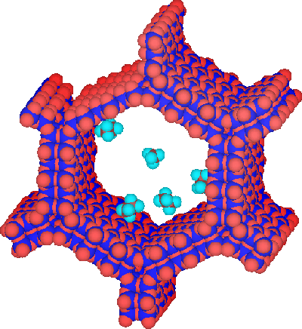

Figure 3: *hexagonal design of MCM-41* (Gusev, 1996)

In this project, MCM-41 has been chosen as the as the absorbent. MCM-41 will be synthesized and tested for removal of nitrate. Amino-functionalized group will be loaded into MCM-41 in order to improve the removal of nitrate. The effect of loading percentages of ammonium-functionalized group in the MCM-41 the removal of nitrate will be studied. The results will be compared and the kinetic removal of nitrate will be study. Generally MCM-41 is made up with a mixed of abundant of silica source and also with a surfactant. Then it will self assembly of the surfactant which will make a hexagonal design of MCM-41.

Next it will further neatly packed through the process condensation of the silica source. By remove the surfactant using calcinations method or acid extraction, the MCM-41 will be produced. MCM-41 has almost uniform hexagonal pores which can be controlled to provide pore size in the range of 16 -100 Å. Figure 4 will show the simulation of how MCM-41 being made.

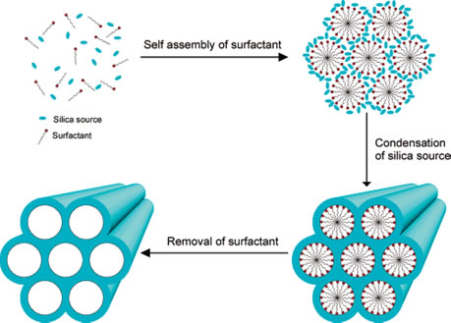

Figure 4: *Simulation of MCM-41*

# CHAPTER 3

# METHODOLOGY

## 3.1 Overall Project Activity Flow

Figure 4 shows the overall of activity flow in the current project

Figure 5: *Block Diagram of Activity Flow*

## 3.2 Experimental Procedure

*The synthesis procedure is outlined as follows*

1. 1 g of CTAB was first dissolved in 240ml distilled water, and then 3.5 ml NaOH solution (2 M) was added to CTAB solution, followed by adjusting the solution temperature to 363 K and stirrer 550rpm.
2. The solution was stirred for 30 min and then 11 ml of tetraethoxysilane (TEOS) were added.
3. The mixture was stirred for 5 h to get white precipitates.
4. The solid product was filtered, washed with deionized water and dried in air.
5. The resulting material will be mixed with 100mL methanol and 10mL HCL and stirred at 550rpm for 5 h to extract the acid.
6. Steps 1-6 are repeated by changing the volume of TEOS and APTES in order to synthesized 10% APTES-functionalized MCM-41. For example, synthesis of 10%APTES-functionalized MCM-41, 5mL of TEOS and 0.5mL of APTES will be used.

## 3.3 Nitrate Adsorption Study

The adsorption capability of the resulting MCM-41and APTES-functionalized MCM-41 toward nitrate adsorption will be study as follows:-

1. Potassium nitrate (KNO3) are prepared by dissolve 10mg of it into 100 mL of distilled water
2. The concentration of aqueous KNO3will be 100mg/L and will be prepared in 4 flasks with different absorbent respectively.
3. Aqueous potassium nitrate is added with 0.2 g of each absorbent including MCM-41, 10% APTES-functionalized MCM-41, 20% APTES-functionalized MCM-41, 30% APTES-functionalized MCM-41.
4. The aqueous potassium nitrate and sample absorbent is mixed using 150 rpm of shaker for 24 hours.
5. After adsorption process, the solid and solution phase are separated using centrifugation
6. Each solution will be collected using clean vials, then will be experimented using UV-VIS
7. The percentage of nitrate removal will be calculated using Equation 2 as follows:-

Re = *C*i– *C*e x 100 in (%)

*C*i

**Equation 2**

Where

Re= removal of nitrate

Ci= Initial nitrate concentration

Ce= Final nitrate concentration

## 3.4 Kinetic Study

Kinetic study is use to study the removal of nitrate using the best absorbent determined in section 3.3. The experimental procedures are outlined as follows

1. Aqueous nitrate solution is prepared by using potassium nitrate by dissolve 10mg of it into 100 mL distilled water
2. 4 same absorbents will be prepared about 0.2 g will be added to different flask and mix with the aqueous potassium nitrate
3. The absorbents will mix with aqueous nitrate solution on the shaker for 5 minutes, 30 minutes, 2 hours, and 8 hours respectively.
4. After that, each of the solution will be collected into the clean vials and then, will be tested using UV-VIS equipment

## 3.5 Characterization Study

The resultant materials will be characterized using Fourier Transform Infrared (FTIR) and N2Physorption Analysis. Table 2 shows the characterization model and their purpose in the experiment.

**Table 2**: *Characterization model and its purpose*

|  |  |
| --- | --- |
| **Characterization model** | **Purpose** |
| **FTIR** | Structural analysis |
| **UV-VIS** | Nitrate concentration measurement |
| **ELEMENTAL ANALYST** | Amount of Nitrate in the sample |

## 3.6 Gantt Chart and Key Milestone

Table 3 and Table 4 show the activity Gantt chart and key milestone for the Final Year Project 1 respectively:-

**Table 3**: *Timelines for FYP 1*

|  |  |  |  |  |  |  |  |  |  |  |  |  |  |  |  |  |
| --- | --- | --- | --- | --- | --- | --- | --- | --- | --- | --- | --- | --- | --- | --- | --- | --- |
| **No.** | **Detail Work** | **1** | **2** | **3** | **4** | **5** | **6** | **7** | MID-SEMESTER BREAKS | **8** | **9** | **10** | **11** | **12** | **13** | **14** |
| 1 | Selection of Project Topic |  |  |  |  |  |  |  |  |  |  |  |  |  |  |
|  |  |  |  |  |  |  |  |  |  |  |  |  |  |  |  |
| 2 | Preliminary Research Work |  |  |  |  |  |  |  |  |  |  |  |  |  |  |
|  |  |  |  |  |  |  |  |  |  |  |  |  |  |  |  |
| 3 | Submission of Extended Proposal Defence |  |  |  |  |  |  |  |  |  |  |  |  |  |  |
|  |  |  |  |  |  |  |  |  |  |  |  |  |  |  |  |
| 4 | Proposal Defence |  |  |  |  |  |  |  |  |  |  |  |  |  |  |
|  |  |  |  |  |  |  |  |  |  |  |  |  |  |  |  |
| 5 | Project Work Continues |  |  |  |  |  |  |  |  |  |  |  |  |  |  |
|  |  |  |  |  |  |  |  |  |  |  |  |  |  |  |  |
| 6 | Submission of Interim Draft Report |  |  |  |  |  |  |  |  |  |  |  |  |  |  |
|  |  |  |  |  |  |  |  |  |  |  |  |  |  |  |  |
| 7 | Submission of Interim Report |  |  |  |  |  |  |  |  |  |  |  |  |  |  |
|  |  |  |  |  |  |  |  |  |  |  |  |  |  |  |  |

Process Suggested Milestone

**Table 4**: *Keymilestone throughout the FYP 1*

|  |  |
| --- | --- |
| **Final Year Project I** | |
| **Week 7** | Completing of extended proposal |
| **Week 8** | Proposal defense |
| **Week 14** | Completing of interim report |

Table 5 and Table 6 show the activity Gantt chart and key milestone for the Final Year Project 2 respectively:-

**Table 5**: *Timelines for FYP 2*

|  |  |  |  |  |  |  |  |  |  |  |  |  |  |  |  |  |
| --- | --- | --- | --- | --- | --- | --- | --- | --- | --- | --- | --- | --- | --- | --- | --- | --- |
| **No.** | **Detail Work** | **1** | **2** | **3** | **4** | **5** | **6** | **7** | MID-SEMESTER BREAKS | **8** | **9** | **10** | **11** | **12** | **13** | **14** |
| 1 | Project Work Continues |  |  |  |  |  |  |  |  |  |  |  |  |  |  |
|  |  |  |  |  |  |  |  |  |  |  |  |  |  |  |  |
| 2 | Submission of Progress Report |  |  |  |  |  |  |  |  |  |  |  |  |  |  |
|  |  |  |  |  |  |  |  |  |  |  |  |  |  |  |  |
| 3 | Project Work continues |  |  |  |  |  |  |  |  |  |  |  |  |  |  |
|  |  |  |  |  |  |  |  |  |  |  |  |  |  |  |  |
| 4 | Pre -Sedex |  |  |  |  |  |  |  |  |  |  |  |  |  |  |
|  |  |  |  |  |  |  |  |  |  |  |  |  |  |  |  |
| 5 | Submission of Draft Report |  |  |  |  |  |  |  |  |  |  |  |  |  |  |
|  |  |  |  |  |  |  |  |  |  |  |  |  |  |  |  |
| 6 | Submission of Dissertation (softbound) |  |  |  |  |  |  |  |  |  |  |  |  |  |  |
|  |  |  |  |  |  |  |  |  |  |  |  |  |  |  |  |
| 7 | Submission of Technical paper |  |  |  |  |  |  |  |  |  |  |  |  |  |  |
| 8 | Oral Presentation |  |  |  |  |  |  |  |  |  |  |  |  |  |  |  |
|  |  |  |  |  |  |  |  |  |  |  |  |  |  |  |  |  |
| 9 | Submission of dissertationHardbound |  |  |  |  |  |  |  |  |  |  |  |  |  |  |  |

Process  Suggested Milestone

**Table 6**: *Keymilestone throughout the FYP 2*

|  |  |
| --- | --- |
| **Final Year Project 2** | |
| **Week 8** | Submission of Progress report |
| **Week 12** | Submission of Draft Report |
| **Week 13** | Submission of Dissertation(softbound) and Technical Paper |
| **Week 14** | Oral Presentation and Submission of Dissertation (Hardbound) |

## 3.7 Tools, Equipments and materials

The chemicals that will be used in this project are listed Table 7

**Table 7**: *Chemicals used in the experiment*

|  |
| --- |
| **Chemical** |
| KNO3, Potassium Nitrate |
| APTES, 3-aminopropyltriEthoxysilane |
| H2O, Water |
| TEOS, Tetraethoxysilane |
| CTAB, Cetyltrimethylammonium Bromide |
| NaOH, Sodium Hydroxide |
| CH3OH, Methanol |
| HCL, Hydrochloric Acid |

These are the equipment or tools that will be uses in this project are listed Table 8

**Table 8***: Equipments used in the experiment*

|  |
| --- |
| **Equipment** |
| Beaker |
| Stirrer |
| Measuring cylinder |
| N2 Physorptionanalyser |
| Oven |
| Synthesis reactor |
| FTIR |

# CHAPTER 4

# RESULTS AND DISCUSSION

The first step in the project 'Kinetic Study Of Removal Of Nitrate Using Mesoporous Silica As Absorbent' is to prepare the absorbent samples which are MCM-41, 10% APTES-functionalized MCM-41, 20% APTES-functionalized MCM-41 and 30% APTES-functionalized MCM-41. By using the 'experimental procedure' explained in the CHAPTER 3: METHODOLOGY, all the samples are successfully synthesized.

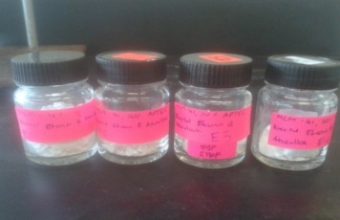

Figure 6: *Sample Absorbents*

The second step is to mixed each of those sample with nitrate solution. For this step, 700 mg of potassium nitrate, KNO3 is mixed in the 700 ml of distilled water. This is to create KNO3 solution with the concentration of 100 mg/ml or 1000 ppm. 400 ml of these solution were put into 4 different conical flask. 0.2 g of each absorbent sample are put into these conical flask for 'nitrate adsorption study' in the CHAPTER 3: METHODOLOGY. Equipment UV-VIS is used to calculate the percentage removal of nitrate and to do that, standard solution is need to be prepared. Potassium nitrate, KNO3 solution is used for standard solution with 5 varied concentration which are 20 mg/ml, 40 mg/ml, 60 mg/ml, 80 mg/ml and 100 mg/ml. To get different concentration, 300 ml of the 100 ppm solution left were being used. By using the equation 3, the volume needed to produce these vary concentration of potassium nitrate, KNO3 can be calculated.

M1 V1 = M2 V2

Equation 3

Where

M1 = Concentration value of first solution

V1 = Volume of the first solution

M2 = Concentration value of second solution

V2 = Volume of the second solution

For example, to get the 20 ppm of the potassium nitrate solution, certain volume of the 100 ppm solution must be needed. So to calculate that:-

(20 ppm) (100 ml) = (100 ppm) (x)

(x) = $\frac{\left(20 ppm\right)(100 ml)}{(100 ppm)}$

(x) = 20 ml

Thus, 20 ml is taken from 100 ppm solution and put into another beaker. That beaker will be added with distilled water until it reaches 100 ml level. Same calculation must be repeated to get the 40 ppm, 60 ppm and 80 ppm solution. With the calculation done, 100 ml of 20 ppm, 40 ppm, 60 ppm, 80 ppm, and 100 ppm standard solution were

The UV-VIS equipment is being set to analyze the absorption with the wavelength of 220 nm. The detail of the instrument settings is shown in the table 9.

**Table 9***: UV-VIS Settings*

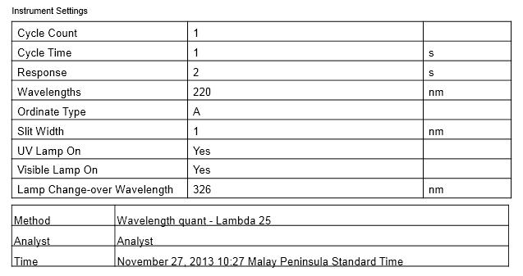

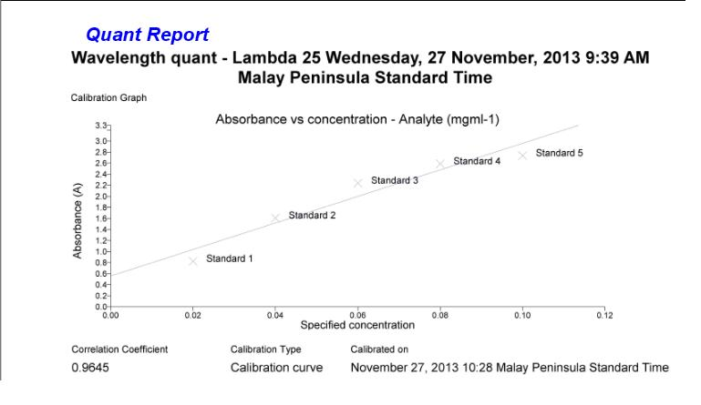 The standard potassium nitrate, KNO3 solution vary in concentration of 20 ppm, 40 ppm, 60 ppm, 80 ppm and 100 ppm were being used for calibration curve. By doing that, the concentration of the potassium nitrate, KNO3 solution with contact of absorbent samples can be calculated. Figure 7 show the graph calibrated using 5 standard solutions and 4 samples solutions.

Figure 7: *Absorbence vs Concentration for MCM-41 and APTES-Functionalized MCM-41*

The graph shows that the calibration curve is being plotted beautifully. Nevertheless, the correlation coefficient is only 0.9645 thus it shows a bit of error because the smoothest correlation coefficient is about 0.98 to 0.99. The equation resulted from the calibrated graph is y = 2.725x. From that equation, the concentration of nitrate that has been absorbed by the absorbent samples. From the concentration calculated, the percentage of the nitrate removal also can be calculated by using Equation 2.

Re = *C*i– *C*e x 100 in (%)

*C*i

**Equation 2**

Where

Re= removal of nitrate

Ci= Initial nitrate concentration

Ce= Final nitrate concentration

The concentration of the standard solution, sample solutions calculated and percentage removal of nitrate are being shown in table 10 below.

**Table 10**: *Percentage of Nitrate Removal for MCM-41 nad APTES-functionalized MCM-41*

|  |  |  |  |  |  |
| --- | --- | --- | --- | --- | --- |
| Concentration, mg/ml | Standard Analyte concentration | Sample Absorbents | Absorbence(A) Value | Sample Concencentration | Percentage of Nitrate Removal (%) |
| 0 | 0 | MCM-41 | 2.028 | 0.744 | 25.58 |
| 0.2 | 1.8896 | MCM-41 with 10% APTES | 2.0275 | 0.744 | 25.60 |
| 0.4 | 1.9373 | MCM-41 with 20% APTES | 2.0193 | 0.741 | 25.90 |
| 0.6 | 2.0041 | MCM-41 with 30% APTES | 2.0036 | 0.735 | 26.47 |
| 0.8 | 2.013 | - | - | - | - |
| 1 | 2.03 | - | - | - | - |

From the table 10, it is shown that MCM-41 has the least percentage of nitrate removal which is about 10.41%. The highest percentage of nitrate removal is 30% APTES-functionalized MCM-41 that shows about 26.47 %. The addition of APTES in the MCM-41 shows the higher nitrate removal compare to the original MCM-41.

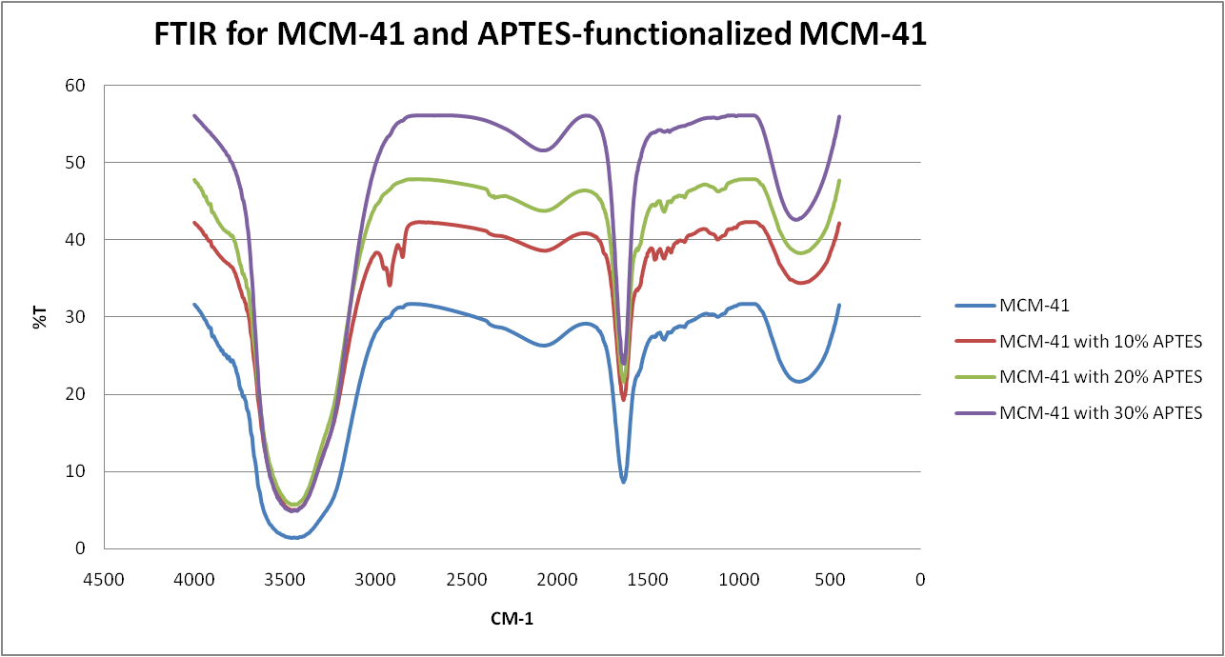

Figure 8: *FTIR results for MCM-41 and APTES-functionalized MCM-41*

Figure 8 shows the FT-IR spectra of the parent calcined mesoporous silica MCM-41 and APTES-functionalized MCM-41absorbent samples. The bands at 1384, 1412, and 1465 cm-1were assigned to the stretching vibrations of the mesoporous framework (C-H) band with the type of functional group of alkanes . The new, comparatively weak bands around 1638 cm-1 were assigned to the overtone bands of the N–H stretching vibrations, which present in the primary amines group. The –OH stretching region (3500–3000 cm-1) shows an intense peak than the overtone region, whereas all the other amine immobilized materials show a weak stretch in the –OH region. This was attributed to the hydrophobicity of the organosilane in the framework, which was already confirmed by presence of the alcohol in the absorbents.

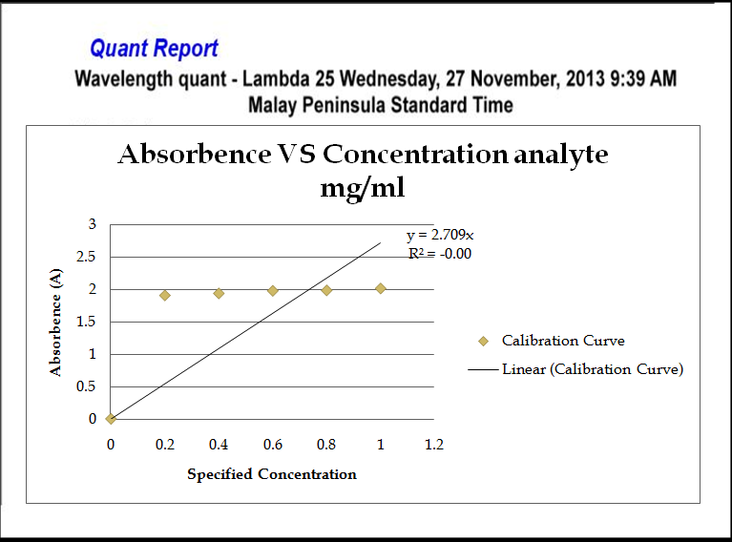

Figure 9: *Absorbence vs Concentration for kinetic study of 30% APTES-Functionalized MCM-41*

The graph shows that the calibration curve is being plotted but the correlation coefficient is only 0.9447. The equation resulted from the calibrated graph is y = 2.709x. From that equation, the concentration of nitrate that has been absorbed by the absorbent samples. From the concentration calculated, the percentage of the nitrate removal also can be calculated by using Equation 2 as mention before. The results of the calculation has been tabulated in the table 11 below.

**Table 11:** *Percentage of Nitrate Removal for kinetic study*

|  |  |  |  |  |  |
| --- | --- | --- | --- | --- | --- |
| Concentration, mg/ml | Standard Analyte concentration | Sample Absorbents | Absorbence(A) Value | Sample Concencentration | Percentage of Nitrate Removal (%) |
| 0 | 0 | MCM-41 with 30% APTES for 5 minutes | 2.0153 | 0.744 | 25.61 |
| 0.2 | 1.912 | MCM-41 with 30% APTES for 30 minutes | 1.9911 | 0.735 | 26.50 |
| 0.4 | 1.9436 | MCM-41 with 30% APTES for 2 hours | 1.9665 | 0.726 | 27.41 |
| 0.6 | 1.9834 | MCM-41 with 30% APTES for 16 hours | 1.944 | 0.718 | 28.24 |
| 0.8 | 1.9901 | - | - | - | - |
| 1 | 2.0194 | - | - | - | - |

From the table 11, it is shown that 30% APTES-functionalized MCM-41 with 5 minutes mixed with potassium nitrate solution has the least percentage of nitrate removal which is about 25.61%. The highest percentage of nitrate removal is 30% APTES-functionalized MCM-41 with 16 hours mixed with potassium nitrate solution that shows about 28.24 %. The addition of APTES in the MCM-41 shows the higher nitrate removal compare to the original MCM-41.

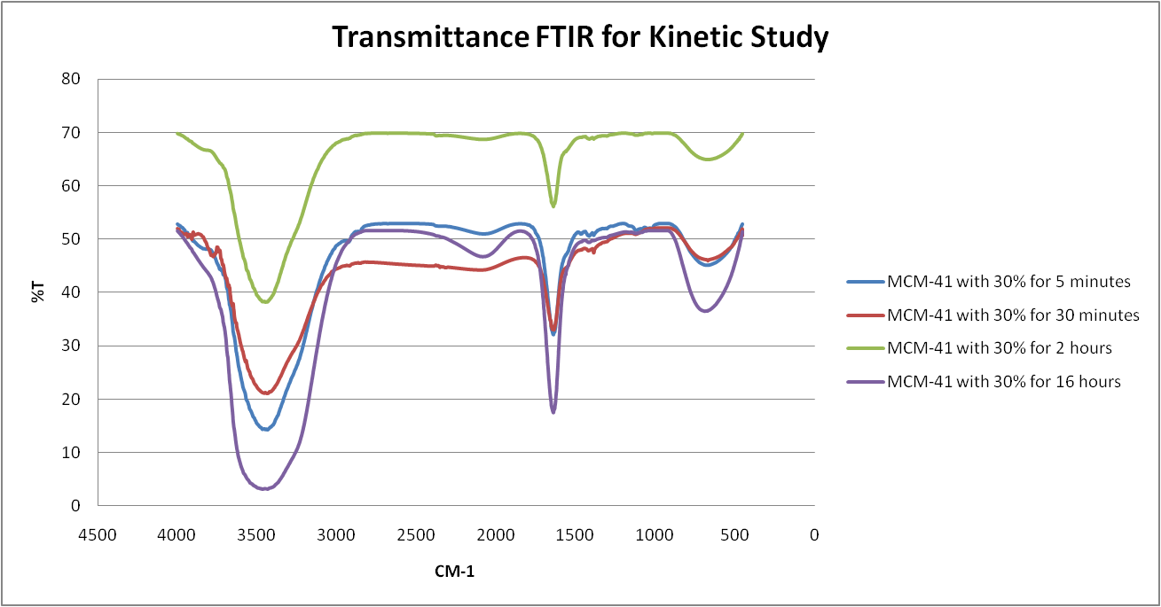

Figure 10: *FTIR results for kinetic study of 30% APTES-Functionalized MCM-41*

In infrared spectroscopy, units called wavenumbers are normally used to denote different types of light. The frequency, wavelength, and wavenumber are related to each other via the following equation 4:

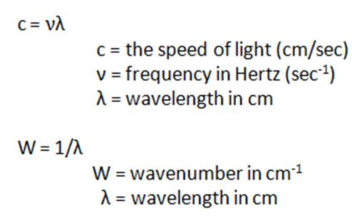

Equation 4

Figure 10 shows the FT-IR spectra of the vary results of 30% APTES-functionalized MCM-41absorbent samples mixed with the potassium nitrate solution. The bands at 1384 and 1412 cm-1were assigned to the stretching vibrations of the mesoporous framework (C-H) band with the type of functional group of alkanes . The new, comparatively weak bands around 1638 cm-1 were assigned to the overtone bands of the N–H stretching vibrations, which present in the primary amines group. The –OH stretching region (3500–3000 cm-1) shows an intense peak than the overtone region, whereas all the other amine immobilized materials show a weak stretch in the –OH region.

# CHAPTER 5

# CONCLUSION

In this study, this research project is focusing on nitrate removal by using the mesoporous silica known as MCM-41. As to get variant results, different absorbents are being prepared known as MCM-41, 10% APTES-functionalized MCM-41, 20% APTES-functionalized MCM-41 and 30% APTES-functionalized MCM-41.

Hybrid MCM-41 materials were synthesized in an alkaline medium in the presence of CTAB as the surfactant using a co-condensation technique. In contrast to the post-grafting technique, CTAB produces larger and more uniform pores, a higher surface area, good long-range order, and well-distributed functionality. Moreover, this outcome was achieved under milder and simpler synthesis conditions, and in less time.

Throughout this project, it has been shown that the preparation of the sample absorbents are being successfully synthesized. Then the absorbent samples are mixed with the potassium nitrate, KNO3 solution. The best absorbent sample which in this case is 30% APTES-functionalized MCM-41 is chose to study the kinetic reaction between the absorbent with the nitrate uptake. It is prepared in 4 different flasks, then they are mixed with the nitrate solutions with different time frame which are 5 minutes, 30 minutes, 2 hours and 16 hours.

By using the UV-VIS, the result shows the reduction of the nitrate from the solution. The characterization study using FTIR shows that the existents of the carbon, hydrogen, alkanes, and also bromide in the absorbent samples. This means that the purity of the absorbents are very high.

# REFERENCE

Afkhami, T. M. (2007). The effect of acid treatment of carbon cloth on the adsorption of nitrite and nitrate ions. *J. Hazard. Mater* , 427-431.

Khani, M. M. (2008). Comparative study of nitrate removal from aqueous solution using powder activated carbon and carbon nanotubes. *2nd International national IUPAC Conference on Green Chemistry* , 14-19.

Amit Bhatnagara, ∗. M. (2011). A review of emerging adsorbents for nitrate removal from water. *Chemical Engineering Journal* , 499.

California Department of Public Health. (2012, November 29). Retrieved June 16, 2013, from http://www.cdph.ca.gov/certlic/drinkingwater/Pages/Nitrate.aspx

Columbia University Press. (2009). *Yahoo Education.* Retrieved June 15, 2013, from Encyclopedia: nitrate: http://education.yahoo.com/reference/encyclopedia/entry/nitrate

Compare Networks. (2009). Retrieved from http://www.labcompare.com/Laboratory- Analytical-Instruments/1437-Physisorption-Analysis/

Farlex. (2013). *The Free Dictionary*. Retrieved from http://www.thefreedictionary.com/nitrate

Gusev, V. (1996). Retrieved from http://www.chm.bris.ac.uk/motm/mcm41/mcm41.htm

Demiral, G. G. (2010). Removal of nitrate from aqueous solutions by activated carbon prepared from sugar beet bagasse. *Bioresour. Technology* , 711-717.

Healthwise Incorporated. (2013, May 10). Retrieved from http://www.webmd.com/heart-disease/nitrates-for-coronary-artery-disease

How Stuff Works. (2004). Retrieved from http://science.howstuffworks.com/dictionary/physics-terms/xray-info1.htm

Bhattacharyya, S. G. (2008). *Advance Colloid Interface Science* , 114–131.

Bhattacharyya, S. G. (2008). Adsorption of a few heavy metals on natural and modified kaolinite and montmorillonite. *Advance Colloid Interface Science* , 114- 131.

Kershner, K. (2011). Retrieved from How StuffWorks: http://science.howstuffworks.com/reverse-osmosis2.htm

Lehnert. (2004). Retrieved from http://www.umich.edu/~lehnert/denitrification.html

Lenntech. (2012). Retrieved from http://www.lenntech.com/electrodialysis.htm

R. Saad, S. H. (2008). Adsorption of phosphate and nitrate anions on ammonium- functionnalized mesoporous silicas. *J. Porous Mater* , 315-323.

Remco Engineering. (2006). Retrieved 2013, from http://www.remco.com/ix.htm

Remco Engineering. (2011). Retrieved from http://www.remco.com/ix.htm

Wang, Y. P. (2010). Natural zeolites as effective adsorbents in water and wastewater treatment. *Chem. Eng. J.* , 11-24.

Soares, M. (2000). Biological Denifitrication of Groundwater. *Water, Air, and Soil Pollution* , 183-193.

U.S. Orlando, A. B. (2002). new procedure to produce lignocellulosic anion exchangers from agricultural waste materials. *Bioresour* , 195-198.

Waskom, J. S. (2013, March 26). *A division of the Office of Engagement*. Retrieved June 16, 2013, from Colorado State University Extension: http://www.ext.colostate.edu/pubs/crops/00517.html

*Wikipedia The free encyclopedia*. (2013, February 10). Retrieved from Wikipedia The free encyclopedia: http://en.wikipedia.org/wiki/Mesoporous_silica

Wisconsin County Extension Office. (n.d.). Retrieved from http://www.co.portage.wi.us/groundwater/undrstnd/no3.htm

Cengeloglu, A. T. (2006). Removal of nitrate from aqueous solution by using red mud. *Separation and Purification Technology* , 374-378.