LOW FREQUENCY EM TRANSMITTERS FOR DETECTING DEEP TARGET HYDROCARBON

by

MOHD RIDZUAN BIN AB RAHIM (13168)

Dissertation submitted in partial fulfilment of
the requirements for the
Bachelor of Engineering (Hons)
(Geoscience and Petroleum Engineering Department)

Supervised by Prof. Dr. Noorhana Yahya

SEPT 2013

Universiti Teknologi PETRONAS
Bandar Seri Iskandar
31750 Tronoh
Perak Darul Ridzuan

LOW FREQUENCY EM TRANSMITTERS FOR DETECTING
DEEP TARGET HYDROCARBON

by

Mohd Ridzuan Bin Ab Rahim

A project dissertation submitted to the Geoscience
and Petroleum Engineering Programme
Universiti Teknologi PETRONAS
in partial fulfilment of the requirement for the
Bachelor of Engineering (Hons)
(Geoscience and Petroleum Engineering Department)

Approved:

_______________
Prof. Dr. Noorhana Yahya
Project Supervisor

UNIVERSITI TEKNOLOGI PETRONAS
TRONOH, PERAK

Sept 2013

CERTIFICATION OF ORIGINALITY

This is to certify that I am responsible for the work submitted in this project, that the original work is my own concept as specified in the reference and acknowledgement, and that the original work contained herein have not been undertaken or done by unspecified sources or persons.

_____________
(Mohd Ridzuan Bin Ab Rahim)

ACKNOWLEDGEMENT

This final year project would not have been possible without the guidance and the help of several individuals who in one way or another contributed and extended their valuable assistance in the preparation and completion of this study.

First and foremost, praise to Allah the Almighty, who has helped and gave me courage and strength in completing Final year Project (FYP). Without His permission, this FYP will not be a success.

My utmost gratitude to my supervisor Prof. Dr. Noorhana Yahya for the continuous support of my final year project, for her patience, motivation, enthusiasm and immense knowledge. Her guidance helped me in all the time of research and writing of this final report. I could not have imagined having a better supervisor and mentor for my final year project.

Besides my supervisor, I would like to thank both post-graduate student, Mr. Rauf and Mr. Tadiwa for their assistance on how to use the software needed for my project.

I would like to thank my family; especially my parents Ab Rahim bin Mhd Nor and Aminah bt Mahmood @ Mohamad, for supporting me spiritually throughout my life. They are my strength and source of courage whatever I do in my life. Thank you so much for always be there through ups and downs in my life.

I would like to take this opportunity to express my deepest gratitude to all parties involved in conducting this project ranging from UTP lecturer, and my friends who have been supportive in helping me completed this project.

ABSTRACT
Today control source electromagnetic method is used for offshore hydrocarbon exploration. Hydrocarbon detection in sea bed logging (SBL) is a very challenging task for deep target hydrocarbon reservoir. In Seabed Logging (SBL) method, antenna is used as a transmitter and device to radiate electromagnetic waves in free space. Response of electromagnetic (EM) field from marine environment is very low and it is difficult to predict deep target reservoir. This work premise deals with developing new transmitters which enhance the detection and focusing ability for deep target hydrocarbon exploration. Aluminum is chosen as the materials for building the new transmitter. Conventional and new EM antennas at 0.125 Hz frequency will be used in modeling for the detection of deep target hydrocarbon reservoir. The proposed area of the seabed model and scaled tank model which is 100 km by 100 km and 9 m by 2.2 m will be simulated by using Computational Simulation Technology (CST). Comparison in term of electric field and magnetic field value were done to determine the ability of the new transmitters. In term of detection, the 0.3r curve transmitter was better compare to the new transmitter, 0.3r bi-curve transmitter. However, 0.3r bi-curve transmitter has better ability in focusing the waves which allow the waves to penetrate deeper into the sediments.

TABLE OF CONTENTS
CHAPTER 1 INTRODUCTION 1
1.1 Background of Study 1
1.2 Problem Statement 2
1.3 Objectives and Scope of Study 2
1.4 Relevancy of Study 3
1.5 Feasibility of the project within the Scope and Time frame 3
CHAPTER 2 LITERATURE REVIEW 4
2.1 Seismic Method 4
2.2 Controlled-Source Electromagnetic (CSEM) 5
2.3 Introduction to Sea Bed Logging (SBL) 6
2.4 Electromagnetic Transmitter 8
2.5 New Antenna Curvature Study 8
2.6 Theory 10
2.6.1 Wave Path in a Hydrocarbon Reservoir 10
2.6.2 Skin depth 11
2.6.3 Electromagnetic Wave 12

CHAPTER 3 METHODOLOGY 14
3.1 Introduction 14
3.2 Gantt Chart 16
3.3 Software Required 17
3.3.1 Computer Simulation Technology (CST) 17
3.4 Tools Required 17
3.4.1 Scaled Tank 17
3.4.2 Function Generator 18
3.4.3 Aluminum Rod 18
3.4.5 Fluxgate Magnetometer and DAS 18
CHAPTER 4 RESULTS AND DISCUSSION 21
4.1 Introduction 21
4.2 Simulation Result on Straight Transmitter 22
4.3 Simulation Result on 0.3r curve Transmitter 33
4.4 Simulation Result on 0.3r bi-curve Transmitter 41
4.5 Detection of Hydrocarbon 50
4.6 Focusing 52
4.7 Simulation Result on Scaled Tank Model 55
4.8 Scaled Tank Experiments Results 58
CHAPTER 5 CONCLUSIONS AND RECOMMENDATIONS 60
5.1 Conclusions 60
5.2 Recommendations 60
CHAPTER 6 REFERENCES 61

List of Figures
Figure 1: Seabed Logging 2
Figure 2: Seismic reflection profiling 4
Figure 3: Earth model and simulated marine EM survey 5
Figure 4: A Sea Bed Logging model 7
Figure 5: Curvature diagram 9
Figure 6: Semi-circle shape 9
Figure 7: Schematic Diagram of EM waves propagation 11
Figure 8: Electromagnetic wave diagram 12
Figure 9: Research Methodology Flow Chart 15
Figure 10: Gantt chart 16
Figure 11: Scaled tank 17
Figure 12: Stanford Function Generator 18
Figure 13: Fluxgate Magnetometer 19
Figure 14: Data Acquisition System (DAS) 19
Figure 15: Scaled Tank Experiment setup 20
Figure 16: 0.3r curve transmitter 22
Figure 17: Reservoir model 22
Figure 18: Reservoir model with HC layer 23
Figure 19: Graph for Straight Transmitter with no Hydrocarbon Layer 24
Figure 20: Graph for Straight Transmitter with Hydrocarbon Layer at
500m below Seafloor 25
Figure 21: Graph for Straight Transmitter with Hydrocarbon Layer at
1000m below Seafloor 26
Figure 22: Graph for Straight Transmitter with Hydrocarbon Layer at
1500m below Seafloor 27
Figure 23: Graph for Straight Transmitter with Hydrocarbon Layer at
2000m below Seafloor 28
Figure 24: Graph for Straight Transmitter with Hydrocarbon Layer at
2500m below Seafloor 29
Figure 25: Graph for Straight Transmitter with Hydrocarbon Layer at
3000m below Seafloor 30
Figure 26: Graph for Straight Transmitter with Hydrocarbon Layer at
3500m below Seafloor 31
Figure 27: Graph for Straight Transmitter with Hydrocarbon Layer at
4000m below Seafloor 32
Figure 28: Graph for 0.3r curved Transmitter with no Hydrocarbon Layer 33
Figure 29: Graph for 0.3r curved Transmitter with Hydrocarbon Layer at 500m 34
Figure 30: Graph for 0.3r curved Transmitter with Hydrocarbon Layer at 1000m 35
Figure 31: Graph for 0.3r curved Transmitter with Hydrocarbon Layer at 2000m 36
Figure 32: Graph for 0.3r curved Transmitter with Hydrocarbon Layer at 2500m 37
Figure 33: Graph for 0.3r curved Transmitter with Hydrocarbon Layer at 3000m 38
Figure 34: Graph for 0.3r curved Transmitter with Hydrocarbon Layer at 3500m 39
Figure 35: Graph for 0.3r curved Transmitter with Hydrocarbon Layer at 4000m 40
Figure 36: Graph for 0.3r bi-curved Transmitter with No Hydrocarbon Layer 41
Figure 37: Graph for 0.3r bi-curved Transmitter with Hydrocarbon Layer at 500m 42
Figure 38: Graph for 0.3r bi-curved Transmitter with Hydrocarbon Layer at 500m 43
Figure 39: Graph for 0.3r bi-curved Transmitter with Hydrocarbon Layer at 1500m 44
Figure 40: Graph for 0.3r bi-curved Transmitter with Hydrocarbon Layer at 2000m 45
Figure 41: Graph for 0.3r bi-curved Transmitter with Hydrocarbon Layer at 2500m 46
Figure 42: Graph for 0.3r bi-curved Transmitter with Hydrocarbon Layer at 3000m 47
Figure 43: Graph for 0.3r bi-curved Transmitter with Hydrocarbon Layer at 3500m 48
Figure 44: Graph for 0.3r bi-curved Transmitter with Hydrocarbon Layer at 4000m 49
Figure 45: E-field value for different receiver’s depth 53
Figure 46: E-field value for different receiver’s depth 53
Figure 47: E-field value for different receiver’s depth 54
Figure 48: E-field value for different receiver’s depth 54
Figure 49: E-field value for different receiver’s depth 55
Figure 50: Diagram of scaled tank model 56
Figure 51: Graph for scaled tank simulation. 56
Figure 52: Comparison of straight and 0.3r transmitter 57
Figure 53: Comparison of 0.3r transmitter and 0.3r bi-curve transmitter 57
Figure 54: Straight Transmitter in Scaled Tank Experiment 58
Figure 55: 0.3r curve Transmitter in Scaled Tank Experiment 58
Figure 56: 0.3r bi-curve Transmitter in Scaled Tank Experiment 58

List of Tables
Table 1: New antenna Ex and Hz field response % difference comparison at different target depth with and without hydrocarbon 10
Table 2: List of Transmitters used in Simulation 21
Table 3: Percentage difference for Straight Transmitter 50
Table 4: Percentage difference for 0.3r curve transmitter 51
Table 5: Percentage difference of 0.3r bi-curve transmitter 52

CHAPTER 1
INTRODUCTION

1.1 Background of study
Electromagnetic wave is a form of energy emitted and absorbed by charged particles which exhibits wave-like behavior as it travels through space. EM wave has both electric and magnetic field components, which stand in a fixed ratio of intensity to each other, and which oscillate in phase perpendicular to each other and perpendicular to the direction of energy and wave propagation.
Frequency plays an important in knowing the target depth. Low frequency have longer wavelength which allow the waves to penetrate deeper into the sediments to detect the hydrocarbon bearing.
The other application of EM wave in oil and gas industry is detecting hydrocarbon in the seawater. The method is called Seabed Logging (SBL). SBL is an application of control source electromagnetic waves. There are two main part of SBL which are the transmitter that emits the EM waves and the EM receiver that receives the EM wave. There are many example of transmitter such as Horizontal Electric Dipole and Vertical Electric Dipole. EM wave is transmitted to the ground and propagate between the hydrocarbons bearings and reflects to the EM wave detector on the seabed. Water is a conducting medium and easily transports EM waves. Whereas, oil as act an insulator which is a large resistive layer that enables the EM wave to be reflected from the layer to the sea floor which detected by receivers.

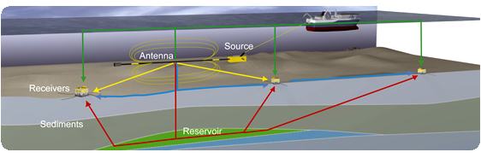
Figure 1: Seabed Logging [1]
1.2 Problem Statement
One of the constraints in developing EM transmitter is to make sure the EM wave generated is able to propagate below the seabed to the hydrocarbon bearing. The wave that is generated is also not focus to the target and the wave that is reflected back will be difficult to be analyzed in order to determine the location of the reservoir. This is due to the nature of the low frequency wave that is highly dispersive. This research deals with simulating and experimenting EM transmitters which are in low frequency and more focus which can reach deep target hydrocarbon reservoir.
1.3 Objective and Scope of Study
The objectives of this research are as follows:
- To design new EM transmitters.
- To enhance hydrocarbon detection and focusing ability using the new transmitters.
- To validate the EM transmitters in scaled tank.
In this study, the author would like to simulate the EM transmitters to optimize the detection of oil at deep target. Firstly, the author will simulate EM transmitter using CST software. Secondly, there will be experiment to test the EM transmitter in a scaled tank.
1.4 Relevancy of Study
There are many method of detecting hydrocarbon in marine environment. For example, Controlled Source Electromagnetic (CSEM) surveying and Sea Bed Logging (SBL) which are widely used in oil and gas exploration. During CSEM surveying, a powerful horizontal electric dipole is towed about 30 m above the seafloor. The dipole source transmits a carefully designed, low-frequency electromagnetic signal into the subsurface.
However, the EM waves that are transmitted by the horizontal electric dipole contain a lot of noise and the waves are highly dispersive in nature. Marine CSEM methods can be used to distinguish hydrocarbon from other fluids in the subsurface due to the resistive nature of hydrocarbon formations [2].
The new EM transmitters are design to be able to focus the wave and increase the ability to detect the hydrocarbon. Eventually, the percentage in detecting the hydrocarbon will be higher.
In addition, electromagnetic (EM) wave has the ability overcome the limitations of the conventional methods. EM wave carries energy and be able to propagate in any direction regardless the type of propagation medium. The new transmitters also more focus to the target and the result from the reflected wave are better.
1.5 Feasibility of the Study within the Scope and Time Frame
All of the objectives stated earlier are achievable and feasible within the scope and time frame. This research comprises of two parts which are simulation and experiment work. CST software will be used to simulate the electromagnetic transmitter to the proposed area of the seabed model. Experiments will be done for the EM transmitter at the scaled tank after all the simulation work has finished.
CHAPTER 2
LITERATURE REVIEW

2.1 Seismic Method
Seismic has become a popular and accurate method in hydrocarbon exploration because it can detect potential hydrocarbon reservoir beneath the seafloor. It maps the boundary layers based on different acoustic [3]. According to [3], acoustic waves are used to map boundaries between layers with contrasting acoustic properties. A sound source that is attached to the ship sends sound waves through the water. As the sound waves are release, the rock layers beneath the seafloor reflect this sound. Using seismic method, the presences of water or hydrocarbon in the traps cannot be differentiated [3]. Depending on seismic data, the success rate of commercially viable exploration wells is about 10-30% [4].
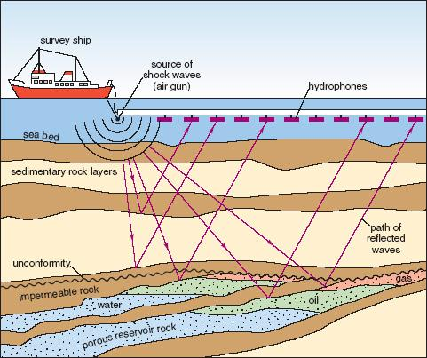
Figure 2: Seismic reflection profiling [5]
2.2 Controlled-Source Electromagnetic (CSEM)
For the past few years, marine controlled-source electromagnetic (CSEM) surveying has become as a useful method for determining the hydrocarbon reservoirs. In this method, a deep-towed electric dipole source is used to excite a low frequency (~0.1 – 10.0 Hz) electromagnetic signal [2]. The signal propagates through the seawater and subsurface and to depths of several kilometers. Low frequency electromagnetic waves attenuate more in the conductive layer and less in the resistance layer due to the skin depth [6]. One advantage of sub-sea measurements is that the highly conductive sea (approximately 3.2 S/m) acts as a low pass filter for fluctuating EM fields [7].
Subsurface resistivity imaging of shallow water CSEM data has been considered difficult due to strong effects of the refracted and reflected energy from the sea surface, commonly referred to as the airwave [8]. In order to demonstrate the effectiveness of diffusive e-field imaging in detecting resistive subsurface targets, 2D e-field imaging is performed for a simulated marine CSEM dataset [2].
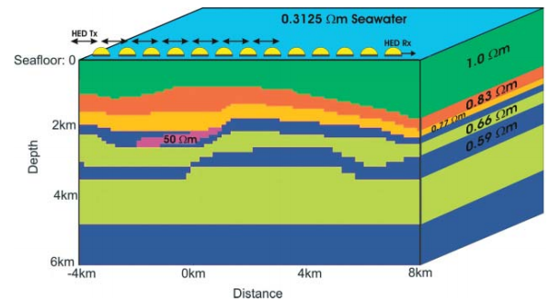
Figure 3: Earth model and simulated marine EM survey [2]
2.3 Introduction to Sea Bed Logging (SBL)
SBL is an application of control source electromagnetic method to detect hydrocarbon below the sea floor by using electromagnetic (EM) waves [9, 10]. SBL method was developed in 1997 by Statoil ASA, which used electromagnetic waves in down-hole tools to investigate reservoir properties. Nowadays, SBL principles rely on two important indicators which are a powerful transmitter and a sensitive receiver.

There are many different types of transmitters available, such as the vertical electrical dipole (VED), horizontal electric dipole in line (HED-R) and horizontal magnetic dipole crossline (HMD-R).They are sensitive in detecting a thin horizontal hydrocarbon layer. It was reported in Figure 2.2.1 that sea water (0.3 ohm-m) with the depth is 2000m, the target which (an oil layer, 50 ohm-m) is at 1000m below the seabed and has 50m thickness with overburden that has the resistivity of 1 ohm-m [11]. The transmitter was placed at 50m above the seabed by using 1 kHz for the frequency and the receivers array was placed on the seabed. As a result, the VED, HED-R (in-line) and HMD-P (crossline) were sensitive in detecting the target while the vertical magnetic dipole (VMD), horizontal electric dipole crossline (HED-P), horizontal magnetic dipole inline (HMD-R) were not sensitive in detecting the target.

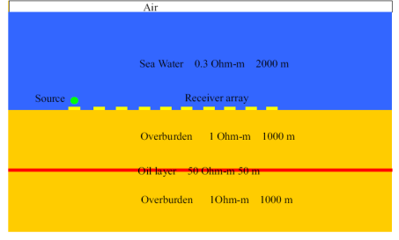
Figure 4: A Sea Bed Logging model [12]
The EM source has been reported as an active source which gives a direct hydrocarbon indication through its sensitivity to the difference of the layer in the seabed [13, 14, 15]. Results from the reports [16, 17] by using this active source from the EM, it is able to detect the presence of hydrocarbons within a reservoir, and will be able to locate accurately the hydrocarbon’s lateral extent through the use of data derivatives. Detection of subsurface hydrocarbons by an active source electromagnetic (EM) sounding application, termed seabed logging (SBL), has recently shown very promising results, but has until now not been fully demonstrated [18].

Currently, dipole is used as the HED transmitter because of its better design in terms of polarization of the EM’s propagation. By using HED transmitter, it may induce up to170% increased subsurface returned signals above the gas accumulation [19]. At the same time, electric fields measured at the seafloor by a receiving dipole at a suitable horizontal range are dominated by the components of the source fields that have followed diffusions paths through the seabed [20]. Seabed logging delivers subsurface resistivity information before drilling a well.

2.4 Electromagnetic Transmitter
The function of transmitter is to transmit EM waves. There are many types of transmitter which has their own characteristic and properties. The electromagnetic waves transmitted from the EM transmitter diffuse in all direction. The waves that are produce will be detected by the receivers which are placed on the seafloor at a certain distance interval. The waves that are reflected back from the high resistive subsurface layers predict the hydrocarbon bearing. The amount of current induced depends on the electrical conductivity of the material itself. Commonly, we use copper as the transmitter since it is a highly electrically conductive material. Shape and size of a transmitter determine how effective it is in propagating the waves into the sediments below the seafloor. In order to design a transmitter, it is important to know the resistance of the antenna itself. The radiation and resistance properties of an antenna are governed by its shape and size and the material of which it is made.
2.5 New Antenna Curvature Study
There has been many works been done in order to develop the best EM transmitters. New antenna with different curvatures was simulated in CST software to know the maximum target depth this antenna can detect [21]. They have tested the electric and magnetic response of four different curvatures which are h=r, h=r/2, h=r/3 and h=r/4. The diagram below show the Horizontal Electric Dipole is made curve until it reached semi-circle.

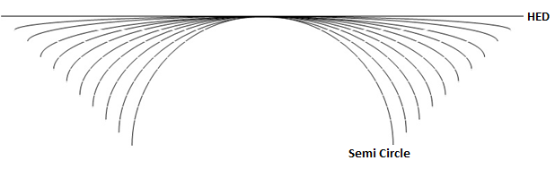
Figure 5: Curvature diagram
Below is the diagram of the semicircle curve where the height is equal to the radius.

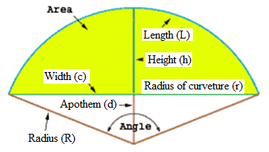
Figure 6: Semi-circle shape

Table 1: New antenna Ex and Hz field response % difference comparison at different target depth with and without hydrocarbon [21].
New antenna curvature height | E-field (V/m) | H field (A/m) | % increase of E-field | % increase of H-field
h=r | 0.00432 | 703 | - | -
h=r/2 | 0.00489 | 1175 | 13 | 67
h=r/3 | 0.00515 | 9048 | 19 | 1187
h=r/4 | 0.00443 | 755 | 3 | 278

As the attenuation factor for electromagnetic field strength for 500m target depth is the same but the electromagnetic field strength for curvature h=r/3 or 0.3r curve is 1187% higher than other curvatures [21]. The h=r/3 curvature is the best among other curvature in term of electromagnetic field strength which is important in detecting deep target hydrocarbon.
2.6 Theory
This section discussed on the basic theories of EM waves which is used to detect hydrocarbon.
2.6.1 Wave Path in a Hydrocarbon Reservoir
In seabed logging, the energy of the EM waves is guided along the oil layers and decay to a certain period. When the waves penetrated high resistance layers such as hydrocarbon, the energy will refracted back to the seabed and detected by the electromagnetic receivers. There are five components of received EM waves which are:
- Air waves: EM waves reflected back at the boundary of air and seawater
- Direct waves: EM waves produced by the EM transmitter
- Reflected waves: EM waves from the seabed
- Reflected waves: EM waves from hydrocarbon
- Guided waves: EM waves through hydrocarbon

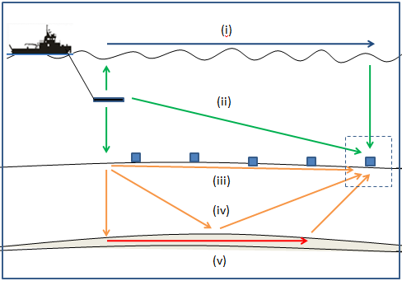
Figure 7: Schematic Diagram of EM waves propagation [22]
2.6.2 Skin depth
The most important concept in any EM method is skin depth. EM energy decays exponentially in conductive rocks over a distance given by the skin depth. In the seabed logging application, the skin depth equation $δ=\sqrt{\frac{2}{ωμσ}}$ is referred so that we could know how much EM waves can propagate and diffuse into the reservoir, where σ is electrical conductivity, μ is magnetic permeability and ω is the angular frequency of the current.
2.6.3 Electromagnetic Wave
Electromagnetic wave is a form of energy emitted and absorbed by charged particles which exhibits wave-like behavior as it travels through space. EM wave has both electric and magnetic field components, which stand in a fixed ratio of intensity to each other, and which oscillate in phase perpendicular to each other and perpendicular to the direction of energy and wave propagation.
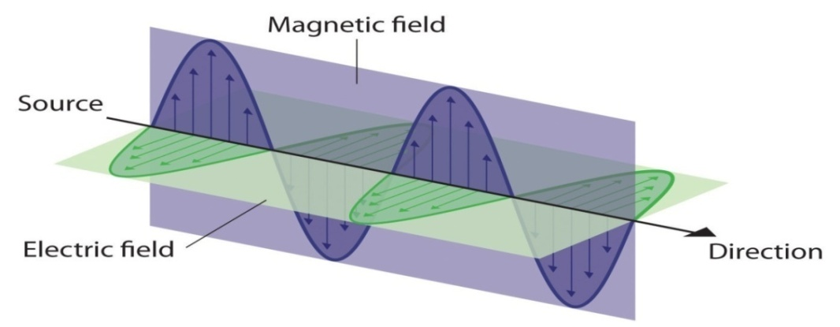
Figure 8: Electromagnetic wave diagram [23]
Maxwell equation states that the magnetic field produced (B) is proportionally related to the current and the type of material used. The bigger current flow inside a conductor, and the higher the permeability of the material used, the bigger B field is produced [24]. Magnetic field and the electric filed is propagating together perpendicularly with the same amplitude where the reduction in magnetic field will cause the same amount of reduction in electric field as well [24].

Based on Maxwell equation [24],
$$B=\frac{μI}{2πr}$$
Where:
B=Magnetic field
μ= Magnetic permeability
I= Current
r=distance

Wavelength and frequency are two characteristics of EM radiation that are important in antenna properties. The relation between wavelength and frequency is given as:
υ=fλ
Where:
υ= velocity (ms⁻¹)
f= frequency of transmitter (Hz)
λ=wavelength (meter)

CHAPTER 3
METHODOLOGY

3.1 Introduction

This chapter discusses on the methodology which consists of simulation and experiment work. The flow of this project was as shown in Figure 3.0.1. It should be noted that this work began by conducting simulations on transmitters at reservoir and scaled tank environment and then continued with experiment at the scaled tank. CST studio software was employed to evaluate the electric field and magnetic field produce by the EM transmitters.

Start

Literature Review
Design of EM transmitter

Simulation on reservoir model

No
Compare with the conventional transmitter

Yes
Simulation on scaled tank model

Scaled tank experiment

Final Result and Discussion

End

Figure 9: Research Methodology Flow Chart
Implementation
This project consists of simulation and experiment work. Specifically it was designing a new transmitter based on the previous work found during the literature review process. The author compared the conventional transmitter which is Horizontal Electric Dipole (HED), h=r/3 transmitter and the new transmitter. They were compared with simulation result on the reservoir model to identify either the new transmitter is better than HED and h=r/3. The simulation was done using Computer Simulation Technology.

3.2 Gantt Chart
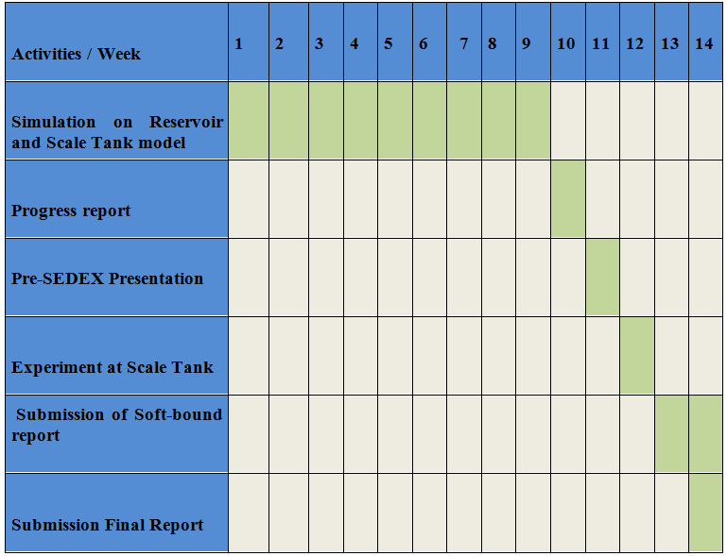
Process
Figure 10: Gantt chart

3.3 Software Required
3.3.1 Computational Simulation Technology (CST)
The electromagnetic simulation software CST STUDIO SUITETM is the culmination of many years of research and development into the most efficient and accurate computational solutions to electromagnetic design. It comprises CST’s tools for the design and optimization of devices operating in a wide range of frequencies.
By using CST, the significant of transmitter’s shape can be analyzed based on the electric field and magnetic field produced. This software will be the main tool for developing the simulation of EM waves in seabed logging applications.
3.4 Tools Required
3.4.1 Scaled tank
Scaled tank was used in the experiment process.
9.0 m

2.2 m

2.0 m

Figure 11: Scaled tank

3.4.2 Function Generator

Function of the function generator is to supply many ranges of frequencies to the EM transmitter.
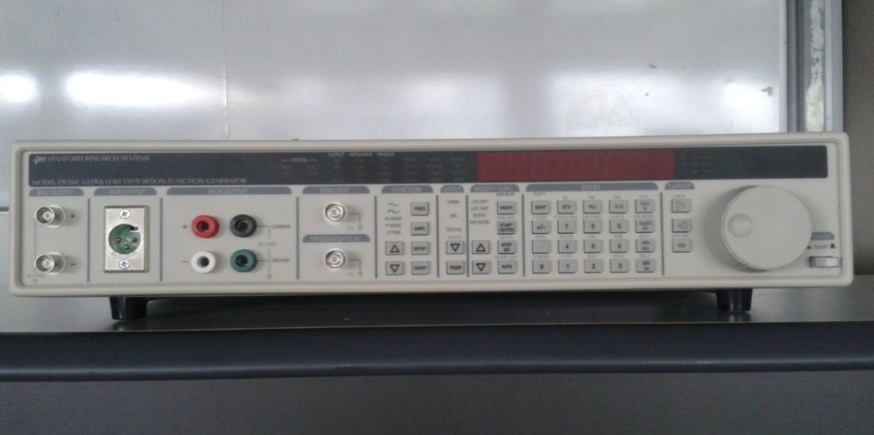
Figure 12: Stanford Function Generator

3.4.3 Aluminum rod

Aluminum has been chosen as the material to build the EM transmitter because of its high conductivity.

3.4.4 Fluxgate Magnetometer and Decaport Data Acquisition System (DAS)

Fluxgate Magnetometer were used as the receiver which detected the EM waves produced by the EM transmitters. It was placed at the bottom of the tank. While, DAS was used to store the data transmitted by the EM transmitter.
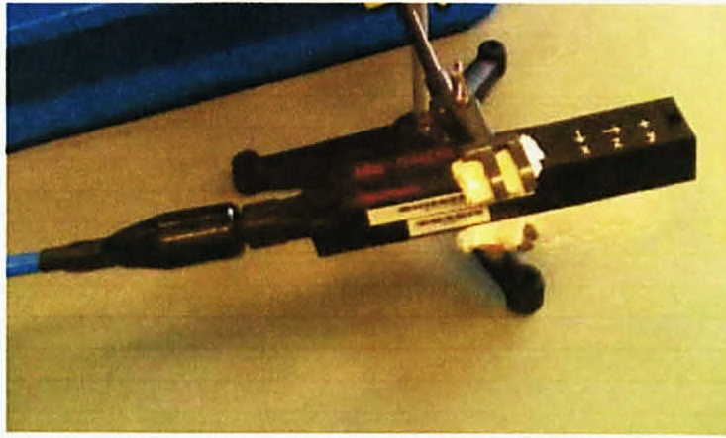
Figure 13: Fluxgate Magnetometer

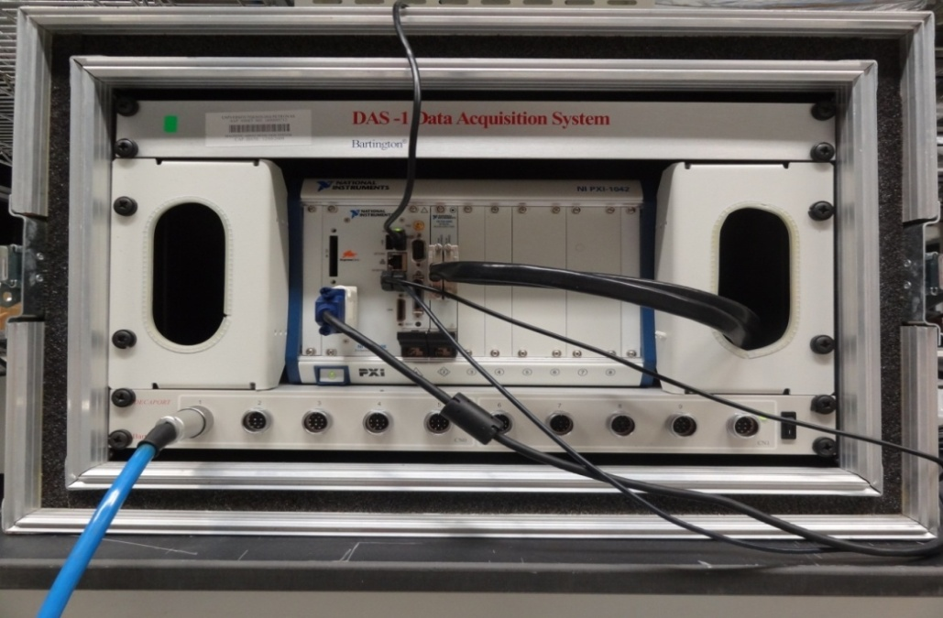
Figure 14: Data Acquisition System (DAS)
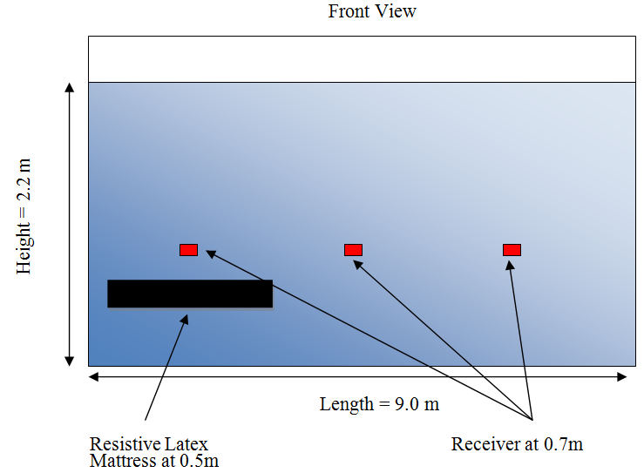
Figure 15: Scaled Tank Experiment setup

CHAPTER 4
RESULTS AND DISCUSSION

4.1 Introduction
Simulations using CST has been done on HED/straight transmitter, h=r/3 and the new transmitter which is 0.3r bi-curve transmitter. The simulation was done on 100 km x100 km model consist of air layer, sea water layer, upper sediment, hydrocarbon layer and lower sediment. The author chose offset ranging from 0 km to 50 km. The offset is the distance of the receivers from the source. The receiver lines were placed at every 100m interval starting from the air until the bottom of the model. The transmitters are 270m in length is placed 30m above the seafloor. It was supplied with 1250 Ampere of current. All the simulations were done using CST.
Table 2: List of Transmitters used in Simulation
Transmitters | HED/Straight | 0.3r Curve | 0.3r Bi-curve
 | 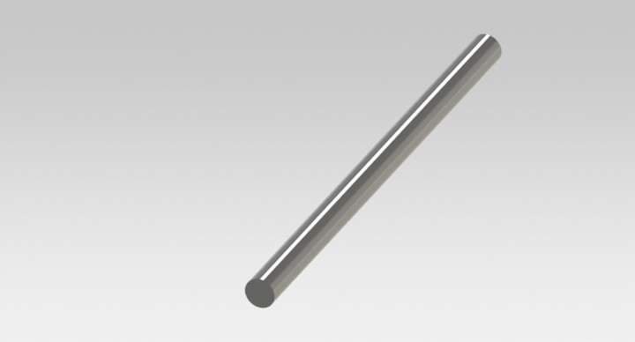  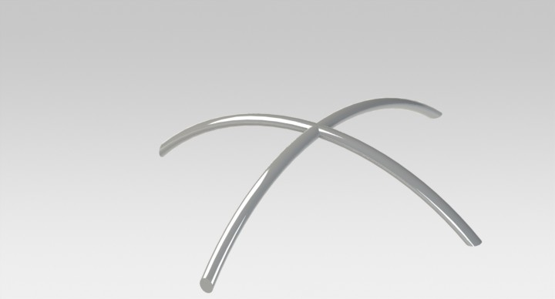  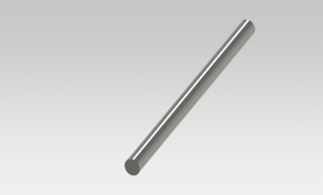 | 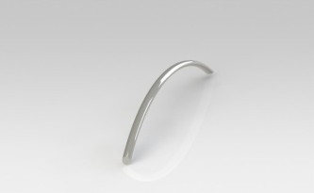 | 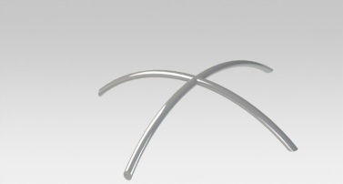

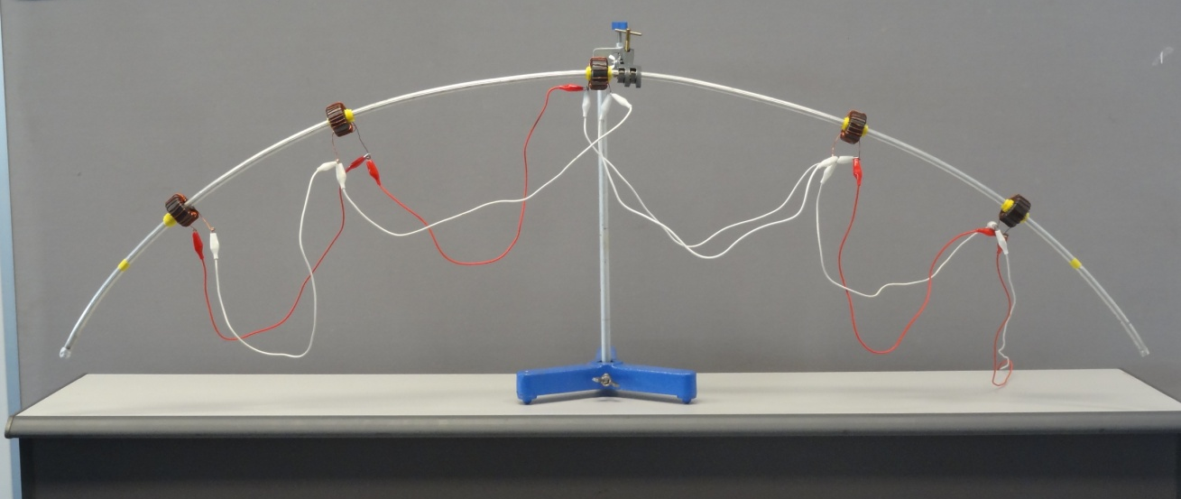
Figure 16: 0.3r curve transmitter
The diagrams show the reservoir models with air layer of 200m thickness, water layer of 300 m thickness and 4500 m of sediment. The hydrocarbon layer with 100m thick was placed starting at 250m interval below the seafloor until 4250m for each reservoir model.
Air 200m

Water 300m

4500m Sediments

Receiver’s line

Figure 17: Reservoir model

Air 200m

Water 300m

Upper sediment 250m
100m of HC layer

4500m Sediments

Figure 18: Reservoir model with HC layer

4.2 Simulation Result on HED/Straight Transmitter
All the graphs were plotted with x-axis is the e-field versus y –axis is the offset in meter. The graphs were plotted to show the e-field value at the receivers which are placed inside the sediments starting from the seafloor until 4200m. The models were simulated using different hydrocarbon layer depth starting with no hydrocarbon layer.

Figure 19: Graph for Straight Transmitter with no Hydrocarbon Layer

Figure 20: Graph for Straight Transmitter with Hydrocarbon Layer at 500m below Seafloor

Figure 21: Graph for Straight Transmitter with Hydrocarbon Layer at 1000m below Seafloor

Figure 22: Graph for Straight Transmitter with Hydrocarbon Layer at 1500m below Seafloor

Figure 23: Graph for Straight Transmitter with Hydrocarbon Layer at 2000m below Seafloor

Figure 24: Graph for Straight Transmitter with Hydrocarbon Layer at 2500m below Seafloor

Figure 25: Graph for Straight Transmitter with Hydrocarbon Layer at 3000m below Seafloor

Figure 26: Graph for Straight Transmitter with Hydrocarbon Layer at 3500m below Seafloor

Figure 27: Graph for Straight Transmitter with Hydrocarbon Layer at 4000m below Seafloor
The similarities between all the graphs were that when there are hydrocarbon layer, there were sudden change in the shape of the graph. This is because hydrocarbon has higher resistivity compare to sediments. In addition, the graphs were decreasing when the offset increased. The distance from the transmitters to the receiver will also affect our wave’s propagation.

4.3 Simulation Results on 0.3r Curved transmitter
The same reservoir model was used for 0.3r transmitter.

Figure 28: Graph for 0.3r curved Transmitter with no Hydrocarbon Layer

Figure 29: Graph for 0.3r curved Transmitter with Hydrocarbon Layer at 500m

Figure 30: Graph for 0.3r curved Transmitter with Hydrocarbon Layer at 1000m

Figure 31: Graph for 0.3r curved Transmitter with Hydrocarbon Layer at 2000m

Figure 32: Graph for 0.3r curved Transmitter with Hydrocarbon Layer at 2500m

Figure 33: Graph for 0.3r curved Transmitter with Hydrocarbon Layer at 3000m

Figure 34: Graph for 0.3r curved Transmitter with Hydrocarbon Layer at 3500m

Figure 35: Graph for 0.3r curved Transmitter with Hydrocarbon Layer at 4000m
The value of e-field at the seafloor were the highest for all the models. There were differences in e-field value for each receiver’s depth. As the hydrocarbon layer’s depth increases, there were a big difference for deep receiver’s depth. For the 0.3r curved transmitter, the value of e-field slightly decrease at the receivers after the hydrocarbon layer. There were gap in value between the receivers before and after the hydrocarbon layer. This was a good indication where there will be percentage difference that will show the availability of the hydrocarbon bearing.

4.4 Simulation Results for 0.3r bi-curved Transmitter

Figure 36: Graph for 0.3r bi-curved Transmitter with No Hydrocarbon Layer

Figure 37: Graph for 0.3r bi-curved Transmitter with Hydrocarbon Layer at 500m

Figure 38: Graph for 0.3r bi-curved Transmitter with Hydrocarbon Layer at 500m

Figure 39: Graph for 0.3r bi-curved Transmitter with Hydrocarbon Layer at 1500m

Figure 40: Graph for 0.3r bi-curved Transmitter with Hydrocarbon Layer at 2000m

Figure 41: Graph for 0.3r bi-curved Transmitter with Hydrocarbon Layer at 2500m

Figure 42: Graph for 0.3r bi-curved Transmitter with Hydrocarbon Layer at 3000m

Figure 43: Graph for 0.3r bi-curved Transmitter with Hydrocarbon Layer at 3500m

Figure 44: Graph for 0.3r bi-curved Transmitter with Hydrocarbon Layer at 4000m
There were big differences of the e-field value at the receiver before and after the hydrocarbon layer. This was due to the resistivity of the hydrocarbon which reduces the e-field. The author can easily identified the availability of the hydrocarbon layer. The graphs were not showing a good curve shape because some of the waves that were transmitted are considered “dead” and were not reflected back to the receivers. 0.3r bi-curve has higher value of e-field at the seafloor compared to 0.3r. In seabed logging, the receivers are only placed at the seafloor. During simulation, we can place the receivers inside the sediments at certain depth to know the strength of the waves.

4.5 Detection of Hydrocarbon
The detection ability of the transmitters was measured using percentage difference of e-field value at seafloor with and without hydrocarbon layer. The results were obtained by comparing the e-field at the seafloor at two reservoir models which were no hydrocarbon layer and hydrocarbon layer at 500m.
Table 3: Percentage difference for Straight Transmitter
Straight Transmitter
Offset/E-field (V/m) | No HC | HC at 500m | Percentage Difference
0 | 1.44E-03 | 1.44E-03 | 0%
2500 | 1.56E-05 | 1.56E-05 | 0%
5000 | 2.68E-06 | 2.68E-06 | 0%
7500 | 1.14E-06 | 1.13E-06 | 0%
10000 | 6.31E-07 | 6.31E-07 | 0%
12500 | 4.07E-07 | 4.07E-07 | 0%
15000 | 2.88E-07 | 2.88E-07 | 0%
17500 | 2.15E-07 | 2.16E-07 | 0%
20000 | 1.70E-07 | 1.71E-07 | 0%
22500 | 1.39E-07 | 1.39E-07 | 0%
25000 | 1.17E-07 | 1.17E-07 | 0%
27500 | 1.01E-07 | 1.01E-07 | 0%
30000 | 8.90E-08 | 8.93E-08 | 0%
32500 | 8.00E-08 | 8.02E-08 | 0%
35000 | 7.31E-08 | 7.32E-08 | 0%
37500 | 6.78E-08 | 6.79E-08 | 0%
40000 | 6.39E-08 | 6.39E-08 | 0%
42500 | 6.09E-08 | 6.10E-08 | 0%
45000 | 5.90E-08 | 5.90E-08 | 0%
47500 | 5.79E-08 | 5.79E-08 | 0%
50000 | 5.73E-08 | 5.76E-08 | 0%

As shown in the table above, there were no differences in the e-field value at the seafloor with or without hydrocarbon layer. It will be difficult to identify the availability of the hydrocarbon bearing in the sediment.

Table 4: Percentage difference for 0.3r curve transmitter
0.3r curve transmitter
Offset/E-field (V/m) | No HC | HC at 500m | Percentage Difference
0 | 1.27E-06 | 1.13E-06 | -13%
2500 | 1.59E-07 | 9.21E-07 | 83%
5000 | 4.56E-08 | 1.97E-07 | 77%
7500 | 2.42E-08 | 9.34E-08 | 74%
10000 | 1.34E-08 | 5.17E-08 | 74%
12500 | 9.08E-09 | 3.63E-08 | 75%
15000 | 6.08E-09 | 2.50E-08 | 76%
17500 | 4.56E-09 | 1.78E-08 | 74%
20000 | 3.61E-09 | 1.38E-08 | 74%
22500 | 2.97E-09 | 1.06E-08 | 72%
25000 | 2.47E-09 | 8.75E-09 | 72%
27500 | 2.17E-09 | 7.14E-09 | 70%
30000 | 1.93E-09 | 6.04E-09 | 68%
32500 | 1.73E-09 | 5.12E-09 | 66%
35000 | 1.55E-09 | 4.40E-09 | 65%
37500 | 1.44E-09 | 3.87E-09 | 63%
40000 | 1.35E-09 | 3.49E-09 | 61%
42500 | 1.30E-09 | 3.14E-09 | 59%
45000 | 1.26E-09 | 2.85E-09 | 56%
47500 | 1.23E-09 | 2.60E-09 | 53%
50000 | 1.23E-09 | 2.36E-09 | 48%

From the table, the highest percentage difference was 83%. This shows that the 0.3r curve transmitter can detect the hydrocarbon better than HED.

Table 5: Percentage difference of 0.3r bi-curve transmitter
0.3r bi-curved SF
Offset/E-field (V/m) | No HC | HC at 500m | Percentage Difference
0 | 1.09E-03 | 1.39E-03 | 21%
2500 | 4.06E-06 | 5.59E-06 | 27%
5000 | 6.48E-07 | 1.07E-06 | 39%
7500 | 2.86E-07 | 4.57E-07 | 37%
10000 | 1.61E-07 | 2.51E-07 | 36%
12500 | 1.03E-07 | 1.54E-07 | 33%
15000 | 7.34E-08 | 1.02E-07 | 28%
17500 | 5.53E-08 | 7.06E-08 | 22%
20000 | 4.37E-08 | 4.84E-08 | 10%
22500 | 3.58E-08 | 3.61E-08 | 1%
25000 | 3.01E-08 | 2.87E-08 | -5%
27500 | 2.59E-08 | 2.46E-08 | -5%
30000 | 2.30E-08 | 2.22E-08 | -4%
32500 | 2.06E-08 | 2.04E-08 | -1%
35000 | 1.88E-08 | 1.89E-08 | 1%
37500 | 1.74E-08 | 1.77E-08 | 1%
40000 | 1.64E-08 | 1.67E-08 | 1%
42500 | 1.57E-08 | 1.59E-08 | 1%
45000 | 1.52E-08 | 1.54E-08 | 2%
47500 | 1.49E-08 | 1.51E-08 | 1%
50000 | 1.49E-08 | 1.50E-08 | 1%

For 0.3r bi-curve transmitter, the highest percentage was only 39% which was less compared to 0.3r curve transmitter. This was slightly different than what the author expected.
4.6 Focusing Ability
Focusing ability is the ability of the transmitter to focus their waves into the target. The more focus the waves are, the deeper the waves can travel into the sediment. In this part, the author chose five different depths which were seafloor, 1000m below the seafloor, 2000m below the seafloor, 3000 m below the seafloor and 4000m below the seafloor.

Figure 45: E-field value for different receiver’s depth

Figure 46: E-field value for different receiver’s depth

Figure 47: E-field value for different receiver’s depth

Figure 48: E-field value for different receiver’s depth

Figure 49: E-field value for different receiver’s depth
All the graphs showed that 0.3r bi-curve has the highest value of e-field. This means that 0.3 bi-curve has the better focusing ability compared to HED and 0.3r transmitter. These results proved that curve transmitter is the best for focusing the EM waves into the sediments.
4.7 Simulation at the Scaled Tank
The scaled tank is 9m long with width of 2.2m and height of 2 m. The water level was set at 1m and 1.2 m of air. The receivers were placed at 0.7m from the bottom of the tank. The blue line represents the receiver line. The transmitter has been scaled down to match the scaled tank dimension. The simulation is done at the scaled tank to validate the transmitters.
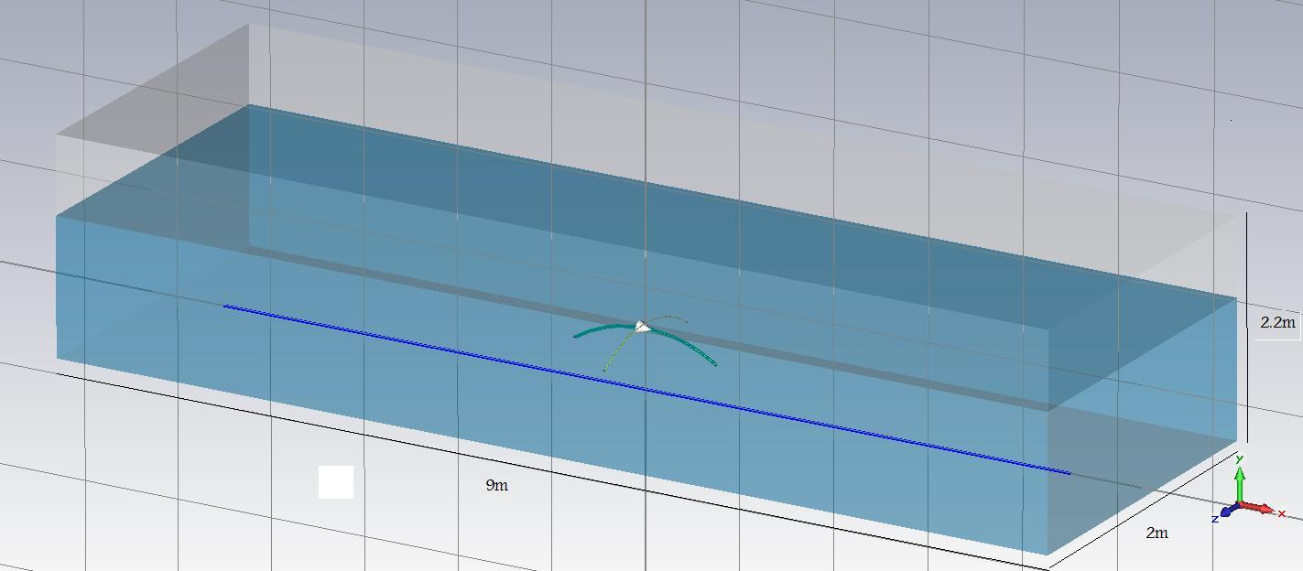
Figure 50: Diagram of scaled tank model
The graphs below were plotted based on the result obtained from the simulation using CST. For the simulation the scaled tank, the author used magnetic field at z axis (Bz) instead of electric field at x-axis (Ex). Bz and Ex are equal because the magnetic field and electric field are perpendicular to each other. So, the x-axis of electric field will be the same as z-axis of magnetic field. However, for reservoir model, the author use Ex because electric field can go deeper compare to magnetic field. Magnetic field is used for shallow depth only.

Figure 51: Graph for scaled tank simulation.

Figure 52: Comparison of straight and 0.3r transmitter

Figure 53: Comparison of 0.3r transmitter and 0.3r bi-curve transmitter
Overall, 0.3r bi-curved has better B-field or magnetic field compared to 0.3r and straight transmitter. Better Bz means that the transmitter is good in focusing and detecting the hydrocarbon.

4.8 Scaled Tank Experiment Results
The scaled tank experiment has the same dimension as used in the simulation. The transmitters were hang to the PVC pipe and move from the starting point until the end of the tank. There were 3 sensors placed at the bottom of the tank to record the waves that were transmitted by the transmitters.

Figure 54: Straight Transmitter in Scaled Tank Experiment
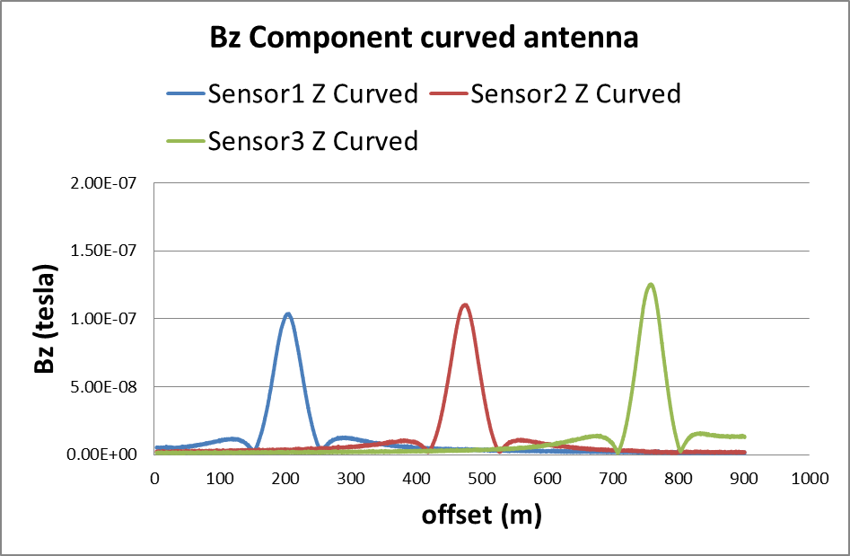
Figure 55: 0.3r curve Transmitter in Scaled Tank Experiment
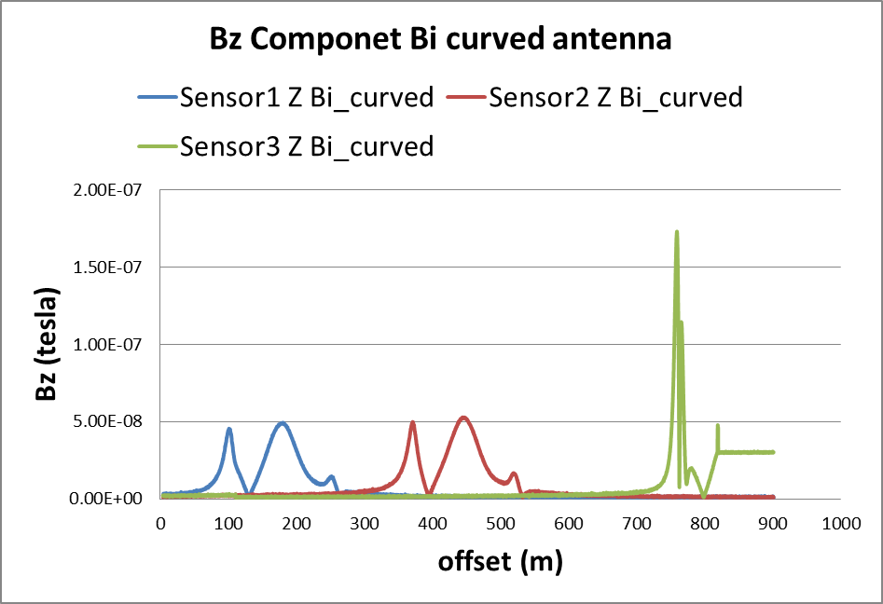
Figure 56: 0.3r bi-curve Transmitter Scaled Tank Experiment
The three transmitters showed low value at sensor 1 and sensor 2 compare with the value at sensor 3. 0.3r bi-curve transmitter shown the highest value at sensor 3 which the resistive layer was located. As a conclusion, 0.3r bi-curve has the most efficient ability in detecting resistive layer in scaled tank experiment.

CHAPTER 5
CONCLUSION AND RECOMMENDATIONS

5.1 Conclusion
The purpose of this work is to design and enhance the transmitter’s ability in focusing and detecting the hydrocarbon at deep hydrocarbon target. The straight transmitter or Horizontal Electric Dipole is the conventional transmitter used in the Seabed Logging (SBL). In order to compare the ability of the new transmitter, two simulations using CST are done.
There were two simulations has been done which were simulation on the reservoir model and scaled tank model. All the result obtained are as expected except the detection ability where the percentage difference of 0.3r transmitter is higher than 0.3 bi-curved. In addition, the waves that are transmitted are not all reflected back to the receivers which give low value in e-field at certain offset. The 0.3r bi-curve transmitter is the best in focusing the wave which the wave can go deeper into the sediment. This is essential to detect hydrocarbon at deep target. Although, the detection ability is quite less compare to 0.3r transmitter, it is still better than the conventional transmitter, HED. It was proven that the new transmitter design has better focusing and detection of hydrocarbon compare to conventional transmitter, HED. The EM transmitter ability was validated using scaled tank simulation and experiment.
5.2 Recommendations
There are some recommendations and improvement that can be done to improve this project in the future. Below are some recommendations:
- Use sand as sediment in the scaled tank experiment to replicate the reservoir.
- Simulate for more combinations of 0.3r curve such as 0.3r tri-curved.
- Conduct and compare scaled tank experiment with and without resistive layer.

CHAPTER 6
REFERENCES

[1] EMGS and NOCA in Innovation Cooperation. Retrieved from http://english.noca.no/News/EMGS/
[2] J. Tompkins, Micheal., “Marine Controlled-source Electromagnetic Imaging for Hydrocarbon Exploration: Interpreting Subsurface Electrical Properties”, August 2004.
[3] Hanita Daud, Noorhana Yahya, Vijanth Asirvadam. “Development of EM Simulator for Seabed Logging Application using MATLAB”. Indian Journal of Geo-Marine Science.
[4] Anuar Bhuiyan, Tor Wicklund, Stale Johansen, “High Resistivity Anomalities at Modgunn Arch in the Norwegian Sea”, Technical Article, first break volume 24, January 2006.
[5] Seismic profiling. Retrieved from http://www.epa.gov/esd/cmb/GeophysicsWebsite/pages/reference/methods/ Marine_Geophysical_Methods/Marine_Seismic_Methods.htm
[6] Noorhana Yahya, Nadeem Nasir, Majid Niaz Akhtar, Muhammad Kashif, Tanvir Hussain, Hasnah Mohd Zaid, Afza Shafie, “ Electromagnetic Response Studies of the Antenna for Deep Water Deep Target CSEM Environments,” October 2012.
[7] Kurang Mehta, Misac Nabighian, Yaoguo Li, Doug Oldenburg, “Controlled Source Electromagnetic (CSEM) Technique for Detection and Delineation of Hydrocarbon Reservoirs: An Evaluation”.
[8] Hakon Toralv Pedersen, M. AkmalAffendi, Azani B. A. Manaf, “Shallow water 3D CSEM: A Case Study from Malaysia”.
[9] D.Ridyard,T.A.Wicklund, B.P.Lindhom, “Electromagnetic Prospect Scanning Moves Seabed Logging from Risk Reduction to Opportunity Creation”, First Break Volume 24, November 2006.
[10] T. Eidesmo, S. Ellingsrud, L.M. Macgregor, “Remote Detection Of Hydrocarbon Filled Layers Using Marine Controlled Source Electromagnetic Sounding”, EAGE 64th Conference & Exhibition Italy, May 2002.
[11] Hakon Toralv Pedersen, M. AkmalAffendi, Azani B. A. Manaf, “Shallow water 3D CSEM: A Case Study from Malaysia”.
[12] B.E. Tossman, D.L. Thayer, W.A. Swartz, “An Underwater Towed Electromagnetic Source for Geophysical Exploration”, IEEE Journal on Oceanic Engineering, pg.84-89, 1979.
[13] S. Ellingsrud, T. Eidesmo, S. Johansen, M.C. Sinha, L. M. MacGregor, S. Constable,“ Remote Sensing Of Hydrocarbon Layers Using Sea-Bed Logging(SBL):Results Of A Cruise Offshore”, West Africa, The Leading Edge, Volume 21,pg.972-982, 2002
[14] T.Eidesmo., S.Ellingsrud, L. M. MacGregor, S. Constable, M.C.Sinha,S.
Johansen, F.N. Kong, H. Westerdahl,“Sea Bed Logging(SBL),A New Method for Remote and Direct Identification of Hydrocarbon Filled Layers in Deep water Areas”, First Break,Volume 20, pg.145, 2002.
[15] M. Sinha, “Controlled Source EM Sounding: Survey Design Considerations for Hydrocarbon Applications”, Lithos Science Report, Volume1, pg.95-101, 1999.
[16] A.A.Greer, L.M.Macgregor, R.Weaver, “Remote Mapping of Hydrocarbon Extent Using Marine Active Source Electromagnet Sounding”, EAGE 65th Conference & Exhibition, 2-5June 2003
[17] L.M. Macgregor, “Joint Analysis of Marine Active and Passive Source Electromagnetic Data for Sub-Salt or Sub-Basalt Imaging”, EAGE 65th Conference & Exhibition, 2-5 June 2003.
[18] N.A. Ahmad, N.Yahya, M.H.Zakariah, P.Puspitasari,“Development of a Powerful EM Transmitter”, AIP Conference Proceeding 1136, pp.406-413, 2009.
[19] L.M.MacGregor, J.L.Rust, M.C.Sinha, “Electromagnetic Surveying for Hydrocarbon Reseivors”, United States Patent, US2006/0129322A1, 2006.
[20] T.Eidesmo, S.Ellingrud, “Sea Bed Logging (SBL), A New Method for Remote and Direct Identification of Hydrocarbon Filled Layers in Deep water Areas”, First Break Volume 20.3, pg.149, March 2002.

[21] Noorhana Yahya, Nadeem Nasir, Majid Niaz Akhtar, Muhammad Kashif, Hasnah Mohd Zaid, Afza Shafie. “Modelling of Antenna for Deep Target Hydrocarbon Exploration.
[22] L.O Loseth, L. Amundsen, “ On the Signal Proapagation in Marine CSEM” , EGM 2007 International Workshop, Innovation in EM, Grav, Mag Methods, a new Prospective for Exploration, Capri, Italy, 15-18 April 2007.
[23] Chapter 6: Waves and Electromagnetic Radiation. Retrieved from http://chemwiki.ucdavis.edu/Under_Construction/Lardbucket/Chapter_6/6.1_Waves_and_Electromagnetic_Radiation
[24] Islam, M.R.; Wadadar, S.S.; Bansal, A., “Enhanced Oil Recovery of Ugnu Tar Sands of Alaska Using Electromagnetic Heating with Horizontal Wells”, presented at International Arctic Technology Conference hled in Anchorage, Alaska, 29-31 May 1991.

