HIGH PERFORMANCE COMPUTING (HPC) CARBON FOOTPRINT SYSTEM

IMA NUR ATHIRAH BT IDRIS

BUSINESS INFORMATION SYSTEM
UNIVERSITI TEKNOLOGI PETRONAS
MAY 2015

High Performance Computing (HPC) Carbon Footprint System

by

Ima Nur Athirah Bt Idris
18075

Dissertation submitted in partial fulfilment of
The requirement for the
Bachelor of Technology (Hons)
(Business Information System)

May 2015

Universiti Teknologi PETRONAS
32610 Bandar Seri Iskandar
Perak Darul Ridzuan

CERTIFICATION OF APPROVAL
High Performance Computing (HPC) Carbon Footprint System
By
Ima Nur Athirah Bt Idris
18075

Dissertation submitted in partial fulfilment of
The requirement for the
Bachelor of Technology (Hons)
(Business Information System)
May 2015

Approved by,  ___________________  (Savita K. Sugathan)  Department of Computer Information Science  Universiti Teknologi PETRONAS | Approved by,  ___________________  (Dr .Subarna Sivapalan)  Department of Management and Humanities  Universiti Teknologi PETRONAS

Universiti Teknologi PETRONAS
32610 Bandar Seri Iskandar
Perak Darul ridzuan
CERTIFICATION OF ORIGINALITY
This is to certify that I am responsible for the work submitted in this project, that the original work is my own except as specified in the references and acknowledgements, and that the original work contained herein have not been undertaken or done by unspecified sources or persons.

__________________
Ima Nur Athirah Bt Idris

ABSTRACT
HPC Carbon Footprint Calculator is web based system which is designed in conjunction of raising the awareness of people towards the greenhouse effect and environment sustainability. HPC is stand for High Performance computing which is actually a data centres for Universiti Teknologi PETRONAS.
This system is used to calculate the amount of carbon emitted based on the electricity consumption of air conditioners and personal computer (PC) data collected by HPC. HPC have the device that connected to its power supply box. The electricity is taken however there is no initiative to convert it into carbon emitted. With this system, HPC can know how much carbon emitted throughout it operation. This system can be a kick start program to raise awareness for UTP peoples and can make initiative to reduce the carbon emission. Along with this system is a integrated website to calculate general carbon footprint such as transportation.
Rapid application development (RAD) methodology has been selected to be used for the project development phase. The calculator then will be shows the carbon emitted. The system will also include the information of Green Data Centre design. It is to give knowledge on how HPC should design data centre to make it greener.

TABLE OF CONTENT

ABSTRACT iv
TABLE OF CONTENT v
LIST OF FIGURE ix
LIST OF TABLE x
Chapter 1 1
INTRODUCTION 1
1.1 Background of study 1
1.2 Problem Statement 2
1.3 Objectives of the Study 3
1.4 Scope of Study 3
Chapter 2 4
LITERATURE REVIEW 4
2.1 Sustainable development 4
2.1.1 Sustainable Campus 6
2.2 What is Green IT 7
2.2.1 Green IT practice in organization. 9
2.2.2 Green IT practice in University 11
2.3 Data Centre 12
2.3.1 What is Data Centre 12
2.3.2 Initiative to reduce data centre effect towards environment 13
2.4 Carbon Footprint 13
2.3.1 Reducing carbon footprint 14
2.3.2 Existing carbon footprint calculator 14
2.4 Asset management system 17
2.4.1 The existing asset management system 18
Chapter 3 22
METHODOLOGY 22
3.1 Methodology 22
3.2 Chosen Project Methodology 26
3.3 Required Tools 32
3.4 Key Milestone 33
3.5 Gant Chart 33
Chapter 4 35
RESULT AND DISCUSSION 35
4.1 Interview and Discussion 35
4.1.1 Health, Safety and Environment Department (HSE) 35
4.1.2 IT & Media Services Department (ITMS) 38
4.1.3 Finance Department 40
4.1.4 High Performance Computing Services Centre ( HPC) 43
4.2 HPC Carbon footprint system Site map 47
4.2.1 Basic Architecture 48
4.2.2 Use Case diagram. 49
4.2.3 Flowchart Diagram 50
4.3 HPC Carbon footprint system 50
4.3.1 Proposed sketches 50
4.3.2 System Interface 54
4.4 System’s testing 57
4.4.1 Functional Testing 57
4.4.2 Usability Testing 57
4.4.3 User Acceptance Test 58
4.5 Discussion 58
Chapter 5 61
CONCLUSION AND RECOMMENDATION 61
5.1 Conclusion 61
5.2 Future recommendation 62
REFERENCE 63

LIST OF FIGURE
Figure 2-1 Triple Bottom Line © www.miratechnologypark.com 5
Figure 2-2 the Greenhouse Effect 8
Figure 2-3 Installing Ruby Gem. 15
Figure 2-4 Code to install AMEE in the desktop 15
Figure 2-5 frontpage of AMS 18
Figure 2-6 Listing in AMS 19
Figure 2-7 Quick Search AMS 20
Figure 2-8 Tabs in AMS 20
Figure 2-9 Display of AMS 21
Figure 3-1 Waterfall Methodology © https://jackgraves.wordpress.com 23
Figure 3-2 Agile methodology © www.heliosco.com 24
Figure 3-3 Rapid Application Development © www.ramsoft.com.au 26
Figure 3-4 Differences between traditional and RAD © www.old.novulo.com 27
Figure 3-5 FYP I Gantt Chart 33
Figure 3-6 FYP II Gantt chart 34
Figure 4-1 User Requirement for the system 40
Figure 4-2 Display Asset - Master Data (General) 41
Figure 4-3 Display Asset - Master Data (Time - Dependent) 42
Figure 4-4 Display Asset - Master Data (Allocations) 42
Figure 4-5 Display Asset - Master Data (Origin) 43
Figure 4-6 the devices to measure electricity consumption 45
Figure 4-7 the PCs in the server room 46
Figure 4-8 the PCs in the server room 46
Figure 4-9 Conceptual Web Site Design 47
Figure 4-10 web application architecture 48
Figure 4-11 Use cased diagram of the system 49
Figure 4-12 Flowchart Diagram 50
Figure 4-13 Proposed homepage 51
Figure 4-14 ADD/ EDIT front page 51
Figure 4-15 Change interface 52
Figure 4-16 View Pages from user view 53
Figure 4-17 Login Page 54
Figure 4-18 Home page 55
Figure 4-19 Asset Listing interface 55
Figure 4-20 Electric Consumption 56
Figure 4-21 General Carbon calculator 56

LIST OF TABLE
Table 2-1 List of devices 16
Table 3-1 Advantage and Disadvantage of waterfall method 24
Table 3-2 Advantage and Disadvantage of Agile Method 25
Table 3-3Advantages and disadvantage of RAD 25
Table 3-4 Interview with HSE 29
Table 3-5 Interview with ITMS 29
Table 3-6 Interview with Finance 30
Table 3-7 Interview with HPC 30
Table 3-8 PCs Specification 32
Table 3-9 System Development tools 32
Table 3-10 FYP I mile stone 33
Table 3-11 FYP II mile stone 33
Table 4-1 Result meeting with Mr. Suhaidi 38
Table 4-2 Result meeting with Ms. Maniza 39
Table 4-3 Result meeting with Mr. Megat Hariri 41

Chapter 1

INTRODUCTION

1.1 Background of study
Currently, the world is facing the environmental threats which are by posing severe scientific social and economic challenges to the human race. It is including the natural resources depleted, diversity lost and the need to develop new form of energy generation whilst efficiently utilising existing energy sources.
To sustain the environment specially, many initiative are been taken. Environment is including the air, water, land, energy and any other resources. The most severe between all is the air as carbon emitted from various sector such as manufacturing, energy consumption, transportation, food production and consumption. To make it worst, there are not enough trees or forest reserve to swallow all the carbon emitted. Hence, IT is being part of the initiative to sustain the environments.
Data centre however included into one of the high contributor of carbon emission. Data centre usually operates 24/7 which makes it consume a lot of electricity and it need air conditioners with low temperature to prevent from the server become overheated. The design of data centre can affect the carbon emission too.

1.2 Problem Statement
- HPC cannot get the extraction from real data computation of electricity data

HPC currently doing the experiment on reducing the electricity consumption and it is been done phase by phase. 1 phase usually takes two weeks. The measurement taken is based on hourly basis. It is electricity consumption of air conditioners and Personal Computers (PCs).

The problem is, HPC cannot get the extraction from the real data. No system is available to trace the electricity consumption and day for them to use. To read the electricity consumption manually is not easy as the number is here and there. There are also another parameter such as temperature, humidity, energy, current power and it is measure hourly. If the experiment is done within 2 week that means 14 days, you have to multiply 14 day with 24 hours which are 336 line to be read in order to get the total and also later have to convert it into carbon emission. Human error can be occurs as the file is too messy to be read.

- HPC operation which involves high computing consumes too much electricity.

High Performance computing is basically a data centre for UTP and as we know it involved high computing. Server room which contains of servers and PCs to store the data have to be in active mode to retrieve the data. To sustain the server room which operates 24 hours every day, air conditioners with low temperature is installed in order to avoid the server from overheated. The PCs and air Conditioners which running simultaneously is what make them consume too much electricity and then emitted carbon to the air.

1.3 Objectives of the Study
- To design a carbon monitoring system that will be used to calculate carbon emitted during experiment
- To integrate a carbon footprint calculator to measure the emission of carbon in general form.
- To perform functionality testing, usability tests and user acceptance testing to the end user to make sure the system meets the requirement and the usability of the system.

1.4 Scope of Study
Based on the objective above, this study will cover on creating a web- based HPC carbon footprint system which will consist function such as carbon footprint calculator and also the information for carbon footprint.
This system has the asset listing as the reference of the asset details, asset IP and its specifications. Another tab is electronic consumptions convert into carbon emission and general carbon footprint calculator such as carbon emission when taking flight or driving a car.
The main area is carbon footprint extraction from the real data computation which generated by the vendor’s system. Author is focusing on the server room inside HPC in UTP. Electricity consumption measured are from the air conditioners and the PCs.
The system will be developed on web based because of it is only used for internal used between user and easy to change the requirement. The web based system can be located in the server and be access by all the people related. Instead of using software, it need to be installed in every PCs and it is memory consumed, contrasting with Web-based it is not memory consumed as the memory all will be in the Server only.

LITERATURE REVIEW

2.1 Sustainable development
Rapid depletion of natural resources have increase for the past few decade have turn the business research and practice into sustainability. This also includes the concern towards wealth gaps and corporate social responsibility (Dao, Langella, & Carbo, 2011). Sustainability development define as the capability to maintain the development to meet the current needs without neglecting the future generations need (Griggs et al., 2013; Harris & Harris, 2000; Kates, Parris, & Leiserowitz, 2005).
Currently, all the development are keep increasing and have increase the concerns if the left of natural resources are enough for the next generation. Hence, many initiatives have been taken to reduce the use of natural resources and sustain the environment. As mention by Lovio & Kuisma (2014) cited in Conceptualizing And Measuring Green IT Readiness In Finnish Companies (Tenhunen, 2011) a company activities can be called sustainable or business practice corporate responsibility if only the definition is met.
Sustainable development are not only focusing on natural resources but also in the wider aspect which are social, environment and economy (Tenhunen, 2011) that is called triple bottom line. Figure 2-1 shows the triple bottom line circles and relationships between social, environment and economy. The triple bottom line has to be balance.
The success of either two such as environmental and economic but neglecting the social aspect are considered as not sustainable. It have to be studied individually even the concept are intertwined so the cause and effect relationship can be both positive and negative (Tenhunen, 2011)
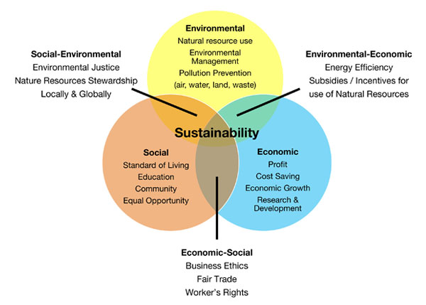
Figure 2-1 Triple Bottom Line © www.miratechnologypark.com
To reduce the natural resources depletion, many initiatives have been done. The practice includes the efforts of defines the concept, establish goal, creating indicator, and asserting values. To complete the practice, it is also includes developing social movement, organizing organization, crafting sustainability of science and technology (Kates et al., 2005).
Science and technology sustainability which are seek to enhance the contribution of knowledge to environmentally sustainable human development around the world (Kates et al., 2005). In order to preserve the environment, many initiatives have been taken especially in using technology as the medium. In the next topic, there will be further discussion on the threat and solution to the sustainable problem.

2.1.1 Sustainable Campus
Since the Earth Summit session on 1992 and 2002, sustainability have become the critical topics of discussion (Abdul Ghani Abdullah, 2007). Because they are the centre of knowledge, the awareness is increasing by the universities around the worlds (Beringer, A., Wright, T. & Malone, 2008). Accordingly, many university have begun to promote strategies for creating sustainable campuses through education and design projects (Davis, G. & Wolski, M., 2009).
“The …. Campus is a world in itself, a temporary paradise, a pleasant stage in life,” Le Corbusier, 1936
Quotes above give the encouragement to the creation of a comfort and pleasant campus or in other words called sustainable campus. University which consist of intelligent student can be a centre where innovative and ideas are generated and it is the most suitable places to cultivate the ideas of sustainability(Zulhanif & Razak, 2011).
It is easy to create public awareness on how to integrate sustainability in everyday life (Jain, S., & Pant, 2010) . Hence, many universities respond to the sustainable development project by implementing ‘Green Campus’ (Isiaka, 2008).
One of the initiatives on sustainable campus is developing building within the existing campus area (Zulhanif & Razak, 2011). The idea is to making a compact area, are to reduce the land usage. Another advantage are stated below (Burton, 2000) :
- Reduced vehicle dependencies as the walking distance from one building to another is close and it can encourage students to walk and cycles between the campuses.
- Reduces usage of emission of pollution as the students are encouraged to walk and cycle instead of drive a car.

2.2 What is Green IT
In this millennium era, every organization in every sector are using the PCs as the main infrastructure to operate and do works such as banking, manufacturer, oil and gas sector. Computers systems have being a part of workplace and it is used widely within the communities. IT community have to make sure that the progress is focusing on servicing the IT consumers in efficient and suitable manner as the technology continues to advance rapidly (Global Action Plan, 2009).
Currently Malaysia and many of the country environments undergoes changes and had given negative impact to the phenomenon call Greenhouse Effect. Global warming is one of the greenhouse Effect as shown in figure 2-2 . The gas emission such as CO2 induced a high consequence in global warming. This gas increases the temperature in atmosphere gradually every year, which impact our earth's climate patterns and gives adverse consequence to people, oceans and ecosystems.
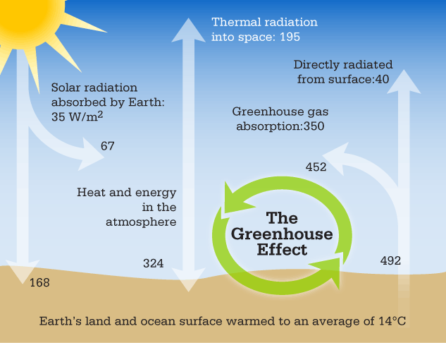
Figure 2-2 the Greenhouse Effect
According to (Hidayah, Mohd, Binti, & Rahman, n.d.) The advancement of IT usage, such as create changes in business flow, which mean from traditional business into e-business. Enterprises, governments and societies ought IT to improve their standard of living and help their work become easier.
However, most people do not realize that IT is one of the reasons that give the negative impacts to our environment. The unplanned of IT manufacturing, the uncontrolled of IT electricity consumption and the unsupervised of IT disposal will disturb our environmental sustainability. In contrast, even though IT gives problems for our earth, but it also can be as a problem solver to help our earth from hazard.
The combination terms between ITs and the environment to produce a new solution in assisting our world to decrease the environmental problems. The new role of IT now focused on how the usage of ITs can be sustainable and enable a business sustainability strategy.
According to (Global Action Plan, 2009), global carbon emission release by manufacture and the use of information and communication (ICT) are about 2%, but yet the 2 % are growing larger every year. The contributors of 98% are crying for solution. Even if the ICT are also the contributor of global carbon emission, it’s also is part of the solution in which improvement to energy efficiency, resources consumption and business travel. This statement had supported what had been saying by (Hidayah et al,2010). That even if IT is helping on provides solution to reduce the effect of Greenhouse Effect; it’s also part of the contributor to the greenhouse effect.
According to (Sendall, Andover, Shannon, Peslak, & Saulnier, 2010), “Green IT is the study and practice on efficiency in using computing resources. Typically, technological system or computing products that incorporate green computing principle take into account the so - called triple bottom line of economic viability, social responsibility, and environmental impacts.
This approach differs somewhat from standard business practices that focus mainly on the economic viability or economics benefits rendered by a computing solution. From the statement we know that Green IT providing solution on reducing greenhouse effect and manage the ICT resources wisely.

2.2.1 Green IT practice in organization.
As mention on (Modular, 2012) on his paper titled “ top ten green IT project on 2012” he have mention several step taken in the organization and the success of the practice taken. The several steps are listed below:
- Reducing the expenses by using the appropriated size printer. If a normal printer can accommodate the whole user in the particular department, it will be wastage if the organization invests into big printer.
- Using the newer version of desktop (thin desktop) as the old desktop version are using more power and emitted too much to the pollution environment.
- Invest in power – saving automation Technologies, it might be costly but the effect is long term and it does save the energy wastage.
- Reduce Printing costs and your impact on the environment by using line matrix printers where possible.
- Reduce cost and environmental impact of day to day office printing by implementing strategic solutions that increase awareness.
- Telecommunicating: enables employees to work from home and hold the meeting visually.
From all the approach, the resources can be well managed by reducing the wastage and also telecommunicating is very famous right now for making less emission either by
The full scopes of Green IT are far broader than virtualizing server, using power management future and decommissioned computing equipment. Because of the expensive reach throughout the academics, research and administrative arm of the institution, technology have offer chances to conserve the resources and reducing energy consumption in more comprehensive ways.
To harness green its full benefit, an IT organization has to look beyond the individual project or action. The key is to view green IT holistically, integrating environmentally friendly technology practices into projects of all kinds throughout the institution so that the green initiatives and the technology come together seamlessly” (Albrecht & Pirani, 2010 , pg.4)

2.2.2 Green IT practice in University
The University of Copenhagen (Schroth, 2011) have taken the challenges on being one of the greenest campus in Europe in 2008 and set the targets for energy and co2 reduction until 2013 and they have met the target. The main challenges are from the high energy consumption and co2 emission resulting from:
- The energy needed to run the building
- Clean air with less energy – the switch to an energy efficient ventilator system saves 19% of the power for process ventilation in laboratories in Frederiksberg
- Lighting adjusted to actual need saves 70 – 90 % of the electricity consumption in the halls and offices in the Panum Insititute.

- The energy needed for laboratory equipment
- The faculties with many laboratories consume the most energy. Therefore it is in these faculties that the biggest energy saving can be made.

- Rising CO2 emission form the numerous flights needed for international knowledge sharing.
According to (Ahmed, 2013) campus sustainability are being the global issue and make the university realize the importance and effect of activities and operation towards the environment. As a part of campus sustainability programs, one can focus on improving energy efficiency, conserving resources and enhancing environmental quality by using information technology (IT) tools and resources.
These efforts can certainly make a significant contribution towards healthy and sustainable environment learning environment.
A number of IT solutions (such as Oracle Content Management 2009 and MS SharePoint 2010) could facilitate organizations to devise mechanisms for creating, routing, approving, and publishing of documents which ultimately could replace paper-based documentation. The proposed green campus initiative is clearly a step in the same direction as it aims to replace or convert paper-based course files and related processes to the electronic versions.

2.3 Data Centre

2.3.1 What is Data Centre
Data centre is a centralize repository which are either physical or virtual for the storage management and dissemination of data(Margaret Rouse,2014) Electrical power and economies of scale determine total data center size: 50,000 – 200,000 servers today (Greenberg & Maltz, 2013).
Data centre is the backbone of the modern economy because every organization have their own server room to store all the data. The statement are agree by (Nrdc, Anthesis, Anthesis, & Nrdc, 2014) and stated that server is what support American corporation, either from small, medium to the enterprise data.
Data centre operation is 24/7 and it will be not stopping unless the server is down and it does consume a lots of electricity to sustain its operation and it is have been said by (Robertson & Romm, 2002) data centre required a large quantities of premium electric power that meet the most stringent quality and availability level.

2.3.2 Initiative to reduce data centre effect towards environment
Many initiatives have been taken to reducing the electricity and initiative to make it environmentally friendly, such as use low energy server, use miniaturization and increase equipment density.
This initiative is to reduce power density (Robertson & Romm, 2002). Also initiative in green it as taking holistic approach by taking green public procurement, efficiency in IT operations and ICT enables environmental efficiency (Honée & Hedin, 2012).

2.4 Carbon Footprint
As mention by Managing Director Advisory Services, Carbon Trust Hugh Jones in the article title New Initiative Announce to help ICT industry measure carbon footprint (World Resources Institute (WRI), 2011), the help of ICT companies worldwide in measures the carbon impact of their products and service as much needed .
This has shown the significant of measuring the carbon impact of the IT products including the PCs.
A carbon footprint is historically defined as "the total sets of greenhouse gas emissions caused by an organization, event, product or person" (Wikipedia, 2013) .
Carbon footprint also can be define as “the measurement of the exclusive total amount of carbon dioxide (CO₂) emission that is directly and indirectly caused by an activity or is accumulated over the life stages of a products,”(Tenhunen, 2011)
Greenhouse gases (GHGs) can be emitted through transport, land clearance, and the production and consumption of food, fuels, manufactured goods, materials, wood, roads, buildings, and services. For simplicity of reporting, it is often expressed in terms of the amount of carbon dioxide, or its equivalent of other GHGs, emitted.
Greenhouse Gases (GHGs) can be emitted by several ways, such as transportation, land clearance, food production and consumptions, fuels and many more. To simplify the reporting, Carbon dioxide equivalent (CO_{2e}) are used to express the amount carbon dioxide of others GHGs emitted. CO_{2e} are a metric used to compare the emission from various greenhouse gases upon global warming potential (Tenhunen, 2011)

2.3.1 Reducing carbon footprint
According to (Shahinaz, 2015) , below are several activities or practice that can be done in order to reduce the carbon footprint at home.
- Buy the Energy Star appliances as Energy Star products are energy saving products. Hence, it can reduce the power consumption.
- Uses the suitable lamp for the house lighting, some bulb are using energy to much that it also emitted heat to the house. Compact fluorescent light bulbs have that cool curly shape and save more than 2/3rds of the energy incandescent.
- Reducing water and electricity when it is not been use. Turn the faucet of while shaving and brushing teeth may save thousand gallons of water annually. Switch off the lamp or television when it is not been used too.
.

2.3.2 Existing carbon footprint calculator
As the use of IT devices are continued to increase and contribute large proportion of CO₂ emissions; IT provides figuring out on how to reduce the emission through cloud computing and other approaches. But the most important requirement is to monitor the system.
There are several approaches to measure the carbon footprint; it is either using hardware or software. For the software, AMEE is the example of the carbon footprint calculator. AMEE or Avoiding Mass Extinction Engine is the platform which providing the framework to track the carbon emission and implementing a several of calculation methodologies. AMEE is a web based system that allows user to store and retrieves many form of consumption data over long periods while applying recognized carbon calculator models to determine environment consequence of the consumptions.
Figure 2-2 and 2-3 are the screenshot of the codes to install AMEE into PCs, and AMEE is using Ruby programming language.
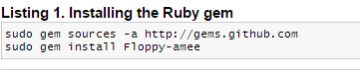Figure 2-3 Installing Ruby Gem.
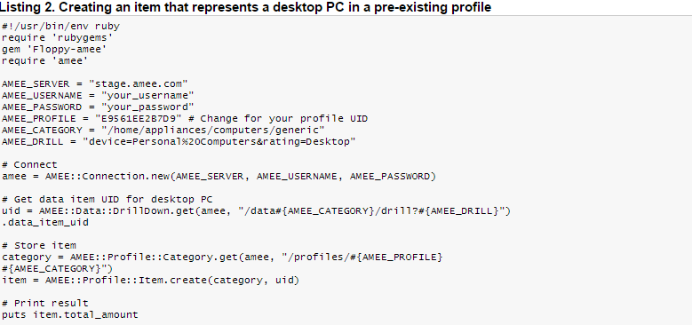Figure 2-4 Code to install AMEE in the desktop
Sources: http://www.ibm.com/developerworks/library/os-green-ict/
And for the hardware devices to measure carbon footprint, there are several type and size. The pictures of the device are shown in table 2-1.
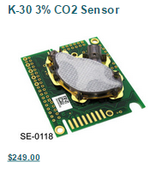 | 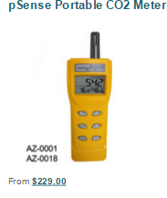 | 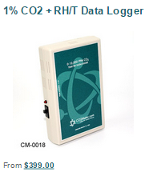
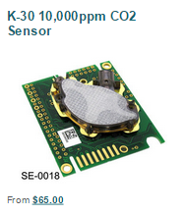 | 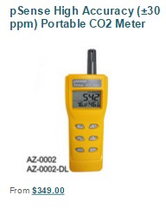 | 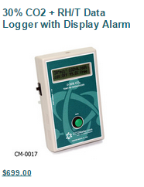
Table 2-1 List of devices
Sources:http://mobile.dudamobile.com/site/co2meter?url=http%3A%2F%2Fwww.co2meter.com%2F#2850

2.4 Asset management system
ISO 55000 defines asset management as the “coordinated activity of an organizational to realize value from assets”(TheIAM, 2015). Asset management which consist of selection, maintenance, inspection and renewal is management of physical assets which play important roles in deciding operational performance and profitability of industries (Jakubicka, 2011).
On the other hand, IT asset management are consist of the asset details, contracts, budget and costing to support the life cycle management and decision making for IT environment. Assets include all elements of software and hardware that are found in the business environment (Intelli, 2015).
Asset management also involving knowing the configuration of assets such as desktop with a dual core processor ;and also the status of the asset whether it is currently in storage, in use , or scheduled to be redeploy (L. Burchan, 2009).In conclusion, the asset management system and HPC Carbon footprint system are similar however IT asset management are more focus on IT assets only such as the PCs, projectors, LCD, programming software and many more.
IT inventory management helps the organization on managing the assets and system effectively without lots of time consuming by avoiding unnecessary purchased of asset and promoting harvesting of the existing resources. by having an effective IT asset management, a company can minimize the incremental risk and other cost of advancing the IT portfolio infrastructures based on old, incomplete and inaccurate information. Talton- McCray, 2014).

2.4.1 The existing asset management system
There are many existing HPC Carbon footprint system in the market. Figures below are the example of the existing asset management system for property custodian on the Accessing the Asset Management (AMS) by Custodians & Guide, (2014).
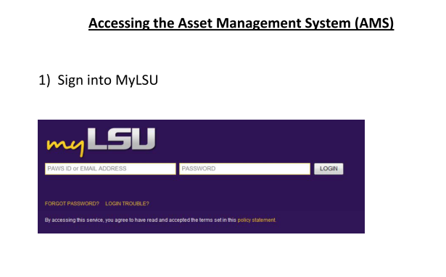Figure 2-5 frontpage of AMS
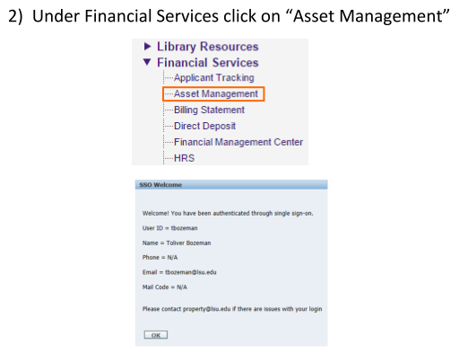
Figure 2-6 Listing in AMS
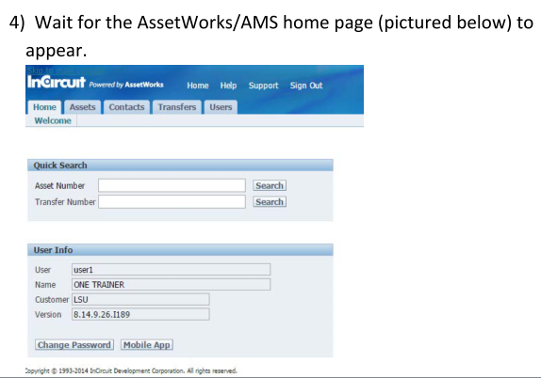
Figure 2-7 Quick Search AMS

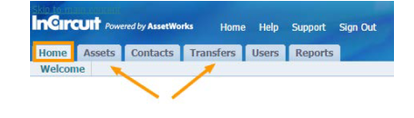
Figure 2-8 Tabs in AMS
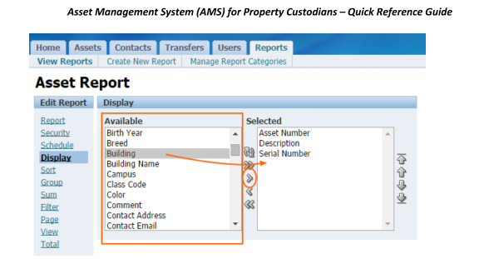
Figure 2-9 Display of AMS

METHODOLOGY
Using the right method is very important in the development phase. It will ensure the project to be completed within the time allocated. Different methodologies will cater different needs of the problem and solutions. Therefore, this chapter will be focusing on the methodology used to develop the HPC Carbon Footprint System. It will emphasize certain topics that are:
- Methodology
- Product Development Phases
- Gant chart
- Development tools

3.1 Methodology
In software development, there are many ways or methodology available to use to assist the process. Methodologies mean way to how the process of the system will be made. There are several software development life cycle (SDLC) design which suitable to be implemented in development of this system. The methodologies available are:

Waterfall model
Waterfall model is also refereed as linear sequential life cycle model. The process progress flowing downward through the several phases starting with planning and continue with analysis, design and testing. After testing is done, the system will be installed to the end user PCs and maintain the system.
Waterfall model does not allow interruption in the phases, which mean if any requirement added or something need to be change its must be started all over again to the planning stages.
Hence, Waterfall model are basically used for small projects with no uncertainty requirement. At the end of each phase, there will be review to determine if the project is in the right path and led to decision making either to continue or discard the projects.
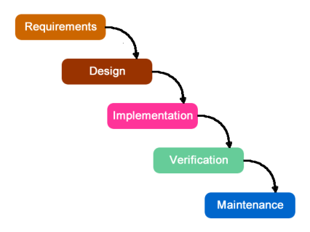

Figure 3-1 Waterfall Methodology © https://jackgraves.wordpress.com

Advantage | Disadvantage
Easy to understand the flow and works according the phased. | Difficulty in measuring the progress in each phase.
Easy to arrange task according to the specializations as each phased has specific deliverables and review process. | High risk for project who have uncertain requirement
suitable for small project with no uncertain requirement | Not a good model for complex and object oriented projects.
Process and results are well documented | Time consuming.
Table 3-1 Advantage and Disadvantage of waterfall method
Agile Software Development
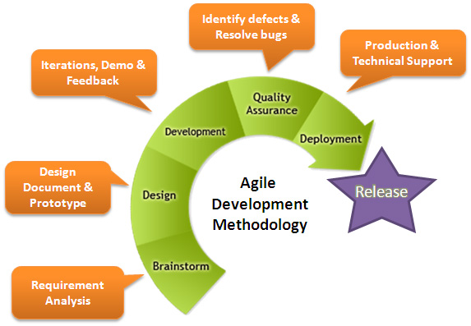
Agile software development is a one of alternative of waterfall model who allowed the interruption between the phases. Solution are evolves through collaboration of self-organizing and cross functional teams. Promotes adaptive planning, evolutionary development, early delivery, continuous improvement, and encourages rapid and flexible respond to change.

Figure 3-2 Agile methodology © www.heliosco.com
Advantage | Disadvantage
The deliverable can finish faster. | Not suitable for handling complex dependencies.
Suitable for system who have simple and complex requirement | Depend heavily on customer interaction, so if customer is not clear, team can be driven in the wrong direction.
Easy to prepare the documentation. | There are high individual dependencies, since there is minimum documentation generated.
Enable concurrent development and delivery within an overall planned context. | Transfer of technology to new team members maybe quite challenging due to lack of documentation.
Table 3-2 Advantage and Disadvantage of Agile Method
Rapid Application Development (RAD)
Advantage | Disadvantage
Changing requirement can be accommodated and progress can be measured | Depend on the team which have strong technical to identify business requirement,
Productivity with fewer people in short time | Required highly skills developers/ designers
Reduces development time | High dependencies on modelling skills.
Iteration time can be short with used of powerful RAD tools | required user involvement throughout the life cycle
Quick initial reviews occurs | Suitable only for project requiring shorted development times.
RAD (rapid application development) is a model based on the concept that higher-quality products can be developed faster through more expedient processes, such as early prototyping, reusing software components and less formality in team Communications. It is one of alternative to the conventional waterfall model which introduce by James Martin on 1991 (Wikipedia, 2015).
Table 3-3Advantages and disadvantage of RAD

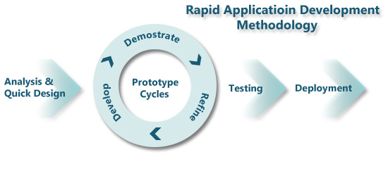
Generally, RAD emphasizing most on development and less on planning task. Besides, it is emphasizing on flexible process that can adapt as the project evolves rather than rigorously defining specification and plans correctly from the start.
Figure 3-3 Rapid Application Development © www.ramsoft.com.au

3.2 Chosen Project Methodology
Time allocation to make research and develop the system is only 7 months. Hence, RAD methodology is chosen to be use in developing HPC Carbon footprint system. RAD focusing more on prototyping instead of planning task; which contrasting with Waterfall model, which emphasizing more on specification and planning.
RAD emphasized on adjusting the requirement in responds of knowledge gain as the projects progresses. This has causes RAD to used prototype in addition to or even sometimes in place of design specification. RAD are well suited on developing software that is driven by user interface requirement.

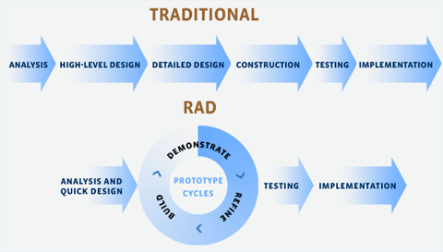
Figure 3-4 Differences between traditional and RAD © www.old.novulo.com
As mention above, RAD is alternative to the traditional model which can be assumed as waterfall model. The figures above give the idea of the differences between the models. For waterfall models, the phases must be completed before begin the next phases from the planning to the implementation.
However in RAD, it will start with planning, prototype cycle which consist of three phases which refine, build and demonstrate; then to the testing and implementation. The prototype cycle is where the planning and user involvement occur to change the requirement or need of user to the system.
RAD also provides greater user satisfaction by involving active participation of the system’s developers and end user in all stages of analysis and development of the application which make this ideal for this project.
The details phases occur in developing HPC Carbon footprint system are shown below:
Phase 1: Analysis and Quick Design
In order to develop HPC Carbon footprint system which are also been integrated with carbon footprint calculator, author required having depth knowledge in two area; which are IT Asset Management which included Electronic waste ( E- waste) and also Carbon Footprint.
Initially, author has to find and read the previous research paper on IT assets management and carbon footprint. Before that, author should have basic knowledge on sustainable development, sustainable campus and also green IT. These three things are the major topic before it’s been narrowed to the IT asset management and also carbon footprint.
In order to collect the qualitative data for the research, authors have decided to interview several targeted respondent. The targeted person are choose base on the position and the knowledge within the scopes. Sets of interview question have been prepared to ensure the process of obtaining the data is smooth. The interview is set to semi – structure interview because it allows the questioning process to be led by the responses of the participant. The interviews are recorded to ensure all the data given are collected.
First Respondent
Interviewee | Purpose | Question
Mr Suhaidi bin Mustafa  Senior Manager HSE UTP | - To know rough idea on how HSE department is working in sustainable campus.  - to get information on what UTP applied in order to protect the environment  - to get to know the current practices in measuring and the gaps happen in HSE and UTP practices | What is the current practice on monitoring, measuring, and reporting on the green indicator for UTP campus?
 |  | Which department responsible on measuring the green indicator?
 |  | How does measurement been taken currently?
 |  | How often the measurement are been taken?
 |  | What is the issue of the current practices of monitoring, measuring and reporting?
Table 3-4 Interview with HSE

Second Respondent.
Interviewee | Purpose | Question
Ms. Maniza binti Mansor  IT Executive ITMS UTP | - To know the management of disposal PCs.  - To know the current practices  - To set the requirement of the system. to get the data of current practices | What is the current practice of asset management and electronic waste?
 |  | What system do ITMS used to monitor the asset?
 |  | Are there any gaps in current system?
 |  | What is the suggested solution?
 |  | What is the preferred platform to be used in the system?
 |  | What is the requirement for the system?
 |  | Who the person in charge of asset management?
Table 3-5 Interview with ITMS

Third Respondent.
Interviewee | Purpose | Question
Mr. Megat Hariri bin Megat A. Hamid  Senior Supervisor Finance & Asset Management UTP | - To know the flow of asset management system.  - To get information the limitation of system | What is the procedure on requesting PCs changes?
 |  | Who have the right to access the system?
 |  | How the report is generated?
Table 3-6 Interview with Finance

Forth Respondent

Interviewee | Purpose | Question
Ahmad Haruna  UTP PHD student on reducing electricity consumption | To know the process of measuring the electricity consumption | How HPC measure the electricity consumption
 |  | How they get the device, device is portable or not
 |  | Where the data is save and what is the perimeter
Table 3-7 Interview with HPC
Phase 2: Prototyping cycle
In prototyping cycle, there are consisting of three phases which are refining, build and demonstrate. Firstly, they will come out with requirement of the system and continue with designing phase whereby it involves creating the diagram such as use case diagram and context diagram. These diagrams will help in giving basic insights about the proposed deliverables and prototype. These diagrams will be explained further in Chapter 4.
After the design is finish, the system will be developed, and will be demonstrate to the user. The user cooperation in giving the right requirement and involvement in the designing phase might minimize the probability of the requirement changes after the system is being deployed.
Phase 3: Testing
In this phase, author have to make functionality testing, usability testing and lastly user acceptance test (UAT) to the end used to make sure the system are working well and if there any changes are required to be made.
Phase 4: Implementation.
The system will be deployed to the server if the system passes the user acceptance test and no changes required. This system is simple and maybe simple guideline will be attached especially on the carbon calculator tabs.

3.3 Required Tools
Several tools and software are required in order to assist the completion of system development.
- Personal computers
Model | Dell Inspiron – N4050
Processor | Intel®Core™ i5 - 2450 CPU @ 2.50GHz
Random Access Memory (RAM) | 4.00 GB
System type | 64 –bit Operating System
Table 3-8 PCs Specification
- Development Tools
Design Development | Adobe Dreamweaver CS3
Banner design | Adobe Photoshop CS6
Database | My PHP admin
Database Link | XAMPP
Documentation | Microsoft Office 2010
Table 3-9 System Development tools

3.4 Key Milestone
Below are the milestones in developing HPC Carbon footprint system.
Activities | week
Selection of project's topic | 1
Proposal Submission and Approval | 3
Conduct Interview | 8 , 9, 11
Interim Report | 12
Proposal defence | 13
Table 3-10 FYP I mile stone

Activities | week
Progress Report | 6
Pre- SEDEX | 10
Technical Report | 11
Dissertation (soft bound) | 11
Viva | 13
Submission of project Dissertation | 14
Table 3-11 FYP II mile stone

3.5 Gant Chart
Below are activities and the estimated time in developing HPC Carbon footprint system in 7 months.
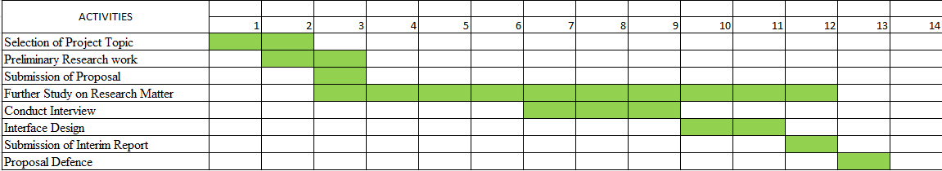
Figure 3-5 FYP I Gantt Chart
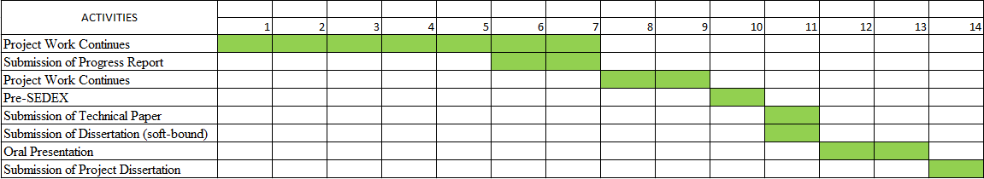
Figure 3-6 FYP II Gantt chart

RESULT AND DISCUSSION

4.1 Interview and Discussion

4.1.1 Health, Safety and Environment Department (HSE)
In the earlier phase of planning, author together with another student , Ms. Hidayah who working on similar topics, with their supervisor have discuss on who they need to meet to get the understanding on how Green IT work in UTP in the context of measuring, monitoring and reporting.
To set up a meeting, an email has been initiated by Dr. Subarna (author’s Co- Supervisor) to some related persons in Property Management and Maintenance Department (PMMD) and Health, Safety and Environment department (HSE) department. However, the only respond got are from Mr. Suhaidi, he willing to assist us to know more regarding the measuring, monitoring and reporting.
The time have been suggested to 5th February 2015, however due to time constraints the meeting have been postpone to another date as both students and Mr.Suhaidi have other commitment to attend. Finally, the meeting is been set on 12th February 2015 with Ms. Hidayah , Dr. Subarna and Dr. Emy (Ms. Hidayah Supervisor) at one of meeting room in Chancellor Complex.
Several questions have been prepared which assist by Ms. Savita to ask in the meeting. The results of the meeting are concluding in the table 4-1.
Question | Answer
What is the current practice on monitoring, measuring, and reporting on the green indicator for UTP campus? | Electricity consumption (PPMD) - IR Fatimie  - Kilo Watt /hour/building - reading by meter. Every building has its own meter to measure the consumption.  Water consumption (PPMD) - IR Fatimie  - Cooling system in UTP is using chill water which are generated from Gas District Cooling (GDC)  - the capacity of chill water , measure using tonnage (RT)  - Heat transfer from chill water to air Cond.  Waste generation. (HSE)  There are two type of waste that being reported to the management, which are:  - Solid wastes – do recycle in term of paper, used paper, box.  - Schedule waste - regulatory waste.  - Waste taken by District council is not included because it is uncontrolled.  E- Waste (ITMS)  - The PC is being sell back to the contractor  - Contractor will send to the centre to dissemble the PC.
Which department responsible on measuring the green indicator? | - Electricity consumption (PPMD)  - Water consumption (PPMD)  - Waste generation. (HSE)  - E- Waste (ITMS)
How does measurement been taken currently? | - Currently using Microsoft Excel to key in the data, monitor the consumption and generated graphs.  - HSE is responsible to prepare a report to the top management. Indeed every department related need to submit the report.  - For Electricity consumption, it has been measured using metre. As they have their own metre in every building.  - For E- waste, it been measured by units.
How often the measurement are been taken? | - Electricity : monthly  - Water consumption: monthly  - Waste generation: quarterly  - E- waste : by project
What is the issue of the current practices of monitoring, measuring and reporting? | - Currently, the reading is manually recorded. Person in charge reading the metre didn’t have exact date to take the reading. It is depend on their availability and contribute to 10 % of human error.  - There are no centralized system  - Reporting individually by each department related.  - No data intervention.  - Data intervention is when it have indicator for example, the reading is high or low. If the readings of electricity consumption are above certain level, they might have suggesting reducing the electricity usage. E.g. campaign to reduce the electricity usage.
Table 4-1 Result meeting with Mr. Suhaidi
In conclusion, meeting with Mr. Suhaidi has given a lots of input on how the works have been done, and knows the initiative that have been taken in order to make UTP as a Green Campus.
He mention that in order to achieve the Green IT campus, the management have decided to change the current building to the green building; however the cost is too high that UTP cannot afford to bear. He also mention that he is willingly to help the students as he himself want to change the current practice into a better practice that can help with the efficiency and effectiveness.
From the meeting, he gives the contact number for respective department person in charge so that authors can directly go and ask for more information.

4.1.2 IT & Media Services Department (ITMS)
As for ITMS, the email has been initiated by Ms.Savita to let Ms. Maniza know what is the purposed of the projects. Meeting with Ms. Maniza have been held twice as she is the part of end user of this project on 2nd march 2015 and also 18th march 2015. In the first meeting, author has come with Ms. Hidayah to gain the information on how IT and Media Services (ITMS) manage the asset management specially in handling Electronic waste (E- Waste) such as PCs.
However, author has been told that currently ITMS already have system given by PETRONAS to handle the asset and changes are impossible to make.
Author has to discuss with her supervisor regarding the matter and her supervisor had meeting with Ms. Maniza personally to discuss on what can be done and also the enhancement of the system towards the environment. So, it have been decided to make a system on tracking the asset management purposely for PCs and been integrated with the carbon footprint calculator.
The 2nd meeting are been held to get further information regarding the processes, the data that want to be included in the system, the users that can access the system, and regarding carbon footprint in IT asset.
Phase | Question | Answer
Phase 1 | What is the current practice of asset management and electronic waste? | - ITMS currently used SAP system given by PETRONAS to handle the asset management. Previously, ITMS have their own system to record all the detail.  - However, it have been found out that system already been scrapped in the server on the 2nd meeting
 | What system do ITMS used to monitor the asset?
 | Are there any gaps in current system? | - No notification message to notify which PCs need to be upgraded or changed.
 | What is the suggested solution? | - Make enhancement to the current SAP system with the addition of notification message.
Phase 2 | What is the preferred platform to be used in the system? | - Used Visual Basic. Net and MySQL
 | What is the requirement for the system? | - The requirement must have follow the chart that have been given to author in table 4-3
 | Who the person in charge of asset management? | - As the ITMS only hold the record, Ms. Maniza have suggested to meet finance officer named Mr. Megat Hariri to know more regarding the asset management.
Table 4-2 Result meeting with Ms. Maniza
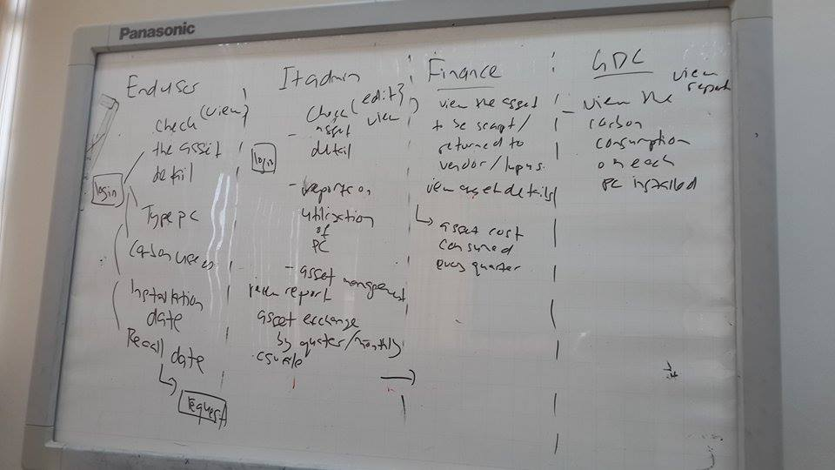Figure 4-1 User Requirement for the system
In conclusion, author found that the existing system has right limitation as it is provided by PETRONAS. The limitation of right make the system are hard to been upgraded and it might cost high as it is using SAP platform. Besides, there are no tracks of the secondary users. After the PCs have been lease or send to the manufacturer, ITMS have lost the track of these PCs. Hence, with the new system, they can entering secondary user detail and at least have information where the PCs go.

4.1.3 Finance Department
Author have initiated the meeting with Mr. Megat by sending email to tell regarding the purpose of the meeting and asking for the available time to meet. The meeting was held on 26th March 2015 at Chancellor Complex. The purpose is to know the flow of the asset management system. He is willingly to cooperate and assisting author.

Question | Answer
What is the procedure on requesting PCs changes? | - User have to fill the change requisition form with the details and submitted to the finance department( Mr. Megat)  - Mr. Megat will lodge the form into the SAP system and get the asset number which generated by the system.  - Write the asset no in the same form and proceed with the changing asset.
Who have the right to access the system? | - Mr. Megat only can access the change requisition to get the asset number , view the list of assets, report on asset changes.  - Finance HQ have the full access on the SAP system
How the report is generated? | - Select which asset and which year, they click the button generate report.  - The report can be in brief form and also in details form.
Table 4-3 Result meeting with Mr. Megat Hariri

Below are the screenshot of the current SAP system which been used in managing the assets.
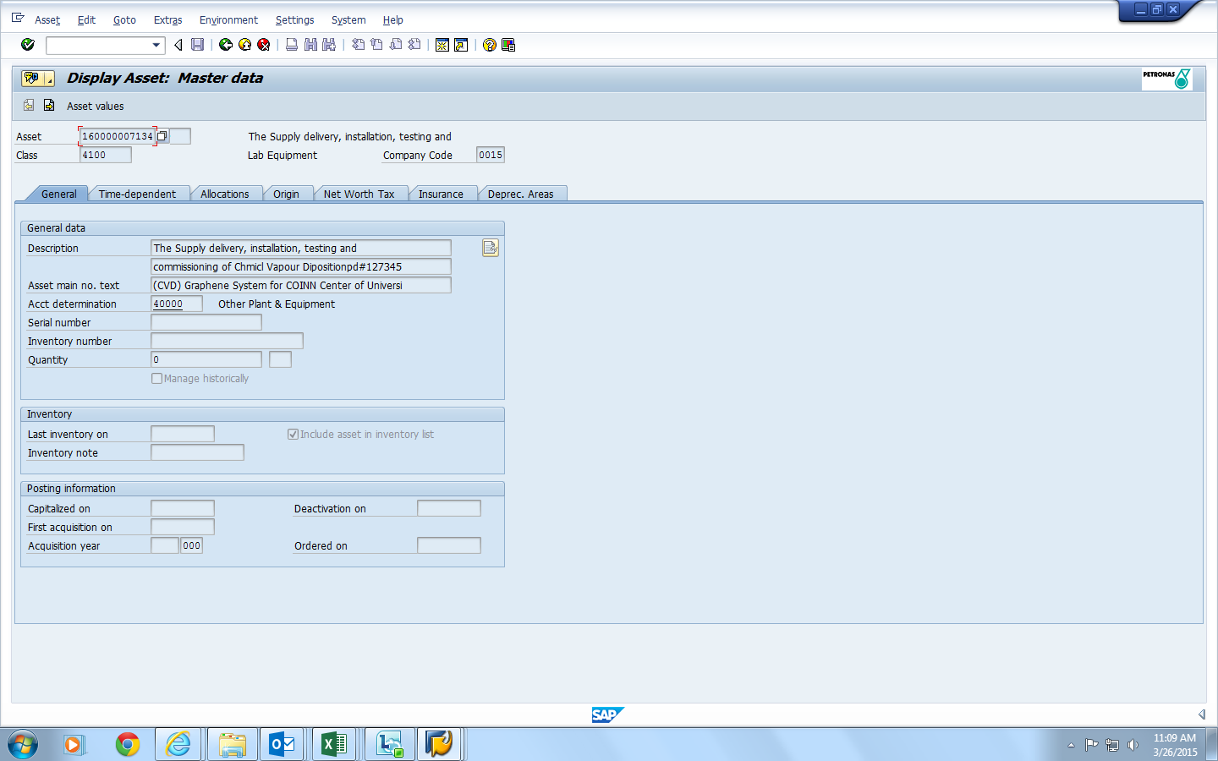
Figure 4-2 Display Asset - Master Data (General)
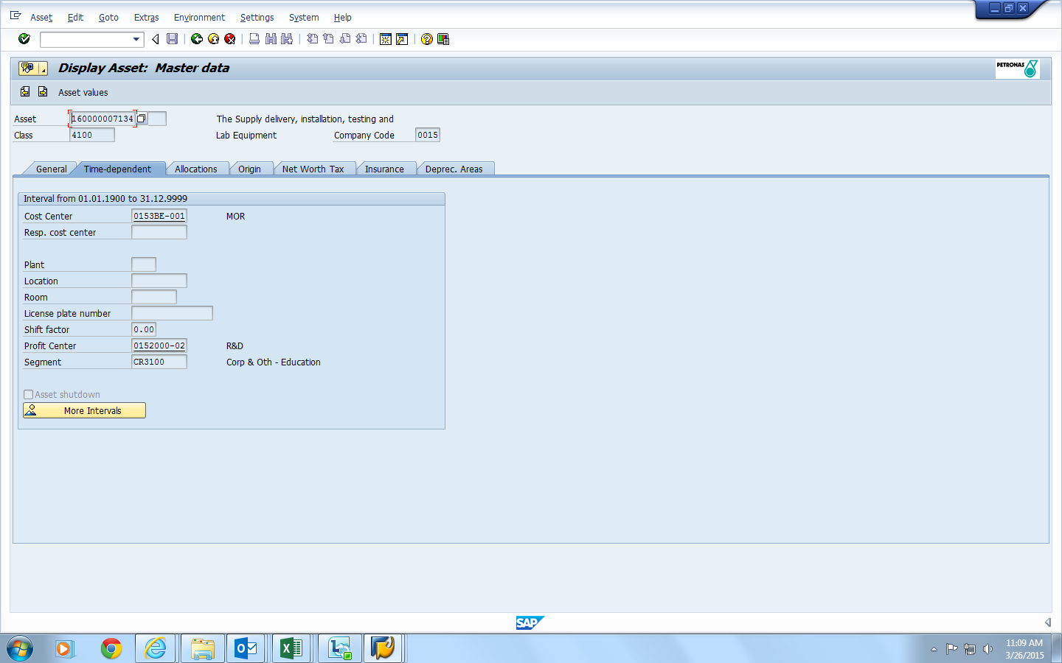Figure 4-3 Display Asset - Master Data (Time - Dependent)
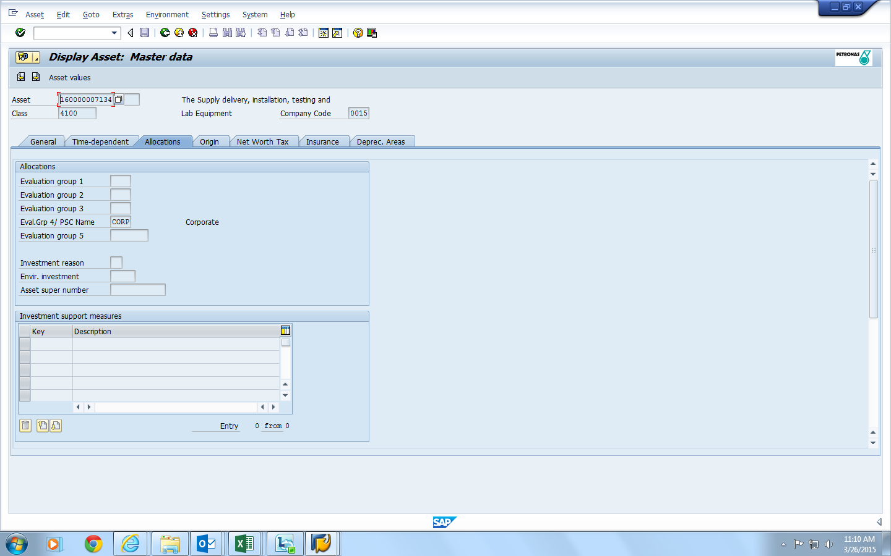
Figure 4-4 Display Asset - Master Data (Allocations)
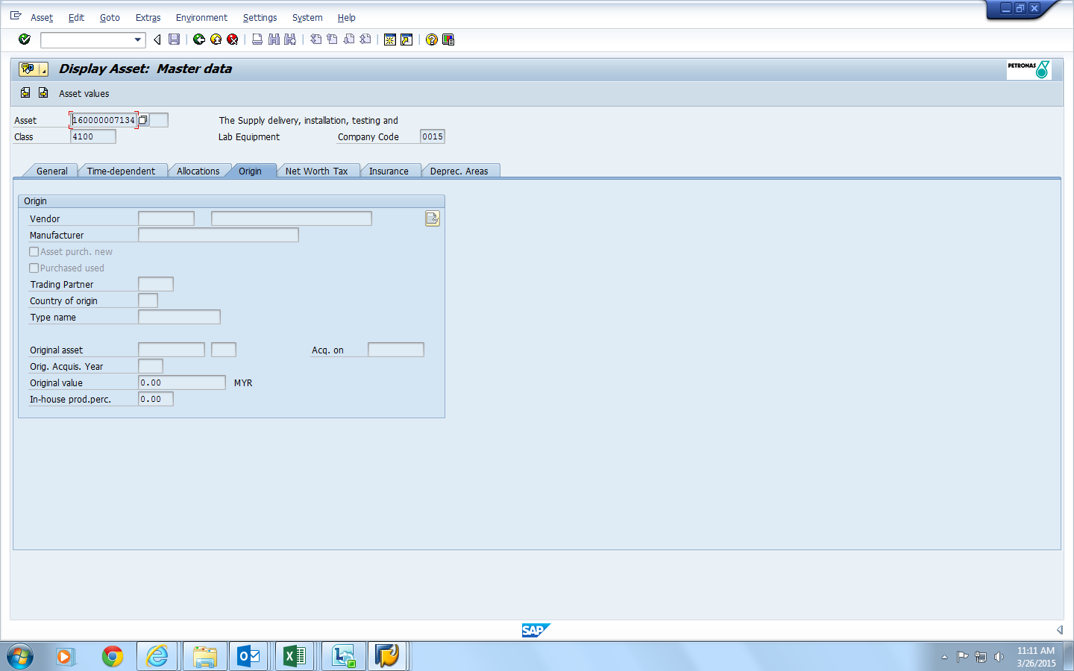Figure 4-5 Display Asset - Master Data (Origin)
Figure 4-2 until Figure 4-5 shows the view of the asset details. The details like asset number, company code and class have been type in order to get the detail of the asset. The details consist of general, time – dependent, allocation, origin, and net worth tax, Insurance and depreciation areas. These details must be to define which account does the assets belong to, cost and others.
In the interview session, instead of knowing the asset management process, author find out that currently, Mr. Megat Harini is no longer have full access to the SAP system as it has been take over by the finance department in Head Quarter (HQ). hence, author get the idea on how to make the system later and give the permission to the respective person to have the full access regarding the IT asset report and asset details.

4.1.4 High Performance Computing Services Centre ( HPC)
On the Research Proposal Defence day, author has given suggestion by the examiner, Mr. Low Tan Jung to meet his student Mr. Ahmad Haruna who is working on the reducing electricity consumption at High Performance Computing Service Centre. The student might help author in the process of making the system. Hence, a date is set to hold a mini tour to HPC with Mr. Ahmad Haruna. Author had come together with Ms. Savita on 28 April 2015. The table below is part of the mini tour question and answer session.

Question | Answer
How HPC measure the electricity consumption | Measuring electricity consumption using a device. We also were measuring the temperature and humidity for outside and inside the room.
How they get the device, device is portable or not | It is installed by vendor and the device is attached to power supply box.
Where the data is save and what is the perimeter | Measurement is taken hourly per day and it is kept in the system.
High Performance Computing (HPC) act as data centre which kept the entire database for UTP. In conjunction of sustainable campus make by UTP, many initiatives have been taken places. For example, HPC are measuring how much electricity does it consume to operate the server room monthly.
The project of reducing the electricity consumption is currently been done by Mr. Ahmad Haruna,a Phd student. He claimed that he is the one who have the access to the system as it is only allowed to access by researchers. When asking him, how many users did access the system, he said probably only two people.
The data is taken via a device that measuring electricity and it is attached on the power supply boxes for both Pcs and air conditioners as shown in figure 4-11. With the electricity consumption data, author suggested to make a calculator to convert the electricity consumption into carbon emitted. It is to let UTP knows how much HPC is currently contributing carbon emission to the environment.
Carbon emission is one of the factors that lead to Greenhouse effect and make the world hotter day by day. This system will focus on the server room inside HPC and the user will be Mr. Ahmad Haruna himself. The user can be added according to Mr. Haruna. The system is built to prevent the people from not getting any advantages just by measuring the electricity without concerning the environment.
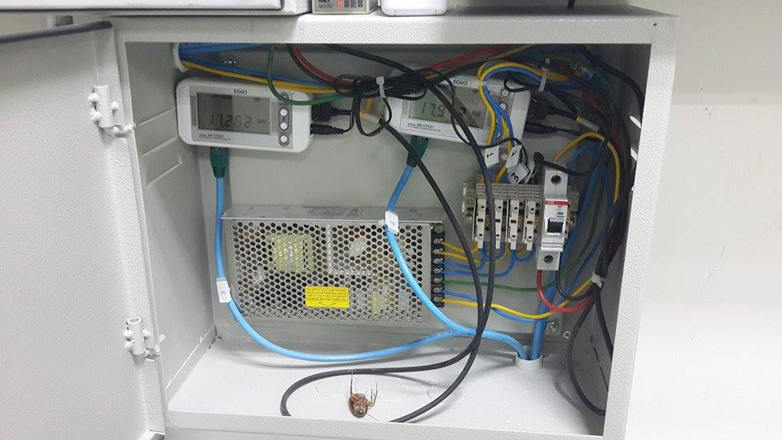
Figure 4-6 the devices to measure electricity consumption
On the next meeting, author is focusing on the IT asset in HPC for the HPC Carbon footprint system function as have been discussed with ITMS previously. However, after observation and some discussion author have found out that the server room assets are limited and it have been tagged according it specification by HPC itself.
Author need to change the function from the HPC Carbon footprint system into an asset listing which will show the information of the asset in server room. It is not convenient to do asset management system for HPC. The details of the asset is collected to be includes in the system. There are 54 PCs in the server room and part of it is shown in figure 4-12 and figure 4-13
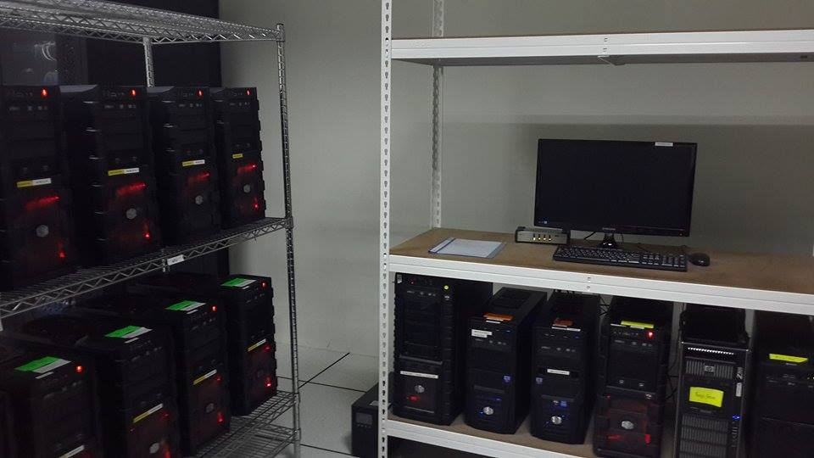
Figure 4-7 the PCs in the server room
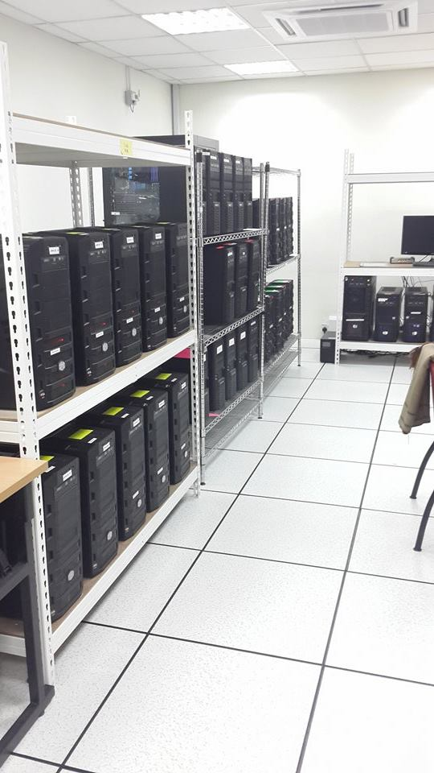
Figure 4-8 the PCs in the server room

4.2 HPC Carbon footprint system Site map
There are four types of user in this system which is the IT admin, User, Finance Executive, and Gas District Cooling (GDC) Officer. Each user has different access level. For instance, IT admin have the overall control of the system, User only can view PCs detail and make PCs change request, the Finance Officer can access the report of the PCs change between academician and GDC officer can access the report of carbon footprint utilisation.

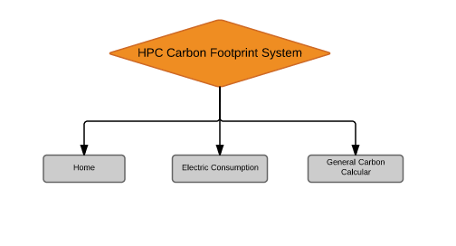Figure 4-9 Conceptual Web Site Design
The system will have 5 pages excluding homepage. The explanations of each of the pages are discussed below:
- HOME

this page is all about information about greenhouse effects and data centre on sustainability.

- Electric Consumption
This is the tab will give the permission to upload the electricity consumption and will automatically generated the graph report.

- Carbon Calculator
For this calculator, a website contain general calculation of carbon is integrated and it does generated reports.

4.2.1 Basic Architecture
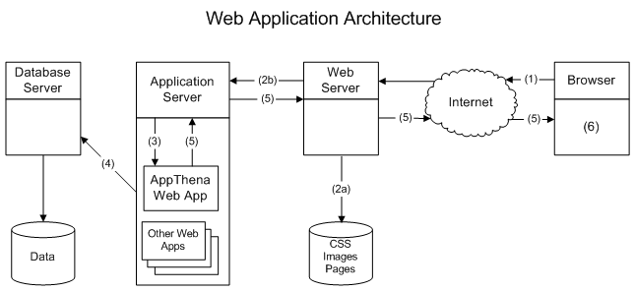
Figure 4-10 web application architecture
The system will be installed into the server and can be open using browser using internet. It is compulsory to use internet to access this system as it is a web based system and the general calculator need internet to open.

4.2.2 Use Case diagram.
A used case is constructed by identifying the main functions of the system describe during the requirement analysis. The system will have four actors which have different access level to the system.
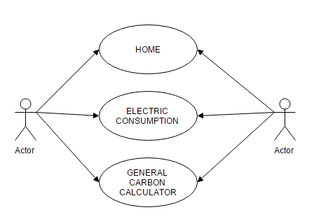
Figure 4-11 Use cased diagram of the system

4.2.3 Flowchart Diagram
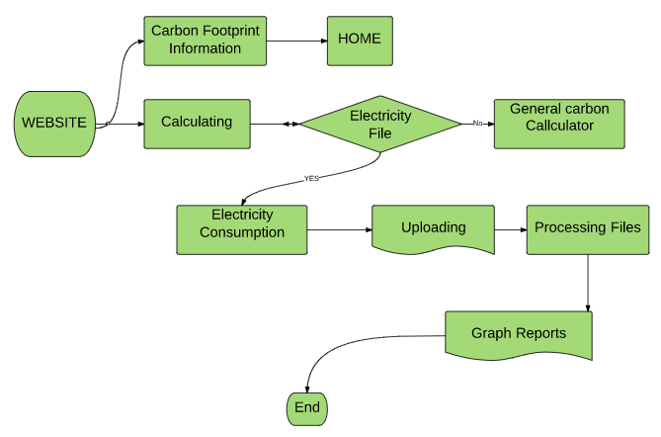
Figure 4-12 Flowchart Diagram

HPC Carbon footprint system
After all the design and requirement, authors have come out with figures 4-13 as the proposed graphic user interface (GUI) and also sketch for the system to be shown to the end user later.

4.3.1 Proposed sketches

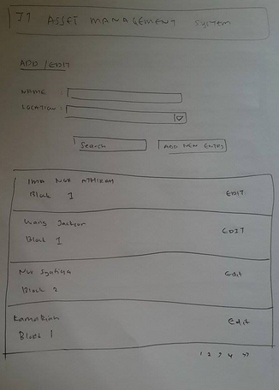
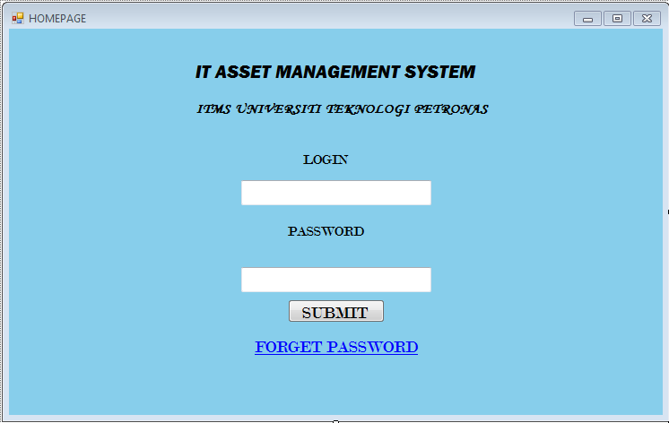Figure 4-13 Proposed homepage
Figure 4-14 ADD/ EDIT front page

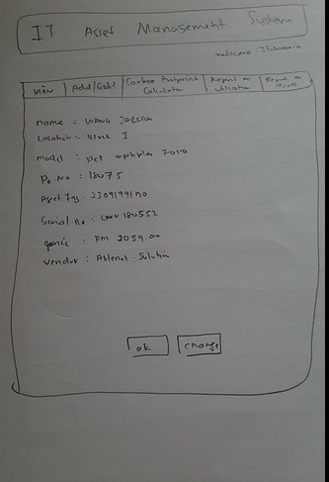Figure 4-15 Change interface
This pages allow IT admin to search for the name required to make the changes or click on new entry button to add the new entry of PCs. Figure 4- 14 front page show the list of academia in alphabetical order, so the search button will the searching faster. Figure 4 -15 shows the interface when the names are selected to be edited.
Figure 4 -16 shows the detail of the PCs such as model, installation date and recall date. If the recall date is closed, user can make a change request through the button change request.

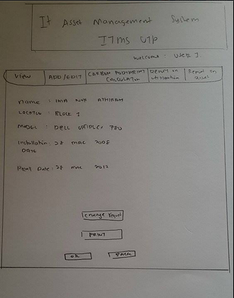Figure 4-16 View Pages from user view
Based the sketches that have been done throughout the analysis processes, the prototype have been designed to meet the requirement of the user.
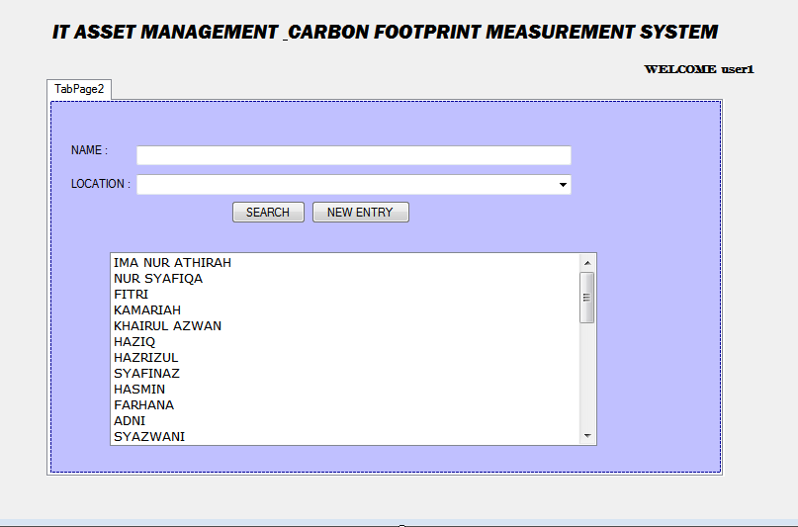

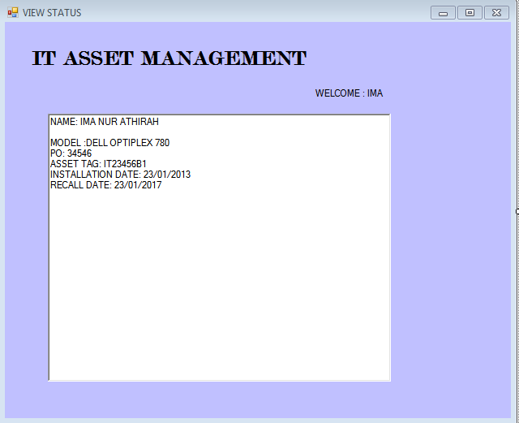

4.3.2 System Interface
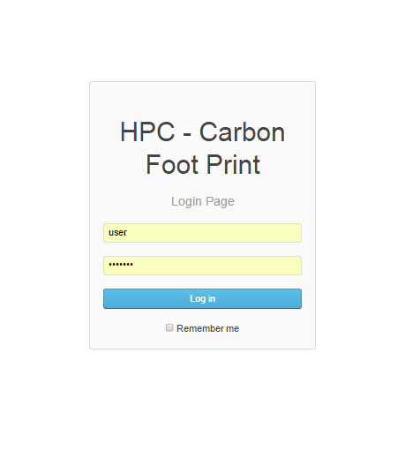
Figure 4-17 Login Page
Figure 4 -21 showing the HPC Carbon Footprint System login page. The user need to key in the username and password. Username and password will be set by the admin into the database and will be verified through emails. So nobody can easily change the user without verification of the admin. Remember me function is for cache so the browser remember the username and password for easy login.
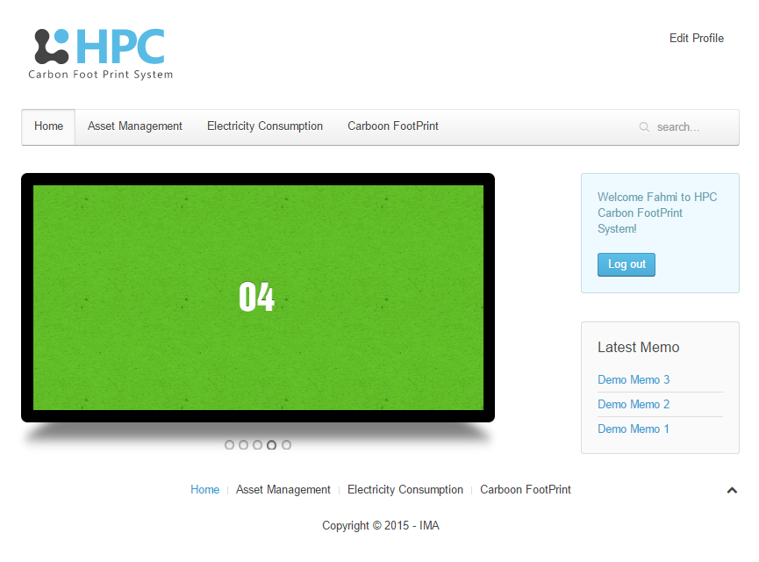
Figure 4-18 Home page
For the Home page, author has designed space for memo and also photos. Memo can be added by anyone, photos can just be uploaded by the admin. There is three others tab on the tab menu and will be added more later.
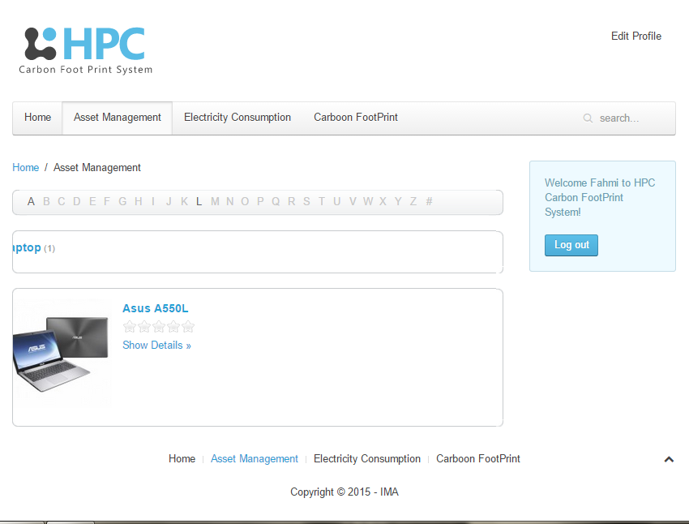
Figure 4-19 Asset Listing interface
This is the asset listing for HPC. It will includes all the PCs in the server room and its will be tagged accordingly and with its specification together with the IP address.
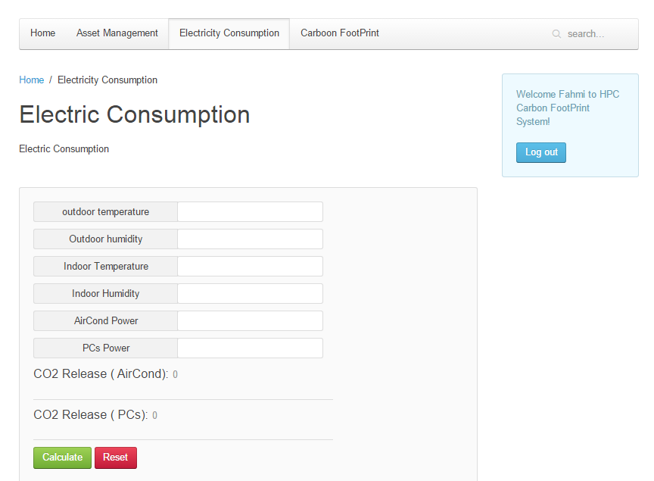
Figure 4-20 Electric Consumption
This is the function where the system calculates the electricity consumption into carbon emission using the formulae.
Carbon release (KG CO₂₎ = Electricity consumption (kWH) x 0.523
Formulae is from Calculating our carbon footprint (Leicestershire Council, 2015) .
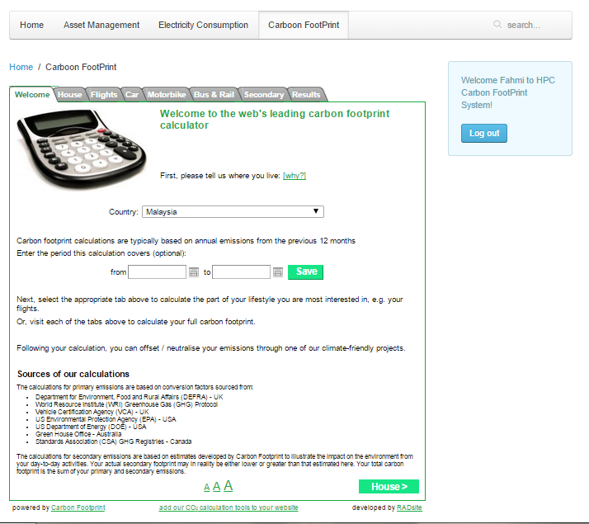
Figure 4-21 General Carbon calculator
Figure 4.25 is the screenshot of the integrated carbon footprint calculator. It is just as a reference and information. This calculator includes the transportation, house consume and food carbon emission.

4.4 System’s testing

4.4.1 Functional Testing
Functional testing is a quality check process and it is a type of black box testing that base on the specification of the software. Functional testing is to verify the program by checking it against document or specification (Kaner, Falk, Nguyen 1999, p. 52).
The system is test by the author herself to see any error or things she need to corrected and supervise by her supervisor. All the system functions are operating well. The system just needs a little change on the perimeter metrics and the selection tab.

4.4.2 Usability Testing
Usability testing is done to evaluate a product by testing it on users. This testing is good as the user get the real experience on using the system. It is also good for gathering the comments and recommendations. While the tester is testing the system, question answer can be done and it is important to jot down the feedback of the tester to improvise the system.
HPC Carbon Footprint System has been test by the end user which is Mr. Ahmad Haruna on 28th July 2015 at High Performance Computing Service Centre. The objective of having usability testing is to make sure he is satisfied with the system design.
“There are nothings new in the system however, the information part is good. You just have to maintain the current system and try to add another tab which will be used for HPC to calculate the carbon emission which the data is save in file. Then generate the graph and it can help people to make decision on how to minimize the carbon emission.”
His recommendations are creating a new tab for carbon footprint and make extraction from the data. The data extraction will be good for the file with rich data, so that they can just extract the carbon emission and day. After the extraction, it wills automatically generating the report in graph method. The people can see the pattern of the carbon emission on the working hours for certain week. It will help them to make the decision and take the effort to minimizing the carbon emission.

4.4.3 User Acceptance Test
User Acceptance test or UAT is the testing where it will be done before the system release to the user. The user feedback will be used to make final changes of the system (Margaret Rouse,2013).
The next testing will be done when the prototype is ready and before the final presentation.

4.5 Discussion
The requirement gathering and sketching have been done through the interview and observation toward the existing system. There are several difficulties encounter by the author that needs to be overcome in order to achieve the objective of the project.
Carbon footprint measurement
For the measuring carbon footprint, it yet to be decided to use the tool that will used to measure the carbon footprint. The device that offered in market cost very high and the author cannot afford to buy. Besides, if carbon footprint calculator is integrated, how do author measure the power consumptions of the PCs and does the measurement and calculator accurate. Hence, the meeting will be held with Gas District Cooling (GDC) department to help on this matter.
On the first half of author’s project development, author has difficulties on deciding which tools to use for measuring carbon footprint. The meeting with GDC also have been cancelled because author had gone to HPC first and get students to assist author in the project development. Besides, HPC really does have real data for electricity consumption.

Re-Scope the system.
As in the second half for system development, here is the real challenge where the sketches and ideas are hard to be realised. as the meeting keep going throughout the process, many ideas has come and the system have to be re-scope so that its meet the objective and problem statement according to the situation and conditions.
For example, after meeting with HPC and there is no connection between assets with ITMS, author need to revise it back and lastly come out with asset listing tab. Re-scoping the system is a limitation as the development process is disturb however it is on the process of making a better system.
The limitation and difficulties had been recovered as the final stage of designing. And author hope there is no more difficulties happen at the end of this process.

.

CONCLUSION AND RECOMMENDATION

5.1 Conclusion
Based on the prototype, author hope this system will raise people’s awareness of carbon emission and its effect towards the environment and the earth especially on the greenhouse effect. Author also hopes this system will help UTP on taking initiative to improve the data centre design into a greener data centre and reduce the electricity consumption so it won’t emit too much carbon to the air.
This system had undergone functional testing and usability testing and will have some changes on the functionality. The additional features will be included in order to increase its commercial value. Based on all these criteria considered, I hope that the project will achieve its main objective and help to reduce carbon emission in UTP.

5.2 Future recommendation
For the betterment of the system, several recommendations are need to give concern. These features will increase the system commercial value and make it more professional.
Firstly, integrated the folder from the HPC system which collecting data of electricity consumption into this system. So that it can easily be read by the system.
Secondly, to add data intervention value so that decision can be made according to the range evaluation and suggestion to reduce the carbon emission.
Last but not least to enhance the market value by posting the system online so that not only focusing on HPC but to all people and organization who want to extracting the their files of carbon emission.

REFERENCE
Abdul Ghani Abdullah, A. I. (2007). Kesediaan Memperkasa Pendidikan Pembangunan Lestari Oleh Pengurus Pendidikan Sekolah : Satu Kajian Case. Universiti Sains Malaysia.
Ahmed, A. M. A. N. (2013). An e-Course file management system : A green campus initiative, 3(1), 1–7.
Albrecht, B., & Pirani, J. A. (2010). Implementing a Holistic Green IT Strategy to Create Institutional Engagement.
Beringer, A., Wright, T. & Malone, L. . (2008). Sustainability In Higher Education In Atlantic Canada. Internation Journal Of Sustainability in Higher Education, 9(1), 48 – 67.
Burton, E. (2000). The Compact City: Just or Just Compact? A Preliminary analysis. Urban Studies, 37(11), 1969 – 2006.
Custodians, P., & Guide, Q. R. (n.d.). Accessing the Asset Management System (AMS) 1) Sign into MyLSU.
Dao, V., Langella, I., & Carbo, J. (2011). From green to sustainability: Information Technology and an integrated sustainability framework. Journal of Strategic Information Systems, 20(1), 63–79. doi:10.1016/j.jsis.2011.01.002
Davis, G. & Wolski, M. (2009). E-Waste And The Sustainable Organisation : Griffith University’s Approach To E-Waste. Internation Journal Of Sustainability in Higher Education.
Global Action Plan. (2009). Green ICT Handbook: a guide to Green ICT, 1–28.
Greenberg, A., & Maltz, D. a. (2013). What Goes Into a Data Center ?
Griggs, D., Stafford-Smith, M., Gaffney, O., Rockström, J., Ohman, M. C., Shyamsundar, P., … Noble, I. (2013). Policy: Sustainable development goals for people and planet. Nature, 495, 305–7. doi:10.1038/495305a
Harris, J. M., & Harris, J. M. (2000). Basic Principles of Sustainable Development. Life Support Systems, (June), 26.
Hidayah, S., Mohd, B., Binti, A., & Rahman, A. (n.d.). E ND USERS ’ ATTITUDE OF GREEN IT READINESS IN, 14–24.
Honée, C., & Hedin, D. (2012). Environmental Performance of Data Centres: A Case Study of the Swedish National Insurance Administration: EGG2012, Berlin. Electronics Goes Green 2012+, ECG 2012-Joint International Conference and Exhibition, Proceedings, 46(0). Retrieved from http://miun.diva-portal.org/smash/record.jsf?pid=diva2:558566
Isiaka, A. . H. C. S. (2008). Developing Sustainable Index for Universiti Campus.
Jain, S., & Pant, P. (2010). Environmental Management Systems For Educatioanal Institution. A Case Study of TERI university, New Delhi.
Jakubicka, M. M. (2011). Software Asset Management in a Large ( Academic) Organization. MASARYKOVA UNIVERZITA.
Kates, R. W., Parris, T. M., & Leiserowitz, A. A. (2005). WHAT IS SUSTAINABLE, 47(3), 8–21.
L. Burchan, W. (2009). Asset Management and Sustainability at the University of Richmond. Retrieved March 17, 2015, from http://www.educause.edu/ero/article/asset-management-and-sustainability-university-richmond
Leicestershire Council. (2015). Calculating our Carbon Footprint, 2.
Modular, S. (2012). Top Ten Green IT Projects for 2012, 1–7.
Nrdc, P. D., Anthesis, J. W., Anthesis, J. W., & Nrdc, P. D. (2014). Data Center Efficiency Assessment Scaling Up Energy Efficiency Across the Data Center Industry : Evaluating Key Drivers and Barriers, (August).
Robertson, C., & Romm, J. (2002). Data Centers , Power , and Pollution Prevention Design for Business and Environmental Advantage, (June).
Schroth, S. T. (2011). University of Copenhagen, (May). doi:10.4135/9781412974615.n116
Sendall, P., Andover, N., Shannon, L., Peslak, A. R., & Saulnier, B. (2010). The Greening of the Information Systems Curriculum, (2009), 1–19.
Shahinaz. (2015). Reducing Carbon Footprint at Home. Retrieved from http://www.allieddubai.com/Blog/blog/reduce-carbon-footprint-home/
Tenhunen, M. (2011). Conceptualizing and Measuring Green IT Readiness in Finish Companies. Application Area: Electronic Invoice.
What is Asset Management. (n.d.). Retrieved from https://theiam.org/what-asset-management
Wikipedia. (2013). Carbon footprint. Retrieved March 26, 2015, from http://en.wikipedia.org/wiki/Carbon_footprint
World Resources Institute (WRI). (2011). New Initiative Anounce to help ICT industry measure carbon footprint. Retrieved March 25, 2015, from http://gesi.org/files/tinymce/uploaded/Press release_Final-march-28-2011.pdf
Zulhanif, M., & Razak, A. (2011). Toward a Sustainable Campus : Comparison of the Physical Development Planning of Research University Campuses in Malaysia, 4(4), 210–221. doi:10.5539/jsd.v4n4p210
Kaner, Falk, Nguyen. Testing Computer Softw are. Wiley Computer Publishing, 1999, p. 42. ISBN 0-471-35846-0.

