DEVELOPMENT OF A NEW BEAM SYSTEM BASED ON
THE PRE-STRESSING CONCEPT OF BICYCLE WHEEL

by
Evon Goh Eu Earn
17509

Final Report submitted in partial fulfillment of the requirements for
Bachelor of Engineering (HONS) Civil Engineering

FYP II Sept 2016

Universiti Teknologi PETRONAS
32610 Bandar Seri Iskandar
Perak Darul Ridzuan

CERTIFICATION OF APPROVAL
Development of a New Beam System Based on
the Pre-Stressing Concept of Bicycle Wheel
by
Evon Goh Eu Earn
17509
A project dissertation submitted to the
Civil Engineering Programme
Universiti Teknologi PETRONAS
In partial fulfilment of the requirement for the
BACHELOR OF ENGINEERING (Hons)
(CIVIL)

Approved by,

___________________
Dr. Airil Yasreen Mohd Yassin

UNIVERSITI TEKNOLOGI PETRONAS
TRONOH, PERAK
SEPT 2016

CERTIFICATION OF ORIGINALITY

This is to certify that I am responsible for the work submitted in this project, that the original work is my own except as specified in the references and acknowledgements, and that the original work contained herein have not been undertaken or done by unspecified sources or persons.

____________________
EVON GOH EU EARN

ABSTRACT

Lightweight beam is always an interest in construction field which provides adequate bending capacity as conventional beam. Innovation on the web to improvise the beam to lighten the self-weight and provide extra space for services are in progress. For the first time, bicycle wheel is introduced to design as web. The bicycle wheel is an efficient structural element which able to resist vertical loads, while withstanding traction, braking, and side loads. Therefore, the idea of integrating the pre-stressing of bicycle wheel with structural I-beam to develop a new beam system. The new beam model integrated with bicycle rim is produced by using a commercial Finite Element software, ANSYS. The research focused on testing bending moment, stress, strain and deformation of the new beam. The study shows the new beam is tested in load carrying capacity and proof the similar behaviour of stress intensity and deformation as ordinary I-beam. In conclusion, the research managed to provide better insight for future research in engineering application. The recommendations for this study is to incorporate different parameters such as spoke length, spoke material, spoke diameter and the arrangement of the rim which will affect the performance of the new beam system.

ACKNOWLEDGEMENT

I would like convey my deepest gratitude towards my main supervisor, Airil Yasreen Mohd Yassin for his guidance and continuous encouragement throughout my final year of my studies as well as the opportunity that he has given to me to work on such unique project. I cannot describe how much I have learnt from one of the most experienced lecturer in Universiti Teknologi PETRONAS. Dr. Airil has always emphasized on performing thorough literature review studies and research on the topic. Furthermore, Dr. Airil has always impressed and motivated me through his depth of knowledge and passion in finite element.

Next, I would like to extend my appreciation towards Ms Suzanne, Mr. Fong Kah Soon and Mr Koh Kim Jie. They are postgraduate researcher pursuing Master studies under Dr. Airil. I have been placed under their custody throughout my final year project research. They showed me and guided me the right way of performing research, from analysis, results tabulation and interpretation and reporting. It was my pleasure to be able to learn researching in the right way within such a short period of time.

Finally, I strongly believe that teamwork has played a major role in completing this research project where the help from friends contributed a lot in this research project. Thus, I am grateful for the guidance and assistance that I have received throughout this 8-month research project in the Department of Civil and Environmental Engineering, Universiti Teknologi PETRONAS.

CONTENTS

List of Figures 1
List of Tables 2
CHAPTER 1 3
INTRODUCTION 3
1.1 BACKGROUND 3
1.2 PROBLEM STATEMENT 5
1.3 OBJECTIVE 6
1.4 SCOPE OF STUDY 6
CHAPTER 2 7
LITERATURE REVIEW 7
CHAPTER 3 14
METHOLOGY 14
3.1 RESEARCH METHOLOGY 14
3.2 Project Work Flow 15
3.3 ANSYS MODELLING 18
3.4 PROJECT KEY MILESTONE 23
3.5 PROJECT TIMELINE 24
CHAPTER 4 26
RESULTS AND DISCUSSION 26
CHAPTER 5 35
CONCLUSION AND RECOMMENDATION 35
REFERENCES 36

List of Figures

Figure 1 Name of Bicycle Parts 3
Figure 2 Illustration of Free Spoke, Unloaded Tensed Spoke and Loaded Tensed Spoke. 4
Figure 3 Force resultants acting on a two-dimensional plate element 8
Figure 4 Moment resultants acting on the two-dimensional plate element 9
Figure 5 Parabolic Catenary 9
Figure 6 Research Flow of Project. 15
Figure 7 Concept evolution of Project. 16
Figure 8 Load Distribution Illustration. 17
Figure 9 Model of Beam 610x305x238 19
Figure 10 Model of New Bicycle Beam 20
Figure 11 Meshing of 610x305x238 Beam 21
Figure 12 Meshing of New Bicycle Beam 22
Figure 13 Key Milestone for Final Year Project I May 2016 Semester. 23
Figure 14 Deformation at Y direction of I beam 28
Figure 15 Length of beam vs deformation of beam 28
Figure 16 Equivalent (von-Mises) Stress for I beam 30
Figure 17 Length of beam vs Equivalent stress of beam 30
Figure 18 Boundary condition and Force placement on the rim 32
Figure 19 Result of deformation of the rim 33
Figure 20 Deflection of New Bicycle Beam 34

List of Tables

Table 1 The mechanical properties of S275JR [1] 11
Table 2 The chemical compositions of S275JR [1] 11
Table 3 The mechanical properties of Alloy Aluminum 6061 12
Table 4 The chemical compositions of Aluminum Alloy 6061 12
Table 5 The mechanical properties of SS304 13
Table 6 The chemical properties of SS304 13
Table 7 Properties of Structural Steel S275, Aluminium Alloy 6061, Stainless Steel SS304 18
Table 8 Dimension of I beam 19
Table 9 Dimension of Bicycle Rim Beam 20
Table 10 Gantt Chart for Final Year Project I May 2016 semester 24
Table 11 Gantt Chart for Final Year Project II Sept 2016 semester 25
Table 12 Constant of I-beam Analysis 27
Table 13 Length of beam vs deformation of beam 29
Table 14 Length of beam vs Equivalent Stress of beam 31
Table 15 Comparison of Deflection 33
Table 16 Comparison of weight of rim beam and I-beam 34

CHAPTER 1

INTRODUCTION

  - BACKGROUND
Since the 1940s, structural engineers had tried different way to lower the cost of steel structure. However, the high strength structural steel cannot be utilized to the best because of the limitation on maximum allowable deflection. Recently, castellated and cellular beams have been used as new method to increase the stiffness of steel member without increase the self-weight of the steel required. [2]
Different studies of various shape and opening size at the web of beam have been proposed to reduce the beam weight while increasing the shear and moment capacity.

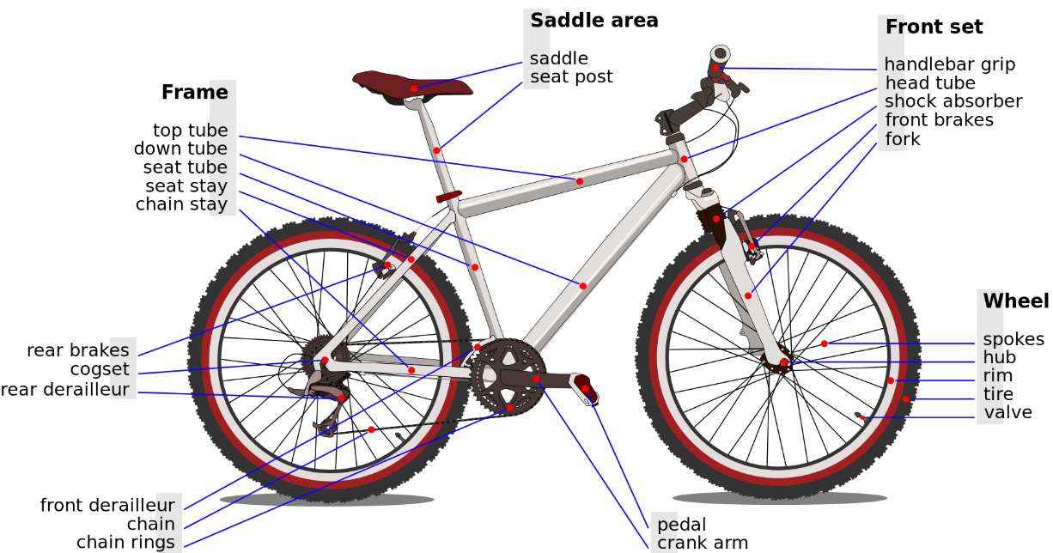
Figure 1 Name of Bicycle Parts
Bicycle is one of the great invention that require a lot of precise engineering calculation. The frame of a bicycle is light weight and used less material but can withstand high load. The bicycle wheel is known as the most efficient structural element use [2].
During old time, to replace the wooden wheel, wire spokes had been introduced. However, wire spokes cannot be placed directly as it will cause buckling after carry load in compression and then wire-spoke bicycle wheel was introduced more than a century ago to replace it. Therefore, to prevent buckling, wires must be pre-tensioned. A light weight bicycle come from tensioning the wires made these wheels possible. With pre-tensioned properties, a wire can support compression until they become slack by reducing the tension in wire. Wire spokes can reduced weight but improved durability. A modern wire wheels can carry a hundred times of the wheel own weight. [3]
When a spoke is assembled in to a wheel set, it will be in the pre-stressed mode which in elongated state when unloaded. When load is applied, it get compressed and the elongation decreases. However, the original elongation provided to the spokes while installing is higher than the decrease in elongation. Therefore, it can be said that a spoke is always in tensed state.
Figure 2 Illustration of Free Spoke, Unloaded Tensed Spoke and Loaded Tensed Spoke.

Spokes on a bicycle do not support the weight as it goes down from hub to bottom of the wheel. The wheel support the weight by pull up the hub to the top of wheel. This is also one of the reason that can make a wheel so flexible as the spoke can be consider to work like a rope.

  - PROBLEM STATEMENT
Light weight material Typical I-beam has high self-weight that will contribute to the weight of the building.
Recently, the fluctuation of structural steel price cause increase of construction cost as steel is one of the important material in construction. Because of that, it increases the price of I-beam.
There is limited literature study on steel beam with proposed novel web. This study helps to widen the limitation for the design of beam web.

  - OBJECTIVE
The objectives of this research are as followed:
- To investigate the potential of non-standard web shape such as bicycle rim and verify against existing work using ANSYS.
- To carry out parametric study on the effect of spoke and rim sizing to the behaviour of the new beam
- To integrate the pre-stressing concept of bicycle wheel and develop a new beam system.

  - SCOPE OF STUDY
An analysis was coordinated in order to integrate a bicycle rim as a replacement module for the I-beam’s ordinary web system. The study was done using a bicycle rim with a 16 spoke – rim in a radial arrangement. The focus of the study was the deflection and deformation of the I-Beam when the replacement (Bicycle Rim) is compared with the ordinary web based system. The outcome was then compared in terms of their effectiveness in handling both deflection and deformation.
Having two different parts, the first part basically involved understanding the pre-stress concept regarding the spokes on a bicycle wheel and the beam connection of a support. The second part on the other hand involves simulating the model using the ANSYS software. Several models were drafted and produced in order to have a comprehensive comparison between the two concepts.

CHAPTER 2

LITERATURE REVIEW

2.1 Steel Beam
Steel beam can be used as column, beam or beam-column. Different between eccentrically loaded column and beam-column is that eccentrically loaded column is where axial pressure is the primary effect while bending as unavoidable imperfection is the secondary, while beam column is where axial pressure is the primary effect and bending is intentionally applied. Steel beam come in various shape such as I beam, O beam, bar, structural tubing, angled, half round and more. This study will use the principle of I beam while replace the web with bicycle wheel.
As the concept of new beam system, there are a few parts of the beam can be resemble into few concepts in finite element method. For the flanges, it will be using plate (see below) method, the wheel rim will resemble ring and the spokes is similar to catenary.

2.2 Bicycle Rim
Despite the evolution in design and the use of modern materials, the basic structure of the modern spoked wheel has remained constant. The basic structure consists of three major components which are a hub that houses the bearings and the axle, pre-tensioned spokes that join the hub to the rim; and, a rim made of rolled or extruded material.
Modern bicycle wheels are now built with a range of spoke patterns radial. The pattern not only change the appearance of the wheel but affect the strength, torque resistance, flexibility, air resistance, weight. For Radial spoke patterns are more likely to be used on front wheels since they do not experience significant torque loading unless hub or disk brakes are used.
2.3 Element
2.3.1 Plate Element
Plank is most common item. A beam (Figure 3) shows the force resultants acting on a two-dimensional plate element and (Figure 4) shows moment resultants acting on the two-dimensional plate element [2]. Each plan of the plank will have 3 nodes. Loads on the plate in the x-, y-, and z -directions are denoted by px, py, and pz in Figure 3. These are the external forces acting on the plate at a given point. External loads can be applied as body forces, such as gravity, and they can be applied as surface tractions, in which case they correspond to the stresses. The moment resultants given will have the units of moment per unit length, and act in the directions shown in Figure 4. Mx and My are bending moment resultants. The directions of these moments are determined so the right-hand vector representation is as seen in Figure 4. Thus the vector Mx is in the y-direction, and My is in the negative x-direction.
Figure 3 Force resultants acting on a two-dimensional plate element
Figure 4 Moment resultants acting on the two-dimensional plate element
2.3.2 Catenary Element
Catenaries are commonly used analysis methods for cable structures. The visible characteristic is that it will slack in compression. The catenary element is very useful in tension mode. The cable which is suspended in two joints and loaded with a continuous load applied onto the horizontal projection is referred to as a parabolic catenary, (Figure 5). Because of a very low bending stiffness, the load-carrying cable is considered in calculations to be an element which does not bear bending moments. The only internal force which arises in the structure is tensile force. All geometric and static quantities are expressed by means of horizontal reaction [6].

Figure 5 Parabolic Catenary

2.3.3 Ring Element
Ring element is usually used for item such as rim, cylindrical object. Ring can be said to have unlimited symmetry, therefore, by doing a part of the structure, we can manage to obtain the same information, constrained by appropriate boundary conditions, which results in an appreciable savings in computer time. [5]
The boundary conditions on the segment are chosen so as to be compatible with the deflections experienced by the complete structure in each mode shape desired. Hence, any modes whose deflections are not compatible with a given set of boundary conditions cannot be obtained from that set. It is obvious from the statements above that symmetry methods are applicable only in cases where the nature of the mode shapes has been predetermined.

2.4 Material
There are different parts in the model that need to be specific define in different material. For the constant I-beam and model flange, structural steel will be used for both item. For this research, structural steel of grade S275JR will be used as it is the common industrial grade in Malaysia. Alloy aluminum is used for the bicycle rim in the beam model. Alloy aluminum is a material that slightly weaker than steel but has much lower density. It will cause the whole structure to be lighter than a pure steel structure. While the spokes of bicycle will be using stainless steels.

2.4.1 Structural Steel S275
Structural Steel grade S275 is usually used for most civil construction to general engineering. Table 1 and Table 2 show the chemical composition and mechanical properties of S275 respectively. There are three other grade under Grade S275, which is S235JR, S235J0 and S235J2 steel grade. They are the common carbon steel place. Based on Table 1, The structural steel has minimum yield point of 275 N/mm² and tensile strength at the range of 410 N/mm² to 560 N/mm². Structural steel S275 has the highest portion of magnesium in it (Table 2).
Table 1 The mechanical properties of S275JR [1]
Grade | Yield Point N/mm²(min.) | Tensile Strength N/mm² | Elongation % (min.)
S275JR | 265 | 410-560 | 23

Table 2 The chemical compositions of S275JR [1]
Grade | Carbon | Magnesium | Phosphorus | Sulphur | Nickel | Copper
S275JR | 0.21 max. | 1.50 max. | 0.035 max. | 0.035 max. | 0.012 max. | 0.55 max.

2.4.2 Alloy Aluminum 6061-T6
6061 alloy aluminum is one of the most common alloy of aluminum. It got the strength of medium to high with good toughness. Table 3 and Table 4 show the chemical composition and mechanical properties of Alloy Aluminium 6061-T6 respectively. Grade 6061 consist of few grade with different temper such as T1, T4, T6. The ultimate tensile strength increases with each temper. T6 has the highest ultimate tensile strength that can reach 310 MPa. Grade 6061 is commonly used for aluminum cans packaging, tactical flashlights, automotive parts. Grade 6061-T6 is highly used in fishing reels, helicopters parts and bicycle rim due to the high strength and low weight.

Table 3 The mechanical properties of Alloy Aluminum 6061
Grade | Hardness (Brinell) | Tensile Strength N/mm² | Elongation % (min.)
6061-T6 | 97 | 310 | 13

Table 4 The chemical compositions of Aluminum Alloy 6061
Grade | Magnesium | Silicon | Iron | Copper | Zinc
6061 | 0.8-1.2 | 0.4-0.8 | 0.7 max. | 0.15-0.40 | 0.25 max
 | Titanium | Manganese | Chromium | Other
 | 0.15 max | 0.15 max | 0.04-0.35 | 0.05

2.4.3 Stainless Steel SS304
Table 5 and Table 6 show the chemical composition and mechanical properties of SS304 respectively. Stainless steel is a form of steel containing a minimum of 18% chromium content that gives resistance to tarnishing and rust. There are three grades of type 304 stainless steel which are SS304, SS304L and SS304H. Grade SS304L has the special properties of lower carbon which does not need post weld annealing. On the other hand, Grade SS304H is highly applicable at elevated temperature because it has higher carbon.

Table 5 The mechanical properties of SS304
Grade | Hardness (Brinell) | Tensile Strength N/mm² | Elongation % (min.)
SS304 | 170 | 600 | 60

Table 6 The chemical properties of SS304
Grade | Manganese | Phosphorus | Sulphur | Silica | Nickel | Chromium
SS304 | 2.0 max. | 0.045 max. | 0.030 max. | 1.0 max. | 8.0-12.0 | 18.0-20.0

CHAPTER 3

METHOLOGY

3.1 RESEARCH METHOLOGY

The research methodology can be divided into two main parts;
1) Supervisor Consultation.
Supervisor is one of the main sources of reference for the project especially when there is a problem that requires expert clarification. Consultation with supervisor is also required during understanding the equation and principles related to the element in the beam set and also problems regarding finite element.
2) Developing ANSYS model, meshing and applying load
To validate the experimental result, simulation of the experiment needs to be performed in ANSYS Workbench. The simulation starts with modeling of a model, which has meet all the requirement. Next, the models are meshed and lastly, the load is applied, in this case, force. The simulation is solved and the result is analyzed.

3.2 Project Work Flow

The research flow of this project is as shown in Figure 6. The research starts with the project title selection until the conclusion and recommendation. Once the topic is decided, extensive research on previous paper that is related to my topic was done in Literature Review section. Certain parameters have been looked for identifying the research gap before conducting the experiment in order to improve the previous research. By relating to this topic, the parameters considering this study are the pre-stress properties and the overall properties of the beam.
At develop structure model stage, a model of beam integrate with bicycle rim will be produce by using ANSYS Workbench.

Figure 6 Research Flow of Project.

Perforated beam Truss beam

Beam system with pre-stressing concept of bicycle wheel

Steel beam Bicycle wheel
Figure 7 Concept evolution of Project.
Figure 7 shows that idea of the new beam concept came from the existing item such as perforated beam, truss beam, steel beam and bicycle wheel. Perforated beam and truss beam managed to show that the web of a beam is not necessary to have full material. It can be perforated to provide space for services and save material. A truss beam always properly designs to withstand the load with truss system. The idea of these items adds up to create a new system by using bicycle wheel will expect to have a good result.
When compression load applies on the flange, it will transfer the load to web. For the experiment, the web will be constructed of bicycle rim, refer to Figure 8. As mentioned about the properties of bicycle rim, the bicycle rim will accept the compression load by decrease the tension in the pre-tension spoke. The failure of the web will occur when the pre-tension spoke receive more compression than the tension in it and it became slack.

Tension
Compression
Figure 8 Load Distribution Illustration.

3.3 ANSYS MODELLING
3.3.1 Define Material Properties
There are few material properties that need to be defined for the models. Each model is made up of SS304 steel as the parent metal and SS308L for the weld metal. There are 3 important parameters hat needs to be defined for each model, modulus of elasticity, Poisson ratio and density for both parent metal and weld area. The Table 7 shows the properties of the three materials.
Table 7 Properties of Structural Steel S275, Aluminium Alloy 6061, Stainless Steel SS304
Material | Structural Steel S275 | Aluminum Alloy 6061 | Stainless Steel SS304
Density (kgm⁻³) | 7860 | 2770 | 7750
Young’s Modulus (MPa) | 200000 | 71000 | 193000
Poisson’s ratio | 0.26 | 0.33 | 0.31
Tensile strength (MPa) | 460 | 310 | 600

3.3.2 Boundary Condition
Both end of the beam will be fixed support, have zero displacement at all direction. Distributed force will be applied on the top of the beam to test the beam.

3.3.3 Modeling
Table 8 and Table 9 show the properties of I beam and the new bicycle beam. Both of the beams got the same flanges size and thickness of web. Figure 9 and Figure 10 show the model of I beam and the new bicycle beam.
Table 8 Dimension of I beam
610x305x238 UB
Designation | Dimension (mm)
Depth of section | 635.8
Width of section | 311.4
Thickness of web | 18
Thickness of flanges | 31.4
Length of beam | 1819

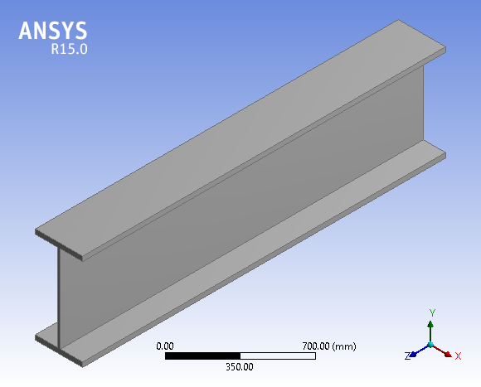
Figure 9 Model of Beam 610x305x238

Table 9 Dimension of Bicycle Rim Beam
Bicycle rim beam
Designation | Dimension (mm)
Depth of section | 635.8
Width of section | 311.4
Diameter of rim | 573
Width of rim | 18
Depth of rim | 20
Diameter of spokes | 3
Thickness of flanges | 31.4
Length of beam | 1819

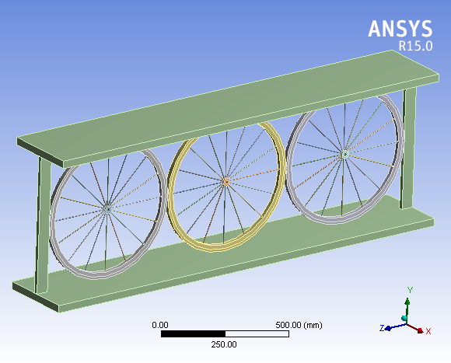
Figure 10 Model of New Bicycle Beam

3.3.4 Meshing
Meshing is performed in ANSYS to represent field variables such as displacement by polynomial function that produces a displacement field compatible with applied boundary conditions. The size of the mesh has significant effect of the final result of the simulation, thus the size of the mesh was kept constant for all models. During meshing, the type of material properties was defined for each volume. Figure 11 shows the meshing of Beam 610x305x238 while Figure 12 shows the meshing of Bicycle Beam. The I-Beam use meshing of 7.5mm that is similar with the verification work (See Chapter 4.1). For the meshing of bicycle beam, the auto mesh is used because the simulation will take too long due to the complicated structure.

Figure 11 Meshing of 610x305x238 Beam
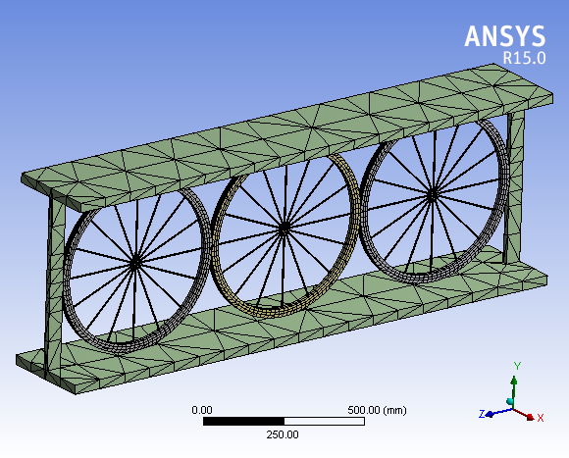
Figure 12 Meshing of New Bicycle Beam
3.3.5 Applying Load
The only applied load in the simulation model is force. Force is applied uniformly on the face of flange. A test will be carried out on distributed load of 150kN while another test will be carried out with the load in the midpoint of the flange.
3.3.6 Connection
Fully bonded connection is used in between the connection of flange to rim and rim to spokes. This is because to prevent gap in the connection and sliding is not allowed in any case. Therefore, it will restrict the movement of the material. The fully bonded connection will have no degree of freedom. In reality, this kind of contact can be archive by using welding, rivet or glue.
3.3.6 Solve
The solve command was used to initiate solving of the simulation. Solve was the last step after the model was meshed, boundary conditions defined and load has been applied. The amount of time required for solve depends on the complexity of the model and the load applied.

3.4 PROJECT KEY MILESTONE

Figure 13 Key Milestone for Final Year Project I May 2016 Semester.

3.5 PROJECT TIMELINE

Table 10 Gantt Chart for Final Year Project I May 2016 semester
Activities | Period of Planning (week)
 | 1 | 2 | 3 | 4 | 5 | 6 | 7 | 8 | 9 | 10 | 11 | 12 | 13 | 14
Selection of FYP Topic & Supervisor
Background study on concept of prestressing of bicycle spokes.
Conduct literature review for beam and bicycle spokes.
Preparation of Extended Proposal for FYP 1
Submission of Extended Proposal
Proposal Defence & Progress Evaluation
Continued modelling of concept.
Preparation of Draft Interim Report.
Preparation of Final Interim Report.

Table 11 Gantt Chart for Final Year Project II Sept 2016 semester
Activities | Period of Planning (week)
 | 1 | 2 | 3 | 4 | 5 | 6 | 7 | 8 | 9 | 10 | 11 | 12 | 13 | 14
Continued modelling and analysis of model
Data collection & tabulation
Preparation of Progress Report.
Submission of Progress Report.
Data analysis and closing up of experimental works.
Pre-SEDEX
Preparation of draft Final Report
Submission of Dissertation & Technical Paper (soft bound)
Viva
Submission of Project Dissertation (hard bound)

CHAPTER 4

RESULTS AND DISCUSSION

Deflection is first tested to predict the behaviour of new beam. For comparison purpose, the bicycle rim integrated beam is fully followed the size of the selected Universal Beam.
The simulation is performed in ANSYS WORKBENCH. The simulation performed is structural simulation whereby force of 100N to 1000N is applied on each beam with the exact same size but different web. The value of force applied on each model is the same in order to compare the model sustaining the least amount of stress.
For the Universal Beam of 610x305x238 from BS4-1:20015, the maximum deflection is lower than the new bicycle rim integrated beam. It has shown how can a set of ring element can withstand the weight while decreasing the self-weight.

4.1 I-Beam Verification
An I-beam is verified using hand calculation and ANSYS simulation. The result is compared to make sure it is similar with analytic solution. There is different of 2.9% between the deflection of beam in analytic solution and ANSYS solution.

4.1.1 Manual Calculation
The deflection of beam is calculated by using Euler–Bernoulli beam equation. The maximum deflection calculated is 2.4856mm.
$$∆_{max}=\frac{pl^{3}}{3EI}=\frac{10000\left({6876}^{3}\right)}{3\left(210000\right)\left(2.076×{10}^{9}\right)}=2.4856mm$$
Maximum moment of beam is 68760kN/mm and the equivalent stress calculated is 10.529MPa.
$$M_{max}=Px=10000\left(6876\right)=68760000$$
$$σ=\left|M_{max}\right|\frac{C}{I}=68760000\frac{317.9}{2.076×{10}^{9}}=10.529$$

4.1.2 ANSYS Simulation
Table 12 shows the constant of I-beam for Ansys simulation. The constant used will be same with hand calculation.
Table 12 Constant of I-beam Analysis
Young's Modulus MPa | Poisson's Ratio | Bulk Modulus MPa | Shear Modulus MPa
2.1e+005 | 0.3 | 1.75e+005 | 80769

Figure 14, Figure 15 and Table 13 shows the deflection result of the I-beam. The maximum deflection occur at the end of the beam where the pointed load is placed. Figure 16, Figure 17 and Table 14 shows the equivalent stress result of the I-beam.
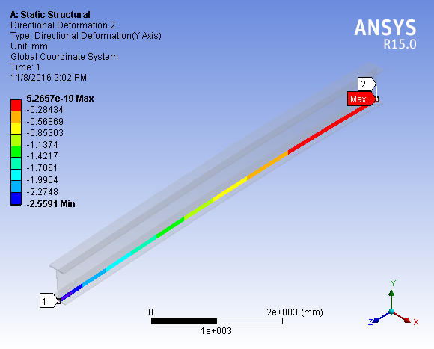
Figure 14 Deformation at Y direction of I beam

Figure 15 Length of beam vs deformation of beam

Table 13 Length of beam vs deformation of beam
Length [mm] | Deformation [mm]
0. | -2.5591
143.25 | -2.4785
286.5 | -2.3992
429.75 | -2.3203
573. | -2.2416
716.25 | -2.1631
859.5 | -2.085
1002.8 | -2.0073
1146. | -1.93
1289.3 | -1.8533
1432.5 | -1.7772
1575.8 | -1.7018
1719. | -1.6271
1862.3 | -1.5533
2005.5 | -1.4803
2148.8 | -1.4082
2292. | -1.3372
2435.3 | -1.2672
2578.5 | -1.1984
2721.8 | -1.1308
2865. | -1.0645
3008.3 | -0.9995
3151.5 | -0.93595
3294.8 | -0.87387
3438. | -0.81335
3581.3 | -0.75445
3724.5 | -0.69723
3867.8 | -0.64176
4011. | -0.58812
4154.3 | -0.53636
4297.5 | -0.48656
4440.8 | -0.43878
4584. | -0.39309
4727.3 | -0.34956
4870.5 | -0.30826
5013.8 | -0.26925
5157. | -0.23259
5300.3 | -0.19837
5443.5 | -0.16664
5586.7 | -0.13747
5730. | -0.11093
5873.2 | -8.7086e-002
6016.5 | -6.6009e-002
6159.7 | -4.7765e-002
6303. | -3.2423e-002
6446.2 | -2.0051e-002
6589.5 | -1.0698e-002
6732.7 | -4.2994e-003
6876. | 5.2657e-019

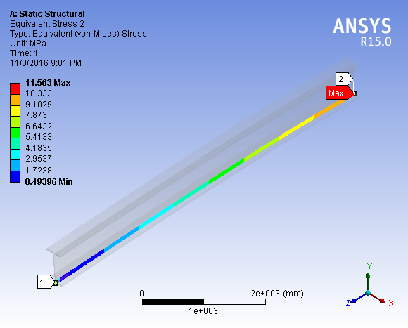
Figure 16 Equivalent (von-Mises) Stress for I beam

Figure 17 Length of beam vs Equivalent stress of beam

Table 14 Length of beam vs Equivalent Stress of beam
Length [mm] | Equivalent Stress [MPa]
0. | 7.6948
143.25 | 1.2348
286.5 | 0.49396
429.75 | 0.661
573. | 0.87476
716.25 | 1.0955
859.5 | 1.316
1002.8 | 1.5352
1146. | 1.7548
1289.3 | 1.9743
1432.5 | 2.1934
1575.8 | 2.4131
1719. | 2.6322
1862.3 | 2.8521
2005.5 | 3.0706
2148.8 | 3.2904
2292. | 3.5093
2435.3 | 3.7289
2578.5 | 3.9487
2721.8 | 4.1677
2865. | 4.387
3008.3 | 4.6065
3151.5 | 4.8259
3294.8 | 5.0448
3438. | 5.2651
3581.3 | 5.484
3724.5 | 5.7032
3867.8 | 5.9226
4011. | 6.1422
4154.3 | 6.3613
4297.5 | 6.5806
4440.8 | 6.8002
4584. | 7.0193
4727.3 | 7.2388
4870.5 | 7.4583
5013.8 | 7.6775
5157. | 7.8967
5300.3 | 8.1162
5443.5 | 8.3355
5586.7 | 8.5547
5730. | 8.7744
5873.2 | 8.9933
6016.5 | 9.2132
6159.7 | 9.4331
6303. | 9.6528
6446.2 | 9.877
6589.5 | 10.145
6732.7 | 10.351
6876. | 11.563

4.2 Bicycle Rim Verification
The radial load deformations of the rim were tested by the FEA model [7] without the additional displacement constraints and compare with ANSYS Simulation, with the different of 2.3%.
4.2.1 Previous Research
Simulation results for the 100 N radial load scenario without displacement constraints on the rim is 0.0522mm. [7]
    - ANSYS Simulation
Figure 18 shows the model of the bicycle rim. Fixed support is located at the hub and support for X and Y direction is placed at the side of the rim. Concentrated load of 100N is applied on the top of the rim. Figure 19 shows that the rim has deformed 0.051mm on top of the rim after load is applied.
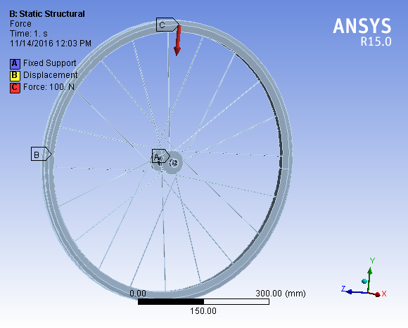
Figure 18 Boundary condition and Force placement on the rim
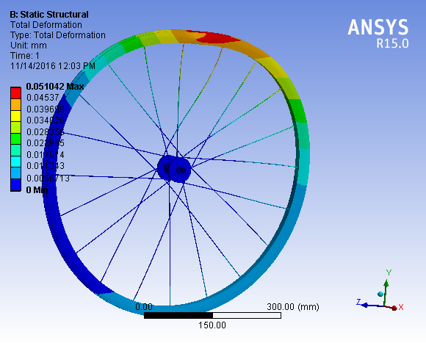
Figure 19 Result of deformation of the rim

  - Rim beam and I-beam Result
The result is compared between the Rim beam and I-beam. For deflection, I-beam has lower deflection than Rim beam. However, the weight of rim beam is much lower than I-beam.

4.3.1 Beam Deflection
Table 15 shows that rim beam and I-beam can take up the same load. However, the I beam has lower deflection than rim beam. This can be the cause of lack of stiffener in the beam to resist shear.
Table 15 Comparison of Deflection
Load (N) | Deflection (mm)
 | Rim Beam | I-Beam
100 | 2.56E-03 | 2.86E-05
200 | 4.06E-03 | 5.73E-05
300 | 5.55E-03 | 8.59E-05
400 | 7.05E-03 | 1.15E-04
500 | 8.54E-03 | 1.43E-04
600 | 1.00E-02 | 1.72E-04
700 | 1.15E-02 | 2.01E-04
800 | 1.30E-02 | 2.29E-04
900 | 1.45E-02 | 2.58E-04
1000 | 1.60E-02 | 2.86E-04

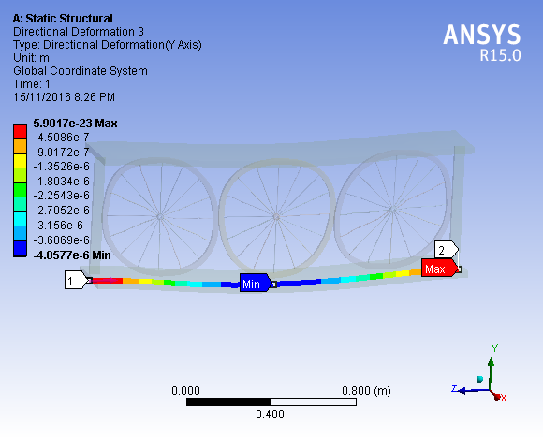
Figure 20 Deflection of New Bicycle Beam

    - Weight comparison
Table 16 shows that the weight of beam is reduced when rim beam is used. It managed to reduce weight u to 27.5%.
Table 16 Comparison of weight of rim beam and I-beam
 | Rim beam | I-Beam
Weight | 309.19 | 426.52
Difference | 27.5%

CHAPTER 5

CONCLUSION AND RECOMMENDATION

As a conclusion, the research details and objective have been clearly discussed and explained which have achieved the objective of producing this report. The simulation has been successfully performed in ANSYS. Structural load (force) has been applied on every model in order to determine the stress sustained by the models. The study show that the new beam will resist load but still far from the typical I beam. The new beam also managed to reduce about 27.5% of the typical beam weight. It can clearly reduce the cost of the material and reduce the self-weight of the beam.
Recommendations for this study would be to look into different parameters such as spoke length, spoke material, spoke diameter and the arrangement of the rim as well as the load transfer.

REFERENCES
[1] "S275JR UB - Universal Beams | Beam | Our Products", Beverlysteel.com.my, 2016. [Online]. Available: http://www.beverlysteel.com.my/Beam/s275jr-ub-universal-beams.html

[2] C. R. S. a. C. D. Balch, "Introduction to the Theory of Plates," p. 41.

[3] J. Brandt, The Bicycle Wheel, Third Edition ed. California.

[4] C. Burgoyne and R. Dilmaghanian, "Bicycle wheel as prestressed structure," Journal of engineering mechanics, vol. 119, pp. 439-455, 1993.

[5] W. L. Cook, "Finite Element Modeling of A Circular Ring Using Half And Quarter Symmetry," p. 22, 1966.

[6] O. S. JAKUB VASEK, "Numerical Analysing the Parabolic Catenary," Recent Advances in Applied and Theoretical Mathematics.

[7] J. Keller, "Optimisation of the Spoked Bicycle Wheel," 2013.

[8] "Conex Stainless Steel Fittings india", http://www.conexstainless.com, 2016. [Online]. Available: http://www.conexstainless.com/technicalspecification/-STAINLESS-STEEL-304-GRADE-SS-304-.html.
[9] S. Metalweb - Aluminium Plate, "Aluminium Alloy 6061 - Composition, Properties, Temper and Applications of 6061 Aluminium", AZoM.com, 2006. [Online]. Available: http://www.azom.com/article.aspx?ArticleID=3328.

