VEHICLE DRIVETRAIN MODELING AND
ANALYSIS FOR AN ADVANCED DRIVETRAIN
OF A CITY CONCEPTCAR

By

SUNTHARESAR A/L SHUMMUGHAM

A project dissertation submitted in partial fulfillment
of the requirements of the
Bachelor of Engineering (Hons)
(Mechanical Engineering)

SEPTEMBER 2013

Supervisor: Mohd Syaifuddin Bin Mohd

Universiti Teknologi PETRONAS
Bandar Seri Iskandar
31750 Tronoh
Perak Darul Ridzuan

CERTIFICATION OF APPROVAL

VEHICLE DRIVETRAIN MODELING AND ANALYSIS FOR AN ADVANCED DRIVETRAIN OF A CITY CONCEPTCAR

By

Suntharesar A/L Shummugham

A project dissertation submitted to the
Mechanical Engineering Programme
Universiti Teknologi PETRONAS
In partial fulfilment of the requirement for the
BACHELOR OF ENGINEERING (Hons)
(MECHANICAL ENGINEERING)

Approved by,

_______________________________
(Mohd Syaifuddin Bin Mohd)

UNIVERSITI TEKNOLOGI PETRONAS
TRONOH, PERAK
September 2013

CERTIFICATION OF ORIGINALITY

This is to certify that I am responsible for the work submitted in this project, that the original work is my own except as specified in the references and acknowledgements, and that the original work contained herein have not been undertaken or done by unspecified sources or person.

___________________________
(Suntharesar A/L Shummugham)

ABSTRACT
Drivetrain is one of the most important systems in every vehicle operations. Due to the increase of fuel prices and stricter regulation on vehicle emission, the need for a better efficient drivetrain had arisen. This research paper presents about the modeling, and analysis of an advance drivetrain system for a small city car concept. This research is conducted by developing a drivetrain model that consists of advanced features such as cylinder deactivation and thermoelectric energy recovery (TEG) module. The model is developed by using ‘Forward Looking Model’ concept in Matlab and simulation is conducted in Simulink by using selected urban drive cycle profiles (UDDS). Analysis of the simulation result is based on two performance evaluations. A) The amount of fuel consumed by the vehicle (best fuel consumption). b) The amount of emission released by the vehicle (low emission figures). In conclusion, it is postulated that this research could offer a mean of information and ideas on developing a better fuel efficient drivetrain for vehicle in the future.

ACKNOWLEDGMENT

First and foremost, thanks to God for giving the strength to carry out the Final Year Project for Mechanical Engineering course successfully. The author believes that without God’s blessing, the author will not be reaching completion and accomplishment of this project.
Deepest appreciation dedicated to author’s supportive supervisor Mohd Syaifuddin Bin Mohd for his guidance and professionalism towards this Final Year Projects, September 2013. The tremendous supervision by him is very helpful to lead into project accomplishment. Besides that, special thanks also goes to author’s examiner Mr. Mui'nuddin Bin Maharun, Dr. Mark Ovinis and Dr Zainal Ambri Abdul Karim for his relevant and valuable advises on author’s project in order to obtain better future result.
The author would like to extend his thanks to his supportive family that given the motivation and strength to the author on completing this project. Not to mention, friends and everyone who has directly or indirectly involve in this project, for their support and motivation during the implementation and undertaking of this project.

TABLE OF CONTENT
CERTIFICATION OF APPROVAL i
CERTIFICATION OF ORIGINALITY ii
ABSTRACT iii
ACKNOWLEDGMENT iv
TABLE OF CONTENTS v
CHAPTER 1: INTRODUCTION 1
1.1 Project Background 1
1.2 Problem Statement 3
1.3 Objectives 3
1.4 Scope Of Study 4
1.5 Significant Of Project 4
CHAPTER 2: LITERATURE REVIEW 5
2.1 Engine Modeling 5
2.2 Drivetrain Modeling 8
2.3 Vehicle Modeling 10
2.4 Forward Looking Model 15
CHAPTER 3: METHODOLOGY 17
3.1 Project Activities 17
3.2 Tools Requirement 18
3.3 Gantt Chart 19
CHAPTER 4: DRIVETRAIN MODELING 20
4.1 Pre-Modelling 20
4.2 Calculation 26
4.3 Detailed Drivetrain Model 32
4.4 Cylinder Deactivation Model 35
4.5 Thermoelectric Generator (Teg) Model 37
CHAPTER 5: RESULT AND DISCUSSION 41
5.1 Drivetrain Modelling Result And Discussion 41
5.2 Simulation Result And Discussion 44

CHAPTER 6: CONCLUSION AND RECOMMENDATION 53
6.1 Conclusion 53
6.2 Recommendation 54
REFERENCE 55

List of Figures
Figure 1: Vehicle Drivetrain [1] 1
Figure 2: Otto Cycle [5] 6
Figure 3: Wiebe’s Function [3] 7
Figure 4: Mass fraction burned against crank angle [5] 7
Figure 5: Clutch Torque Equation [5] 8
Figure 6: Driveshaft Torque Equation [5] 8
Figure 7: Axle Torque Equation [5] 9
Figure 8: Tractive Force Equation [5] 9
Figure 9: Tractive Force and Resistance Force [5] 10
Figure 10: Pressure Distribution on Contact Surface [5] 10
Figure 11: Force acting on tire versus tire deformation on loading and
unloading [5] 11
Figure 12: Rolling Resistance Moment [5] 11
Figure 13: Force acting at the centre of wheel [5] 11
Figure 14: Vehicle Rolling Force on Horizontal [5] 12
Figure 15: Vehicle Rolling Force on a Slope [5] 12
Figure 16: Flow across an object [5] 12
Figure 17: Aerodynamic Drag [5] 13
Figure 18: Grading Resistance [5] 13
Figure 19: Road Angle [5] 14
Figure 20: Vehicle Climbing a Grade [5] 14
Figure 21: Total Resistance Force 14
Figure 22: Forward Looking Block Diagram [6] 15
Figure 23: Backward-Looking Block Diagram [6] 16
Figure 24: Project Flow Chart 17
Figure 25: Torque vs. RPM Curve [6] 23

Figure 26: Preliminary Drivetrain Model 30
Figure 27: Gear Selector Model 33
Figure 28: Gear Ratio Corresponding to Vehicle Speed 33
Figure 29: UDDS Drive Cycle Profile 34
Figure 30: Cylinder Deactivated Model 36
Figure 31: Engine Torque Corresponding to Engine RPM 36
Figure 32: 30% Engine Power Modelling 38
Figure 33: Volumetric Flow Rate Model 39
Figure 34: Volumetric Flow Rate Corresponding with Engine RPM 40
Figure 35: Thermoelectric Generator (TEG) Modelling 40
Figure 36: Drivetrain Model with Advance Technologies 43
Figure 37: Hot Fuel Use Map for Normal Drivetrain 44
Figure 38: Fuel Efficiency Map for Normal Drivetrain 45
Figure 39: Mass of CO2 Released for Normal Drivetrain 45
Figure 40 Hot Fuel Use Map for Deactivated Cylinder 47
Figure 41: Fuel Efficiency Map for Deactivated Cylinder 48
Figure 42: Mass of CO₂ Released for Cylinder Deactivated Drivetrain 48
Figure 43: Energy Developed by TEG System 50
Figure 44: Power Generated by TEG System 51
Figure 45: Mass of CO2 Released for Cylinder Deactivated + TEG Drivetrain 51

List of Table
Table 1: Tool & Equipment Requirement 18
Table 2: Gantt chart for FYP 1 and FYP 2 19
Table 3: Specification of Myvi 1.3 22
Table 4: Assumption Table 24
Table 5: Torque vs. RPM Data 29
Table 6: Gear selection corresponding to vehicle speed data 33
Table 7: Torque vs. RPM for Cylinder Deactivated 35
Table 8: Volumetric Flow Rate vs. RPM 39

List of Abbreviations

Abbv Definitions
UTP Universiti Teknologi PETRONAS
TEG Thermoelectric Generator
UDDS Urban Dynamometer Driving Schedule
RPM Revolution per minute
CO₂ Carbon Dioxide

CHAPTER 1
INTRODUCTION
  - Project Background
Drivetrain is a component of vehicle that enables a vehicle to move or driven. Drivetrain of a vehicle can be classified into several categories which are Front Wheel Drive (FWD), Rear Wheel Drive (RWD) and Four Wheel Drive (4WD). According to [1] the drivetrain serves two functions which are, to transmit the power generated from engine to drive wheels and another function is to vary the torque amount. The transferring of power from engine to drive wheels is done by using various mechanical parts such as transmission, driveshaft, long shaft, clutch, torque converter, CV joints, differential and axles [1]. Each of these components has its own function in the operation of the vehicle and also differs according to the vehicle specification.

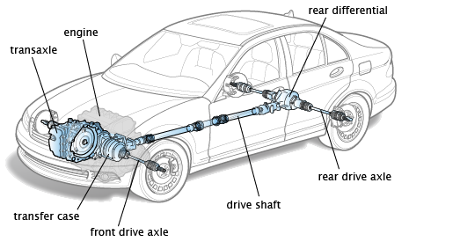
Figure 1: Vehicle Drivetrain (Schappell, n.d)

Even though modern vehicle drivetrain is equipped with high and reliable technology, the need for a more fuel efficient drivetrain is always been a question among users especially with the increase of the fuel prices recently. This is because the current drivetrain has many lacks in term of efficiency due to the losses in the rotating equipment. But with the use of drivetrain modeling, the vehicle drivetrain system is easily analyzed and the losses from the drivetrain are reduced. There are two types of approaches in developing drivetrain models which is ‘Forward Looking Model’ and ‘Backward Looking Model’. In forward-looking model, the driver model will send an accelerator or brake pedal input to the different powertrain and component controllers in order to follow the desired vehicle speed trace. The driver model will then modify its command depending upon how close the trace is followed thus enabling it to implement advance component models into the system [2]. Meanwhile, in a backward-looking model, the desired vehicle speed travels from the vehicle model back to the engine to find out how each component should be used to follow the speed cycle [2]. By using the advantage of modeling, this research is conducted to develop a drivetrain model that has advance features and analyze as well as optimize it in order to get the best fuel efficiency and low emission drivetrain model. In this project, Myvi 1.3 liter with manual transmission (FWD) is considered in developing the drivetrain modeling using ‘Forward-Looking Model’.

1.2 Problem Statement
Recent price hike in fossil fuels and a stricter regulation imposed on vehicle emission, demands for a fuel efficient vehicle have increased rapidly. Due to these factors, the vehicle manufacturer’s has forced to develop good fuel efficient vehicles and one of the niche markets is city cars. The reason for choosing city car is because it is lightweight, equipped with small displacement engines and most of the time travels following a low velocity with transitional type drive cycle profiles. Not only that, the proposed city car will also include an advanced features such as crankshaft starter generator, which allows the engine to be shutdown at traffic stop, cylinder deactivation capability, thermoelectric energy recovery module, electric motor assist and regenerative braking capability. So, in order to analyze the proposed city car concept, an accurate model for the complex proposed drivetrain needs to be developed.
Therefore, this project is proposed to develop an accurate model of the complex proposed drivetrain system in order to simulate and analyze the performance of the proposed city car concept to achieve the best fuel consumption and lowest emission figures.
1.3 Objectives
The objective of this research can be classified into two components which is:
1. To develop a drivetrain model of the proposed city car concept with cylinder deactivation technology and thermoelectric generator energy recovery module.
2. To simulate and analyze the performance of the vehicle according to the selected urban drive cycle profiles in order to obtain the best fuel consumption and lowest emissions figures possible.

1.4 Scope of study
Throughout the research, the scope of study will focus on the modeling and analysis of the drivetrain for the purposed city car concept. Therefore, the research is carried out to develop a drivetrain model with consists of cylinder deactivation technology and thermoelectric generator energy recovery module. The drivetrain modeling will be developed using ‘Forward Looking Model’ concept. The research also will analyze and evaluate the performance of the vehicle. The analysis will be done in Matlab/Simulink software by using several selected urban drive cycle profiles (UDDS) and the performance evaluation will be made by measuring two main elements, which are:
- The amount of fuel consumed by the vehicle (best fuel consumption).
- The amount of emission released by the vehicle (low emission figures)
1.5 Significant of the Project
The research on the vehicle drivetrain is very important to the engineering world especially for automobile side. This is because through this research, engineer can further understand and develop an efficient drivetrain for the vehicles so that a better fuel efficient vehicle can be achieved. Besides that, engineer will able to design an advanced drivetrain that able to reduce the emission and also increases the vehicle millage. Furthermore, engineer also will able to design the drivetrain with more durability and higher life cycle.

CHAPTER 2
Literature Review
This chapter is a literature review of various research and publication done on the subject of drivetrain modeling and analysis. The literature review is divided into 4 sections and has been summarized into these paragraphs:
  - Engine Modeling
  - Drivetrain Modeling
  - Vehicle Modeling
  - Forward Looking Model (Software Modeling)
Drivetrain is an important system in a vehicle that enables the vehicle to function. Drivetrain also is a crucial system that contributes to the efficiency of a vehicle, thus making it as one of the main factors in fuel efficiency. Since drivetrain is an important component, improvement of the system will definitely give a big impact to the fuel efficiency and also to the vehicle emission. Although a lot of work has been done on the drivetrain system, the development of a fuel efficient and low emission drivetrain is still a new field that needs more exploration.
2.1 Engine Modeling
Most common engine used in the city cars nowadays is spark ignition (SI) engines. [3] states that, spark ignition engines, diesel engines and other producing engines operate on cycles and all of this engines operated by burning the fuel within the system boundary. The SI engine operate according to Otto cycle. Otto cycle is a theoretical cycle commanly used to describe the SI engines [3]. It is assumed that the air fuel mixture is confined in a cylinder by using piston that moves from BDC and TDC [3]. The Otto cycle consist of 4 internal reversible processes. First process is the isentropic compression of an air-fuel mixture from Point 1 to Point 2.
Then the second to third process is a constant volume heat addition. Point 3 to point 4 is isentropic expansion process and finally point 4 to point 1 is constant volume heat rejection [3]. The Otto cycle circulation is shown in the diagram below.
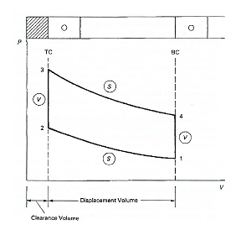
Figure 2: Otto Cycle (Georgios, 2005)
According to [3] internal combustion engine obtain their energy from combustion of hydocarbon fuel with air. The chemical energy stored in the fossil fuel is converted into heat and kinetic energy. [4] states that in a SI engine, combustion happens in three type of stages; initial burning phase, faster burning phase and final burning phase. During the initial burning phase, the fraction of mass burned is negligible and follows laminar flame speed [4] .Meanwhile in faster burning phase, the burning period are equal to turbulant flame speed. In final burning phase, the fuel is burned in a turbulant way but some amount of the fuel is not burned after the termination of propagation process [4]. The mass fraction burned is the ratio of the cumulative heat release to the total heat release. The mass fraction burned can be explained using Wiebe’s function when it is plotted in a graph (mass fraction burned vs. crank angle).

Wiebe’s function is functional form that is used to represent the mass fraction burned versus crank angle [3].
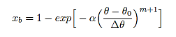
Figure 3: Wiebe’s Function (Georgios, 2005)
where:
Ө = crank angle
Ө₀ = angle where the start of combustion occurs
ΔӨ = total combustion duration
α and m = adjustable parameters
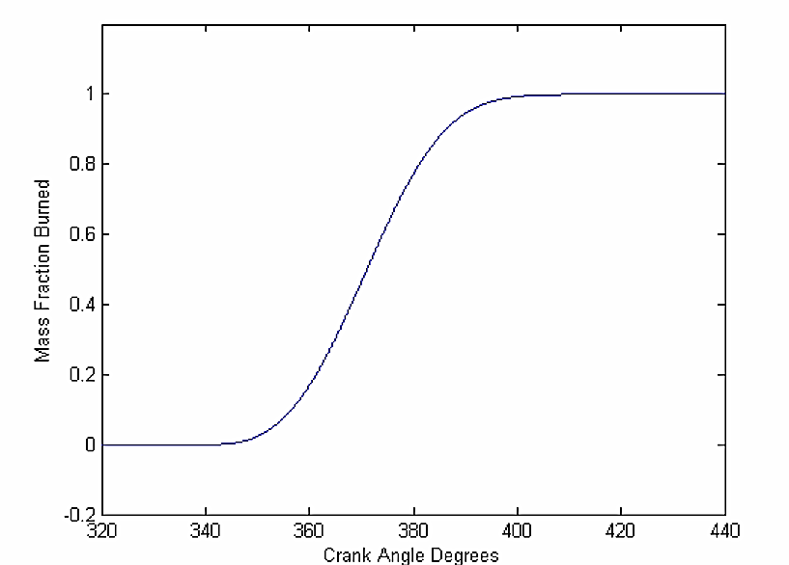
Figure 4: Mass fraction burned against crank angle (Georgios, 2005)
Due to this unburned mass fraction in the SI engine, the efficiency of the engine is much lower compared with the theoretical assumption. So to overcome this unburned mass fraction issue, the timing angle, heat release rate and combustion characteristics of the vehicle is being altered in order to get the best combustion in the SI engine. The method of doing this was varying the spark timing time in the combustion chamber. So the result of this alteration is usually measured using Wiebe’s function. This theory will be used in this project when modelling the engine in order to get the best efficiency of the engine.

2.2 Drivetrain Modeling
Acceleration performance of a vehicle depends on the losses happened in the drivetrain due to the traction limit on the drive wheel. According to [5], torque that is produced by the engine is not the same amount when it reaches the drive wheel. This is because the torque delivered by the engine is reduced in the drivetrain as inertia to the rotating equipment. According to [5], drivetrain system can be brokendown into several component such as clutch, transmission, driveshaft and axles. All these component has its own losses value and [5] has produces several equation that can be represent the losses. First equation that is represented is the losses in the clutch component.
Figure 5: Clutch Torque Equation (Gillespie, 1992)
where:
T_{c} = Torque at the clutch (input to the transmission)
T_{e} = Engine torque at a given speed (from dynometer data)
I_{e} = Engine rotational inertia
α_{e} = Engine rotational acceleration
The second equation given by [5] is for transmission, where the torque delivered at the output of the transmission is amplified by the gear ratio but it is subsentialy decreases due to the inertia losses in the gears and shafts.
Figure 6: Driveshaft Torque Equation (Gillespie, 1992)
where:
T_{d} = Torque ouput to the drive shaft
N_{t} = Numerical ratio of the transmission
I_{t} = Rotational inertia of the transmission

Third equation to represented the losses in the drivetrain is for axles. Similar to the transmision losses concept, the torque from the transmission is amplified in the final drive ratio and reduces due to the inertias of the driveline components in rotating the wheels and providing tractive forces on the ground. [5].
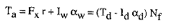
Figure 7: Axle Torque Equation (Gillespie, 1992)
where:
T_{a} = Torque on the axles
F_{x} = Tractive force at the ground
r = Radius of the wheels
I_{w} = Rotational inertia of the wheels and axle shafts
α_{w} = Rotational acceleration of the wheels
I_{d} = Rotational inertia of the driveshaft
α_{d} = Rotational acceleration of the driveshaft
N_{f} = Numerical ratio of the final drive
Together with these equations, [5] also has established equation for the tractive force available at the ground and related it as an effort to overcome the road load forces in accelerating the vehicle.
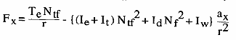
Figure 8: Tractive Force Equation (Gillespie, 1992)
So in order to establish an accurate drivetrain model, all these losses need to be considered because as the losses in the drivetrain will affect the performance and efficiency of a vehicle.

2.3 Vehicle Modelling
In modeling a vehicle, all the forces that act on the vehicle needed to be considered. According to [5], the movement behavior of a vehicle along its moving path is completely determined by all the forces acting on it at that direction. For example, the tractive effort, Ft, is created at the contact area between the tires of the wheels and road surface when the vehicle moves forward and at the same time during movement, resistance force, F_{r} tries to stop the movement of the vehicle [5]. The resistance force that usually act on the vehicle are tire rolling resistance, aerodynamic drag and grading resistance.
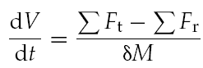
Figure 9: Tractive Force and Resistance Force (Gillespie, 1992)
2.3.1 Rolling Resistance
According to [5] rolling resistance are created due to the hysteresis in the tire material. Hysteresis is described as the energy lost as heat when a section of vulcanized rubber is deformed in a regular constant manner [5]. The more flexing and deformation is done to the tire, the more heat will build within the tire.

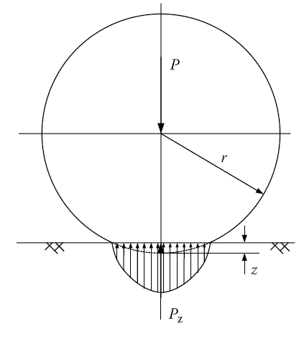
Figure 10: Pressure Distribution on Contact Surface (Gillespie, 1992)

Due to hysteresis in the deformation of rubber material, the load effect at loading is greater than the load effect at the unloading at the same deformation, z [5].
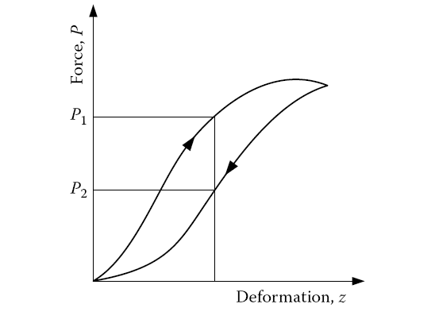
Figure 11: Force acting on tire versus tire deformation on loading and unloading (Gillespie, 1992)
During tire rolling, the leading half of the contact area is loading and the trailing half is unloading thus creating the hysteresis that causes an asymmetric distribution of the ground reaction forces [5]. This ground reaction force is shifted into forward ground reaction force [5]. When this forward shifted ground force has normal load acting on the wheel center, it creates a moment that oppose the rolling of the wheel [5]. This moment is called as rolling resistance moment. So in order to keep the wheel rolling, a force, F, acting on the center of the wheel is needed to balance the rolling resistant moment.
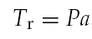
Figure 12: Rolling Resistance Moment (Gillespie, 1992)

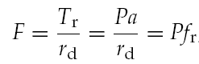
Figure 13: Force acting at the centre of wheel (Gillespie, 1992)

The rolling resistance moment can be replaced by horizontal force acting on the wheel centre in the opposite movement direction of the wheel [5].
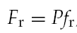
Figure 14: Vehicle Rolling Force on Horizontal (Gillespie, 1992)
where: P = normal load acting on the centre of the rolling wheel
f_{r} = function of tire material, tire structure, tire temperature, tire inflation, thread geometry, road roughness, road material, and presence or absence of liquid on the road.
If the vehicle is operated on a slope, then the normal load will be replaced with a component that is perpendicular with the road surface [5].
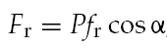
Figure 15: Vehicle Rolling Force on a Slope (Gillespie, 1992)
2.3.2 Aerodynamic Drag
According to [5], aerodynamic drag occurs when the air encounters an object that resists its flow making the pressure and velocity of the air to vary, thus creating forces and moment. Aerodynamic drag creates two components which is shape drag and skin friction.
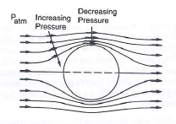
Figure 16: Flow across an object (Gillespie, 1992)

Shape drag is defined as the effect of the vehicle pushing air in front it during motion. During this phenomenon, the air cannot instantaneously move out of the way thus increasing the air pressure [5]. Meanwhile skin friction is happened when speed different occurs on the two air molecules, where first molecule travels with the same speed of the vehicle with close to the body and second molecules is at a stand still, located away from the vehicle [5]. Combining these two component, aerodynamic drag is created. Using the information above, aerodynamic drag can be characterized as the function of vehicle speed, V, vehicle frontal area, A_{f} , shape of the vehicle body, and air density, ρ.
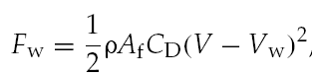
Figure 17: Aerodynamic Drag (Gillespie, 1992)
where:
C_{D} = Aerodynamic drag coefficient
A_{f} = Vehicle frontal area
V_{w} = Wind speed on the vehicle moving direction
V = Vehicle speed
p = Air density
2.3.3 Grading Resistance
Grading resistance is a force that occurs when the vehicle is moving up or down a slope. This is because the weight of the vehicle, where it always directed to the downward direction [5]. The component can either be oppose the motion or together with the motion of the vehicle. There are several ways in expressing the slope, which are as an angle of inclination to the horizontal (α) or as a percentage [5]. In the developing the vehicle model, only uphill operation is considered and it can be represented as:
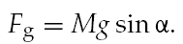
Figure 18: Grading Resistance (Gillespie, 1992)

If the road angle is small, then:
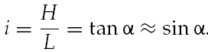
Figure 19: Road Angle (Gillespie, 1992)

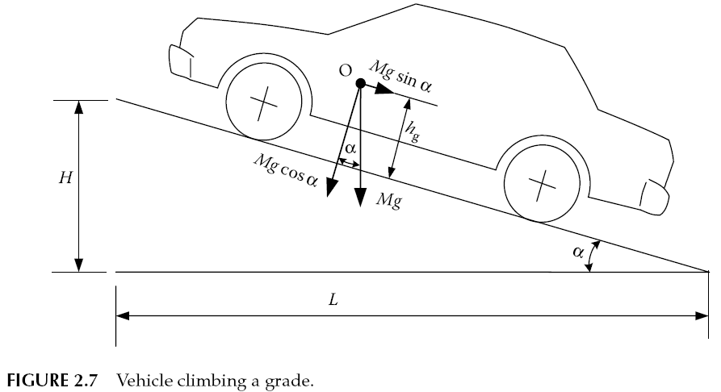
Figure 20: Vehicle Climbing a Grade (Gillespie, 1992)

So in developing a vehicle model, these rolling resistances, aerodynamic drag, grading resistance and acceleration inertia (d’ Alembert Force) need to be included because these parameters are directly involved with the vehicle performance. So it can be said that the total resistance in a vehicle is the sum of all these parameters.
P_{total} = P_{aero} + P_{rolling} + P_{grading} + P_{acce}

Figure 21: Total Resistance Force

2.4 Forward Looking Model
[6] has conducted a reserch on the developing of forward looking and backward looking models in MATLAB/Simulink. According to [6], forward looking model uses a driver model to consider the required speed and the present speed in order to develop an apporiate throttle and brake command. The throttle command that is developed is then translated into a torque provided by the engine and also into as energy use rate [6]. The torque given by the engine is inputed into the transmission model, where the torque is transformed according to the transmission efficiency and ratio [6]. The computer torque is then passed forward through the drivetrain until the tractive force at the tire is obtained.
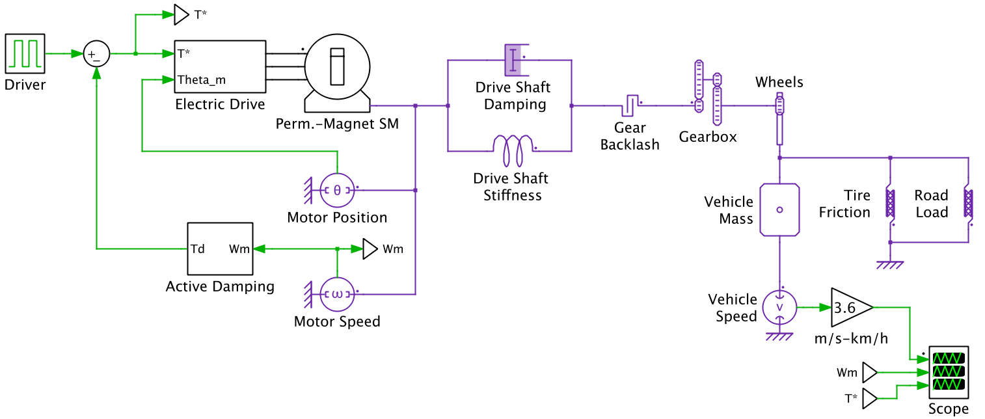
Figure 22: Forward Looking Block Diagram (Keith, Matthew and Steven, 1999)
Meanwhile in backward looking model, vehicle simulator uses backward-facing approach to answer the question such as, how much each component must perform in order to match the vehicle trace/requirement [6]. Backward looking model does not uses driver model in the modeling, instead the force required to accelerate the vehicle through the step time is calculated directly from the required speed trace [6]. The required force is then translated into a torque that must be provided by the components before them [6]. This calculating approach moves backward through the drivetrain against the tractive power flow direction until the amout of fuel or rate of electrical energy usage can be computed [6].
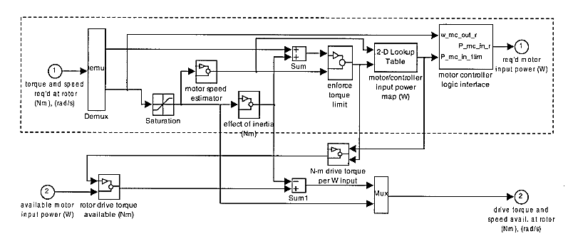
Figure 23: Backward-Looking Block Diagram (Keith, Matthew and Steven, 1999)
From the analysis done by [6] on the difference of forward looking model and backward looking model, it is concluded that the forward looking model concept is much more preferable. This is because the forward looking model deals with quantities measurable in a pyhsical drivetrain such as control signal and true torque [6]. Not only that, forward looking model also enables the vehicle controller to be developed and test it in the simulation. Other than that, dynamic model also can be included directly in the modeling [6].

CHAPTER 3
Methodology

3.1 Project Activities
No
Yes
Performance Evaluation
Simulation
Gathering Required Data
Modeling Development
Define Problem & Objective

Does the Model is Okay?

No

Can Simulation Be Performed

Yes
Thesis

Figure 24: Project Flow Chart

The project initiated by first identifying and defining the problem statement of the project. Then, the project objectives were identified. Once the objectives has been known, an extensive study were done by the author on the project by gathering information and data through available journals, articles, books and references. This enables the author to understand more about the project to be carried out and enables the author to correlate the project with other previous researches done by researchers.
Once the information has been collected, mathematical model were developed according to the project objective. The mathematical modelling developed expresses the vehicle drivetrain and also advanced features that is cylinder deactivation technology and thermoelectric generator energy recovery module. The developed mathematical model then converted into an analysis model by creating the drivetrain model in Matlab software by using ‘Forward Looking Model’ approach. Drivetrain model that has been developed in Matlab undergoes simulation process through Simulink software which is integrated together with Matlab software. The simulations are carried out based on selected urban drive cycle profiles in order to replicate the real driving profile. Graphical data from the simulation are collected and analysed to evaluate the performance of the drivetrain that has been developed. Once the evaluation is done which is the measurement of fuel usage and emission figure, dissertation will be produced.

3.2 Tools Requirement

Table 1: Tool & Equipment Requirement
Tools | Usage
Matlab R2010b | Modelling of Drivetrain for City Car Concept
Simulink R2010b | Simulation and Analysing Drivetrain Performance
Vehicle Data Acquisition Unit | Collect vehicle performance data

FYP Schedule Timeline |  | FYP I  ( 20 May – 23 Aug 2013 ) |  |  |  |  |  |  |  |  |  |  |  |  |  | FYP 2  ( 23 Sept – 27 Dec 2013 )
 |  | 1 | 2 | 3 | 4 | 5 | 6 | 7 | 8 | 9 | 10 | 11 | 12 | 13 | 14 | 1 | 2 | 3 | 4 | 5 | 6 | 7 | 8 | 9 | 10 | 11 | 12 | 13 | 14
1 | Introduction  * - Understanding project description. (Whats is Drivetrain, Modeling and Simulation)  * - Generating project backgrounds, objectives, scope of study and significant of project
2 | Literature Review  * Research about Drivetrain Modeling  * Research on ‘Forward Looking Model’ Concept  * Research on Vehicle and Engine Modeling
3 | Modeling  * Generation of Mathematical Modeling  * Generation of Preliminary Modeling in Mathlab  * Generation of Modeling in Software (Matlab)
4 | Simulation  * Simulink (Analyzing and evaluating the performance of the drivetrain)
5 | Report  Thesis/Dissertation
Table 2: Gantt chart for FYP 1 and FYP 2

Key Milestone
Extension

CHAPTER 4
Drivetrain Modelling
4.1 Pre-Modelling
A basic model to represent the forces acting on a vehicle is developed in the Matlab software in order to understand the drivetrain system of the vehicle. The basic model is not a forward looking or backward looking model, its more to a preliminary model that consist of all the forces and losses in a vehicle drivetrain. The reason for developing a preliminary model is to enable the development of mathematical function for the drivetrain losses and forces that is going to be used in developing drivetrain modelling. Before developing mathematical function, the losses and forces of the drivetrain were identified. Relating to previous literature reviews and studies, the forces and losses that is needed to consider are tractive force and road load force. These two forces can be broken down into more detail equations. According to [5] tractive force can be defined as:
$$Fx=\frac{(Te )(Ntf)}{r}-\{\left(I_{e}+I_{t}\right){N_{tf}}^{2}+I_{d}{N_{f}}^{2}+I_{w}\}\frac{a_{x}}{r^{2}}$$
Where:
F_{x} = Tractive Force
T_{e} = Engine Torque at a given speed
N_{tf} = Numerical ratio of transmission and final drive
r = Wheel radius
I_{e} = Engine rotational inertia
I_{t} = Rotational inertia of transmission
I_{d} = Rotational inertia of the driveshaft
N_{f} = Numerical ratio of transmission
I_{w} = Rotational inertia of the wheel
a_{x} = Acceleration of the vehicle

Meanwhile, road load force can be broken into:
P_{road load} = P_{aero} + P_{rolling} + P_{grade} + P_{acce}
But in the preliminary modelling, only the aerodynamic and rolling will be considered because it is assumed that the vehicle is moving in flat road. So the equation will be only involving the aerodynamic and rolling forces.
$$P_{road load}=\frac{1}{2}pA_{f}C_{d}(V-V_{w})^{2}+Pf_{r}$$
Where:
p = Density of air
C_{D} = Aerodynamic drag coefficient
A_{f} = Vehicle frontal area
V_{w} = Wind speed on the vehicle moving direction
V = Vehicle speed
P = normal load acting on the centre of the rolling wheel
f_{r} = function of tire material, tire structure, tire temperature, tire inflation, thread geometry, road roughness, road material, and presence or absence of liquid on the road.

Not only have that, the vehicle’s engine Revolution per Minute (RPM) and torque information also needs to be inserted inside the preliminary model in order to replicate the various speed of the vehicle or engine during operation. So to successfully develop the preliminary model all this information is needed, so the first thing needs to be done is to obtain the vehicle specification, in this project the specification will be based on the Perodua Myvi 1.3 with manual transmission.

Figure below shows the specification of the Perodua Myvi 1.3:
Table 3: Specification of Myvi 1.3
ENGINE INFORMATION | SPECIFICATIONS
Engine Manufacturer | Daihatsu K3
Engine Type | K3VE
Fuel Type | Petrol (gasoline)
Fuel System | Indirect Injection
Charge System | Naturally Aspirated
Valves per Cylinder | 4
Valves Timing | DVVT (Daihatsu Variable Valve Timing)
Additional Features | Multi-Port Fuel Injection
Cylinder Arrangement | Line 4
Displacement | 1298 cm³ / 79 cui
Bore | 72 mm / 2.83 in
Stroke | 79.7 mm / 3.14 in
Compression Ratio | 10:1
Power Net | 64 kW / 87 PS / 86 hp / 6000
Torque | 116 Nm / 86 ft-Ib / 3200
TRANSMISSION INFORMATION | SPECIFICATION
Gearbox Transmission Type | Manual
Numbers of Gear | 5
Gear Ratios (overall)
I | 3.182
II | 1.842
III | 1.25
IV | 0.865
V | 0.75
R | 3.142
Final Drive | 4.267
Standard Tires | 175/65/R14
Brake Type | Ventilated Disc (F)  Closed Drum I
Rim Size | 14’’
DIMENSIONS & CAPACITIES | SPECIFICATION
Length | 3760 mm / 148 in
Width | 1665 mm / 65.6 in
Height | 1550 mm / 61 in
Wheel Base | 2440 mm / 96.1 in
Front Track | 1455 mm / 57.3 in
Rear Track | 1465 mm / 57.7 in
Ground Clearance | 160 mm / 6.3 in
Turning Circle btw. Walls | 10.2 m / 33.5 ft
Turning Circle btw. Curbs | 9.4 m / 30.8 ft
Drag Coefficient | 0.35
Curb Weight (without driver) | 945 kg / 2083 Ib

Once the specification sheet of the Perodua Myvi is obtained, the Torque vs. RPM curve is collected.

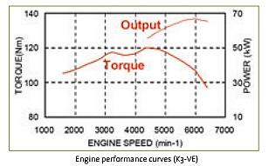

Figure 25: Torque vs. RPM Curve (Keith, Matthew and Steven, 1999)
Once this information is gained, other related information/value that is not provided in the specification table needs to be assumed. The assumed information/values are shown in the table below:
Table 4: Assumption Values
INFORMATION | DESCRIPTION
A_{f} | 2.1 m²
k_{r} | 1.05
Mass of Flywheel, m_{flywheel} | 15 kg
Flywheel Outer Diameter, Do | 0.3 m
Flywheel Inside Diameter, Di | 0.04 m
1st Gear Outer Diameter, Do | 0.15 m
1st Gear Inner Diameter, Di | 0.04 m
1st Gear Mass, m₁ | 0.9 kg
2nd Gear Outer Diameter, Do | 0.13 m
2nd Gear Inner Diameter, Di | 0.04 m
2nd Gear Mass, m₂ | 0.9 kg
3rd Gear Outer Diameter, Do | 0.11 m
3rd Gear Inner Diameter, Di | 0.04 m
3rd Gear Mass, m₃ | 0.7 kg
4th Gear Outer Diameter, Do | 0.10 m
4th Gear Inner Diameter, Di | 0.04 m
4th Gear Mass,m₄ | 0.7 kg
5th Gear Outer Diameter, Do | 0.085 m
5th Gear Inner Diameter, Di | 0.04 m
5th Gear Mass, m₅ | 0.55 kg
Final Drive Gear Outer Diameter, Do | 0.2 m
Final Drive Gear Inner Diameter, Di | 0.03 m
Final Drive Gear Mass, m_{f} | 3 kg
CV Joint Mass, m_{cv} | 1.2 kg
CV Joint Diameter, D_{cv} | 0.072 m
Drive Axle Mass, m_{axle} | 3 kg
Drive Axle Diameter, D_{axle} | 0.022 m
Mass of Rim | 14 kg
These information/value has been assumed because the accurate value can only be obtained when detail measurement were conducted on the vehicle, Perodua Myvi. Not only that, some parts measurement only can be taken when the part are fully opened up. For example, the 1st , 2nd , 3rd , 4th , 5th and final drive gears diameter and mass only can be measured when the vehicle transmission is opened up. This requires some time and speciality as it is a complicated process. These measurements were decided to be taken in the FYP 2 process so in order to establish the preliminary model, these parts measurement were assumed as it is needed to generate the inertia value for the equation.
Once all the values are obtained, the mathematical modelling was done by first starting with solving the tractive force:

$$F_{t}=\frac{(Te )(Ntf)}{r}-\{\left(I_{e}+I_{t}\right){N_{tf}}^{2}+I_{d}{N_{f}}^{2}+I_{w}\}\frac{a_{x}}{r^{2}}$$

Where:
F_{x} = Tractive Force
T_{e} = Engine Torque at a given speed
N_{tf} = Numerical ratio of transmission and final drive
r = Wheel radius
I_{e} = Engine rotational inertia
I_{t} = Rotational inertia of transmission
I_{d} = Rotational inertia of the driveshaft
N_{f} = Numerical ratio of transmission
I_{w} = Rotational inertia of the wheel
a_{x} = Acceleration of the vehicle

4.2 Calculations
T_{e} = Based on the Torque vs. RPM curve

N_{tf} = $\sum{Multipication of current gear ratio with final drive ratio}$
= G_{i} x FD

r = Diameter of wheel including tire
= 0.356 m

I_{e} = Assume the inertia losses is from flywheel
= Assume flywheel as a solid disc:
= $\frac{1}{2}m_{flywheel}(R^{2})$
= 0.5*15*0.15²
= 0.16875 kgm²

I_{t} = Assuming that the gear 1 and 2 in one shaft, 3 and 4 in one shaft, 5 in one shaft and final drive gear in one shaft. Using the inertia due to motor load equation, the inertia of the transmission is calculated.

= I_{flywheel} + I₁ + I₂ + (N₂/N₃)²{ I₃ + I₄ + (N₄/N₅)²( I₅ + (Final Ratio)²( I_{f}))}
I₁ = $\frac{1}{2}m_{flywheel}(R^{2})$
= 0.5*15*0.15²
= 0.16875 kgm²

By using this disk inertia formula, all inertia for I₂, I₃, I₄, I₅ and I_{f} is calculated.
I₂ = 2.08 x 10⁻³ kgm²
I₃ = 1.20 x 10⁻³ kgm²
I₄ = 1.02 x 10⁻³ kgm²
I₅ = 6.07 x 10⁻⁴ kgm²
I₆ = 0.015 kgm²

Once all the inertia is calculated then, the inertia is inserted into the I_{t} formula to obtain the transmission inertia:

I_{t} = 0.16875 + (2.08 x 10⁻³) + (2.08 x 10⁻³) + (1.25²){( 2.08 x 10⁻³) + (1.02 x 10⁻³) + (0.75²)[( 6.07 x 10⁻⁴) + (4.267²)(0.015)]}
= 0.421 kgm²

I_{d} = I_{cv} + I_{axle} + I_{cv}
Assuming that the drive shaft consist of three parts which is CV joint inner, outer and drive axle. All these parts are assumed as solid cylinder, so the rotational inertia is:
I_{cv} = $\frac{1}{2}m_{cv}(R^{2})$
= 0.5*1.2*0.072²
= 3.11 x 10⁻³ kgm²

I_{axle} = $\frac{1}{2}m_{cv}(R^{2})$
= 0.5*3*0.011²
= 1.815 x 10⁻⁴ kgm²

I_{cv} = $\frac{1}{2}m_{cv}(R^{2})$
= 0.5*1.2*0.072²
= 3.11 x 10⁻³ kgm²

I_{d} = I_{cv} + I_{axle} + I_{cv}
= (3.11 x 10⁻³) + (1.815 x 10⁻⁴) + (3.11 x 10⁻³)
= 6.402 x 10⁻³ kgm²

I_{w} = Rotational inertia of wheel is calculated by inserting the size of the rim and mass of the rim inside the software provided by[7]
= 1.356 kgm²

N_{f} = Refer to Table 2 under transmission ratio
a_{x} = Varies with the speed of the vehicle (variable function)
The tractive force:

$$Fx=\frac{(Te )(Ntf)}{r}-\{\left(I_{e}+I_{t}\right){N_{tf}}^{2}+I_{d}{N_{f}}^{2}+I_{w}\}\frac{a_{x}}{r^{2}}$$

$=\frac{(0.1718)(12.156)}{0.356}-\{\left(0.1718+0.421\right){12.156}^{2}+\left(6.402 x 10-3\right){4.267}^{2}+1.356\}\frac{a_{x}}{0.356}$

= 5.866 – 250.9a_{x}

This is the tractive force function where the a_{x} value will be varied according to the vehicle velocity. This function will be broken into two elements when developing the preliminary model because after the required torque is selected from the Torque vs. RPM curve by the engine rpm, the torque needs to be multiplying with the first element (left side) the result will need to subtract the second element (right side). So to easy the modelling, the tractive function is broken into two elements. The second mathematical equation needs to be solved is the road load force:

$$P_{road load}=\frac{1}{2}pA_{f}C_{d}(V-V_{w})^{2}+Pf_{r}$$

Where:
p = Density of air
C_{D} = Aerodynamic drag coefficient
A_{f} = Vehicle frontal area
V_{w} = Wind speed on the vehicle moving direction
V = Vehicle speed
P = normal load acting on the centre of the rolling wheel
f_{r} = function of tire material, tire structure, tire temperature, tire inflation, thread geometry, road roughness, road material, and presence or absence of liquid on the road.

In this equation all the variables are known except for the wind speed on vehicle and vehicle speed. This two unknown variables will be represented as a function in the Matlab modelling so that these function can varies according to the vehicle speed (rpm). Once the mathematical modelling is done, the Torque vs. RPM curve needs to be interpreted and converted into a table that can be used in the modelling. So the table generated from the Torque vs. RPM curve is:

Table 5: Torque vs. RPM Data
Speed (RPM) | Torque (Nm)
500 | 57.64
1000 | 74.58
1500 | 87.78
2000 | 92.26
2500 | 99.58
3000 | 103.82
3500 | 105.72
4000 | 107.45
4500 | 115.06
5000 | 115.16
5500 | 119.06
6000 | 117.16
6500 | 110.37
7000 | 101.79

Once all this data/information is collected, modelling can be done in the Math LAB. Figure below shows the preliminary model of the vehicle drivetrain.
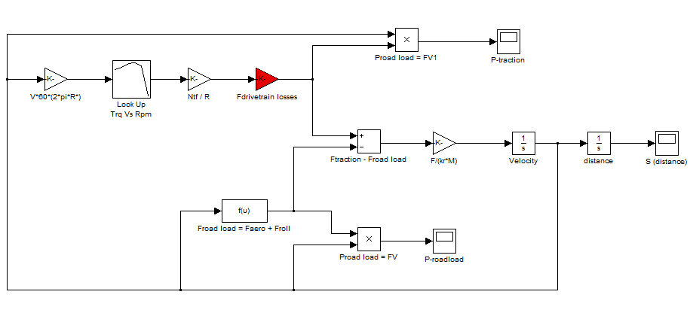
Figure 26: Preliminary Drivetrain Model

As can be seen in the modelling the first triangle function is used to convert the input of the reference velocity into rpm value so that the next block which is the Torque vs. RPM curve can be used to obtain the appropriate torque for the velocity reference input. Once the torque value is obtained, it will transfer to the next block which is the first element of tractive force.
Once the value is multiplied with the tractive force first element, it will move to the next block which is the second element of the tractive force. In this block the value will be subtracting the second element values. When the value is subtracted, it will be sent to the function block that is the subtracting block as the tractive force. Meanwhile a new algebraic function block is created for representing the road load. In this block, the mathematical modelling derived will be inserted with the values. Once it is set, it is sent to the subtracting block as the road load force. In the subtracting block the tractive force obtained will subtract the road load forces and sending it to the next function block which is the acceleration block. Here the value obtained will be intergraded to become velocity and finally distance by using the integral block. At end of the integral block a scope block is fitted to show the performance of the vehicle in term of distance. Not only that, two more scopes were fitted at the end of the tractive force and road load force in order to see the fluctuation in the forces during running. So by fitting the scopes in the forces, the preliminary modelling for the vehicle drivetrain is completed but this model will further undergo many changes as the real measurement of the vehicle is taken and also by fitting the forward looking model (PID controller).

4.3 Detailed Modelling
A detailed drivetrain modelling was developed by expanding the existing preliminary model that has been built previously in Matlab. The expansion of the preliminary model was done by inserting several additional elements such as driver model, gear selector model, thermoelectric generator (TEG) model and cylinder deactivation model. In order to develop this detailed model, the mathematical functions and calculation that has been used previously in the preliminary modelling is used back with some minor modification to it. As previously mentioned, in order to develop a drivetrain model all the losses and forces in the drivetrain and vehicle needed to be identified. So by referring to [5] the forces and the losses occur in the vehicle can be calculated using in the following equations:
Tractive Force:
$$F_{t}=\frac{(Te )(Ntf)}{r}-\{\left(I_{e}+I_{t}\right){N_{tf}}^{2}+I_{d}{N_{f}}^{2}+I_{w}\}\frac{a_{x}}{r^{2}}$$
Road Load Force:
$$P_{road load}=\frac{1}{2}pA_{f}C_{d}(V-V_{w})^{2}+Pf_{r}$$
During the preliminary modelling development, the values for the inertia losses and forces were calculated and shown in the preliminary modelling development section. During the calculation, some values were obtained from the vehicle manufacturer specification and some values were assumed due to difficulty of measuring the component because the components needs to dismantled in order to measure. In this detailed drivetrain modelling development, the estimated value is considered to be correct but certain value has been changed in order to replicate the real effect of the vehicle drivetrain losses. For example, previously in the basic model, the acceleration, a_{x} value for the tractive force were assumed to be varied according to the vehicle speed, but after detail analysing it is fixed in a constant value that represents the average increment of the vehicle acceleration. The constant acceleration value is obtained by first collecting the vehicles 0-100 km/h acceleration time data. Once the time is obtained, it is simplified to obtain the time needed to accelerate from 0 to 10 km/h. The obtained value was 2.53 m/s².
Other than that, the combined final drive and transmission ratio, N_{tf} in the tractive force equation were changed by inserting a gear selector model where, the gear ratio will be varied according to the vehicle speed. The gear selection corresponding to the vehicle speed data is shown in the table below:
Table 6: Gear selection corresponding to vehicle speed data
GEAR NUMBER | N | 1_{st} | 2_{nd} | 3_{rd} | 4_{th} | 5_{th}
GEAR RATIO | 0 | 3.142 | 1.842 | 1.25 | 0.865 | 0.75
SPEED (km/h) | -0.1 – 0 | 0.1- 25 | 25.1 - 48 | 48.1 - 72 | 72.1 – 88.5 | 88.6 - 200

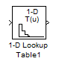
Figure 27: Gear Selector Model

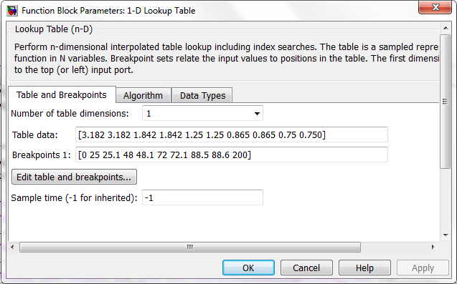
Figure 28: Gear Ratio Corresponding to Vehicle Speed

Once the gear selector model is developed, the drivetrain were needed to be attached with a driver model to provide the input for the model in term of acceleration, braking and deceleration. The driver model developed in the Matlab is a simple PID controller where the proportional, differential, and integration value is adjusted to obtain a perfect curve (low oscillation) during the simulation. Once the driver model is developed, UDDS drive cycle data were attached to the driver model to provide the driver with urban drive cycle schedule input. This input will be followed by the driver model and implement it inside the drivetrain model to simulate the vehicle urban drive style. The UDDS drive cycle runs for 1369 seconds (22.8 minutes) and has various driving style such as climbing hills, braking, accelerating, decelerating and traffic light stopping.
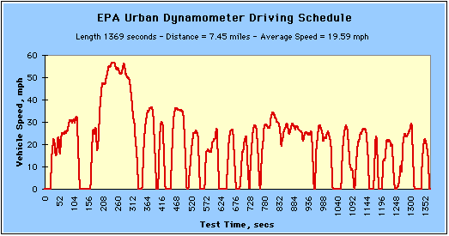
Figure 29: UDDS Drive Cycle Profile

After inserting the driver model (PID) and gear selector model, the detailed drivetrain has been completed around 80%. The next component needed to be inserted inside the model will be TEG model and cylinder deactivation model.

4.4 Cylinder Deactivation Model
In cylinder deactivation model, two cylinders (piston) of the vehicle is being shut off, in other words cylinder no. 1 and 3 will not provide any power stroke to the engine. So an appropriate model is needed to be developed to simulate the vehicle drivetrain with cylinder deactivation system. In order to develop the cylinder deactivation model, important data such as the torque vs. rpm needs to be obtained. Through using GT-Power software, a Myvi engine model with cylinder deactivated system were developed and simulated to obtain the torque vs. rpm curve and data. The obtained data is shown below:
Table 7: Torque vs. RPM for Cylinder Deactivated
Speed (RPM) | Torque (Nm)
500 | 25.17
1000 | 33.57
1500 | 39.38
2000 | 41.08
2500 | 43.83
3000 | 43.87
3500 | 44.72
4000 | 44.92
4500 | 48.04
5000 | 47.94
5500 | 46.28
6000 | 44.14
6500 | 39.21
7000 | 34.64

These data is then inserted inside the Matlab software via using 1D lookup table thus creating a cylinder deactivated model for the drivetrain. This cylinder deactivated model will be used to replace the normal engine model when cylinder deactivated drivetrain model is needed to be simulate.

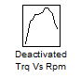
Figure 30: Cylinder Deactivated Model

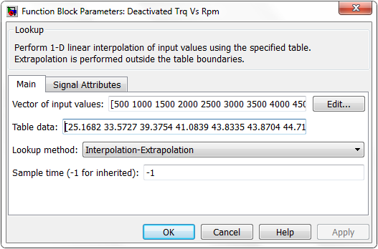
Figure 31: Engine Torque Corresponding to Engine RPM

4.5 Thermoelectric Generator (TEG) Model
In the purposed city concept car, one of the advance technologies that are purposed is the thermoelectric generator (TEG) system. Thermoelectric generator (TEG) system is a component that uses the waste heat from vehicle exhaust to produce electricity. This system is known as the heat recovery system and it is very valuable system as it converts the waste exhaust heat gas into useful electric via power. Since this technology is used in the vehicle, a modelling needs to be done for the system so that it can be incorporated in the vehicle drivetrain model and simulated it. In order to develop a model for the TEG system, the mathematical equation that represents the recovered heat power by TEG system corresponding to the vehicle system needs to establish. The corresponding power equation that incorporates both TEG system and vehicle system is shown below:
TEG Power:
$$Power=\frac{{ΔT}_{act}}{{ΔT}_{max}} x 20 watt x No. of TEG$$
In order to obtain the power values, several information needs to be gained such as the T_{act} value, T_{max} value and number of TEG used. Actual temperature value is exhaust temperature that the engine produces during various RPM and torque conditions. So to represent the actual engine exhaust temperature, an equation that includes the engine variables needs to be used. Hence the equation for the actual temperature is created:
Actual Temperature, ΔT_{act}:
$${ΔT}_{act}=\frac{Q}{pὐC_{p}}$$
Where:
Q = 30% of Engine power, P_{engine}
p = Density of air
$ὐ$ = Volumetric flow rate
C_{p} = Specific heat value
So to obtain the Q value, the engine power needs to be calculated and multiplied with 30%. The reason why the engine power is multiplied with 30% is because the engine releases 30% of its power as exhaust heat. In order to obtain the engine power, P_{engine}, the torque (Nm) produced by the engine needs to multiplied with the engine speed (rad/s). These two values is not a constant value because it changes with the velocity of the vehicle, so the RPM value and the torque value that is being used in the drivetrain model is applied in the TEG model to simulate the real driving condition vehicle.
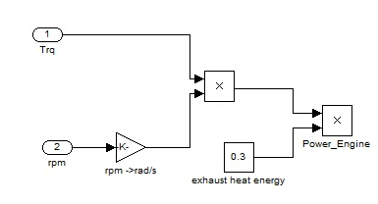
Figure 32: 30% Engine Power Modelling

As can be seen in the model, the torque and RPM value is obtained from the drivetrain model and multiplied with the 30% to obtain the exhaust power. Meanwhile, the air density value is used as 1.23 kg/m³ and for the C_{p} of air, 1.005 kJ/kg K is used. As for volumetric flow rate, cubic feet per minute (CFM) equation is used to calculate the volumetric flow rate.
Cubic Feet per Minute (CFM):
$$CFM=\frac{CID x RPM x VE}{3456}$$
Where:
CID = Engine displacement in cubic inches
= Myvi 1.3 liter ≈ 79.2 cu in
RPM = Revolution per Minute
VE = Volumetric Efficiency
= 100%
So using the CFM equation, the CFM value for the engine corresponding to the RPM is obtained and these values are converted into volumetric flow rate using unit conversion method. The obtained volumetric flow rate,$ὐ$, and engine RPM is inserted into the 1D lookup table so that, the proper volumetric flow rate can be taken according to the vehicle speed during the simulation.
Table 8: Volumetric Flow Rate vs. RPM
Speed (RPM) | CFM (ft³/min) | $ὐ$ (m³/s)
500 | 11.46 | 0.0054
1000 | 22.92 | 0.011
1500 | 37.38 | 0.016
2000 | 45.83 | 0.022
2500 | 57.29 | 0.027
3000 | 68.75 | 0.032
3500 | 80.21 | 0.038
4000 | 91.67 | 0.043
4500 | 103.13 | 0.049
5000 | 114.58 | 0.054
5500 | 126.04 | 0.059
6000 | 137.50 | 0.065
6500 | 148.96 | 0.070
7000 | 160.42 | 0.076

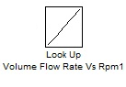
Figure 33: Volumetric Flow Rate Model

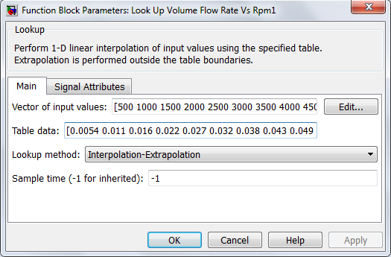
Figure 14: Volumetric Flow Rate Corresponding with Engine RPM

Once the volumetric flow rate model is developed, the lookup table will be inserted into the actual temperature, T_{act} equation to obtain the values. As for the T_{max} value it is set at 300 ⁰C because the TEG module can only work until 300 ⁰C. Meanwhile for the quantity of the TEG module, it is set to install only 3 TEG modules in the vehicle. Once all these parameters were established, the TEG model is developed for the system and several measuring scopes is attached to the model. The attached scopes are power and energy, which purpose is to determine the amount of power and energy developed by the TEG system.
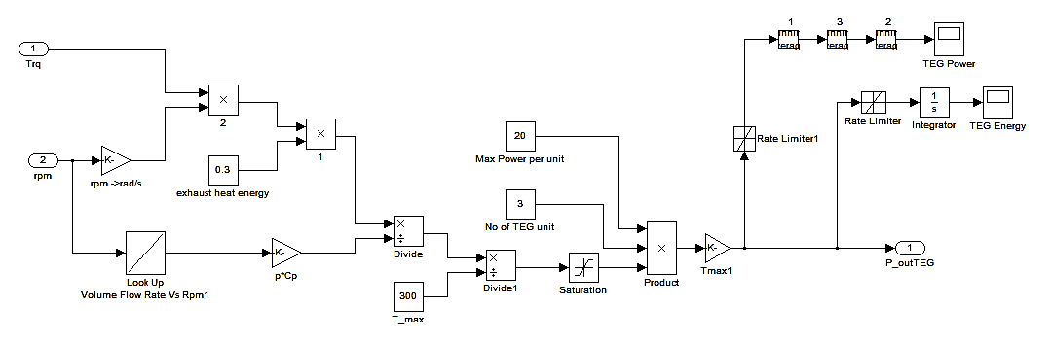
Figure 35: Thermoelectric Generator (TEG) Modelling

CHAPTER 5
RESULT AND DISCUSSION

5.1 Drivetrain Modelling Result and Discussion
The developed drivetrain modelling with advance technologies such as cylinder deactivation and thermoelectric generator (TEG) for the purposed city concept car is shown in figure 35.
As can be seen in the drivetrain modelling the normal engine model, cylinder deactivation model and TEG model is ready to be used in the simulation. The drivetrain model will be working by inserting the UDDS drive cycle data into the driver model (PID), where the driver will response on the throttle and brakes to follow the drive cycle pattern. The response from the driver will be multiplied with the tractive force that has been generated from the engine torque and drivetrain losses. The obtain value will be used to minus the road load losses due to aerodynamic drag and rolling resistance. Once the value is obtained, it will be transferred to the next block which is to calculate the acceleration of the vehicle by dividing the vehicle mass. The acceleration value is then integrated to obtain velocity and distance of the vehicle travelled. These velocity and distance data is shown in a graphical manner.
Due to the closed looped modelling, the velocity obtained is feed backed to the driver model to calculate the difference between desired (input) value and delivered (output) value so that the driver can adjust it acceleration or deceleration values. Besides that, some additional scopes such as gear exchange scope, road load power scope, tractive power scope were attached in the model to monitor the simulation of the drivetrain either it is functioning properly or not. Other than that, there were some mathematical blocks and gain blocks are used to convert the unstandardized units into SI units as well as to perform mathematical functions.
During cylinder deactivation simulation, the normal torque vs. RPM lookup table will be replaced with the cylinder deactivated torque vs. RPM model and the drivetrain will function as same as during the normal engine simulation but the torque value will be taken from the cylinder deactivated lookup table. As for the TEG system, the model will only be used during the cylinder deactivation simulation using the cylinder deactivated torque and RPM data.

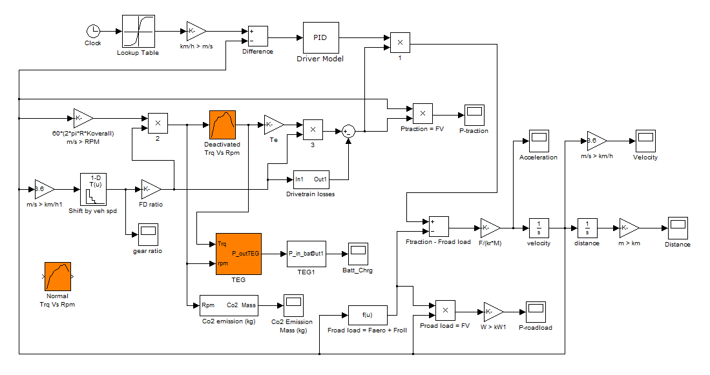
Figure 36: Drivetrain Model with Advance Technologies

5.2 Simulation Result and Discussion
5.2.1 Normal Drivetrain (without cylinder deactivation and TEG)
First simulation was conducted to the developed drivetrain model without using any new technologies such as the cylinder deactivation and TEG system. The simulation uses the UDDS drive cycle profile and ordinary torque vs. rpm data. Two results were obtained from the simulation which is fuel consumption rate and emission figures in order to evaluate the vehicle performance. The results were shown below:
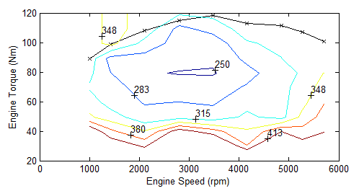
Figure 37: Hot Fuel Use Map for Normal Drivetrain

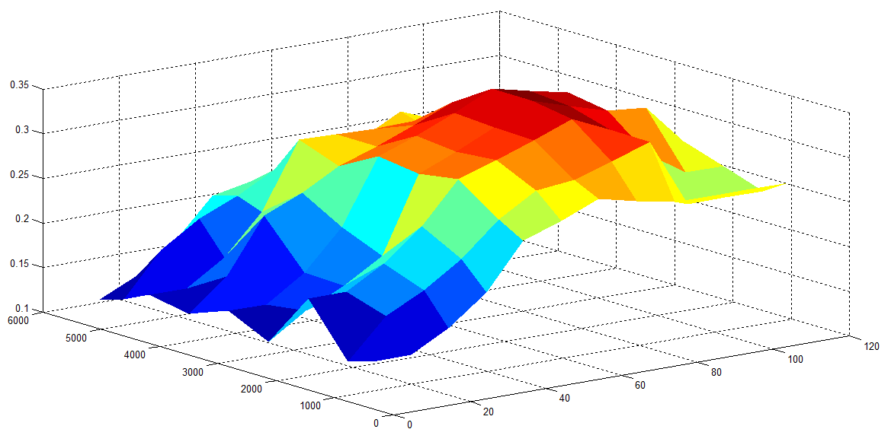
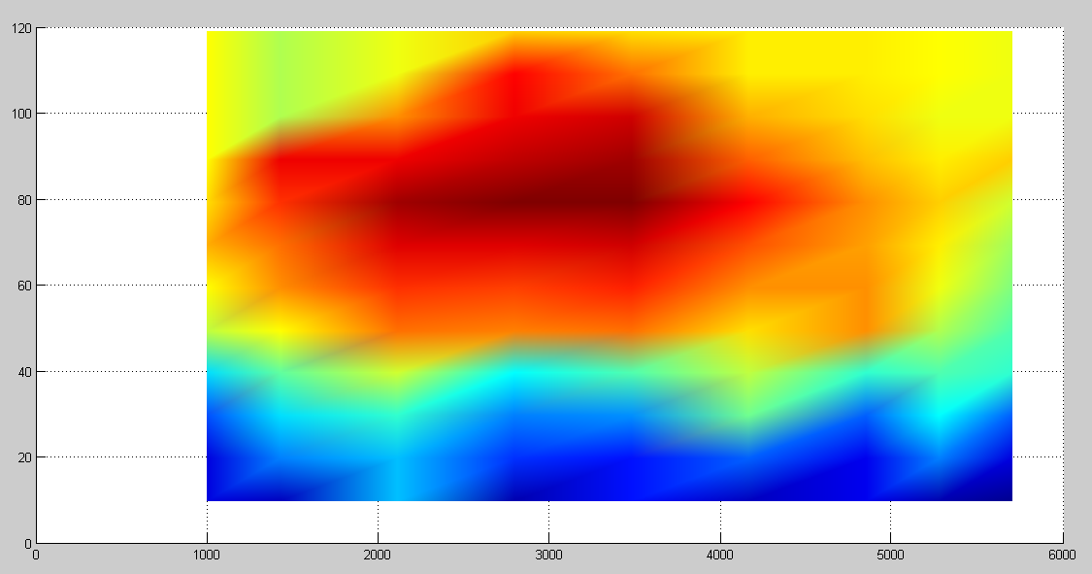
Speed (RPM)
Torque (Nm)
Figure 38: Fuel Efficiency Map for Normal Drivetrain

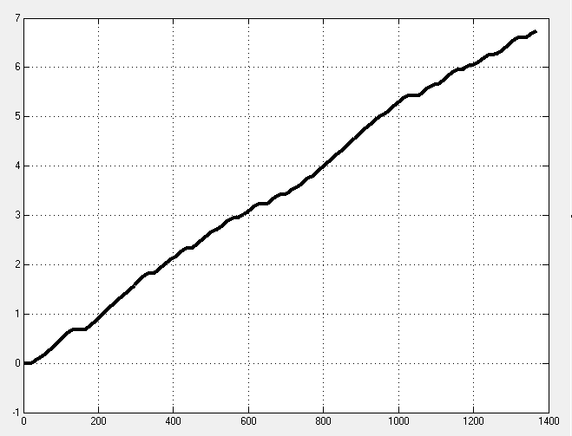
Time (s)
CO₂ Released (kg)

Figure 39: Mass of CO₂ Released for Normal Drivetrain

From hot fuel use diagram, the vehicle has high efficiency of fuel usage (250 g/kWh) if it operates at 2500 to 3500 RPM with a torque ranging from 75 to 84 Nm but by referring to the actual engine torque vs. rpm curve corresponding to the fuel map, the vehicle most efficient usage of fuel (283 to 315 g/kWh) fall in between 1500 to 3200 RPM with torque ranging from 90 to 117 Nm. Since the simulation is done by using the UDDS drive cycle profile, the engine will be operating at a range from 500 to 3000 RPM, thus making the engine to operate at a fuel usage of 315 to 290 g/kWh depending on the vehicle speed corresponding to the UDDS cycle. This indicates that the engine is operating at its average efficiency level. So from the simulation it is founded that the vehicle uses fuel around 5.9 L/100km or 17.1 km/l to complete the UDDS drive cycle and this result is same as compared to the Perodua Myvi fuel consumption. Meanwhile as for the carbon dioxide, CO₂ release, the vehicle releases around 6.7 kg of carbon dioxide for 0.38 hour (22.8 minute) driving. This is because during the simulation, the vehicle experiences acceleration, constant and deceleration drive profile. Hence the vehicle has to meet this requirement thus enabling it to use variety power range. Due to the variety of power range usage, the vehicle engine also has to operate according to the requirement. So, a variable volumetric flow rate is needed in order to achieve the UDDS drive cycle requirement and this makes the vehicle to have different air mass flow rate throughout the simulation, thus making the vehicle to produce 6.7 kg of CO₂.

    - Cylinder Deactivated Drivetrain (without TEG)
The second simulation for the city concept car drivetrain was conducted by using the cylinder deactivation model. The purpose of using this cylinder deactivated model is because it enables the vehicle to reduce the fuel usage thus making the vehicle to be fuel saving vehicle. In the second simulation the same UDDS drive cycle profile is used and the ordinary torque vs. rpm data is replaced with the cylinder deactivated torque vs. rpm data. The result of the simulation is shown below:
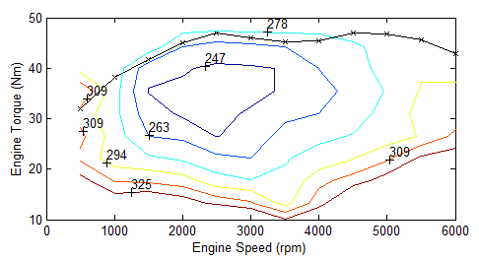
Figure 40: Hot Fuel Use Map for Deactivated Cylinder

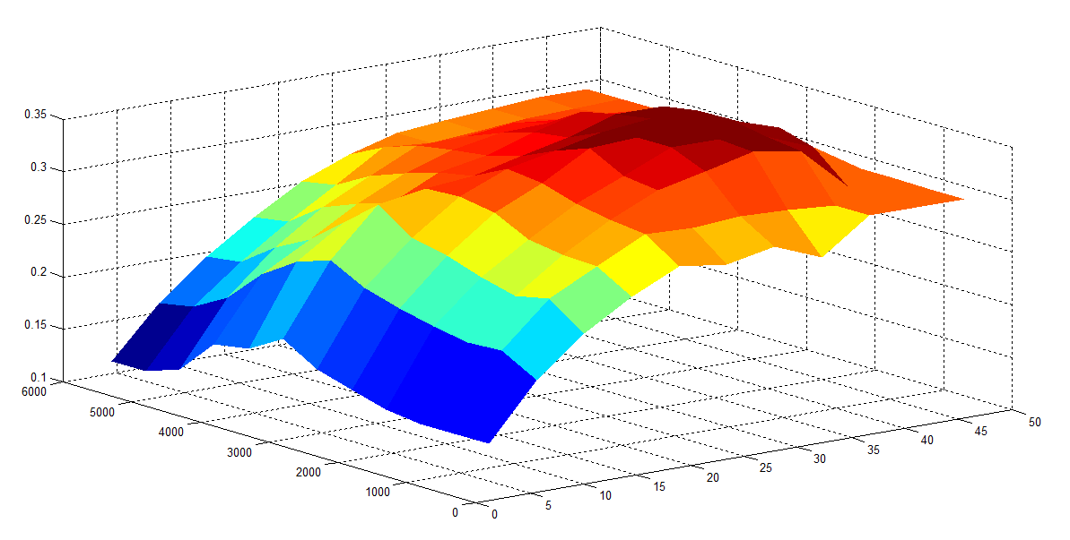
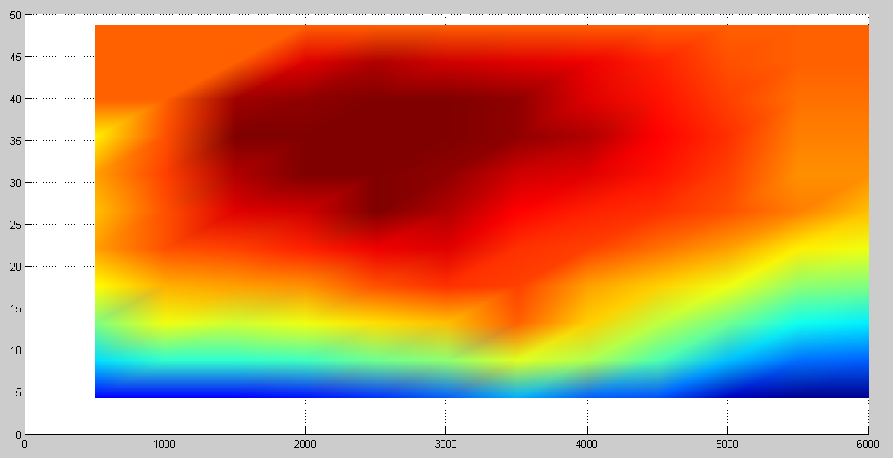
Speed (RPM)
Torque (Nm)

Figure 41: Fuel Efficiency Map for Deactivated Cylinder

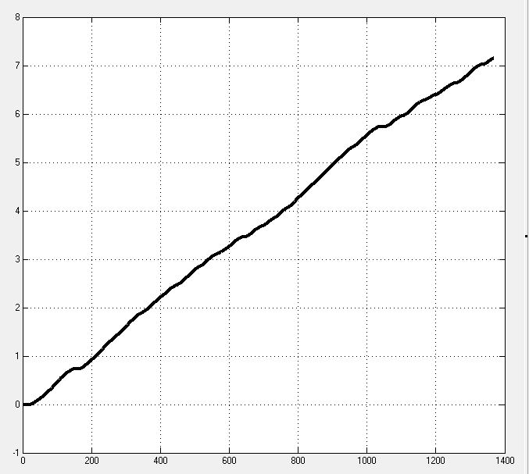
Time (s)
CO₂ Released (kg)

Figure 42: Mass of CO₂ Released for Cylinder Deactivated Drivetrain
From the result obtain, it can be seen that the during cylinder deactivation, the vehicle produces 7.15 kg of carbon dioxide, CO₂. This is because the cylinder deactivated torque and power are lesser than the normal engine. Therefore, during acceleration, to achieve the required speed and power, higher volumetric flow rate needs to be obtained. So, due to this reason, the air mass will be larger during the cylinder deactivation model rather than the normal cylinder system. Hence making the CO₂ amount produced is higher than normal cylinder system. Meanwhile as for the fuel consumption rate, the vehicle with cylinder deactivation technology has reasonable higher efficiency of fuel usage compared to the normal engine condition. As can been seen from the hot fuel map usage, the deactivated cylinder engine curve operates at a lower torque compared to the normal engine curve. Not only that the deactivated cylinder curve operates at the region where the fuel usage is quiet low compared to the normal engine curve. Since the simulation is using the UDDS drive cycle profile, the vehicle will be operating at an rpm of 500 to 3000; this indicates that the deactivated cylinder engine will be using fuel at a rate from 309 g/kWh to 272 g/kWh. Even though initially the engine consumes higher fuel but once it reaches its optimum operating point the fuel usage reduces drastically as it operates close to the 263 g/kWh range. Not only that, due to the cylinder deactivation technology, only two cylinders will be operating by burning the fuel meanwhile other two will not consume any fuel. Thus enables the engine to reduce the fuel usage and provide a higher fuel burning efficiency due to the increased pressure inside the cylinder. This aids the vehicle to consume low fuel compared to the normal vehicle. Hence from the simulation, it is founded that the vehicle only uses fuel around 4.6 L/100km or 21.7 km/l. This shows that from deactivating the cylinders, the fuel consumption rate has reduced around 25%.

    - Cylinder Deactivated Drivetrain with TEG System
The third simulation conducted for the developed drivetrain model is by using cylinder deactivation and TEG system. The simulation conducted using the UDDS drive cycle profile. Several results were obtained from the simulation which is TEG power generated, energy generated, fuel consumption rate and emission rate in order to evaluate the vehicle performance. The results were shown below:
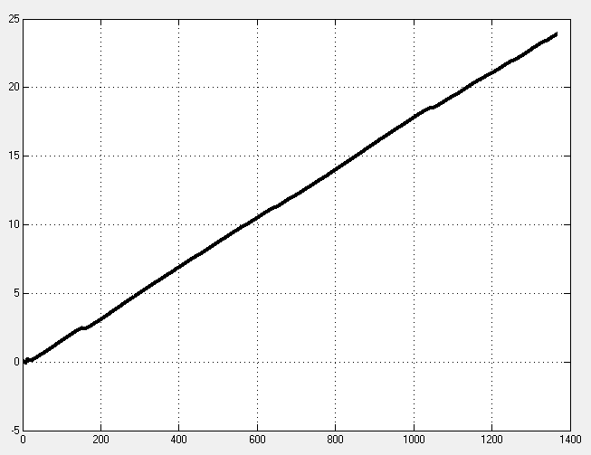
Time (s)
Energy (kJ)

Figure 43: Energy Developed by TEG System

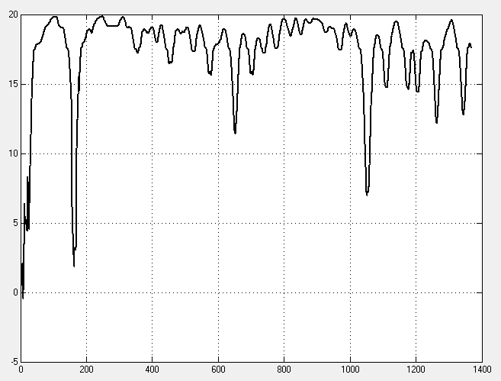
Time (s)
Power (Watt)

Figure 44: Power Generated by TEG System

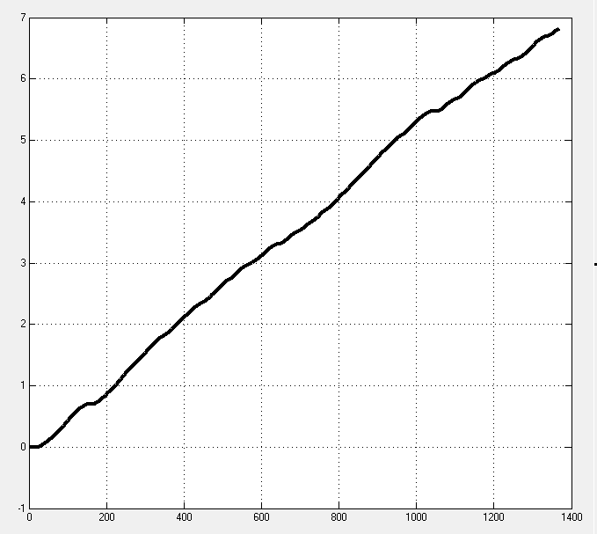
CO₂ Released (kg)
Time (s)

Figure 45: Mass of CO₂ Released for Cylinder Deactivated + TEG Drivetrain

As can be seen from the result the vehicle using cylinder deactivation and TEG system produces 6.8 kg of CO₂. This combined cylinder deactivation and TEG system produces less CO₂ (6.8 kg) compared with vehicle using cylinder deactivation system only (7.15 kg). This is because the TEG system absorbs or recovers 30% of the exhaust heat that vehicle releases as waste heat and converts it into electricity. This generated electricity is commonly used to charge the vehicle battery and also to power up some minor auxiliaries. From the simulation conducted, by using 3 TEG modules with maximum power of 20 Watt per module, the total energy that the TEG system can be generate were obtained and shown in the figure above. The TEG system is capable of producing a total of 23.91 kJ of energy throughout the drive cycle. Not only have that, the TEG system also able to produce an average power of 20 Watt throughout the drive cycle. Therefore, equipment such as air condition, power steering and water pump can be replaced with electrical ones. Thus enables the engine to use the fuel only to generate power for propulsion only. So from the simulation conducted, the TEG systems were able to increase 5% to 6% of fuel efficiency to the engine thus making the fuel usage to be 4.5 L/100 km or 22.2 km/l.

CHAPTER 6
CONCLUSION AND RECOMMENDATION

6.1: Conclusion
In conclusion, based from the result of the simulation done on the developed drivetrain, it is clarify that the vehicles with advance technology drivetrain which is cylinder deactivation with TEG system has the lowest fuel consumption which is 4.5 L/100 km or 22.2 km/l, compared with cylinder deactivated drivetrain fuel consumption, 4.6 L/100km or 21.7 km/l, and normal drivetrain normal drivetrain fuel consumption, 5.9 L/100km or 17.1 km/l. Not only that, the drivetrain with cylinder deactivation with TEG system provides a low CO₂ emission, 6.8 kg, compared to cylinder deactivated drivetrain only which releases 7.15 kg of CO₂. Besides that, the cylinder deactivated with TEG drivetrain also uses the waste heat from the exhaust and converts it into useful energy, thus making the drivetrain to be more favourable. So, it can be concluded that the drivetrain with cylinder deactivation and TEG system is more fuel economy and efficient. Furthermore, a better understanding on the vehicle drivetrain can be accomplished with the aid of the developed drivetrain thus enables engineers and manufactures to create and developed a much efficient drivetrain system for future vehicles.

6.2: Recommendation
Due to the time constraint and unavailability of skilled personnel, several information such as the 1st, 2nd, 3rd, 4th and 5th actual gear mass and shaft diameter were unable to be obtained. So these values were assumed after some intense research was done. Not only that other value such as the driveshaft mass and flywheel mass were also assumed because of the complexity of dismantling the parts. So the drivetrain model that has been developed would not be 100% same as the actual drivetrain due to this matter, hence it is recommended that the individual up taking this project as a continuation should seek some professional help to dismantle and measure the actual dimension as well the mass of the gearing, flywheel and driveshaft. The next recommendation will be on the cylinder deactivation technology, where it is known that when the vehicle cylinder is deactivated the engine torque will be reduced drastically so to compensate it as well as reducing the fuel usage, it is suggested to use an electric turbo charging (e-turbo) system. So to prove this theory it is recommended that a model for the electric turbo charging should be made and analyses it. These are the recommendation that is provided in order to make this drivetrain model more efficient.

REFERENCES

[1] Schappell, K. (n.d.). Your Drive Train Explained. Retrieved 20 Jun, 2013, from Lee Myles TRANSMISSIONS & AutoCare: http://leemyles.com/articles/your-drive-train-explained.html
[2] Vehicle Modeling Approaches. (September, 2010). Retrieved 22 Jun, 2013, from Autonomie: http://www.autonomie.net/references/vehicle_mods_25.html
[3] Georgios, Z. (2005). Mathematical and Numerical Modeling of Flow and Combustion Processes in a Spark Ignition Engine. Department of Applied Mathematics.
[4] Heywood, J. B. (1988). Internal Combustion Engine Fundamentals. Massachusetts Institute of Technology: McGraw Hill.
[5] Gillespie, T. D. (1992). Fundamental Of Vehicle Dynamics. Warrendale: Society of Automotive Engineers. Inc.
[6] Keith B. Wipke, M. R. (1999). ADVISOR 2.1: A User-Friendly Advanced Powertrain Simulation Using Combined Backward/Forward Approach. IEEE TRANSSACTION ON VEHICULAR TECHNOLOGY, Vol 48, No 6.
[7] Stephen, M. The Effect of Rotational Inertia on Automotive Acceleration. Rotational Inertia: http://stephenmason.com/cars/rotationalinertia.html

