

**DESIGN AND FABRICATION OF WIND POWER EXPERIMENT LAB KIT**

By

Syed EhsanulHaqGlani

(12916)

Submitted to the Department of Mechanical Engineering in Partial Fulfilment of the Requirements for the Degree Bachelor of Engineering (Hons) (Mechanical Engineering)

**SUPERVISOR**

**Associate Professor Dr. Hussain H. Al-Kayiem**

September 2013

*UniversitiTeknologi PETRONAS*

*Bandar Seri Iskandar*

*31750 TronohPerakDarulRidzuan*

CERTIFICATION OF APPROVAL

**DESIGN AND FABRICATION OF WIND POWER EXPERIMENT LAB KIT**

By

Syed EhsanulHaqGlani

(12916)

A project dissertation submitted to the

Mechanical Engineering Programme

UniversitiTeknologi PETRONAS

In partial fulfilment of the requirement for the

BACHELOR OF ENGINEERING (Hons)

(MECHANICAL ENGINEERING)

Approved by,

________________________________

(**AP Dr. Hussain H. Al-Kayiem**)

UNIVERSITI TEKNOLOGI PETRONAS

TRONOH, PERAK

SEPTEMBER, 2013

**CERTIFICATE OF ORIGINALITY**

This is to certify that I am responsible for the work submitted in this project, that the original work is my own except as specified in the references and acknowledgements, and that the original work contained herein have not been undertaken or done by unspecified sources or persons

------------------------------------------

*SYED EHSAN UL HAQ GILANI*

*12916*

*MECHANICAL ENGINEERING*

**ACKNOWLEDGEMENT**

First and foremost, I would like to thank Allah (S.W.T) for endowing me with health, patience, and knowledge to complete this work. Next I would like to use this opportunity to thank several people for their help in completing the work for this Project. I would like to express my sincerest gratitude to:

**My supervisor; Dr. Hussain Al-Kayiem** for his whole-hearted supervision throughout this project as well as his patience and guidance whilst allowing me the room to work in my own way. I highly appreciate his time and effort and his guidance to establish a better understanding of the subject matter. His enthusiasm and dedication had inspired me to strive harder in completing this project.

The members of UTP design center especially **Mr. Shahrul** and **Mr. Saiful** for their help in fabrication of the lab kit in such a short amount of time.

I would also like to take this opportunity to thank to my father **Dr. S.I. Gilani** for his continuous support, excellent direction, invaluable feedback and constructive suggestions that helped me in bringing some innovation to the design. Thereafter, I am deeply indebted and grateful to **Mr.Mohammad Irfan** for his support and invaluable advice on setting up the in time data analysis system which played an enormous role in the success of this project.

Last but not least, heartfelt gratitude to my family who has been giving the courage and moral support to keep me constantly engaged in this project.

Thank you.

**ABSTRACT**

Practical demonstration and measurement are crucial to support the teaching deliverables for the Under Graduate students to understand the theories. The energy conversion terminology, in general and the wind energy conversion, in particular are within the courses of Mechanical engineering department in UTP.Unfortunately there is no well-established lab under this cause. This project is being designed to allow students to understand the effect of rotor design on the performance of wind power systemso as to help understand the wind energy conversion systems better. Accordingly, a demonstration and experimental system was designed, fabricated and tested to take place in the new lab which is under establishment. This setup can later be used to test the performance of different types of wind rotors.

**LIST OF FIGURES**

Figure 2.1: The types of wind turbine: left side is VAWT and the right side is HAWT

Figure 2.2: The HAWT cut view

Figure 2.3: The swept area and radius of wind turbine

Figure 2.4: American Classic wind turbine

Figure 2.5: The performance graph of classic American wind power

Figure 2.6: the schematic of Savonius rotor

Figure 3.1: The top view of the conceptual design

Figure 3.2: Side view of the conceptual design

Figure 3.3: Orthographic view of the lab kit experiment kit (conceptual design)

Figure 3.4: The complete experimental setup to test the wind turbine

Figure 3.5: The front view of the experimental setup

Figure 3.6: The connection board (left), The data logger for debimo measuring blades (right).

Figure 3.7: Data acquisition system layout for lab experiment

Figure 3.8 lab experiment junction box diagram

Figure 4.1: The detailed drawing of wind tunnel

Figure 4.2: The plot of Turbine voltage (V) against the Wind speed (m/s) for HAWT

Figure 4.3: The plot of Turbine voltage (V) against the Wind speed (m/s) for VAWT

Figure 4.4: Power curve for VAWT and HAWT

**TABLE OF CONTENTS**

CHAPTER 1 1

INTRODUCTION 1

1.1. BACKGROUND 1

1.2. PROBLEM STATEMENT 2

1.3. OBJECTIVE 2

1.4. SCOPE 2

CHAPTER 2 4

LITERATURE REVIEW 4

2.1. INTRODUCTION 4

2.2. HARVESTING WIND ENERGY 4

2.3. EXTRACTABLE WIND POWER 6

2.4. ENERGY CONVERSION EFFICIENCY 7

2.5. ROTOR PERFORMANCE 7

2.6. LAB EQUIPMENT TO DEMONSTRATE WIND POWER AND EFFICIENCY 8

2.7. THE DEBIMO AIR FLOW MEASURING BLADES 8

2.8. FLUID FLOW RATE 9

2.9. TYPES OF WIND TURBINE 10

2.9.1. CLASSIC AMERICAN WIND TURBINES – HAWT. 10

2.9.2. THE SAVINOUS ROTORS -VAWT 12

CHAPTER 3 14

METHODOLOGY 14

3.1. SOLUTION PROCESSED 14

3.2. EXECUTIVE FLOW CHART AND GANTT CHART 14

3.3. CONCEPTUAL MODEL 17

3.4. MATERIAL SELECTION 19

3.5. EXPERIMENTAL SETUP 20

CHAPTER 4 25

RESULTS AND DISCUSSIONS 25

4.1. CONSTRUCTION OF THE WIND REGULATOR 25

4.2. DATA COLLECTED FROM LAB VIEW 26

4.3. PERFORMANCE OF THE CLASSIC AMERICAN WIND TURBINE 29

CHAPTER 5 32

CONCLUSION AND RECOMMENDATIONS 32

5.1. CONCLUSION 32

5.2. RECOMMENDATIONS 32

REFERENCES 33

APPENDICES 35

CHAPTER 1

INTRODUCTION

* 1. BACKGROUND

Renewable energy is receiving increased attention as a possible alternative to non-renewable electrical and power generation. One of the most prominent of the renewable energy is the wind power. Recently, wind energy has grown at an impressive rate in entire world. Wind energy has become a particularly interesting field for scientist and engineers to work in [1].A typical wind power generation system includes many components. The efficiency of the wind turbine system depends on a number of parameters for example the flow rate of air, the gear unit, the generator or the weight of power transmitting shaft but the most important parameter for an efficient wind turbine is the shape and design of the rotors. The rotors come in many different shapes and sizes depending on external factors and the scale of the wind power project. Previously there had been no fix mechanism for testing the efficiency of a turbine’s rotor. This project will focus on designing and fabrication of an experimental setup for testing and monitoring the efficiency and power generation capacity for different types of wind turbine rotors.

As it is known, the blades are the most important components of wind turbine. In order to increase the energy conversion efficiency, the size of wind turbine blades increases. The blade diameter ranges from about 20 m to about 100 m. However, wind turbine blades are facing increasingly harsh and complexity service environment. It is necessary to test, inspect and monitor the wind turbine blades in order to guarantee the service safety of wind turbine blades [9].

Large Scale Wind Turbines (LSWTs) have been studied extensively for decades but only few studies have been conducted on the small scale wind turbines (SSWTs) especially for low wind speed applications[10]. In this project, an energy conversion analysis will be performed on different wind power systems as discussed earlier, including both horizontal and vertical axis wind turbines. This study will provide the theoretical and experimental results on small diameter wind energy portable turbine (SWEPT) with some rated wind speed. In order to test these rotors a complete experimental setup is needed to demonstrate the effect of wind on them.

* 1. PROBLEM STATEMENT

Due to lack of proper testing equipment in the UTP mechanical engineering department for energy conversion system, a lab kit is being designed which will enable the students to understand the energy conversion systems better. The current lab kit in market is very expensive and it does not have an in time wind speed measuring system. This new lab kit will be used to demonstrate the effect of wind on different type of turbines. The demonstration will include the wind energy conversion to useful power. The lab kit has to be designed and fabricated; and an online interface is also to be designed for the collection of data so as to analyze the effect of varying wind speed on the performance of turbine. All the experimental data can be visualized and plotted in time via a computer.

* 1. OBJECTIVE

The objectives of this project are:

* To design and implement wind energy conversion kit
* To design and implement online interface for in time data analysis
  1. SCOPE

Since this is a design, fabrication project, it therefore has a lot of parameters. Firstly in the designing phase it was ensured that the proper designing standards are followed and the correct tolerances are used in order to avoid any discrepancies later on wards. ISO tolerance standards were used in designing. Apart from designing and fabricating the experimental setup for the wind turbine experiment, a miniature model of the turbinewere also designed and fabricated which will be tested in this setup.

An online data plotter will be used in order to record and plot the results on a computer from the generator that is attached to the turbine. The scaled down turbines will be tested in the new lab kit and the results will be compared to the specification of the actual sized turbine.

CHAPTER 2

LITERATURE REVIEW

* 1. INTRODUCTION

To understand the objectives of this project better, a study of wind energy and its conversion efficiency has been carried from various sources. In order to continue this project it is very important that an extensive research on basic calculation of wind energy conversion system and there efficiencies is carried out. A brief literature on the wind energy system and lab kits is explained below.

* 1. HARVESTING WIND ENERGY

In order to understand how wind power is turned into electricity, we look back into a simple windmill, which was used in the past to grind flour by using shafts and gears mechanism.

In fact, the principle of work of old windmill and modern wind machines are pretty much similar. Both have blades, which are rotated by the power of wind [2].

Energy harvesting is the process by which energy is derived from external sources, in our case the energy isextracted from wind. Wind turbines are used to harvest wind energy [3]. Wind turbines convert energy contained in the wind into mechanical energy which is thus converted into electric power via the generator [4]. The shaft and gear units are used in most of the wind turbines in order to transmit the power extracted from the wind to the generators. There are two main type of wind turbine configurations, the first being the horizontal-axis wind turbine (HAWT) and the second is vertical-axis wind turbine (VAWT).the major difference in these two types are the axis of rotation of the rotors, the HAWT devices rotate in the horizontal plane while VAWT devices rotate in the vertical plane [5]. The amount of electricity a turbine produces depends on its type, size and speed of the wind. In terms of installed kilowatts and efficiency, the total capacity as well as efficiency of HAWTs exceeds that of the VAWTs [6]. Besides that, HAWTs are more common compared to VAWTs [5].

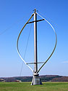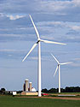

*Figure 2.1: The types of wind turbine: left side is VAWT and the right side is HAWT [7]*

The HAWT type is more commonly used in large scale electricity production as it is less complicated to erect and also it is more efficient in producing electricity. The VAWT is also desirable as it is much more safe compared to HAWT as the generator is placed on the ground below compared to HAWT whereby the generator is hanging in the air as can be seen in figure 2.1.

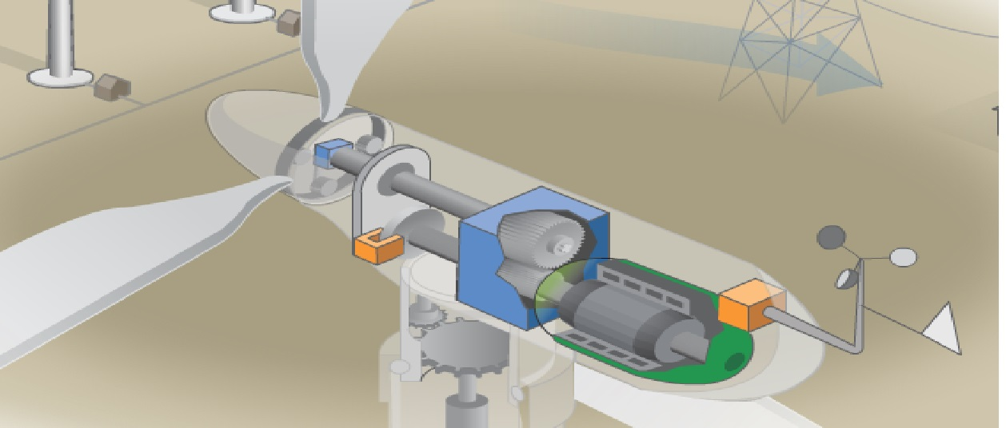

*Figure 2.2: The HAWT cut view [7]*

Both types of the wind turbines have the same basic parts: rotors, a tower, a gearbox and generator. The rotors are used to harvest wind energy and convert it into rotating motion. All the other parts work together to convert the rotating motion(mechanical energy) intoelectrical energy. Below is how a basic wind turbine functions [7]:

* The moving air spins the turbine blades or rotors.
* The blades are connected to a low-speed shaft. When the blades spin, the shaft turns.
* The low-speed shaft is connected to a gearbox. Inside a large slow-moving gear turns a small gear quickly. This is known as a gear unit
* The gear unit turns another shaft at high speed.
* The high-speed shaft is connected to a generator. As the shaft turns inside the generator, it produces electricity.
* The electric current is sent through cables down the turbine tower to a transformer the changes the voltage of the current before it is sent out on transmissions lines.
  1. EXTRACTABLE WIND POWER

Only a fraction of the total power available in the wind is extractable. The maximum power extraction from wind is as shown [8]:

Betz Law states that “even with the ideal wind energy conversion, the maximum power transferable is only 0.593 or 16/27 of the total power in the wind

$P_{ex(max)}=0.593×0.5×⍴×A×v^{3}$ (1)

Where

Pex is the maximum extractable power

⍴ is the fluid density

A is the swept Area of the turbine

V is the fluid velocity

The swept area of the turbine can be calculated from the length of the turbine blades using the equation for the area of a circle [14]:

$A=πr^{2 }$ (2)

Where the radius is equal to the blade length as shown in the figure 2.3:

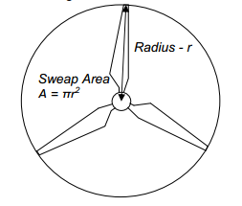

*Figure 2.3: The swept area and radius of the wind turbine [15].*

* 1. ENERGY CONVERSION EFFICIENCY

Energy conversion efficiency is the ratio between the useful outputs of energy conversion machine and the input, in energy terms. The useful output may be electric power, mechanical work, or heat. Energy conversion efficiency is not defined uniquely, but instead depends on the usefulness of the output. [5]

The efficiency (ƞ) of the wind turbine can be calculated as below:

Ƞ = $\frac{P_{out}}{P_{in}}$ (3)

Where,

Pout is the output power

Pin is the input power

* 1. ROTOR PERFORMANCE

Once a wind turbine rotor is designed for a specific application its performance characteristic are to be brought out before we fabricate the prototype. Dimensionally similar scaled down models of proposed design are tested under wind tunnel for this purpose.

The rotor is tested for different wind velocities and shaft loads. Power-speed and torque-speed characteristics of the rotor at different wind velocities can be generated from the data collected. This can be used to estimate the power coefficient and the tip speed ratio relationship of the model rotor

The power coefficient Cp is estimated from the following relation:

Cp(4)

Where

Cpis the power coefficient of the turbine

P is the pressure

$⍴$ is the fluid density

d is the diameter

v is the volume

* 1. LAB EQUIPMENT TO DEMONSTRATE WIND POWER AND EFFICIENCY

Wind energy Conversion Systems (WECS) have increasingly been developed over the last 10 years [11].The lab equipment to demonstrate wind power and its conversion efficiency is also a wind energy conversion system. The majority of WECS are built to harvest wind energy to produce electricity for consumption, however this lab equipment is built for learning purposes. After development, the lab equipment can be used to help ease the understanding process for wind power related studies. The lab equipment will be fully equipped with a data logger or an online data collector to conduct the experiment and also calculateefficiencies of the wind turbines.

* 1. THE DEBIMO AIR FLOW MEASURING BLADES

One of the equipment to be used in the lab kit is the Debimo air flow measuring blades. They actually have two functions; one of them is that they measure the air flow. Its working principal is very simple a differential pressure is generated as the air flows over these blades. This pressure is measured using differential pressure device which calculates the air flow from the differential pressure. The formula that relates differential pressure and air flow is:

$Air flow (\frac{m^{3}}{h})=K_{L}×√(P_{d})×S×3600$ (5)

Where,

KL is Debimo blade factor

Pd= Pt– Ps = dynamic pressure

S=duct suction (m2)

The velocity can also be measured using the differential pressure:

$Velocity (\frac{m}{s})=K_{L}×√(Pd)$ (6)

The other function of these blades is to prevent vortex that is caused by the fan. Vortices are not desired in the experiment as the velocity of the wind is not constant in a vortex and this could cause inaccuracies in the final results and data. The details of these air flow blades are mentioned in the appendices.

* 1. FLUID FLOW RATE

Mass flow rate is basically the rate at which a given mass passes through a given surface. Mass flow rate depend on the density of the fluid that is flowing, the cross sectional area of the surface across which the fluid is flowing and also the velocity of the flowing fluid. Mass flow rate can be calculated using the equation 5.

$\dot{m}= ⍴×A×v$ (7)

Where,

$\dot{m}$ is the mass flow rate in kg/sec.

⍴ is the density of the fluid in kg/m3

A is the cross sectional area of the surface in m2.

v is the velocity of the flowing fluid in m/sec

In a confined space the when the cross section area of the surface changes, it changes the velocity of the fluid also. In elementary form of continuity equation this can be expressed as:

$⍴_{1}×A_{1}×v_{1} = ⍴_{2}×A_{2}×v_{2}$ (8)

Since the fluid density remains the same on both sides of the surface, the density factor can be omitted from the equation.

* 1. TYPES OF WIND TURBINE
     1. CLASSIC AMERICAN WIND TURBINES – HAWT.

The American classic wind turbine was used to pump water from the ground. They are not commonly used today for producing electricity. It has multiple set of rotors and it is a type of HAWT. The wind turbine used for the short experiment was around 12cm in diameter and it had multiple set of blades. The figure 2.4 shows a typical American Classic wind turbine.

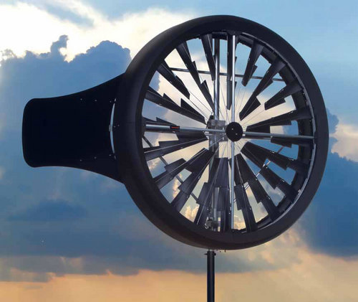

*Figure 2.4: American Classic wind turbine*

This type of turbine has more number of rotors as compared to the conventional 3 or 2 rotor turbines. It can rotate at higher speeds compared to the conventional wind turbine. The higher the number of rotors a turbine has the more energy it can capture from the wind turbine, thus increasing it efficiency.

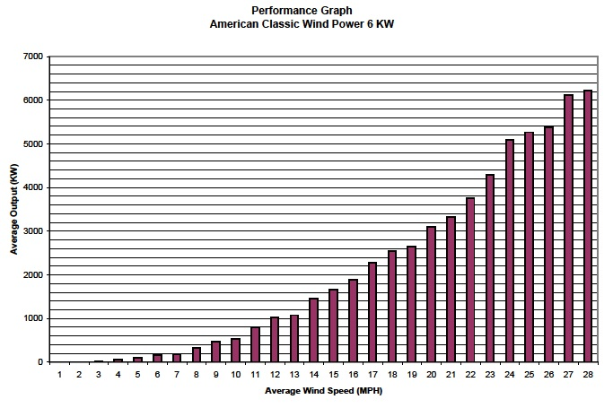

*Figure 2.5: the performance graph of classic American wind power (12)*

The power produced by this wind turbine increases as the wind speed increases. This can be seen in the figure 2.5. It shows the plot of average wind speed (MPH) against average output (KW)

It can be seen from this plot that as the wind power increases the turbine’s output also increases until it reaches a maximum output. After that an increase in wind power will not increase the average output of the turbine.

Generators convert rotational to electrical energy. This process results in energy loss, which affects the reading obtained during testing phase. This resistance from the generator to the rotor means that the rotor will only start spinning at a certain wind speed, this is known as the ‘cut in’ speed and is usually much lower than the optimal speed at which most power is generated, so basically the actual power produced by the generators is higher as compared to what is displayed during testing phases. In order to minimize this effect a multiplying factor is used for different types of generators and connections

Other types of losses are cabling losses and conversion losses. It is a well known fact that Energy is always lost through transmission to correct this in large scale application the cables are carefully specified and designed to minimize losses over long distance. In miniature lab scale experiments and testing, there are very few line losses but there is a lot of noise in the circuit which fluctuate the results obtained. These noises can be corrected using a RC-circuit.Energy is lost both in overcharging and that of exporting the DC supply through an inverter for domestic AC use (13).

* + 1. THE SAVINOUS ROTORS -VAWT

The Savonius type vertical axis wind rotor was first invented in 1929 by S. J. Savonius. Flettner's rotor was the design basis for the Savonius turbine. The rotor wasformed by cutting a Flettner's cylinder from top to bottom and then by moving the two semi-cylinder surfaces sideways along thecutting plane. The cross section of the rotors loosely resembles the letter ‘S’. It can be directly placed in flowing stream of the fluid to generate mechanical power from kinetic energy of flowing fluid. Applications of Savonius rotor, in general, include ventilation pumping water, driving an electrical generator.[15]

Figure 2.6 indicates schematic diagram of Savonius rotor with nomenclatures used. Two parameters which are the aspect ratio α and Overlap ratio, β, affect the performance of Savonius turbine. These two parameters are important in construction of the Savonius wind turbine

Aspect ratio:

The aspect ratio (α) represents the height of rotor relative to diameter. The relation is shown by

$α=\frac{H}{D}$ (9)

Where,

H is the height

D is the diameter

The aspect ratio α of the turbine designed was 2.5 with a height (H) of 20 cm and plate diameter (D) of 8 cm.

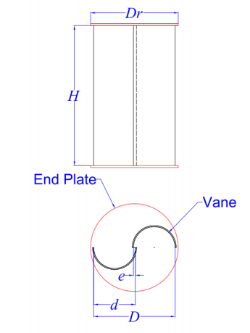

*Figure 2.6: The schematic diagram of a Savonius rotor [16].*

Overlap Ratio

The equation for the overlap ratio is given by

Overlap ratio is one important factor affecting the performance of the turbine. In present study, effort is made to find optimum overlap ratio to get best coefficient of performance [16].

$β=\frac{e}{d}$ (10)

The overlap ratio β of the designed turbine was 0.1 and the diameter of rotor (d) was 7 cm and the offset of the two rotors (e) are 0.7 cm. The turbine was designed without air sluice so that the energy conversion efficiency is better. A higher efficiency design was chosen to counter all the hindrance to the rotation of the rotors caused by friction.

CHAPTER 3

METHODOLOGY

* 1. SOLUTION PROCESSED

In order to carry out this project, a methodology is devised as a guide. The methodology is divided into two parts: Final Year Project I (FYP I) and Final Year Project II (FYP II). Below is the description for FYP I.

During the first part of this project, the first step was to study the basics of wind, wind energy and wind power from various sources such as articles, journals, books and website. After that some of the problems were identified. These problems were due to the equipment such as vortex generation due to the fan. Next a basic sketch was created for the design. This sketch acted as a guide for the author in order to proceed with modeling. The scope of study and limitations were put into consideration and calculations and tests will be conducted to know the parameters for the designs. A basic model for the online data logger was also studied so that it can be made before the start of FYP-II.

* 1. EXECUTIVE FLOW CHART AND GANTT CHART

The process flow for this project is given on the next page. It includes all the steps taken in order to complete this project. The project starts with identifying the scope and objectives of the project, gather valuable related literature for this topic which involves going through researches conducted on wind power and also the literature on the principals and laws that will be used in processing the data later onwards. After that a conceptual design is made on software and then fabricated. The miniature wind turbines are attached to the lab kit and the data is plotted online. Lastly the tests are conducted and the final data is presented to the supervisor.

The Gantt chart shows the progress of the project with respect to time. As it can be seen from the Gantt chart that the slowest process in this project is the fabrication process and maximum amount of time was allocated for the fabrication of different components of the lab kit.

EXUCUTIVE FLOW CHART FOR FINAL YEAR PROJECT



THE GANTT CHART FOR FINAL YEAR PROJECT

* 1. CONCEPTUAL MODEL

In order to have an idea how the experimental setup of the wind power lab kit will look like a conceptual design was made. This design has many features, firstly it is not very big and all its components can be transported or shifted easily from one place to another. The design is easy to assemble and disassemble. Apart from ease in fabrication and transportation

This lab kit has four basic components. The first one is the base plate, the base plate serves as platform upon which all the other components can be fitted and also it is thick so that it can absorb any vibration either from the fan or the resistance to wind flow, this will enable us to get a more accurate data. The second component of this lab kit is the fan which will be placed behind the wind tunnel and it will provide the flow of air for the experiment. The third equipment in this lab kit is the air flow tunnel which basically serves two functions. Firstly it holds the air flow measuring blades which measure the wind speed and secondly it ensures that there is no vortex generation which is caused by the motion of blades of the fan used. The fourth and final equipment of the lab kit is the turbine holder mechanism. The purpose of the holder mechanism is to hold the miniature model turbine and the generator in place while the wind flows through it. The holder mechanism could be installed at different lengths and height from the wind tunnel depending on the requirements.

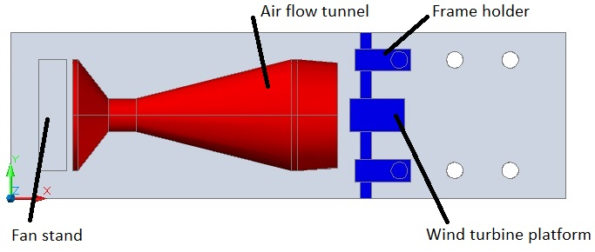

*Figure 3.1: The top view of the conceptual design*

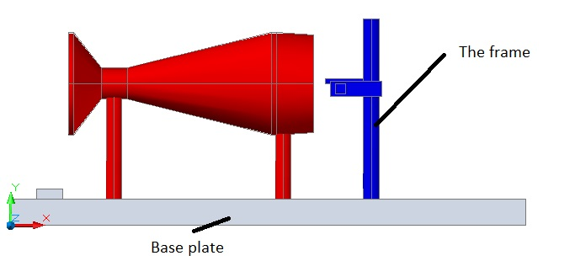

*Figure 3.2: Side view of the conceptual design*

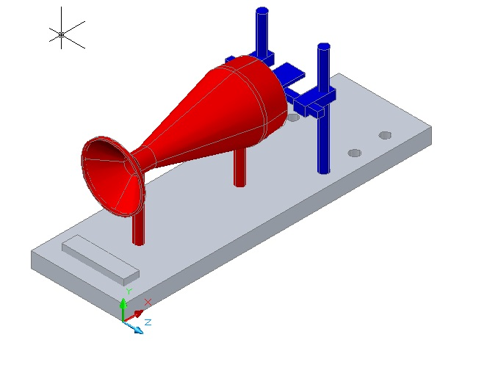

*Figure 3.3: Orthographic view of the lab kit experiment kit (conceptual design)*

* 1. MATERIAL SELECTION

The material required for each component of this lab kit is as given below in table 3.1.

Table 3.1: Material selection table

|  |  |
| --- | --- |
| **COMPONENT** | **MATERIAL** |
| Air flow tunnel (red) | Steel |
| The base plate (grey) | Plastic |

The reason for choosing steel for air flow tunnel is that thin steel sheets can be bent and rolled easily and they are also rigid and can support their own weight without collapsing. The design of the wind tunnel is such that it cannot be fabricated without bending the steel sheets and then joining them so therefore the sheets need to be cut, bent and riveted in order to take shape. The other reason is that the air flow measuring blades are to be attached inside the air flow tunnel so therefore the walls of the air flow tunnel have to be rigid enough to support the weight of the debimo measuring blades.

The base plate and the jig assembly are made up of plastic due the fact that the plastic is cheap and it can be fabricated with ease. The plastic base plate can easily support the weight of the wind tunnel and has enough space to hold other instruments also which are needed for the experiment.

Table 3.2: Material section for theSavonius turbine

|  |  |
| --- | --- |
| **COMPONENT** | **MATERIAL** |
| Rotor | Steel |
| The mounting plates (grey) | Plastic |
| The supporting shaft | Aluminum |

The material selected for the rotors of the turbine was steel due to two reasons, firstly the steel has higher yield strength and it can support the weight of the two mounting plates easily and secondly it can be bent and cut into desired shape easily.

The mounting plates were made up of plastic as they can be cut easily using the CNC milling machine and also they are light weight so they do not increase the weight of the turbine thus keeping the turbine lighter. Four threaded holes were also drilled into the mounting plates in order to connect the shafts. The plastic material made it easier to drill threaded holes through them.

The supporting shafts were made up of aluminum as they are light weight, easy to cut and they have higher friction coefficient with the inner walls of bearing thus ensuring that there is no slippage while the turbine rotates. The generator was also attached to the bottom shaft. The generator shaft was connected to the supporting shaft of the bearing by a screw.

* 1. EXPERIMENTAL SETUP

This purpose of this experiment was to design a lab equipment to measure the relation of wind speed and the turbines voltage. For this experiment a typical miniature American classic wind turbine was used. The turbine was connected to a 12V generator via a shaft joint as shown in figure 3.1. The wind turbine along with the generator was clamped in position using a finger clamp on a laboratory retort stand. A regular 3 speed table fan was used to provide the airflow. This wind passed through the wind tunnel and then it was used to rotate the turbine’s blade. The setup of the experiment can be seen in thefigure 3.2.The fan is placed at one end of the tunnel and the wind turbine is placed at the other end of the wind tunnel. The wind turbine is not placed inside the wind tunnel as it can be seen in figure 3.3; it is done due to the fact that the turbines generally operate in open spaces. The rotation of the turbine blade created a voltage from the generator. The generator was connected to a connection board. The generator’s voltage was recorded on the computer.

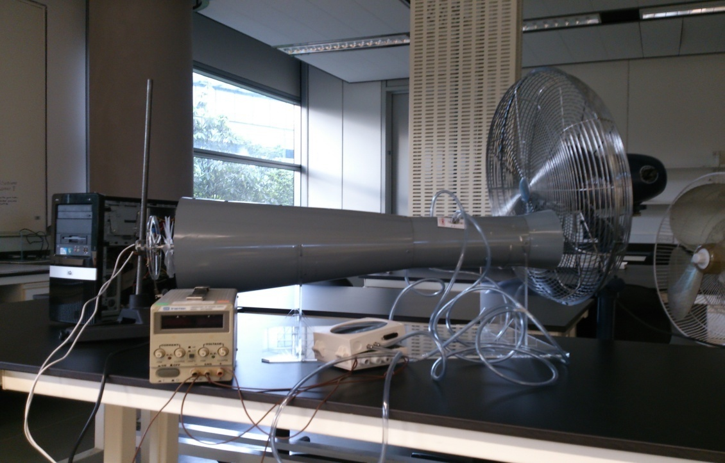

*Figure 3.4: the complete experimental setup to test the wind turbine*

As it can be seen in figure 3.4 the wind tunnel is at an offset from the center of the fan, this was done to ensure that max air can flow into the wind tunnel so that the turbine at the end of the wind tunnel can rotate.

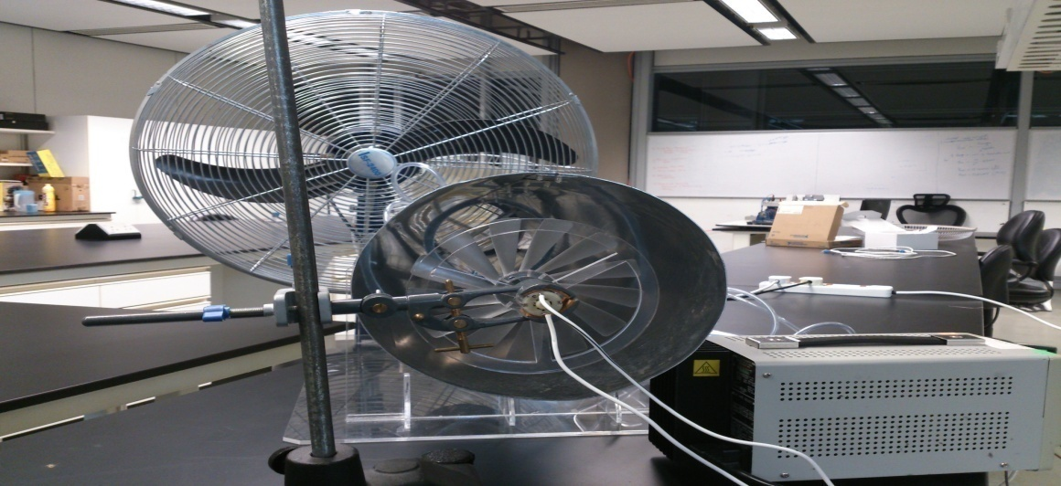

*Figure 3.5: The front view of the experimental setup*

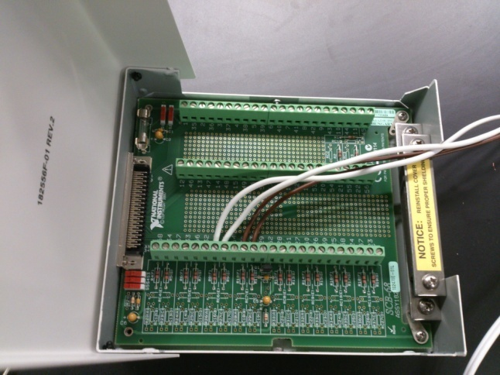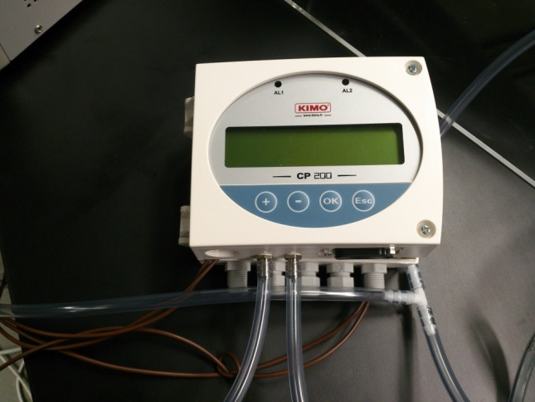

*Figure 3.6: The connection board (left), The data logger for debimo measuring blades (right).*

The wind velocity was measured using the Debimo air flow measuring blade. These blades were connected to a data logger as shown in figure 3.6, which converts the partial pressure into voltage; this output voltage readings along with generator’s voltage measurements were also stored in the computer through the connection board. The partial pressure over the measuring blades can also be viewed directly from the data logger’s LCD display. This data logger can only be used to measure the partial pressure of the air flowing over it. The recorded partial pressure was converted to velocity using equation 4.

The data from the turbine and the generator was input in the computer using a PC data acquisition card. The data was stored using the LABVIEW software. The output data was stored in raw form in terms of voltage. The raw data was processed in Microsoft Excel, the voltage that was recorded from thedebimo measuring blade was converted back to partial pressure using interpolation.

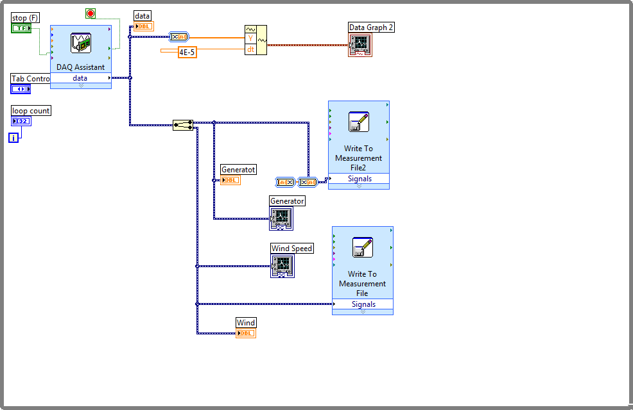

*Figure 3.7: Data acquisition system layout for lab experiment*

In order to retrieve the data from the turbine and the data logger, a block diagram was designed in labview. Following the pattern of this block diagram the PC data acquisition card retrieved the signal from the input devices and the final readings were then displayed on the monitor. The figure 3.7 shows the block diagram (system layout) for in time data analysis using labview software. As it can be seen in figure 3.7 the “DAQ assist data” block is used to acquire the input voltages from the connection board. It then plots both these inputs against time and record the data into excel file.

In order to join the generator and data logger to the PC data acquisition card a connection board was needed the connection scheme for this connection board was generated by the labview software. This particular connection scheme was for the data logger, another connection for the generator was also produced by the labview software. If this connection scheme is not followed, the data cannot be stored into the computer.

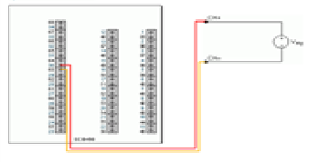

Vavg

CH-

CH+

*Figure 3.8: Lab experiment junction box diagram*

CHAPTER 4

RESULTS AND DISCUSSIONS

* 1. CONSTRUCTION OF THE WIND REGULATOR

The wind tunnel is an important part of the experiment as it ensures that all the air flow from the fan is transferred to the turbine with minimal losses and also it will house the measuring blade which are used to measure the partial pressure of wind in the tunnel and also they help to ensure that the air flow is smooth and there is no vortex generation in the flow of air. The detailed drawing of the wind tunnel along with all the dimensions can be viewed in figure 4.1. The 70 angle was maintained while fabricating the wind tunnel front section. The 70 was important because it will ensure that the boundary layer does not break off from the surface, which will result turbulence at the break off point. The disadvantage of turbulence is that it will disrupt the readings from the generator of the wind turbine thus it will not produce smooth readings and it will be hard to filter out correct readings.

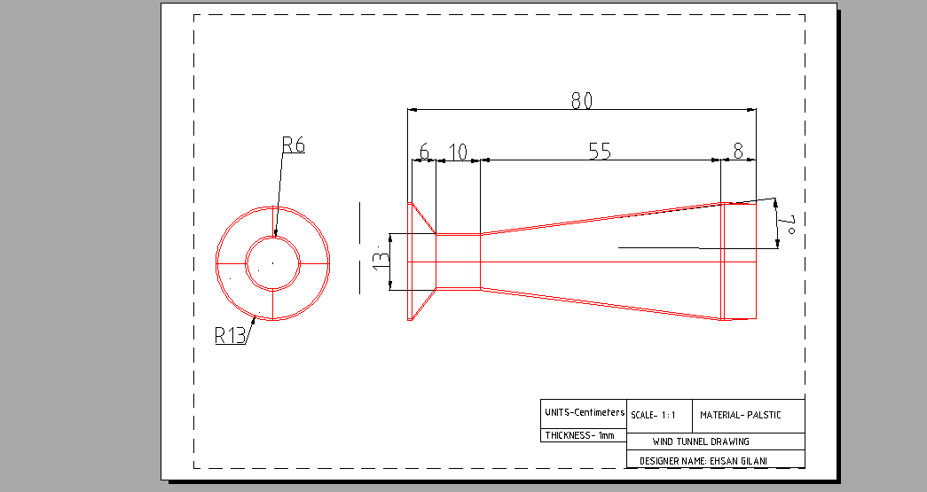

*Figure 4.1: The detailed drawing of wind tunnel*

* 1. DATA COLLECTED FROM LAB VIEW

The data collected from the lab view software was taken at a rate of 100 reading per second which means that 100 readings were taken from the data logger as well as the turbine generators in a second simultaneously. This was done to increase the accuracy of the data obtained. From the data collected a table was constructed which recorded the data at fixed intervals. The table 5.1 shows the voltage generated by the turbine’s generator in volts and wind velocity in meters per second at those fixed time intervals.

TABLE 4.1 (a) SELECTED DATA FROM THE LAB VIEW FOR HAWT.

|  |  |
| --- | --- |
| Voltage from generator (V) | Wind velocity at tunnel opening (m/s) |
| 0 | 0 |
| 0.3 | 1.22 |
| 0.47 | 2.14 |
| 0.68 | 2.72 |
| 0.82 | 3.1 |
| 1.1 | 3.77 |
| 1.27 | 3.92 |
| 1.76 | 4.48 |
| 1.93 | 4.77 |
| 2.11 | 5.13 |
| 2.11 | 5.25 |

The wind velocity was recorded at the opening of the wind tunnel because the velocity of wind changes as the cross sectional area of the tunnel changes as mentioned in the chapter 2.8 earlier. By following the flow rate equation it can be seen that the velocity at throat is twice that of velocity at the opening whereas the flow rate remains constant. The voltage from the turbine’s generator was recorded directly into the computer. A plot of turbine’s voltage versus the wind speed at the throat was obtained through MS Excel. The figure 4.2 shows the plot of the datafrom table 4.1 (a).

*Figure 4.2: The plot of Turbine voltage (V) against the Wind speed (m/s)*

From this graph it can be seen that an increase in wind speed at end opening of the wind tunnel will increase the voltage produced by the turbine. The maximum voltage is produced at a wind speed of around 5 m/s. The maximum voltage that can be produced by this turbine using the available generator is 2.1V. This max voltage can increase if an expensive generator with low internal resistance and less friction is used. However the power produced by the turbine will remain the same as it depends on the design of the turbine, only the voltage produced will be affected.

The same experiment was repeated for the VAWT and table 4.1 (b) shows the data of the experiment which is plotted in figure 4.3.

Table 4.1 (b) SELECTED DATA FROM THE LAB VIEW FOR VAWT.

|  |  |
| --- | --- |
| voltage from generator (V) | wind velocity at opening (m/s) |
| 0 | 0 |
| 0.08 | 1.52 |
| 0.24 | 2.61 |
| 0.33 | 3.06 |
| 0.41 | 3.44 |
| 0.51 | 3.82 |
| 0.62 | 4.23 |
| 0.77 | 4.7 |
| 0.81 | 4.84 |
| 0.94 | 5.21 |
| 1.01 | 5.4 |
| 1.11 | 5.67 |

*Figure 4.3: The graph of turbine output against wind velocity for VAWT.*

* 1. PERFORMANCE OF THE CLASSIC AMERICAN WIND TURBINE

The voltage from the turbine was converted into the power produced (P) by the turbine using the equation:

P = $\frac{V^{2}}{R}$ (11)

Where,

V is the voltage from the generator in Volts

R is the generator’s internal resistance in ohms

The internal resistance of the generator connected to the HAWT was specified on the generator which was 13 ohms. The internal resistance of the generator connected to the VAWT was 10 ohms. The wind velocity in both the experiments was calculated using the equation 6.

Table 4.2 (a): Data HAWT for wind velocity and turbine power

|  |  |
| --- | --- |
| Wind velocity (m/s) | Turbine output power (W) |
| 0 | 0 |
| 1.22 | 0.01 |
| 2.14 | 0.02 |
| 2.72 | 0.04 |
| 3.1 | 0.06 |
| 3.77 | 0.1 |
| 3.92 | 0.13 |
| 4.48 | 0.24 |
| 4.77 | 0.29 |
| 5.13 | 0.34 |
| 5.25 | 0.34 |

Table 4.2 (b) Data for VAWT wind velocity and turbine power

|  |  |
| --- | --- |
| Wind velocity (m/s) | Turbine output (W) |
| 0 | 0 |
| 1.52 | 0.01 |
| 2.61 | 0.01 |
| 3.06 | 0.02 |
| 3.44 | 0.02 |
| 3.82 | 0.03 |
| 4.23 | 0.04 |
| 4.7 | 0.06 |
| 4.84 | 0.07 |
| 5.21 | 0.09 |
| 5.4 | 0.11 |
| 5.67 | 0.13 |

The values from the table 4.2 (a) and 4.2 (b) were plotted on the same graph and the figure 4.4 shows the result of the plotted data. It can be seen in the figure 4.4 that turbine output is limited by the wind velocity. The output increases as the power in wind also increase. The gradient of these curves could be used to represents the efficiency of the turbine and from the figure 4.3 it can be noted that the maximum efficiency of HAWT is greater than that of VAWT. The power produced at 5 m/s wind speed by HAWT 0.32 W is also greater than the power produced at 5 m/s wind speed by VAWT 0.13 W but whereas the HAWT is producing no more extra power i.e. reached its maximum capacity, the power produced by the VAWT keeps on increasing.

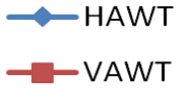

*Figure 4.4: Graph of turbine output (W) against wind velocity (m/s).*

CHAPTER 5

CONCLUSION AND RECOMMENDATIONS

* 1. CONCLUSION

In the end the whole lab experiment kit proved out to be a success.The lab equipment to demonstrate wind power and its conversion efficiency was successfully built. The lab equipment was designed using computer aided design software: AUTOCAD, The wind tunnel was designed and fabricated on timein the UTP design center. The wind was produced by the electric fan and measured using Debimo measuring blades. This wind then drove wind turbine to rotate the generator attached to the turbine blades. The rotation of the generator produced voltage which was measured simultaneously with the wind speed in real time in the lab view software using a PC data acquisition card and a connection board and a computer. The results for each of the turbines (VAWT and HAWT) were plotted. These results were in agreement with the actual specs of the wind turbine. This shows that the lab kit is very accurate and any miniature models of the turbine can be tested using this type of lab kit.

* 1. RECOMMENDATIONS

As this report draws to an end there are certain number of recommendations that the author would like to suggest for further expansion of this work. Firstly the experiment can be repeated while varying different parameters such as the distance of turbine from the wind source and the orientation of the wind turbine the graphs of which could be plotted.Next, different types of wind turbine can be tested on this lab kit for example a miniature S-rotor or a three rotor horizontal turbine with variable angles of rotors. The power curves for these turbines could be obtained and plotted from the lab kit. Lastly the author would like to add an amendment to the design of the wind regulating tunnel by increasing the diameter of the opening of the wind tunnel so that more air can be regulated inside the wind tunnel which will result in higher flow rate and thus more accurate data for the turbines.

REFERENCES

1. H.H. Al-Kayiem and G.J. Ming. Experimental investigation of S-rotors in open and bounded flows. *World acade. Sci., Eng. and Tech.,* 2011, Vol. 60, pp: 144-149.
2. (2013), How Wind Energy Works. [online], Available: [*http://www.benefits-of-recycling.com/howdoeswindenergywork/*](http://www.benefits-of-recycling.com/howdoeswindenergywork/)
3. (29 May 2012),Energy Harvesting System. [online], Available: [*http://en.wikipedia.org/wiki/Energy_harvesting*](http://en.wikipedia.org/wiki/Energy_harvesting)
4. Jung, S.N., T.S. No and K.W. Ryu,Aerodynamic Performance Prediction of a 30kW counter-rotating wind turbine system,*Renewable energy*, 2005,Vol. 30, pp:631-644.
5. Manwell J.F et al, Wind Energy Explained: Theory, Design and Application, 2002

# K.Pope, I. Dincer, G.F. Naterer.Energy and exergy efficiency comparison of horizontal and vertical axis wind turbines.*Renewable Energy*, 2010, Vol. 35, pp: 2102-2113.

# (17 Jan 2013), How Do Wind Turbines Work. [online], Available: [*https://www1.eere.energy.gov/wind/wind_how.html*](https://www1.eere.energy.gov/wind/wind_how.html)*.*

1. R.D. Begamudre, Energy Conversion Systems. ***New Age International (P) Limited***,1st edition, 2000.

# Testing, inspecting and monitoring technologies for wind turbine blades: A survey [Bin Yang](http://www.sciencedirect.com/science/article/pii/S1364032113000129)National Center for Materials Service Safety, University of Science and Technology Beijing, Beijing 100083, China (yang)

# Kishore R.A.: Design and experimental verification of a high efficiency small wind energy portable turbine (SWEPT), *Journal of Wind Engineering and Industrial Aerodynamics*, Vol.118, pp. 12-19

1. Ph. Delarue, A. Bouscayrol, A. Tounzi, X. Guillaud, G. Lancigu, Modelling, control and simulation of an overall wind energy conversion system, *Renewable Energy*, Vol. 28, Issue 8, July 2003, pp. 1169-1185.

# Retreived from http://www.potomacwindenergy.com/id15.html on December 2013

# (2013), Domestic scale wind turbine,Green Spec,[online], Available at *http://www.greenspec.co.uk/small-wind-turbines.php*

# John Bird, Basic Engineering Mathematics, Wind Turbine Power Calculation, Elsevier Ltd, 2007

# Nakajima M; Iio S, Ikeda T, Performance of Double-step Savonius Rotor for Environmentally Friendly Hydraulic Turbine,*J. of Fluid Sci. and Tech*. Vol. 3, Issue 3, 2008, pp:410-419

# Patel C.R., Patel V.K., Prabhu S.V., Eldho T.I, Investigation of Overlap Ratio for Savonius Type Vertical Axis Hydro Turbine, *International Journal of Soft Computing and Engineering (IJSCE)*, Vol. 3, issue 2, May 2013, pp: 379- 38.

APPENDICES

# Appendix 1:Data set with selected intervals for classic American wind turbine

|  |  |  |  |  |  |  |
| --- | --- | --- | --- | --- | --- | --- |
| Voltage from data logger (V) | Voltage from generator (V) | Partial pressure of air (Pa) | Wind velocity in throat (m/s) | Wind velocity at opening (m/s) | Power in wind (W) | Turbine output power (W) |
| 0 | 0 | 0 | 0 | 0 | 0 | 0 |
| 0.006 | 0.3 | 5.91 | 2.44 | 1.22 | 0.02 | 0.01 |
| 0.016 | 0.47 | 18.18 | 4.27 | 2.14 | 0.11 | 0.02 |
| 0.026 | 0.68 | 29.52 | 5.44 | 2.72 | 0.23 | 0.04 |
| 0.034 | 0.82 | 38.4 | 6.2 | 3.1 | 0.33 | 0.06 |
| 0.049 | 1.1 | 56.69 | 7.53 | 3.77 | 0.59 | 0.1 |
| 0.054 | 1.27 | 61.45 | 7.84 | 3.92 | 0.67 | 0.13 |
| 0.069 | 1.76 | 79.96 | 8.95 | 4.48 | 0.99 | 0.24 |
| 0.079 | 1.93 | 90.85 | 9.54 | 4.77 | 1.19 | 0.29 |
| 0.091 | 2.11 | 105.01 | 10.25 | 5.13 | 1.48 | 0.34 |
| 0.095 | 2.11 | 109.99 | 10.49 | 5.25 | 1.59 | 0.34 |

# Appendix 2: Data set with selected intervals for Savonius rotor

|  |  |  |  |  |  |  |
| --- | --- | --- | --- | --- | --- | --- |
| voltage from data logger (V) | voltage from generator (V) | partial pressure of air (Pa) | wind velocity in throat (m/s) | wind velocity at opening (m/s) | power in wind (W) | turbine output power (W) |
| 0 | 0 | 0 | 0 | 0 | 0 | 0 |
| 0.008 | 0.03 | 9.14 | 3.03 | 1.52 | 0.04 | 0.01 |
| 0.024 | 0.09 | 27.19 | 5.22 | 2.61 | 0.2 | 0.01 |
| 0.033 | 0.16 | 37.25 | 6.11 | 3.06 | 0.32 | 0.01 |
| 0.041 | 0.24 | 47.33 | 6.88 | 3.44 | 0.45 | 0.01 |
| 0.051 | 0.33 | 58.29 | 7.64 | 3.82 | 0.62 | 0.02 |
| 0.062 | 0.43 | 71.4 | 8.45 | 4.23 | 0.83 | 0.02 |
| 0.077 | 0.55 | 88.22 | 9.4 | 4.7 | 1.14 | 0.03 |
| 0.081 | 0.73 | 93.33 | 9.67 | 4.84 | 1.24 | 0.06 |
| 0.094 | 0.93 | 108.39 | 10.42 | 5.21 | 1.55 | 0.09 |
| 0.101 | 1.17 | 116.6 | 10.8 | 5.4 | 1.73 | 0.14 |
| 0.111 | 1.29 | 128.47 | 11.34 | 5.67 | 2 | 0.17 |